Stakeholder Consultation and Program Coordination member: | Jessica Hollingshead
Date completed or revision date: | 9/21/16. Revised 9/27/16
ESSA Spoke Committee | Title Programs Spoke Committee
Stakeholder Consultation and Program Coordination(SC/PC) Overview
The Stakeholder Consultation and Program Coordination committee is charged with ensuring that Colorado meets or exceeds the ESSA stakeholder consultation requirements and program coordination requirements for state plan development. With that charge in mind, SC/PC members are reaching out to spoke committees to offer assistance in evaluating stakeholder consultation efforts, strengthening where applicable, and to begin collecting information necessary to draft the stakeholder consultation section of the ESSA state plan.

SC/PC members have identified five areas of stakeholder consultation and program coordination which will need to be addressed in the state plan. This report is the first step in ensuring Colorado meets the requirements outlined below:

ESSA Stakeholder Consultation Requirements (taken directly from ESSA text)
- Plan must be developed by the SEA with meaningful consultation with the Governor, members of the State legislature, the State board of education, LEAs, representatives of Indian tribes (in CO), teachers, principals, other school leaders, charter school leaders, specialized instructional support personnel, paraprofessionals, administrators, other staff, and parents.
Limit: Consultation with the above members may not interfere with the timely submission of the plan.
Item 1: Meaningful stakeholder consultation is a critical step in drafting and implementing a plan that can address the needs of all students (see graphic below). The SC/PC committee would like to connect on how we can strengthen and supplement stakeholder consultation efforts relative to the requirements and decision points of your section of
the ESSA state plan.

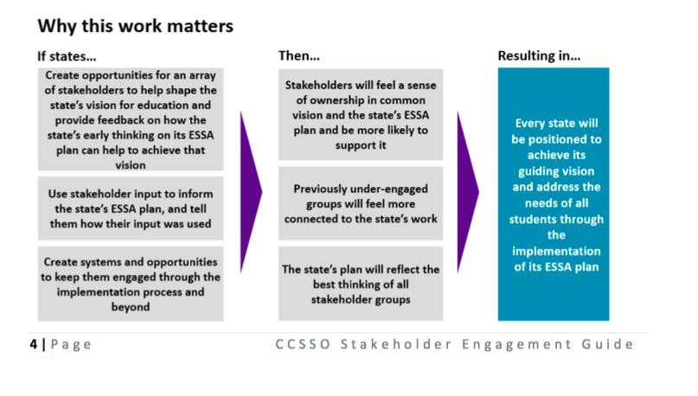
Item 2: Describe the process for creating or supplementing spoke committee membership. How can the SC/PC members assist in addressing any membership gaps related to the meaningful consultation requirements?
Title Programs spoke committee membership list: http://www.cde.state.co.us/fedprograms/titleprogramsmembership082616
Item 3: Describe your plan to address the feedback received from the Listening Tour. Do you see any challenges in accepting or not accepting that feedback?
Item 4: Where do you see your committee work aligning with programs listed in ESSA program coordination requirements?
ESSA Plan Coordination Requirements (taken directly from ESSA text) Plan must be coordinated with:
- other programs under this Act,

- the IDEA,
- the Rehabilitation Act of 1973,
- the Carl D. Perkins CTE Act of 2006,
- the Workforce Innovation and Opportunity Act,
- the Head Start Act,
- the Child Care and Development Block Grant of 1990,
- the Education Sciences Reform Act of 2002,
- the Education Technical Assistance Act of 2002,
- the National Assessment of Educational Progress Authorization Act,
- the McKinney-Vento Homeless Assistance Act, and
- the Adult Education and Family Literacy Act.
Item 5: Are there any decision points on which your spoke committee has not been able to obtain meaningful input from a particular stakeholder group(s)? If so, please provide the necessary information so that the SC/PC Spoke Committee can assist you with obtaining this input. Please provide the following:
- What are the decision points?
- What is the relevant background information that stakeholders will need when providing input?
- From whom is input still needed?
Next steps:
Follow up meeting scheduled in two weeks.

CCSSO Stakeholder Engagement Resources: http://www.ccsso.org/Documents/2016/ESSA/CCSSO%20Stakeholder%20Engagement%20Guide%20FINAL.pd f

