RIGOROUS ACTION THROUGH REDESIGN

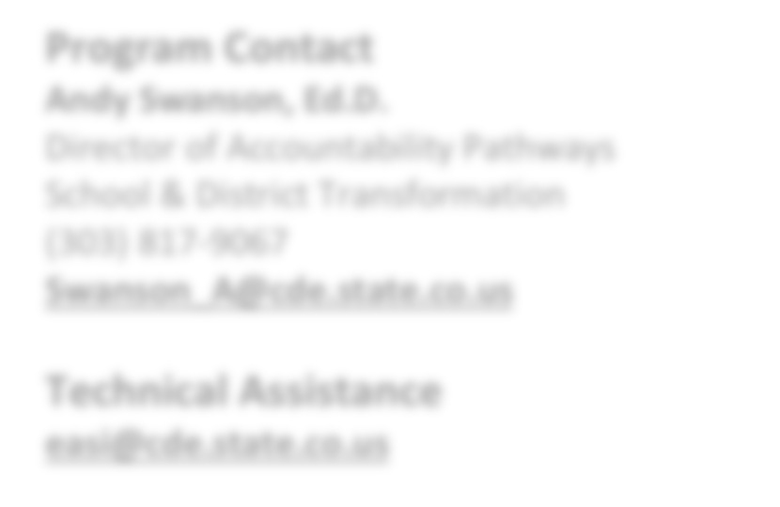

**EASI Route: Offered Services**

# Introduction

The Rigorous Action through Redesign is intended to support Local Educational Agencies (LEAs) and schools with deep school design intended to address systemic issues impacting school performance and create sustained improvement for schools in Years 2-3 on the State Accountability identification system or for schools reaching Years 3 or more on the Federal accountability identification system.

**Program Contact**

**Andy Swanson, Ed.D.**

Director of Accountability Pathways School & District Transformation

(303) 817-9067

[**Swanson_A@cde.state.co.us**](mailto:Swanson_A@cde.state.co.us)

**Technical Assistance**

[**easi@cde.state.co.us**](mailto:easi@cde.state.co.us)

School redesign, in the context of this grant, is a process facilitated by a

CDE approved external partner that includes a deep comprehensive review of the existing school systems and structures (e.g. people, time, resources, school model, alignment to Four Domains for Rapid School Improvement) driven by a representative school-design team. Participating schools should expect to spend 12-18 months on comprehensive design work and an additional 12 months on early implementation and prototyping identified new school design priorities. Therefore, funding would be available for design development and implementation for up to 2.5 years.

For a list of CDE approved external providers, visit [CDE’s Advisory List of Providers.](https://www.cde.state.co.us/accountability/cde-advisory-list-of-providers) Districts should select providers approved for Improvement Implementation support, particularly those identified as having expertise in Whole School Redesign. CDE is available to consult on provider selection for grantees.

*Note: Engaging in school redesign does not necessarily mean that a school is required to consider or adopt a new school model, although that may be an outcome for some participating schools.*

# Eligibility & Prioritization

*Eligibility.* Schools that meet the following criteria are eligible to apply:

* Schools identified for improvement under ESSA as Comprehensive Support (CS) Lowest 5% or Comprehensive Support Low Graduation Rate for 3 or more years (i.e. CS Year 3+); and/or
* Schools with a state identification School Performance Framework plan type of Priority Improvement or Turnaround in Year 2 or 3

For LEAs with schools meeting this eligibility criteria this redesign grant can serve as a vehicle for redesigning a school and implementing significant school-wide changes with enough time for full implementation as part of an Early Action proposal to the State Board or prior to reaching Year 5 on the state accountability framework and the associated requirements of a full Pathways Plan. This redesign grant can also serve as a designated “more rigorous action” for schools identified as Comprehensive Supports (CS) for 3 or more years.

*Prioritization.* If not all EASI proposals can be funded, proposals that meet grant expectations will be funded in the order of the EASI school-level prioritization list. Schools with the highest number of prioritization points will be funded first. Details on how prioritization points are calculated and the points for each EASI eligible school are available on the [EASI Resources and Technical Assistance](https://www.cde.state.co.us/fedprograms/easiappresourcesandtechnicalassistance) webpage.

Updated August 2024

# Program Considerations & Fit

*Program Considerations*. Rigorous Action through Redesign aims to address systemic issues impacting school performance and create sustained improvement for schools. Schools should consider factors of school readiness including staffing, consistency and buy-in from school leadership, district-level engagement and support for redesign, culture and culture, and other initiatives and/or improvement efforts prior to engaging in this support for more rigorous action.

*Program Fit*. Rigorous Action through Redesign requires the school’s staff to engage in an extensive process of school redesign. Rigorous Action through Redesign is a good fit for schools on Year 2 or 3 of the Accountability Clock. This program is not a good fit for schools currently supported through other EASI or other grants that require significant staff engagement or school leadership capacity such as Connect for Success, Transformation Network, District Designed & Led. This support does not pair well with Exploration as extensive diagnostic and planning is a part of Rigorous Action Through Redesign.

# Sequence of Program Support

The sequence of the work for participating schools is intended to be a 2.5 year engagement in school redesign efforts. The exact sequence is determined by the district, but must include the following:

* Year 1 (6 months) Key Activities – Launch
  + Initial kick-off meeting with CDE
  + Finalize scope of work with external partner
  + Develop design team
  + Facilitate stakeholder engagement including staff and student experience data and feedback At the end of Year 1 schools should have:
  + A working design team that is representative of key stakeholder groups including district and school leaders, key school staff, students and other stakeholders as determined by the school
* Year 2 Key Activities - Design
  + Work with external provider to facilitate design process including: understanding current state, developing/confirming vision, identifying 1-2 design levers to launch and prototype in year 2, and initial planning for launch of these design lever changes

At the end of Year 2 schools should be able to answer a few big questions:

* + What is our vision of excellence for our school and for student experience?
  + What systems and structures do we need to change or create at both the school and system levels to make that vision a reality for all of our students?
  + What resources and structures are necessary to support the launch of identified levers?
  + What strategic work do we need to do for our talent management domain? What new job descriptions do we need to develop to match our vision? What recruitment and retention tools might be necessary?
* Year 3 Key Activities - Launch and Prototype
  + Work with external provider to support design team and launch of identified levers
  + Support initial launch of 1-2 identified design levers
  + Support design team in guiding launch and early implementation
  + Soliciting stakeholder feedback on early implementation of identified design levers
  + Progress monitoring early implementation and leading indicators of impact At the end of Year 3 schools should have:
  + Established progress monitoring tools and research and development processes to support ongoing short-cycle design, prototyping, and implementation
  + Strong foundation to apply for full implementation funding through the EASI grant (pending eligibility)
  + Initial demonstration of impact on identified levers and leading indicators

*Note: Schools that remain eligible for EASI following redesign may choose to apply for another EASI grant to support ongoing implementation. However, schools should consider long term sustainability in overall redesign planning. Schools that progress to Years 4-5 on the state accountability system should consider applying for Accountability Pathways.*

# Available Funds & Duration

*Available Funds.* Applicants may request up to the maximum award amount for a school who has not yet started redesign efforts. If a school has completed initial key activities, then requests should be adjusted according to the support supported by the grant. Award may be:

* Up to $20,000 for Year 1 “launch” of grant (2024-25)
* Up to $100,000 per year for Years 2-3 of the grant to support redesign and early implementation (2025-26 and 2026-27)

*Duration.* Program support is designed to support schools for a period of 2.5 years (2024-25 to 2026-27).

# Allowable Use of Funds

Funds are intended to support design, planning, and implementation of a school redesign effort. Allowable use of funds include costs associated with:

* Year 1 Launch
  + Hiring an approved external provider to facilitate design and/or planning activities outlined above
  + Stakeholder engagement (stipends, translation, childcare, surveys, etc.)
  + Coordination and/or professional learning of the design team (stipends, meeting materials)
* Year 2 Design Year
  + Hiring an approved external provider to facilitate design and/or planning activities outlined above
  + Stakeholder engagement (stipends, translation, childcare, surveys, etc.)
  + Coordination and/or professional learning of the design team (stipends, meeting materials)
  + Bright spot visits of schools with aligned school models
  + Development of a comprehensive school design plan
  + Participating in CDE convenings and meetings
* Year 3 Launch/Prototype Year
  + Hiring an approved external provider to facilitate design and/or planning activities outlined above
  + Prototyping and early implementation of 1-2 design elements identified in the design and planning year and any associated evidence-based strategies
  + Expenses to support the prototyping and early implementation of identified design elements (e.g., stipends for school staff participating receiving training for implementation of the selected evidence- based strategies, substitutes, etc.)
  + Coordination and/or professional learning of the design team (stipends, meeting materials)
  + Data collection, progress monitoring implementation, and evaluating impact (e.g. costs associated with conducting progress monitoring activities, and revising design and prototypes based on evaluation results).
  + Bright spot visits of schools with aligned school models
  + Participating in CDE convenings and meetings

*Budget Recommendations.* For the application submission, a draft budget should include how the funds may be used as aligned to the outlined sequence of work for Rigorous Action through Redesign. It is acceptable, however, to use a general placeholder in the budget for activities in Year 2 or Year 3 that are dependent on the completion of previous key activities. Any expenses related to an external provider must be supported by a scope of work (draft version acceptable) that clearly outlines timelines, deliverables, and costs for the eligible school.

*Note: If entering indirect costs, the total request amount may not exceed the maximum allowable amount.*

## Fund Considerations.

* Funds from this opportunity must be used to **supplement and not supplant** any federal, state, and local funds currently being used to provide activities.
* Post-award revisions must be approved by 06/30 and funds drawn down by 09/30 of each respective fiscal year.
* A school or district may carry funds forward in alignment with funding source restrictions and with CDE approval. At the end of the grant performance period, any non-requested federal funds are reverted and any unspent state funds must be returned to the state.
* CDE may terminate a grant award upon thirty days’ notice if it is deemed by CDE that the applicant is not fulfilling the requirements of the funded program as specified in the approved project application, or if the program is generating less than satisfactory results.
* Multi-year or future award year amounts are contingent on allocations of state and federal funds to CDE in each respective fiscal year.

# Important Program Dates

|  |  |
| --- | --- |
| **Program Dates** | **Activity** |
| **September- December** | Meet with CDE School Transformation Specialist to discuss interest in applying for support and outline a proposed budget |
| **December** | Application due |
| **January** | Award notifications |
| **February/March** | Initial meeting with CDE program lead to outline activities, consult on partner selection, and finalize budget activities |

**Evaluation and Reporting**

Each grantee of the program must, at a minimum, agree to the following evaluation, reporting, and/or progress monitoring components:

* Integration of pathways work within the school or LEA’s Unified Improvement Plan (UIP)
* If the school or district reaches the end of the Accountability Clock, the LEA will be expected to present its pathway plan—developed with CDE support—to the State Board of Education prior to any end-of-clock statutory deadlines. LEAs using grant funds for implementation activities will be required to comply with all progress monitoring requirements requested by CDE staff and the state board.
* Annual Financial Report (AFR) each fiscal year by 09/30

*Note: All data collected will protect personally identifiable information (PII) protected and is only reported on an aggregate level for purposes of evaluating the EASI support and/or supporting future program improvements.*

# Program Assurances

## LEA Commitments:

* Identify a district point person with decision-making authority who will support the redesign and early implementation process for the school(s) being served by the grant. Ideally this would be the principal supervisor;
* District partner will participate on the design team in all grant activities; and
* District partner commits to a design process that will identify key systemic and/or structural priorities and associated changes to holistic school systems including but not limited to: people, time, and money; and
* District partner will manage the process to select an external partner in consultation with the school

## School Leadership Commitments:

* School leader will develop and convene a design team that is representative of school leadership, school staff, students and other key stakeholders as defined by the school;
* School leader will participate on the design team in all grant activities;
* School leader commits to a design process that will identify key systemic and/or structural priorities and associated changes to holistic school systems including but not limited to: people, time, and money.

# ADDITIONAL INFORMATION AND RESOURCES

**EASI: Accountability Pathways:** [**www.cde.state.co.us/fedprograms/exploration-accountabilitypathways**](http://www.cde.state.co.us/fedprograms/exploration-accountabilitypathways)

**CDE: Accountability Clock Webpage:** [**www.cde.state.co.us/accountability/accountability_clock**](http://www.cde.state.co.us/accountability/accountability_clock)