EXPLORATION SUPPORTS

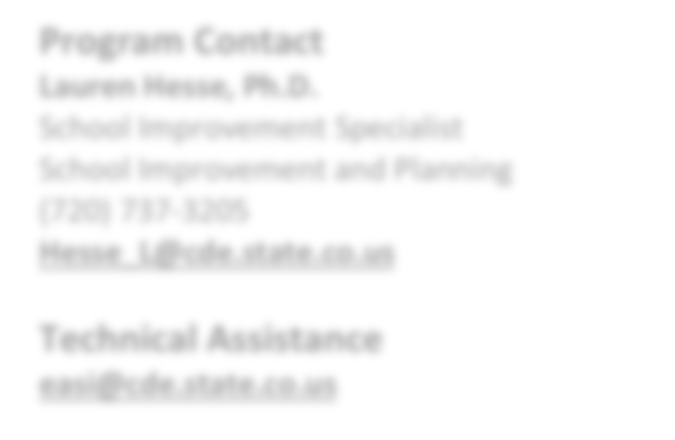

**EASI Route: Exploration Supports**

# Introduction

The Exploration route of the Empowering Action for School Improvement (EASI) application is focused on identifying needs and exploring options through external diagnostic reviews, stakeholder engagement, and effective improvement planning. The components of the Exploration route assist LEAs in identifying areas of strength and need (External Diagnostic Review), engaging a variety of stakeholders in improvement conversations (Stakeholder Engagement), and building a plan centered around those prioritized needs (Improvement Planning). The EASI

**Program Contact**

**Lauren Hesse, Ph.D.**

School Improvement Specialist School Improvement and Planning (720) 737-3205

[**Hesse_L@cde.state.co.us**](mailto:Hesse_L@cde.state.co.us)

**Technical Assistance**

[**easi@cde.state.co.us**](mailto:easi@cde.state.co.us)

application also offers the opportunity for LEAs/schools to focus their Exploration work on a particular population of students, content areas, or school models (i.e., English Learners, AECs/Online schools or Early Literacy).

The Exploration route differs from the other routes within EASI. Reviewers of applications for the EASI Exploration Route assess readiness and fit for this set of supports, rather than awarding points through a competitive grants process. If the collective amount of requests exceeds availability of funds, then a prioritization process is used. The duration of the awards is typically shorter than the other EASI routes and spans 18 months (e.g. January of the award year through June of the following year). Early Implementation funds may be available for initial implementation of activities and strategies associated with the review and planning process.

The diagram below outlines the four components of the Exploration route. *Because the different elements of the Exploration route work so closely together, LEAs are encouraged to select the same provider for the external diagnostic review, stakeholder engagement and improvement planning work – or at least negotiate a way for the different providers to align their work.* These four components are explained in greater detail on the following pages.

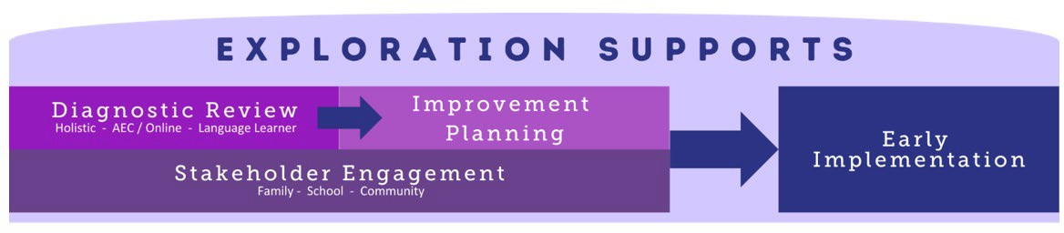

# External Diagnostic Reviews

Based upon years of best practice, the department has identified external diagnostic reviews as an important component in helping a school prepare for rapid, effective school improvement work. The types of reviews have expanded within the last few years to include the traditional holistic diagnostic review that looks at the comprehensive school system, as well as specialized reviews for schools that want a more detailed look at programming for English Language (EL) students, Alternative Education Campuses and Online Schools, or Early Literacy (K-3). The Exploration Route also offers district-level services for Specialized Reviews or Strategic Planning.

Updated August 2024

***Holistic Diagnostic Review.*** The Holistic Diagnostic Review is ideal for schools that would benefit from an external eye taking a comprehensive look at the school system to identify areas for improvement. LEAs are awarded funds on behalf of their schools to work with a CDE-approved and -trained partner to conduct a school-based diagnostic review. External partners will provide the following services:

1. Conduct a comprehensive, evidence-based review and corresponding report organized by the [Colorado Four](https://www.cde.state.co.us/fourdomains) [Domains for Rapid School Improvement](https://www.cde.state.co.us/fourdomains) detailing how the school’s infrastructure supports culture and climate shift, instructional transformation, talent management and leadership for rapid improvement.
2. Facilitate a staff debrief, including key findings from the review, high-level observations, opportunities for improvement, and a timeline for next steps for turnaround work.

Currently, the holistic review is only available at the school level. CDE is working to update district level standards for district level reviews in the future. Note that the external partner must be selected prior to submission and a scope of work must be uploaded to the application. In January, CDE will provide training to selected partners to ensure they understand the intent of the grant and reporting expectations.

For a list of preferred service providers approved by the CDE, visit [CDE’s Advisory List of Providers.](https://www.cde.state.co.us/accountability/cde-advisory-list-of-providers)

***Alternative Education Campus (AEC) and Online Review.*** Participating AECs and online schools work with CDE staff to conduct a school-based diagnostic review, discuss recommendations and major areas to build on, engage stakeholders in planning efforts, and visit other participating schools. The Diagnostic reviews result in a formal report, recommended improvement actions, and other partner sites for visits. The facilitated improvement planning process is designed to assist the school in designing implementation plans and refining the Unified Improvement Plan (UIP) to incorporate priorities from the review. See the [Diagnostic Review and Planning for AECs and Online Schools fact sheet](https://www.cde.state.co.us/fedprograms/infosheet_aecandonlineschoolreview) for more information.

***Language Learner Partnership*** *(formerly English Language Development Program Review).* The Language Learner Partnership offers targeted services for districts and schools seeking to improve their English language development instruction. It includes a CDE-led diagnostic review focused on identifying strengths and areas for improvement in systems, supports, and opportunities for English Learners (ELs)/Multilingual Learners (MLs). The review is followed by collaborative action planning and supports and by quarterly progress monitoring and short-cycle planning support. See the [Language Learner Partnership fact sheet](https://www.cde.state.co.us/fedprograms/eldreviewschool) **(**PDF) for more information.

***District Strategic Planning.*** This opportunity provides funding to districts who are seeking to strengthen district systems that are necessary to support sustainable school improvement in one or more identified schools. These district systems may include Talent Management, Instructional Infrastructure, Turnaround Leadership development, and/or Culture and Climate. Grantees will partner with an approved external provider to conduct a systems review, stakeholder engagement activities, and prioritization and improvement planning. See the [District Strategic Planning fact sheet](https://www.cde.state.co.us/fedprograms/easidisrtictstrategicplanning) (PDF) for more information.

# Stakeholder Engagement

State and federal expectations highlight the importance of stakeholder engagement (e.g., building leadership, teachers, families, community members, local board members) throughout the school improvement process. Funding for this opportunity may be used for (1) contracting with a CDE-approved provider that has knowledge of working with the selected stakeholders and background knowledge of the content area, and (2) costs associated with the stakeholder engagement proposed activities (e.g., substitutes, stipends, copying, translation services, childcare, food for community events, travel). The Family-School-Community Partnerships (FSCP) office at CDE is available to provide technical support

related to evidence-based stakeholder engagement strategies. It is recommended that a team of diverse stakeholders implement high-impact strategies that are aligned to the National Standards for Family-School Partnerships and Colorado’s FSCP Framework. Additional resources are available through CDE’s [Office of Family, School and Community](http://www.cde.state.co.us/familyengagement) [Partnerships](http://www.cde.state.co.us/familyengagement) page.

# Improvement Planning

All schools and districts are expected to have a coherent plan that meaningfully involves stakeholders, builds upon a thorough data analysis and needs assessment, and proposes evidence-based strategies that address the school’s most pressing issues. The improvement planning component is intended to build upon the external diagnostic review and stakeholder engagement work. Available supports include

* Assistance on data gathering and organizing (pre-planning for data analysis)
* Review of student performance data
* Identification of trends and performance challenges
* Prioritization of performance challenges
* Root cause analysis (including integration of the external review)
* Target setting
* Action planning
* Progress monitoring

Grantees may select an external partner or CDE to facilitate the planning process. Typically, three to five days of onsite work is needed, as well as time to share feedback on the written plan. The facilitator will not write the plan for the school but will provide feedback, ultimately assisting the school in completing it and advising on how to keep it updated as the school progresses in its improvement efforts. If working with an external partner, this must be done prior to submitting the application. The partner must participate in an annual, mandatory training on the planning process that includes recent updates on federal and state requirements.

# Early Implementation

For schools that complete the Exploration route and develop a strong improvement plan, funds may be available for the early stages of implementation for this plan. Before accessing these funds, if they are awarded, schools must

1. update their Unified Improvement Plan (UIP) based on an improvement plan that draws on the results of a diagnostic review and incorporates stakeholder input, AND
2. submit a revised budget detailing the proposed use of implementation funds on evidence-based strategies incorporated into the updated UIP.

# Eligibility & Prioritization

*Eligibility.* Schools that meet the following criteria are eligible to apply:

* + Schools identified for improvement under ESSA as Comprehensive Support (CS), Targeted Support (TS), or Additional Targeted Support (ATS); and/or
  + Schools with a state identification School Performance Framework plan type of Priority Improvement, Turnaround, or On Watch

*Prioritization.* If not all EASI proposals can be funded, proposals that meet grant expectations will be funded in the order of the EASI school-level prioritization list. Schools with the highest number of prioritization points will be funded first. District level supports will use the average prioritization of all EASI eligible schools. Details on how prioritization points are calculated and the points for each EASI eligible school are available on the [EASI Resources and Technical](https://www.cde.state.co.us/fedprograms/easiappresourcesandtechnicalassistance) [Assistance](https://www.cde.state.co.us/fedprograms/easiappresourcesandtechnicalassistance) webpage**.**

*Limitations.* Alternative Education Campus and Online Review and Language Learner Partnership are both direct CDE supports. The number of new schools awarded each grant cycle may be limited due to CDE staff capacity to conduct the reviews. If not all EASI proposals for CDE provided review requests can be supported, prioritization points and service capacity in a single district or region may be considered.

# Program Considerations & Fit

*Program Considerations*. The Exploration route has been designed to be a good entry point for EASI support, providing a diagnostic review or needs assessment to inform and guide improvement plans and possible subsequent EASI grant applications.

*Program Fit*. The Exploration route is a good fit for systems that are newly or recently identified for improvement (e.g., “early on the accountability clock” or recently ESSA-identified) and/or that are new to EASI. Systems that have not had a diagnostic review in the last two years or that have experienced significant recent context changes (e.g., large-scale leadership turnover, rapid demographic shifts, or other significant community events) will benefit from the external perspective supplied by CDE approved providers.

# Sequence of Program Support

The components of the Exploration route work together to support the creation of a thorough improvement plan. A Diagnostic Review (either holistic or specialized) informs a rigorous process of Improvement Planning. The Improvement Plan also draws on initial Stakeholder Engagement work and incorporates future stakeholder input as a part of the planning process. Note that applying for subsequent implementation activities through EASI will require evidence of an external diagnostic review, meaningful community engagement and a well-developed improvement plan. The Exploration Route has been designed as a cohesive bundle (Diagnostic Review, Stakeholder Engagement ***and*** Improvement Planning) to ensure a thorough exploration process. However, as EASI is a needs-based process, LEAs who have previously engaged providers for Diagnostic Reviews or Stakeholder Engagement work should only opt schools into the services that are needed. The timing of the diagnostic review, stakeholder engagement, and improvement planning activities is determined in partnership between grantees and providers. The release of Early Implementation funds, if awarded, is contingent upon the completion of the other phases of work, the submission of the diagnostic review report, and the approval of updated budget items in alignment with the results of the diagnostic review.

# Available Funds & Duration

*Available Funds.* Award amounts depend on the services that the LEA selects for eligible schools. Grantees will receive funds according to the schedule of awards and recommended allocations in the tables below. Note that an LEA/school may use the information obtained through the review and improvement planning process to develop an application for additional funds in the District Design and Led route in a subsequent EASI application.

|  |  |  |  |  |  |
| --- | --- | --- | --- | --- | --- |
|  | | **Recommended Funds Allocations** | | | |
|  | **Total Award Amount** | **Review** | **Stakeholder Engagement** | **Improvement Planning** | **Early Implementation** |
| School-level award with Holistic Review and Improvement Planning *(External Provider)* | $80,000 | $25,000 | $10,000 | $25,000 | $20,000 |
| School-level award with Specialized Review and Improvement Planning *(CDE provides services)* | $42,000 | $10,000 | $10,000 | $2,000 | $20,000 |

|  |  |  |  |  |  |
| --- | --- | --- | --- | --- | --- |
| District Strategic Planning  *(External Provider)* | $80,000 -  $150,000 | *Award amounts will vary based on district size, identification status, and number of schools identified for improvement. Contact Sam Schneider,* [*(Schneider_S@cde.state.co.us)*](mailto:(Schneider_S@cde.state.co.us) *with any questions.* | | | |
| District-level award with Specialized Review  *(CDE provides services)* | $42,000 | $10,000 | $10,000 | $2,000 | $20,000 |

*Duration.* Program support is designed to support schools or LEAs for a period of 18 months (2024-25 to 2025-26).

# Allowable Use of Funds

Funds are intended to support the four components of Exploration Supports. Allowable use of funds includes costs associated with:

* + - Hiring an approved external provider to facilitate reviews and/or planning activities outlined above.
    - Stakeholder engagement (stipends, translation, childcare, etc.)
    - Development of an improvement plan (or strategic plan, at the district level)
    - Early implementation of the plan activities (e.g., leadership or teacher development, stipends to support job- embedded training or teacher collaboration, etc.).
    - Other expenses to support process (e.g., stipends, substitutes, etc.)

*Budget Recommendations.* For the application submission, the budget should include each of the components of Exploration Supports- review, stakeholder engagement, improvement planning, and early implementation. General placeholders in the budget are acceptable for stakeholder engagement, improvement planning, and early implementation as specific activities will be determined by the outcome of the diagnostic review.

For example, the draft budget for Holistic Review may include the following budget lines:

* + - * Year 1 (2024-25)- Cost of approved external provider (insert provider name) to complete diagnostic review for $25,000
      * Year 2 (2025-26)- Placeholder for stakeholder engagement activities as part of diagnostic review and improvement planning for $10,000.
      * Year 2 (2025-26)- Cost of improvement planning activities facilitated by external provider (insert provider name) for $25,000.
      * Year 2 (2025-26)- Placeholder for early implementation activities as determined by the outcome of the diagnostic review for $20,000.

Any expenses related to an external provider must be supported by a scope of work (draft version acceptable) that clearly outlines timelines, deliverables, and costs for the eligible school. If the external provider is facilitating multiple components of the support including the diagnostic review, stakeholder engagement, and improvement planning, schools are strongly encouraged limit provider costs to no more than $60,000 to reserve at least $20,0000 for early implementation activities. The amount and budget lines must be separated by each of the components of Exploration Supports.

*Note: If entering indirect costs, the total request amount may not exceed the maximum allowable amount.*

*Fund Considerations*.

* + Funds from this opportunity must be used to **supplement and not supplant** any federal, state, and local funds currently being used to provide activities.
  + Post-award revisions must be approved by 06/30 and funds drawn down by 09/30 of each respective fiscal year.

**ADDITIONAL INFORMATION AND RESOURCES**

**Colorado Department of Education’s EASI Website**

[**www.cde.state.co.us/fedprograms/easiapplication**](http://www.cde.state.co.us/fedprograms/easiapplication)

* + A school or district may carry funds forward in alignment with funding source restrictions and with CDE approval. At the end of the grant performance period, any non-requested federal funds are reverted and any unspent state funds must be returned to the state.
  + CDE may terminate a grant award upon thirty days’ notice if it is deemed by CDE that the applicant is not fulfilling the requirements of the funded program as specified in the approved project application, or if the program is generating less than satisfactory results.
  + Multi-year or future award year amounts are contingent on allocations of state and federal funds to CDE in each respective fiscal year.

# Important Program Dates

|  |  |
| --- | --- |
| **Program Dates** | **Activity** |
| **September- December** | Meet with CDE School Transformation Manager to discuss interest in applying for support and outline a proposed budget |
| **December** | Application due |
| **January** | Award notifications |
| **February – April** | Complete external Diagnostic Review  *Note: Timeline is suggested; please contact the program lead if the school needs to adjust*  *to an early fall diagnostic review.* |
| **February – August** | Conduct Stakeholder Engagement work (in both review and planning phases) |
| **May – August** | Conduct Improvement Planning and goal setting |
| **September – June (following year)** | Upon completion of external diagnostic review, stakeholder engagement, and improvement planning work, the school may begin some early implementation of strategies and activities identified during the diagnostic and improvement planning work.  Consider using information gathered during the Diagnostic Review and Planning to apply for additional EASI funds in the next grant cycle. Note that there is no guarantee of additional funds and eligibility may vary by grant cycle. |

**Evaluation and Reporting**

Each grantee of the program must, at a minimum, agree to the following evaluation, reporting, and/or progress monitoring components:

* + Incorporate the findings of the review in the school’s UIP during the school year to reflect the exploration work (i.e., external review, parent and community engagement, improvement planning).
  + *[Schools identified for support and improvement through ESSA (i.e., CS, TS, and ATS schools)]* Use the Exploration results to inform their improvement plan that may be included in their UIP.
  + Annual Financial Report (AFR) each fiscal year by 09/30
  + Final Reports from the Holistic Diagnostic Review must be submitted to CDE within 30 days of receipt. Grantees are responsible for ensuring these reports are submitted in this time period. Note that the final report is paid for with public funds and must be shared with the public, if requested.

*Note: All data collected will protect personally identifiable information (PII) protected and is only reported on an aggregate level for purposes of evaluating the EASI support and/or supporting future program improvements.*

# Program Assurances

See individual information sheets for specific program assurances. Otherwise, there are no additional assurances for this route beyond the general assurances in the EASI application.