Chapter 2:
2018 Performance of
All K-12 Students

December 2018

Data, Program Evaluation, & Reporting Office
Federal Programs Unit

1560 Broadway, Denver, CO 80202
303-866-6205
Mohajeri-Nelson_N@cde.state.co.us
Table of Contents

Academic Achievement 3
How did students perform on the 2018 CMAS, SAT, and CoAlt math assessments? 4
How did students perform on the 2018 CMAS, SAT, and CoAlt English language arts assessment? 7
How did students perform on the 2018 CMAS and CoAlt science assessments? 12

Academic Growth 14
How much growth did students make from 2017 to 2018 on the CMAS and SAT math assessments? 15
How much growth did students make from 2017 to 2018 on the CMAS and SAT English language arts assessments? 16

Graduation Rates 18
What was the 2017 4-year graduation rate? 18
What was the 7-year graduation rate? 19

English Language Proficiency 20
How did English learners perform on the 2018 ACCESS for ELLs assessment? 20
How many English Learners achieved English language proficiency? 20

Indicators of School Quality or Student Success 21
How did students perform, based on mean scale scores (MSS), on the 2018 CMAS and CoAlt science assessments? 21
What was the 2017 dropout rate? 22

Long-Term Goals 23
What is the academic achievement performance, using mean scale scores, of students on the CMAS and SAT math and
English language arts assessments? 23
What were the 4-year and extended-year (7-year) adjusted cohort graduation rates? 27
How many English learners were on track to achieving English language proficiency? 28

Participation in the State Assessments 29
How many students tested on the 2018 CMAS, SAT, and CoAlt assessments? 29

Information Submitted in Accordance with the Civil Rights Data Collection 31
Measures of School Quality, Climate, and Safety 31
Students Enrolled in Preschool Programs 32
Students Enrolled in Accelerated Coursework 32

Per-Pupil Expenditures 33

Students Taking Alternate Assessments 33

National Assessment of Educational Progress 34

Enrollment in Programs of Postsecondary Education 36

Academic Achievement
Students in grades 3 through 8 were administered the Colorado Measures of Academic Success (CMAS) assessments in mathematics and English language arts, and students in grade 11 were administered the SAT assessment in mathematics and evidence-based reading and writing. In addition, students in grades 5, 8, and 11 were administered the CMAS assessment in science. Students with significant cognitive disabilities were eligible to take the Colorado Alternate (CoAlt) assessments instead. For more information on the state assessments, and for school- and district-level results, please visit the CDE Assessment Unit webpage (www.cde.state.co.us/assessment).
Under the Every Student Succeeds Act (ESSA), states are required to present information on student achievement, at each level of achievement, for all students and disaggregated by
- Each major racial and ethnic group,
- Economically disadvantaged students compared to students who are not economically disadvantaged,
- Students with disabilities compared to students without disabilities,
- English proficiency status,
- Gender,
- Migrant status,
- Homeless status,
- Status as a child in foster care, and
- Status as a student with a parent who is a member of the Armed Forces on active duty.
How did students perform on the 2018 CMAS, SAT, and CoAlt math assessments?
Table 1 shows the number and percent of students performing at each performance level on the CMAS math assessment. Statewide, approximately 34.1% of students in grades 3 through 8 met or exceeded state expectations. By race/ethnicity, 16.9% of American Indian or Alaska Native students, 57.0% of Asian students, 17.3% of Black or African American students, 18.6% of Hispanic or Latino students, 44.4% of White students, 25.9% of Native Hawaiian or Other Pacific Islander students, and 39.2% of students of two or more races met or exceeded state expectations. Approximately 17.6% of students who were economically disadvantaged met or exceeded state expectations, compared to 47.0% of students who were not economically disadvantaged. Of the students with disabilities, 7.1% met or exceeded state expectations, compared to 37.3% of students without disabilities. Approximately 8.9% of English learners, 34.9% of male students, 33.3% of female students, 9.4% of migrant students, 10.8% of students experiencing homelessness, 9.4% of students in foster care, and 39.3% of military connected students met or exceeded state expectations.
Table 1. Number and Percentage of Students Scoring at Each Performance Level, by Student Group, on the CMAS Math Assessment
Student Group | Did Not Yet Meet Expectations | Partially Met Expectations | Approached Expectations | Met Expectations | Exceed Expectations
Number (N) All Students | 56,049 | 87,617 | 106,506 | 111,650 | 17,859
Percent (%) of All Students | 14.8% | 23.1% | 28.1% | 29.4% | 4.7%
Number (N) American Indian or Alaska Native | 720 | 799 | 664 | 407 | 36
Percent (%) of American Indian or Alaska Native | 27.4% | 30.4% | 25.3% | 15.5% | 1.4%
Number (N) Asian | 804 | 1,596 | 2,801 | 5,225 | 1,661
Percent (%) of Asian | 6.7% | 13.2% | 23.2% | 43.2% | 13.7%
Number (N) Black or African American | 4,595 | 5,275 | 4,446 | 2,787 | 208
Percent (%) of Black or African American | 26.5% | 30.5% | 25.7% | 16.1% | 1.2%
Number (N) Hispanic or Latino | 31,037 | 40,765 | 36,185 | 22,875 | 1,806
Percent (%) of Hispanic or Latino | 23.4% | 30.7% | 27.3% | 17.2% | 1.4%
Number (N) White | 16,789 | 35,508 | 57,568 | 74,767 | 13,117
Percent (%) of White | 8.5% | 18.0% | 29.1% | 37.8% | 6.6%
Number (N) Hawaiian/Pacific Islander | 182 | 265 | 288 | 226 | 31
Percent (%) of Hawaiian/Pacific Islander | 18.3% | 26.7% | 29.0% | 22.8% | 3.1%
Number (N) Two or More Races | 1,911 | 3,395 | 4,544 | 5,357 | 1,000
Percent (%) of Two or More Races | 11.8% | 20.9% | 28.0% | 33.1% | 6.2%
Number (N) Eligible for Free/Reduced Meals | 40,072 | 51,925 | 45,370 | 27,429 | 1,881
Percent (%) of Eligible for Free/Reduced Meals | 24.0% | 31.2% | 27.2% | 16.5% | 1.1%
Number (N) Not Eligible for Free/Reduced Meals | 15,977 | 35,692 | 61,136 | 84,221 | 15,978
Percent (%) of Not Eligible for Free/Reduced Meals | 7.5% | 16.8% | 28.7% | 39.5% | 7.5%
Number (N) Students with Disabilities | 19,534 | 12,229 | 5,313 | 2,558 | 271
Percent (%) of Students with Disabilities | 49.0% | 30.6% | 13.3% | 6.4% | 0.7%
Number (N) Students without Disabilities | 36,515 | 75,388 | 101,193 | 109,092 | 17,588
Percent (%) of Students without Disabilities | 10.7% | 22.2% | 29.8% | 32.1% | 5.2%
Number (N) English Learners (NEP/LEP) | 17,354 | 17,256 | 10,199 | 4,100 | 254
Percent (%) of English Learners (NEP/LEP) | 35.3% | 35.1% | 20.7% | 8.3% | 0.5%
Number (N) Males | 31,130 | 43,933 | 52,068 | 57,796 | 10,237
Percent (%) of Males | 16.0% | 22.5% | 26.7% | 29.6% | 5.2%
Number (N) Females | 24,919 | 43,684 | 54,438 | 53,854 | 7,622
Percent (%) of Females | 13.5% | 23.7% | 29.5% | 29.2% | 4.1%
Number (N) Migrant Students | 377 | 390 | 265 | N/A | N/A
Percent (%) of Migrant Students | 33.1% | 34.2% | 23.3% | N/A | N/A
Number (N) Students Experiencing Homelessness | 2,116 | 2,170 | 1,420 | 657 | 36
Percent (%) of Students Experiencing Homelessness | 33.1% | 33.9% | 22.2% | 10.3% | 0.6%
Number (N) Students in Foster Care | 584 | 465 | 344 | 140 | 5
Percent (%) of Students in Foster Care | 38.0% | 30.2% | 22.4% | 9.1% | 0.3%
Number (N) Military Connected Students | 646 | 1,492 | 2,352 | 2,568 | 345
Percent (%) of Military Connected Students | 8.7% | 20.2% | 31.8% | 34.7% | 4.7%

Table 2 shows the number and percent of students performing at or above benchmark on the SAT math assessment. Statewide, approximately 39.6% of students in grade 11 were at or above benchmark. By race/ethnicity, 24.6% of American Indian or Alaska Native students, 62.6% of Asian students, 19.0% of Black or African American students, 20.7% of Hispanic or Latino students, 50.5% of White students, 34.0% of Native Hawaiian or Other Pacific Islander students, and 44.9% of students of two or more races were at or above benchmark. Approximately 19.2% of students who were economically disadvantaged were at or above benchmark, compared to 49.6% of students who were not economically disadvantaged. Of the students with disabilities, 6.0% were at or above benchmark, compared to 42.1% of students without disabilities. Approximately 3.5% of English learners, 42.0% of males, 37.3% of females, 6.2% of migrant students, 10.6% of students experiencing homelessness, 7.9% of students in foster care, and 44.0% of military connected students were at or above benchmark.
Table 2. Number and Percentage of Students Scoring at Each Performance Level, by Student Group, on the SAT Math Assessment
Student Group | Below Benchmark | At or Above Benchmark
Number (N) All Students | 34,693 | 22,744
Percent (%) of All Students | 60.4% | 39.6%
Number (N) American Indian or Alaska Native | 313 | 102
Percent (%) of American Indian or Alaska Native | 75.4% | 24.6%
Number (N) Asian | 742 | 1,244
Percent (%) of Asian | 37.4% | 62.6%
Number (N) Black or African American | 2,015 | 472
Percent (%) of Black or African American | 81.0% | 19.0%
Number (N) Hispanic or Latino | 14,518 | 3,780
Percent (%) of Hispanic or Latino | 79.3% | 20.7%
Number (N) White | 15,818 | 16,147
Percent (%) of White | 49.5% | 50.5%
Number (N) Hawaiian/Pacific Islander | 93 | 48
Percent (%) of Hawaiian/Pacific Islander | 66.0% | 34.0%
Number (N) Two or More Races | 1,168 | 950
Percent (%) of Two or More Races | 55.1% | 44.9%
Number (N) Eligible for Free/Reduced Meals | 15,234 | 3,615
Percent (%) of Eligible for Free/Reduced Meals | 80.8% | 19.2%
Number (N) Not Eligible for Free/Reduced Meals | 19,459 | 19,129
Percent (%) of Not Eligible for Free/Reduced Meals | 50.4% | 49.6%
Number (N) Students with Disabilities | 3,793 | 240
Percent (%) of Students with Disabilities | 94.0% | 6.0%
Number (N) Students without Disabilities | 30,900 | 22,504
Percent (%) of Students without Disabilities | 57.9% | 42.1%
Number (N) English Learners (NEP/LEP) | 3,460 | 126
Percent (%) of English Learners (NEP/LEP) | 96.5% | 3.5%
Number (N) Males | 16,508 | 11,978
Percent (%) of Males | 58.0% | 42.0%
Number (N) Females | 18,047 | 10,733
Percent (%) of Females | 62.7% | 37.3%
Number (N) Migrant Students | 121 | 8
Percent (%) of Migrant Students | 93.8% | 6.2%
Number (N) Students Experiencing Homelessness | 631 | 75
Percent (%) of Students Experiencing Homelessness | 89.4% | 10.6%
Number (N) Students in Foster Care | 210 | 18
Percent (%) of Students in Foster Care | 92.1% | 7.9%
Number (N) Military Connected Students | 433 | 340
Percent (%) of Military Connected Students | 56.0% | 44.0%

Table 3 shows the number and percent of students performing at each performance level on the CoAlt math assessment. Statewide, approximately 11.7% of students (grades 3-8 and 11) were at target or advanced. By race/ethnicity, 14.3% of American Indian or Alaska Native students, 8.3% of Asian students, 7.1% of Black or African American students, 11.6% of Hispanic or Latino students, 12.7% of White students, and 11.0% of students of two or more races were at target or advanced. Approximately 12.8% of students who were economically disadvantaged were at target or advanced, compared to 10.3% of students who were not economically disadvantaged. Approximately 10.4% of English learners, 12.1% of male students, 11.1% of female students, 14.7% of students experiencing homelessness, 8.6% of students in foster care, and 13.6% of military connected students were at target or advanced.
Table 3. Number and Percentage of Students Scoring at Each Performance Level, by Student Group, on the CoAlt Math Assessment
Student Group | Emerging | Approaching the Target | At Target | Advanced
Number (N) All Students | 2,463 | 1,085 | 385 | 87
Percent (%) of All Students | 61.3% | 27.0% | 9.6% | 2.2%
Number (N) American Indian or Alaska Native | 27 | 21 | N/A | N/A
Percent (%) of American Indian or Alaska Native | 48.2% | 37.5% | N/A | N/A
Number (N) Asian | 72 | 28 | N/A | N/A
Percent (%) of Asian | 66.1% | 25.7% | N/A | N/A
Number (N) Black or African American | 198 | 77 | 16 | 5
Percent (%) of Black or African American | 66.9% | 26.0% | 5.4% | 1.7%
Number (N) Hispanic or Latino | 973 | 419 | 157 | 25
Percent (%) of Hispanic or Latino | 61.8% | 26.6% | 10.0% | 1.6%
Number (N) White | 1,056 | 492 | 177 | 48
Percent (%) of White | 59.6% | 27.7% | 10.0% | 2.7%
Number (N) Hawaiian/Pacific Islander | N/A | N/A | N/A | N/A
Percent (%) of Hawaiian/Pacific Islander | N/A | N/A | N/A | N/A
Number (N) Two or More Races | 119 | 42 | 16 | 4
Percent (%) of Two or More Races | 65.7% | 23.2% | 8.8% | 2.2%
Number (N) Eligible for Free/Reduced Meals | 1,379 | 682 | 248 | 54
Percent (%) of Eligible for Free/Reduced Meals | 58.4% | 28.9% | 10.5% | 2.3%
Number (N) Not Eligible for Free/Reduced Meals | 1,084 | 403 | 137 | 33
Percent (%) of Not Eligible for Free/Reduced Meals | 65.4% | 24.3% | 8.3% | 2.0%
Number (N) Students with Disabilities | 2,463 | 1,085 | 385 | 87
Percent (%) of Students with Disabilities | 61.3% | 27.0% | 9.6% | 2.2%
Number (N) Students without Disabilities
Percent (%) of Students without Disabilities
Number (N) English Learners (NEP/LEP) | 519 | 188 | N/A | N/A
Percent (%) of English Learners (NEP/LEP) | 65.8% | 23.8% | N/A | N/A
Number (N) Males | 1,535 | 664 | 239 | 64
Percent (%) of Males | 61.4% | 26.5% | 9.6% | 2.6%
Number (N) Females | 928 | 421 | 146 | 23
Percent (%) of Females | 61.1% | 27.7% | 9.6% | 1.5%
Number (N) Migrant Students | N/A | N/A | N/A | N/A
Percent (%) of Migrant Students | N/A | N/A | N/A | N/A
Number (N) Students Experiencing Homelessness | 50 | 43 | N/A | N/A
Percent (%) of Students Experiencing Homelessness | 45.9% | 39.4% | N/A | N/A
Number (N) Students in Foster Care | 39 | 25 | N/A | N/A
Percent (%) of Students in Foster Care | 55.7% | 35.7% | N/A | N/A
Number (N) Military Connected Students | 62 | 27 | N/A | N/A
Percent (%) of Military Connected Students | 60.2% | 26.2% | N/A | N/A

How did students perform on the 2018 CMAS, SAT, and CoAlt English language arts assessments?
Table 4 shows the number and percent of students performing at each performance level on the CMAS English language arts assessment. Statewide, approximately 44.5% of students in grades 3 through 8 met or exceeded state expectations. By race/ethnicity, 27.7% of American Indian or Alaska Native students, 61.6% of Asian students, 29.4% of Black or African American students, 28.6% of Hispanic or Latino students, 54.9% of White students, 36.9% of Native Hawaiian or Other Pacific Islander students, and 51.1% of students of two or more races met or exceeded state expectations. Approximately 27.2% of students who were economically disadvantaged met or exceeded state expectations, compared to 57.8% of students who were not economically disadvantaged. Of the students with disabilities, 8.1% met or exceeded state expectations, compared to 48.8% of students without disabilities. Approximately 9.9% of English learners, 37.7% of male students, 51.7% of female students, 14.1% of migrant students, 18.9% of students experiencing homelessness, 18.5% of students in foster care, and 51.8% of military connected students met or exceeded state expectations.
Table 4. Number and Percentage of Students Scoring at Each Performance Level, by Student Group, on the CMAS English Language Arts Assessment
Student Group | Did Not Yet Meet Expectations | Partially Met Expectations | Approached Expectations | Met Expectations | Exceed Expectations
Number (N) All Students | 48,591 | 64,756 | 95,500 | 134,683 | 32,872
Percent (%) of All Students | 12.9% | 17.2% | 25.4% | 35.8% | 8.7%
Number (N) American Indian or Alaska Native | 623 | 606 | 670 | 643 | 85
Percent (%) of American Indian or Alaska Native | 23.7% | 23.1% | 25.5% | 24.5% | 3.2%
Number (N) Asian | 883 | 1,269 | 2,449 | 5,298 | 2,083
Percent (%) of Asian | 7.4% | 10.6% | 20.4% | 44.2% | 17.4%
Number (N) Black or African American | 3,788 | 3,975 | 4,443 | 4,445 | 628
Percent (%) of Black or African American | 21.9% | 23.0% | 25.7% | 25.7% | 3.6%
Number (N) Hispanic or Latino | 26,142 | 30,614 | 35,670 | 32,464 | 4,601
Percent (%) of Hispanic or Latino | 20.2% | 23.6% | 27.5% | 25.1% | 3.6%
Number (N) White | 15,402 | 25,730 | 47,996 | 85,007 | 23,629
Percent (%) of White | 7.8% | 13.0% | 24.3% | 43.0% | 11.9%
Number (N) Hawaiian/Pacific Islander | 159 | 210 | 258 | 294 | 73
Percent (%) of Hawaiian/Pacific Islander | 16.0% | 21.1% | 26.0% | 29.6% | 7.3%
Number (N) Two or More Races | 1,581 | 2,344 | 4,008 | 6,517 | 1,773
Percent (%) of Two or More Races | 9.7% | 14.4% | 24.7% | 40.2% | 10.9%
Number (N) Eligible for Free/Reduced Meals | 34,554 | 39,357 | 45,181 | 39,650 | 4,890
Percent (%) of Eligible for Free/Reduced Meals | 21.1% | 24.1% | 27.6% | 24.2% | 3.0%
Number (N) Not Eligible for Free/Reduced Meals | 14,037 | 25,399 | 50,319 | 95,033 | 27,982
Percent (%) of Not Eligible for Free/Reduced Meals | 6.6% | 11.9% | 23.6% | 44.7% | 13.2%
Number (N) Students with Disabilities | 19,306 | 10,988 | 6,094 | 2,914 | 280
Percent (%) of Students with Disabilities | 48.8% | 27.8% | 15.4% | 7.4% | 0.7%
Number (N) Students without Disabilities | 29,285 | 53,768 | 89,406 | 131,769 | 32,592
Percent (%) of Students without Disabilities | 8.7% | 16.0% | 26.5% | 39.1% | 9.7%
Number (N) English Learners (NEP/LEP) | 15,787 | 14,708 | 10,678 | 4,380 | 169
Percent (%) of English Learners (NEP/LEP) | 34.5% | 32.2% | 23.4% | 9.6% | 0.4%
Number (N) Males | 32,076 | 37,917 | 50,513 | 61,803 | 11,160
Percent (%) of Males | 16.6% | 19.6% | 26.1% | 31.9% | 5.8%
Number (N) Females | 16,515 | 26,839 | 44,987 | 72,880 | 21,712
Percent (%) of Females | 9.0% | 14.7% | 24.6% | 39.8% | 11.9%
Number (N) Migrant Students | 374 | 324 | 267 | 146 | 13
Percent (%) of Migrant Students | 33.3% | 28.8% | 23.8% | 13.0% | 1.2%
Number (N) Students Experiencing Homelessness | 1,848 | 1,702 | 1,548 | 1,088 | 99
Percent (%) of Students Experiencing Homelessness | 29.4% | 27.1% | 24.6% | 17.3% | 1.6%
Number (N) Students in Foster Care | 515 | 377 | 353 | 258 | 25
Percent (%) of Students in Foster Care | 33.7% | 24.7% | 23.1% | 16.9% | 1.6%
Number (N) Military Connected Students | 518 | 1,054 | 1,998 | 3,147 | 684
Percent (%) of Military Connected Students | 7.0% | 14.2% | 27.0% | 42.5% | 9.2%

Table 5 shows the number and percent of students performing at or above benchmark on the SAT evidence-based reading and writing assessment. Statewide, approximately 60.3% of students in grade 11 were at or above benchmark. By race/ethnicity, 41.4% of American Indian or Alaska Native students, 71.5% of Asian students, 39.6% of Black or African American students, 39.7% of Hispanic or Latino students, 72.9% of White students, 50.4% of Native Hawaiian or Other Pacific Islander students, and 67.1% of students of two or more races were at or above benchmark. Approximately 38.8% of students who were economically disadvantaged were at or above benchmark, compared to 70.8% of students who were not economically disadvantaged. Of the students with disabilities, 14.5% were at or above benchmark, compared to 63.8% of students without disabilities. Approximately 5.9% of English learners, 58.0% of male students, 62.7% of female students, 16.3% of migrant students, 31.7% of students experiencing homelessness, 25.4% of students in foster care, and 69.1% of military connected students were at or above benchmark.
Table 5. Number and Percentage of Students Scoring at Each Performance Level, by Student Group, on the SAT Evidence-Based Reading and Writing Assessment
Student Group | Below Benchmark | At or Above Benchmark
Number (N) All Students | 22,799 | 34,638
Percent (%) of All Students | 39.7% | 60.3%
Number (N) American Indian or Alaska Native | 243 | 172
Percent (%) of American Indian or Alaska Native | 58.6% | 41.4%
Number (N) Asian | 567 | 1,419
Percent (%) of Asian | 28.5% | 71.5%
Number (N) Black or African American | 1,503 | 984
Percent (%) of Black or African American | 60.4% | 39.6%
Number (N) Hispanic or Latino | 11,041 | 7,257
Percent (%) of Hispanic or Latino | 60.3% | 39.7%
Number (N) White | 8,657 | 23,308
Percent (%) of White | 27.1% | 72.9%
Number (N) Hawaiian/Pacific Islander | 70 | 71
Percent (%) of Hawaiian/Pacific Islander | 49.6% | 50.4%
Number (N) Two or More Races | 697 | 1,421
Percent (%) of Two or More Races | 32.9% | 67.1%
Number (N) Eligible for Free/Reduced Meals | 11,539 | 7,310
Percent (%) of Eligible for Free/Reduced Meals | 61.2% | 38.8%
Number (N) Not Eligible for Free/Reduced Meals | 11,260 | 27,328
Percent (%) of Not Eligible for Free/Reduced Meals | 29.2% | 70.8%
Number (N) Students with Disabilities | 3,447 | 586
Percent (%) of Students with Disabilities | 85.5% | 14.5%
Number (N) Students without Disabilities | 19,352 | 34,052
Percent (%) of Students without Disabilities | 36.2% | 63.8%
Number (N) English Learners (NEP/LEP) | 3,374 | 212
Percent (%) of English Learners (NEP/LEP) | 94.1% | 5.9%
Number (N) Males | 11,971 | 16,515
Percent (%) of Males | 42.0% | 58.0%
Number (N) Females | 10,721 | 18,059
Percent (%) of Females | 37.3% | 62.7%
Number (N) Migrant Students | 108 | 21
Percent (%) of Migrant Students | 83.7% | 16.3%
Number (N) Students Experiencing Homelessness | 482 | 224
Percent (%) of Students Experiencing Homelessness | 68.3% | 31.7%
Number (N) Students in Foster Care | 170 | 58
Percent (%) of Students in Foster Care | 74.6% | 25.4%
Number (N) Military Connected Students | 239 | 534
Percent (%) of Military Connected Students | 30.9% | 69.1%

Table 6 shows the number and percent of students performing at each performance level on the CoAlt English language arts assessment. Statewide, approximately 30.7% of students were at target or advanced. By race/ethnicity, 37.9% of American Indian or Alaska Native students, 23.2% of Asian students, 27.4% of Black or African American students, 28.3% of Hispanic or Latino students, 33.7% of White students, and 27.6% of students of two or more races were at target or advanced. Approximately 32.3% of students who were economically disadvantaged were at target or advanced, compared to 28.4% of students who were not economically disadvantaged. Approximately 23.9% of English learners, 29.6% of male students, 32.4% of female students, 43.1% of students experiencing homelessness, 30.0% of students in foster care, and 25.2% of military connected students were at target or advanced.
Table 6. Number and Percentage of Students Scoring at Each Performance Level, by Student Group, on the CoAlt English Language Arts Assessment
Student Group | Emerging | Approaching the Target | At Target | Advanced
Number (N) All Students | 1,800 | 994 | 992 | 244
Percent (%) of All Students | 44.7% | 24.7% | 24.6% | 6.1%
Number (N) American Indian or Alaska Native | 19 | 17 | N/A | N/A
Percent (%) of American Indian or Alaska Native | 32.8% | 29.3% | N/A | N/A
Number (N) Asian | 58 | 28 | 22 | 4
Percent (%) of Asian | 51.8% | 25.0% | 19.6% | 3.6%
Number (N) Black or African American | 146 | 69 | 59 | 22
Percent (%) of Black or African American | 49.3% | 23.3% | 19.9% | 7.4%
Number (N) Hispanic or Latino | 749 | 381 | 365 | 82
Percent (%) of Hispanic or Latino | 47.5% | 24.2% | 23.1% | 5.2%
Number (N) White | 736 | 440 | 480 | 119
Percent (%) of White | 41.5% | 24.8% | 27.0% | 6.7%
Number (N) Hawaiian/Pacific Islander | N/A | N/A | N/A | N/A
Percent (%) of Hawaiian/Pacific Islander | N/A | N/A | N/A | N/A
Number (N) Two or More Races | 81 | 50 | 39 | 11
Percent (%) of Two or More Races | 44.8% | 27.6% | 21.5% | 6.1%
Number (N) Eligible for Free/Reduced Meals | 1,015 | 590 | 608 | 157
Percent (%) of Eligible for Free/Reduced Meals | 42.8% | 24.9% | 25.7% | 6.6%
Number (N) Not Eligible for Free/Reduced Meals | 785 | 404 | 384 | 87
Percent (%) of Not Eligible for Free/Reduced Meals | 47.3% | 24.3% | 23.1% | 5.2%
Number (N) Students with Disabilities | 1,800 | 994 | 992 | 244
Percent (%) of Students with Disabilities | 44.7% | 24.7% | 24.6% | 6.1%
Number (N) Students without Disabilities
Percent (%) of Students without Disabilities
Number (N) English Learners (NEP/LEP) | 413 | 187 | 156 | 32
Percent (%) of English Learners (NEP/LEP) | 52.4% | 23.7% | 19.8% | 4.1%
Number (N) Males | 1,160 | 607 | 600 | 144
Percent (%) of Males | 46.2% | 24.2% | 23.9% | 5.7%
Number (N) Females | 640 | 387 | 392 | 100
Percent (%) of Females | 42.1% | 25.5% | 25.8% | 6.6%
Number (N) Migrant Students | N/A | N/A | N/A | N/A
Percent (%) of Migrant Students | N/A | N/A | N/A | N/A
Number (N) Students Experiencing Homelessness | 41 | 21 | 38 | 9
Percent (%) of Students Experiencing Homelessness | 37.6% | 19.3% | 34.9% | 8.3%
Number (N) Students in Foster Care | 27 | 22 | 17 | 4
Percent (%) of Students in Foster Care | 38.6% | 31.4% | 24.3% | 5.7%
Number (N) Military Connected Students | 54 | 23 | 19 | 7
Percent (%) of Military Connected Students | 52.4% | 22.3% | 18.4% | 6.8%

Third and fourth grade English learners who meet eligibility criteria are able to participate in the Colorado Spanish Language Arts (CSLA) assessment instead of the English language arts assessment. Table 7 shows the number and percent of students performing at each performance level on the CSLA assessment. Statewide, approximately 24.4% of students met or exceeded state expectations. Approximately 24.1% of students who were economically disadvantaged met or exceeded expectations, compared to 28.9% of students who were not economically disadvantaged. Of the students with disabilities, 6.3% met or exceeded expectations, compared to 26.3% of students without disabilities. Approximately 24.4% of Hispanic or Latino students, 19.3% of male students, 29.2% of female students, and 15.1% of students experiencing homelessness met or exceeded state expectations.
Table 7. Number and Percentage of Students Scoring at Each Performance Level, by Student Group, on the Colorado Spanish Language Arts Assessment
Student Group | Did Not Yet Meet Expectations | Partially Met Expectations | Approached Expectations | Met Expectations | Exceed Expectations
Number (N) All Students | 213 | 735 | 1,084 | 558 | 98
Percent (%) of All Students | 7.9% | 27.3% | 40.3% | 20.8% | 3.6%
Number (N) American Indian or Alaska Native | N/A | N/A | N/A | N/A | N/A
Percent (%) of American Indian or Alaska Native | N/A | N/A | N/A | N/A | N/A
Number (N) Asian | N/A | N/A | N/A | N/A | N/A
Percent (%) of Asian | N/A | N/A | N/A | N/A | N/A
Number (N) Black or African American | N/A | N/A | N/A | N/A | N/A
Percent (%) of Black or African American | N/A | N/A | N/A | N/A | N/A
Number (N) Hispanic or Latino | N/A | N/A | 1,073 | N/A | N/A
Percent (%) of Hispanic or Latino | N/A | N/A | 40.3% | N/A | N/A
Number (N) White | N/A | N/A | N/A | N/A | N/A
Percent (%) of White | N/A | N/A | N/A | N/A | N/A
Number (N) Hawaiian/Pacific Islander | N/A | N/A | N/A | N/A | N/A
Percent (%) of Hawaiian/Pacific Islander | N/A | N/A | N/A | N/A | N/A
Number (N) Two or More Races | N/A | N/A | N/A | N/A | N/A
Percent (%) of Two or More Races | N/A | N/A | N/A | N/A | N/A
Number (N) Eligible for Free/Reduced Meals | 198 | 695 | 1,011 | 521 | 83
Percent (%) of Eligible for Free/Reduced Meals | 7.9% | 27.7% | 40.3% | 20.8% | 3.3%
Number (N) Not Eligible for Free/Reduced Meals | 15 | 40 | 73 | 37 | 15
Percent (%) of Not Eligible for Free/Reduced Meals | 8.3% | 22.2% | 40.6% | 20.6% | 8.3%
Number (N) Students with Disabilities | 68 | 124 | 48 | N/A | N/A
Percent (%) of Students with Disabilities | 26.6% | 48.4% | 18.8% | N/A | N/A
Number (N) Students without Disabilities | 145 | 611 | 1,036 | N/A | N/A
Percent (%) of Students without Disabilities | 6.0% | 25.1% | 42.6% | N/A | N/A
Number (N) English Learners (NEP/LEP) | 213 | 735 | 1,084 | 558 | 98
Percent (%) of English Learners (NEP/LEP) | 7.9% | 27.3% | 40.3% | 20.8% | 3.6%
Number (N) Males | 144 | 412 | 497 | 224 | 28
Percent (%) of Males | 11.0% | 31.6% | 38.1% | 17.2% | 2.1%
Number (N) Females | 69 | 323 | 587 | 334 | 70
Percent (%) of Females | 5.0% | 23.4% | 42.4% | 24.2% | 5.1%
Number (N) Migrant Students | N/A | N/A | N/A | N/A | N/A
Percent (%) of Migrant Students | N/A | N/A | N/A | N/A | N/A
Number (N) Students Experiencing Homelessness | 7 | 18 | 20 | N/A | N/A
Percent (%) of Students Experiencing Homelessness | 13.2% | 34.0% | 37.7% | N/A | N/A
Number (N) Students in Foster Care | N/A | N/A | N/A | N/A | N/A
Percent (%) of Students in Foster Care | N/A | N/A | N/A | N/A | N/A
Number (N) Military Connected Students | N/A | N/A | N/A | N/A | N/A
Percent (%) of Military Connected Students | N/A | N/A | N/A | N/A | N/A

How did students perform on the 2018 CMAS and CoAlt science assessments?
Table 8 shows the number and percent of students performing at each performance level on the CMAS science assessment. Statewide, approximately 31.2% of students in grades 5, 8, and 11 met or exceeded state expectations. By race/ethnicity, 17.6% of American Indian or Alaska Native students, 46.4% of Asian students, 12.7% of Black or African American students, 14.4% of Hispanic or Latino students, 43.3% of White students, 21.9% of Native Hawaiian or Other Pacific Islander students, and 36.7% of students of two or more races met or exceeded state expectations. Approximately 14.3% of students who were economically disadvantaged met or exceeded state expectations, compared to 43.6% of students who were not economically disadvantaged. Of the students with disabilities, 5.5% met or exceeded state expectations, compared to 34.0% of students without disabilities. Approximately 1.9% of English learners, 31.1% of male students, 31.3% of female students, 3.4% of migrant students, 9.1% of students experiencing homelessness, 7.6% of students in foster care, and 40.2% of military connected students met or exceeded state expectations.
Table 8. Number and Percentage of Students Scoring at Each Performance Level, by Student Group, on the CMAS Science Assessment
Student Group | Partially Met Expectations | Approached Expectations | Met Expectations | Exceeded Expectations
Number (N) All Students | 53,080 | 58,538 | 45,226 | 5,430
Percent (%) of All Students | 32.7% | 36.1% | 27.9% | 3.3%
Number (N) American Indian or Alaska Native | 592 | 391 | 200 | 10
Percent (%) of American Indian or Alaska Native | 49.6% | 32.8% | 16.8% | 0.8%
Number (N) Asian | 1,142 | 1,703 | 2,082 | 377
Percent (%) of Asian | 21.5% | 32.1% | 39.3% | 7.1%
Number (N) Black or African American | 3,966 | 2,531 | 904 | 42
Percent (%) of Black or African American | 53.3% | 34.0% | 12.1% | 0.6%
Number (N) Hispanic or Latino | 28,311 | 21,047 | 7,908 | 407
Percent (%) of Hispanic or Latino | 49.1% | 36.5% | 13.7% | 0.7%
Number (N) White | 17,171 | 30,356 | 31,979 | 4,297
Percent (%) of White | 20.5% | 36.2% | 38.2% | 5.1%
Number (N) Hawaiian/Pacific Islander | 188 | 143 | 82 | 11
Percent (%) of Hawaiian/Pacific Islander | 44.3% | 33.7% | 19.3% | 2.6%
Number (N) Two or More Races | 1,693 | 2,363 | 2,070 | 286
Percent (%) of Two or More Races | 26.4% | 36.9% | 32.3% | 4.5%
Number (N) Eligible for Free/Reduced Meals | 33,889 | 24,740 | 9,358 | 392
Percent (%) of Eligible for Free/Reduced Meals | 49.6% | 36.2% | 13.7% | 0.6%
Number (N) Not Eligible for Free/Reduced Meals | 19,191 | 33,798 | 35,868 | 5,038
Percent (%) of Not Eligible for Free/Reduced Meals | 20.4% | 36.0% | 38.2% | 5.4%
Number (N) Students with Disabilities | 11,937 | 3,024 | 818 | 55
Percent (%) of Students with Disabilities | 75.4% | 19.1% | 5.2% | 0.3%
Number (N) Students without Disabilities | 41,143 | 55,514 | 44,408 | 5,375
Percent (%) of Students without Disabilities | 28.1% | 37.9% | 30.3% | 3.7%
Number (N) English Learners (NEP/LEP) | 13,687 | 3,386 | N/A | N/A
Percent (%) of English Learners (NEP/LEP) | 78.6% | 19.5% | N/A | N/A
Number (N) Males | 29,081 | 28,530 | 23,090 | 2,908
Percent (%) of Males | 34.8% | 34.1% | 27.6% | 3.5%
Number (N) Females | 23,999 | 30,008 | 22,136 | 2,522
Percent (%) of Females | 30.5% | 38.1% | 28.1% | 3.2%
Number (N) Migrant Students | 333 | 150 | N/A | N/A
Percent (%) of Migrant Students | 66.6% | 30.0% | N/A | N/A
Number (N) Students Experiencing Homelessness | 1,491 | 785 | 220 | 7
Percent (%) of Students Experiencing Homelessness | 59.6% | 31.4% | 8.8% | 0.3%
Number (N) Students in Foster Care | 500 | 217 | N/A | N/A
Percent (%) of Students in Foster Care | 64.4% | 28.0% | N/A | N/A
Number (N) Military Connected Students | 598 | 1,113 | 1,030 | 120
Percent (%) of Military Connected Students | 20.9% | 38.9% | 36.0% | 4.2%

Table 9 shows the number and percent of students performing at each performance level on the CoAlt science assessment. Statewide, approximately 38.4% of students were at target or advanced. By race/ethnicity, 36.6% of Asian students, 30.8% of Black or African American students, 38.4% of Hispanic or Latino students, 40.3% of White students, and 34.3% of students of two or more races were at target or advanced. Approximately 42.4% of students who were economically disadvantaged were at target or advanced, compared to 33.2% of students who were not economically disadvantaged. Approximately 31.0% of English learners, 37.6% of male students, 39.8% of female students, 61.5% of students experiencing homelessness, 44.4% of students in foster care, and 27.3% of military connected students were at target or advanced.
Table 9. Number and Percentage of Students Scoring at Each Performance Level, by Student Group, on the CoAlt Science Assessment
Student Group | Emerging | Approaching the Target | At Target | Advanced
Number (N) All Students | 270 | 787 | 585 | 74
Percent (%) of All Students | 15.7% | 45.9% | 34.1% | 4.3%
Number (N) American Indian or Alaska Native | N/A | N/A | N/A | N/A
Percent (%) of American Indian or Alaska Native | N/A | N/A | N/A | N/A
Number (N) Asian | N/A | N/A | N/A | N/A
Percent (%) of Asian | N/A | N/A | N/A | N/A
Number (N) Black or African American | 17 | 75 | N/A | N/A
Percent (%) of Black or African American | 12.8% | 56.4% | N/A | N/A
Number (N) Hispanic or Latino | 104 | 322 | 236 | 30
Percent (%) of Hispanic or Latino | 15.0% | 46.5% | 34.1% | 4.3%
Number (N) White | 132 | 318 | 269 | 35
Percent (%) of White | 17.5% | 42.2% | 35.7% | 4.6%
Number (N) Hawaiian/Pacific Islander | N/A | N/A | N/A | N/A
Percent (%) of Hawaiian/Pacific Islander | N/A | N/A | N/A | N/A
Number (N) Two or More Races | 10 | 36 | 20 | 4
Percent (%) of Two or More Races | 14.3% | 51.4% | 28.6% | 5.7%
Number (N) Eligible for Free/Reduced Meals | 130 | 432 | 366 | 47
Percent (%) of Eligible for Free/Reduced Meals | 13.3% | 44.3% | 37.5% | 4.8%
Number (N) Not Eligible for Free/Reduced Meals | 140 | 355 | 219 | 27
Percent (%) of Not Eligible for Free/Reduced Meals | 18.9% | 47.9% | 29.6% | 3.6%
Number (N) Students with Disabilities | 270 | 787 | 585 | 74
Percent (%) of Students with Disabilities | 15.7% | 45.9% | 34.1% | 4.3%
Number (N) Students without Disabilities
Percent (%) of Students without Disabilities
Number (N) English Learners (NEP/LEP) | 40 | 169 | N/A | N/A
Percent (%) of English Learners (NEP/LEP) | 13.2% | 55.8% | N/A | N/A
Number (N) Males | 182 | 489 | 358 | 46
Percent (%) of Males | 16.9% | 45.5% | 33.3% | 4.3%
Number (N) Females | 88 | 298 | 227 | 28
Percent (%) of Females | 13.7% | 46.5% | 35.4% | 4.4%
Number (N) Migrant Students | N/A | N/A | N/A | N/A
Percent (%) of Migrant Students | N/A | N/A | N/A | N/A
Number (N) Students Experiencing Homelessness | N/A | N/A | N/A | N/A
Percent (%) of Students Experiencing Homelessness | N/A | N/A | N/A | N/A
Number (N) Students in Foster Care | 7 | 13 | N/A | N/A
Percent (%) of Students in Foster Care | 19.4% | 36.1% | N/A | N/A
Number (N) Military Connected Students | N/A | N/A | N/A | N/A
Percent (%) of Military Connected Students | N/A | N/A | N/A | N/A

Academic Growth
Under ESSA, states are required to present information on student growth on the academic assessments, for all students and disaggregated by students from major racial and ethnic groups, by economically disadvantaged students, by students with disabilities, and by English learners.
Colorado calculates student growth for the CMAS math and English language arts assessments, as well as the SAT math and evidence-based reading and writing assessments. A student growth percentile (SGP) defines how much relative growth a student made, compared to that student’s academic peers. The Colorado Growth Model essentially compares each student’s current achievement to students in the same grade throughout the state who had similar scores in past years. A student growth percentile of 60, for example, indicates a student grew as well as or better than 60% of his/her academic peers. The median is then calculated by taking the individual student growth percentiles of all the students in the group being analyzed, ranking them from lowest to highest, and identifying the middle score. Medians are more appropriate to use than averages when summarizing a collection of percentile scores. For more information regarding median growth percentiles (MGPs), please visit the Colorado Growth Model FAQs (www.cde.state.co.us/schoolview/generalgrowthmodelfaq#q22).

How much growth did students make from 2017 to 2018 on the CMAS and SAT math assessments?
Figure 1 shows the median growth percentiles (MGP) of students in grades 4-8 on the CMAS math assessment. Given how MGPs are calculated, the MGP for all Colorado students tends to fall around the 50th percentile. By race/ethnicity, the MGP was 48.0 for American Indian or Alaska Native students, 59.0 for Asian students, 46.0 for Black or African American students, 47.0 for Hispanic or Latino students, 52.0 for White students, 51.0 for Native Hawaiian or Other Pacific Islander students, and 51.0 for students of two or more races. The MGP was 46.0 for students who were economically disadvantaged, 43.0 for students with disabilities, and 48.0 for English learners.
Figure 1. Median Growth Percentiles (MGP), by Student Group, on the CMAS Math Assessment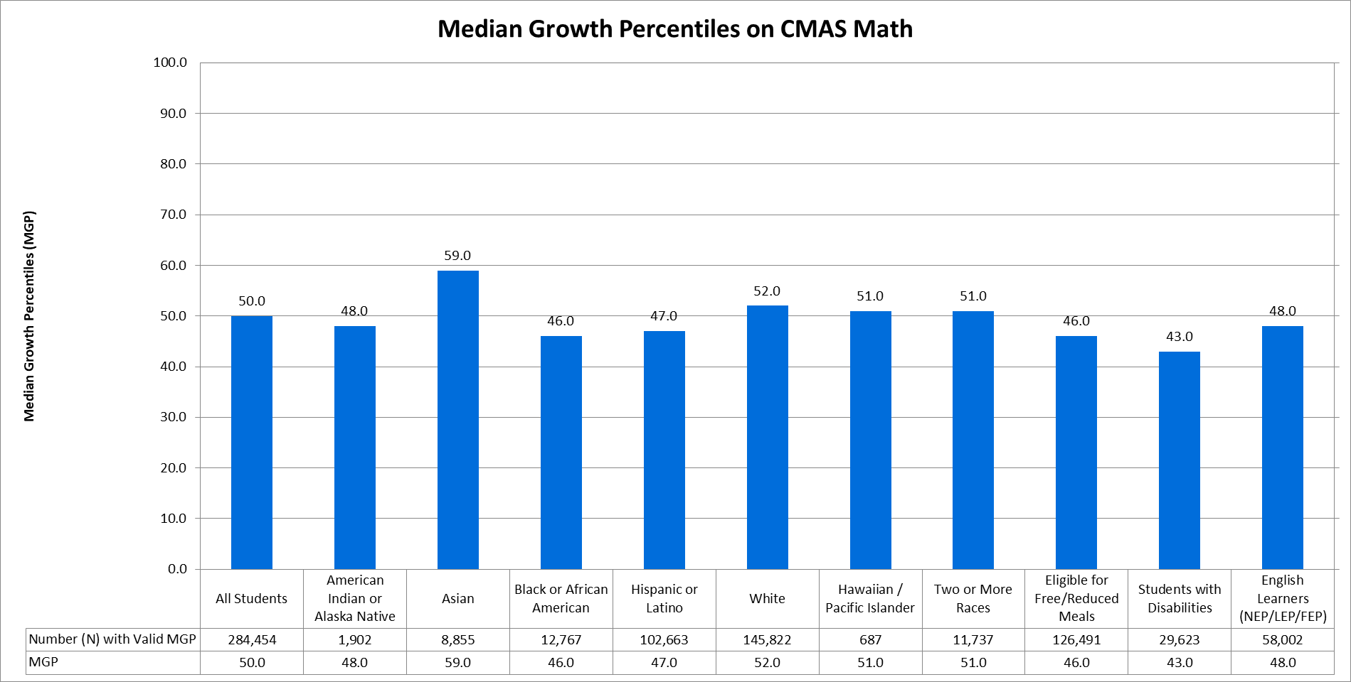
Figure 2 shows the median growth percentiles (MGP) of students in grades 11 on the SAT math assessment. Again, given how MGPs are calculated, the MGP for all Colorado students tends to fall around the 50th percentile. By race/ethnicity, the MGP was 43.0 for American Indian or Alaska Native students, 58.0 for Asian students, 46.0 for Black or African American students, 45.0 for Hispanic or Latino students, 54.0 for White students, 47.5 for Native Hawaiian or Other Pacific Islander students, and 51.0 for students of two or more races. The MGP was 44.0 for students who were economically disadvantaged, 36.0 for students with disabilities, and 40.0 for English learners.
Figure 2. Median Growth Percentiles (MGP), by Student Group, on the SAT Math Assessment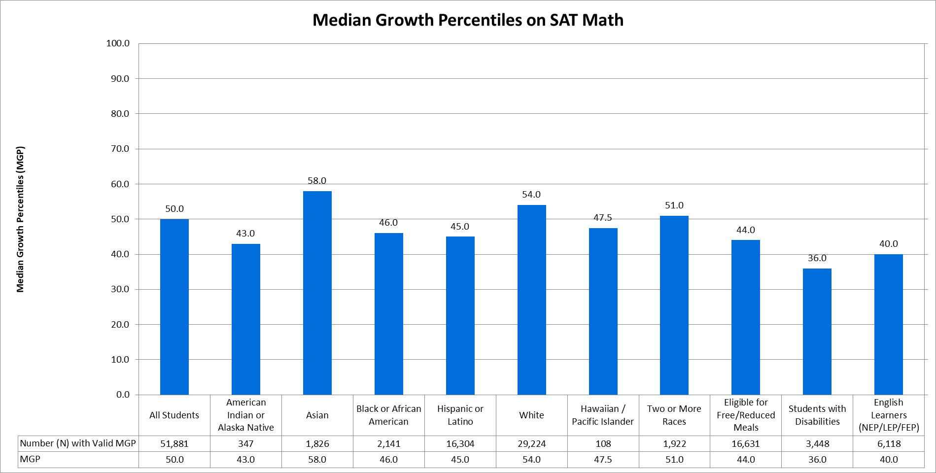

How much growth did students make from 2017 to 2018 on the CMAS and SAT English language arts assessments?
Figure 3 shows the MGP of students in grades 4-8 on the CMAS English language arts assessment. The MGP for all Colorado students was at the 50th percentile. By race/ethnicity, the MGP was 46.0 for American Indian or Alaska Native students, 58.0 for Asian students, 46.0 for Black or African American students, 48.0 for Hispanic or Latino students, 51.0 for White students, 50.0 for Hawaiian/Pacific Islander students, and 50.0 for students of two or more races. The MGP was 47.0 for students who were economically disadvantaged, 42.0 for students with disabilities, and 50.0 for English learners.
Figure 3. Median Growth Percentiles (MGP), by Student Group, on the CMAS English Language Arts Assessment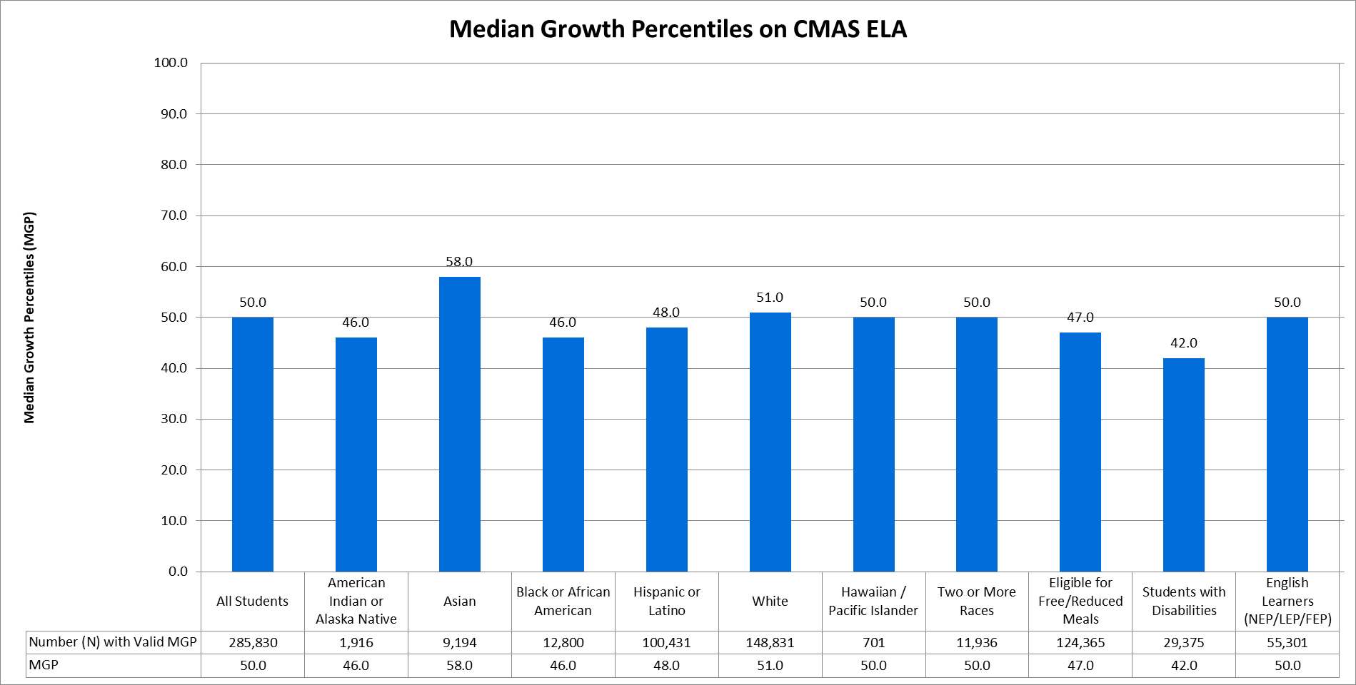
Figure 4 shows the median growth percentiles (MGP) of students in grades 11 on the SAT evidence-based reading and writing (EBRW) assessment. Again, given how MGPs are calculated, the MGP for all Colorado students was at the 50th percentile. By race/ethnicity, the MGP was 42.0 for American Indian or Alaska Native students, 52.0 for Asian students, 42.0 for Black or African American students, 43.0 for Hispanic or Latino students, 55.0 for White students, 44.5 for Native Hawaiian or Other Pacific Islander students, and 51.0 for students of two or more races. The MGP was 43.0 for students who were economically disadvantaged, 41.0 for students with disabilities, and 42.0 for English learners.
Figure 4. Median Growth Percentiles (MGP), by Student Group, on the SAT Evidence-Based Reading and Writing Assessment 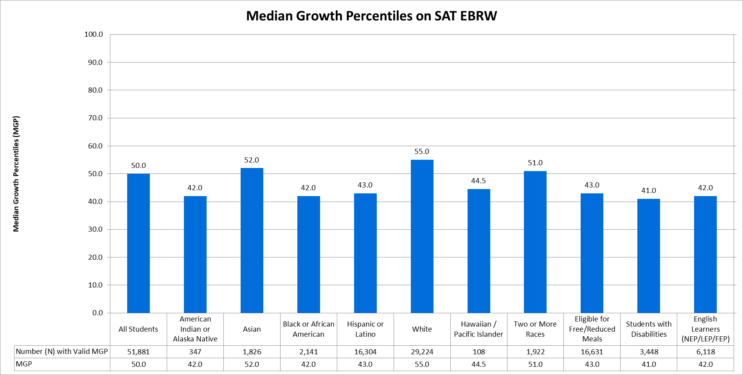

Graduation Rates
Under ESSA, states are required to present information on graduation rates, for all students and disaggregated by each major racial and ethnic group, by economically disadvantaged students, by students with disabilities, by English proficiency status, by homeless status, and by status as a child in foster care. Collection of foster status data begin in the 2017-18 school year; therefore, graduation rates will be disaggregated by foster status beginning with 2018 data.
ESSA requires states to present the four-year adjusted cohort graduation rates, but also gives states the discretion to include extended-year adjusted cohort graduation rates as well. Extended-year rates account for students who may require additional time to complete high school, such as those in five-year programs (e.g., ASCENT: Accelerating Students through Concurrent Enrollment, a state program that allows a limited number of students to attend a post-secondary education after completion of 12th grade, while still in the K-12 system), those who started below grade-level, and students whose coursework is interrupted for a semester or more. For more information on graduation rates, and for school- and district-level results, please visit the CDE Graduation Statistics webpage (www.cde.state.co.us/cdereval/gradratecurrent).
What was the 2017 4-year graduation rate?
Table 10 displays the 4-year adjusted cohort graduation rate for the class of 2017, showing that 79.0% of all students in the 2016-17 cohort graduated within four years. Graduation rates, by race/ethnicity, were 64.1% for American Indian or Alaska Native students, 89.8% for Asian students, 71.9% for Black or African American students, 71.1% for Hispanic or Latino students, 83.9% for White students, 76.5% for Native Hawaiian or Other Pacific Islander students, and 80.2% for students of two or more races. Four-year graduation rates were 68.5% for students who were economically disadvantaged, 56.8% for students with disabilities, 64.6% for English learners, and 55.8% for students experiencing homelessness.
Table 10. Four-Year Adjusted Cohort Graduation Rates, by Student Group
Student Group | Number (N) of Students in Graduation Base | Number (N) of Graduates | Graduation Rate (%)
All Students | 64,140 | 50,700 | 79.0%
American Indian or Alaska Native | 549 | 352 | 64.1%
Asian | 1,973 | 1,772 | 89.8%
Black or African American | 3,175 | 2,284 | 71.9%
Hispanic or Latino | 20,601 | 14,648 | 71.1%
White | 35,456 | 29,738 | 83.9%
Hawaiian/Pacific Islander | 196 | 150 | 76.5%
Two or More Races | 2,190 | 1,756 | 80.2%
Eligible for Free/Reduced Meals | 30,138 | 20,646 | 68.5%
Students with Disabilities | 6,553 | 3,723 | 56.8%
English Learners (NEP/LEP) | 7,685 | 4,961 | 64.6%
Students Experiencing Homelessness | 3,216 | 1,793 | 55.8%

What was the 7-year graduation rate?
Table 11 displays the 7-year adjusted cohort graduation rate for the class of 2014, showing that 85.3% of all students in the 2013-14 cohort graduated within seven years. Graduation rates, by race/ethnicity, were 71.8% for American Indian or Alaska Native students, 92.3% for Asian students, 80.4% for Black or African American students, 78.5% for Hispanic or Latino students, 88.8% for White students, 79.7% for Native Hawaiian or Other Pacific Islander students, and 87.4% for students of two or more races. Seven-year graduation rates were 75.9% for students who were economically disadvantaged, 75.4% for students with disabilities, 74.1% for English learners, and 65.2% for students experiencing homelessness.
Table 11. Seven-Year Adjusted Cohort Graduation Rates, by Student Group
Student Group | Number (N) of Students in Graduation Base | Number (N) of Graduates | Graduation Rate (%)
All Students | 60,366 | 51,492 | 85.3%
American Indian or Alaska Native | 515 | 370 | 71.8%
Asian | 1,944 | 1,794 | 92.3%
Black | 3,031 | 2,438 | 80.4%
Hispanic | 17,618 | 13,836 | 78.5%
White | 35,249 | 31,309 | 88.8%
Hawaiian/Pacific Islander | 153 | 122 | 79.7%
Two or More Races | 1,856 | 1,623 | 87.4%
Eligible for Free/Reduced Meals | 27,029 | 20,507 | 75.9%
Students with Disabilities | 5,832 | 4,399 | 75.4%
English Learners (NEP/LEP) | 6,453 | 4,783 | 74.1%
Students Experiencing Homelessness | 3,015 | 1,965 | 65.2%

English Language Proficiency
English learners (NEP and LEP) in grades K-12 were administered the Assessing Comprehension and Communication in English (ACCESS for ELLs®), in order to measure students’ progress in acquiring academic English. Students with significant cognitive disabilities were eligible to take the alternate ACCESS assessment instead. For more information on the state assessments, and for school- and district-level results, please visit the CDE Assessment Unit webpage (www.cde.state.co.us/assessment).
How did English learners perform on the 2018 ACCESS for ELLs assessment?
Table 12 shows the number and percent of English learners performing at each proficiency level overall on the ACCESS for ELLs assessment. Statewide, 11.0% of English learners were at Level 1, 15.6% at Level 2, 40.9% at Level 3, 27.1% at Level 4, 4.9% at Level 5, and 0.4% at Level 6.
Table 12. Number and Percentage of English Learners Scoring Overall at Each Proficiency Level on the ACCESS for ELLs Assessment
 | Level 1 - Entering | Level 2 - Emerging | Level 3 - Developing | Level 4 - Expanding | Level 5 - Bridging | Level 6 - Reaching
Number (N) English Learners (NEP/LEP) | 11,109 | 15,686 | 41,194 | 27,303 | 4,973 | 442
Percent (%) English Learners (NEP/LEP) | 11.0% | 15.6% | 40.9% | 27.1% | 4.9% | 0.4%

Table 13 shows the number and percent of English learners performing at each proficiency level on the alternate ACCESS for ELLs assessment. Statewide, 4.2% of English learners were at Level A1, 9.5% at Level A2, 22.8% at Level A3, 28.5% at Level P1, and 35.0% at Level P2.
Table 13. Number and Percentage of English Learners Scoring Overall at Each Proficiency Level on the Alternate ACCESS for ELLs Assessment
 | A1 - Initiating | A2 - Exploring | A3 - Engaging | P1 - Entering | P2 - Emerging
Number (N) English Learners (NEP/LEP) | 46 | 104 | 251 | 314 | 385
Percent (%) English Learners (NEP/LEP) | 4.2% | 9.5% | 22.8% | 28.5% | 35.0%

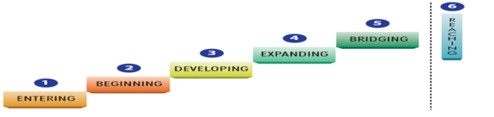
How many English Learners achieved English language proficiency?
Students are eligible for redesignation if they meet English language proficiency criteria, having both an overall proficiency level and a literacy proficiency level of at least 4.0 on the ACCESS for ELLs assessment, or having both an overall proficiency level and a literacy proficiency level of at least P1 on the alternate ACCESS assessment . Table 14 shows that 25.5% of English learners achieved English language proficiency.
Table 14. Number and Percentage of English Learners Achieving English Language Proficiency on the ACCESS for ELLs or Alternate ACCESS Assessment
 | Total Records | Number (N) Proficient | Percent (%) Proficient
English Learners (NEP/LEP) | 101,807 | 26,005 | 25.5%

Indicators of School Quality or Student Success
Under ESSA, states are required to select at least one indicator of school quality or student success, presenting results for all students and disaggregated by students from major racial and ethnic groups, by economically disadvantaged students, by students with disabilities, and by English learners. For elementary and middle grade spans, Colorado has proposed using mean scale scores on the 5th and 8th grade CMAS science assessment, as well as change in chronic absenteeism rates. For high school grade spans, Colorado has proposed using mean scale scores on the 11th grade CMAS science assessment, as well as dropout rates. Mean scale scores on the CMAS science assessment and dropout rates are presented below. Colorado is continuing to evaluate the data quality of chronic absenteeism rates; therefore, change in chronic absenteeism is not currently reported.
How did students perform, based on mean scale scores (MSS), on the 2018 CMAS and CoAlt science assessment?
On the CMAS science assessment, scale scores range from 300 to 900. Figure 5 shows a mean scale score (MSS) of 590.2 for all students in grades 5, 8, and 11. By race/ethnicity, MSS were 544.1 for American Indian or Alaska Native students, 629.0 for Asian students, 527.7 for Black or African American students, 541.5 for Hispanic or Latino students, 626.4 for White students, 559.8 for Native Hawaiian or Other Pacific Islander students, and 608.4 for students of two or more races. MSS were 539.9 for students who were economically disadvantaged, 484.1 for students with disabilities, and 515.8 for English learners.

Figure 5. Mean Scale Scores, by Student Group, on the CMAS and CoAlt Science Assessment
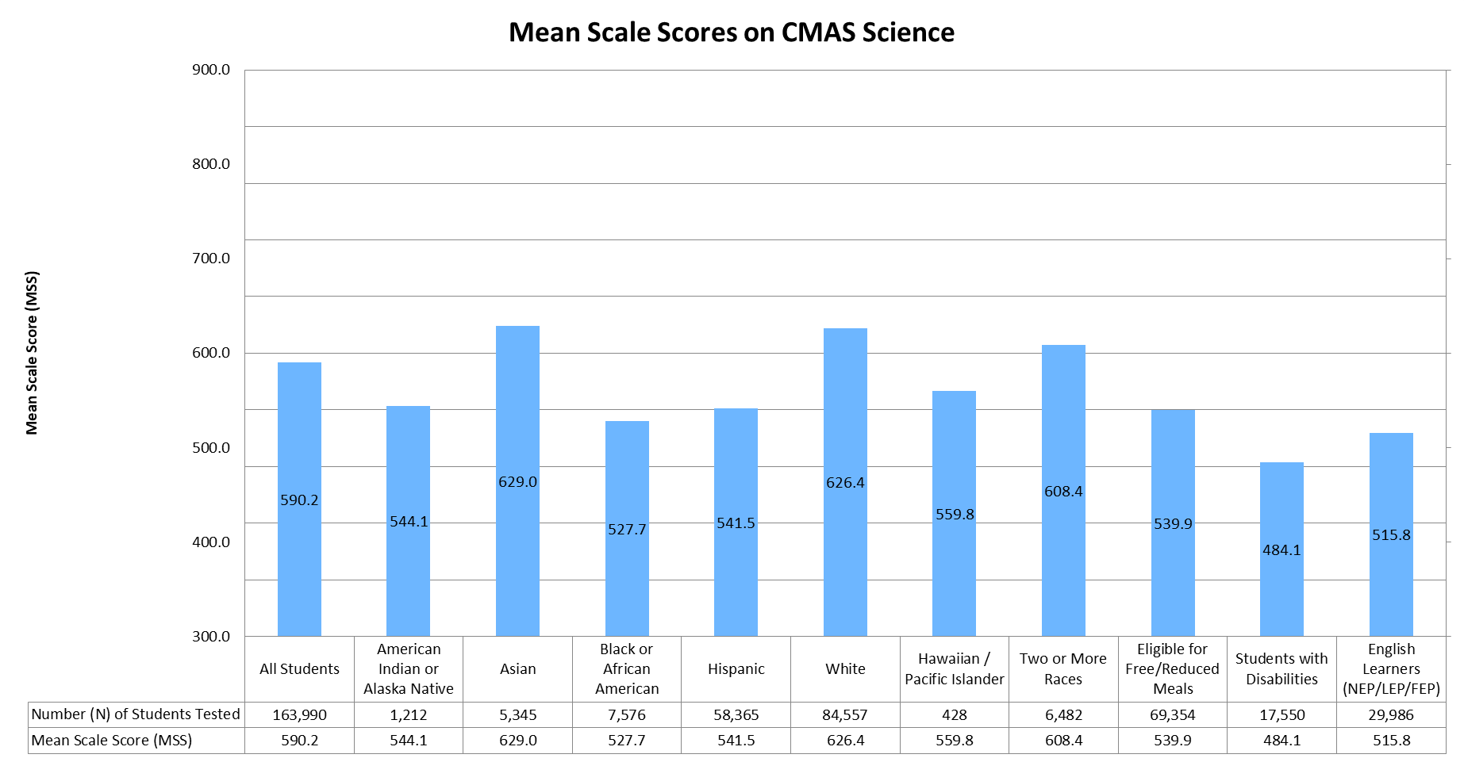

What was the 2017 dropout rate?
Table 15 displays the 2017 dropout rate for students in grades 9 through 12, showing that 3.3% of all students discontinued their educational services without receiving credentials or providing adequate documentation of a transfer to another educational setting. These rates include both students who drop out and who age out of eligibility at age 21. Dropout rates, by race/ethnicity, were 5.6% for American Indian or Alaska Native students, 1.3% for Asian students, 4.5% for Black or African American students, 5.1% for Hispanic or Latino students, 2.2% for White students, 3.6% for Native Hawaiian or Other Pacific Islander students, and 2.7% for students of two or more races. Dropout rates were 4.6% for students who were economically disadvantaged, 4.3% for students with disabilities, and 5.8% for English learners.
Table 15. Dropout Rates, by Student Group
Student Group | Number (N) of Total Students | Number (N) of Dropouts | Dropout Rate (%)
All Students | 301,569 | 9,928 | 3.3%
American Indian or Alaska Native | 2,627 | 146 | 5.6%
Asian | 9,445 | 120 | 1.3%
Black or African American | 15,251 | 690 | 4.5%
Hispanic or Latino | 100,833 | 5,164 | 5.1%
White | 161,781 | 3,487 | 2.2%
Hawaiian/Pacific Islander | 815 | 29 | 3.6%
Two or More Races | 10,817 | 292 | 2.7%
Eligible for Free/Reduced Meals | 107,826 | 4,940 | 4.6%
Students with Disabilities | 29,538 | 1,262 | 4.3%
English Learners (NEP/LEP) | 33,089 | 1,924 | 5.8%

Long-Term Goals
Under ESSA, states are required to establish long-term goals, and measures of interim progress, for academic achievement, graduation rates, and, for English learners, increases in the percentage of students making progress in achieving English language proficiency. Progress towards academic achievement and graduation rate long-term goals must be reported for all students and disaggregated by students from major racial and ethnic groups, by economically disadvantaged students, by students with disabilities, and by English learners.
What is the academic achievement performance, using mean scale scores, of students on the CMAS and SAT math and English language arts assessments?
On the CMAS math and English language arts assessments, scale scores range from 650 to 850. Mean scale scores are presented in Figure 6, along with the 2018 interim targets and the long-term goals, for students in grades 3-8 on the CMAS math assessment. The long-term goals establish targets for all student groups that are at or above a MSS of 750, which corresponds to meeting state expectations (Level 4), by the year 2037. Long-term goals for student groups that were close to or exceeding a MSS of 750 at baseline were set higher based on an expectation that students continue to make yearly growth consistent with historical trends.
Overall, the mean scale score (MSS) for all students in grades 3-8 was 735.0, corresponding to Level 3 on the CMAS assessment. By race/ethnicity, MSS were 719.0 for American Indian or Alaska Native students (Level 2), 753.8 for Asian students (Level 4), 719.2 for Black or African American students (Level 2), 721.8 for Hispanic or Latino students (Level 2), 744.0 for White students (Level 3), 728.7 for Native Hawaiian or Other Pacific Islander students (Level 3), and 739.3 for students of two or more races (Level 3). MSS were 720.8 for students who were economically disadvantaged, 702.6 for students with disabilities, and 719.4 for English learners (all Level 2). Overall, mean scale scores were below the 2018 interim targets, with gaps ranging from 0.1 for Asian students (753.8 compared to 753.9) to 4.0 for Native Hawaiian or American Indian students (728.7 compared to 732.7).
Figure 6. Mean Scale Scores and Long-Term Goals, by Student Group, on the CMAS and CoAlt Math Assessment
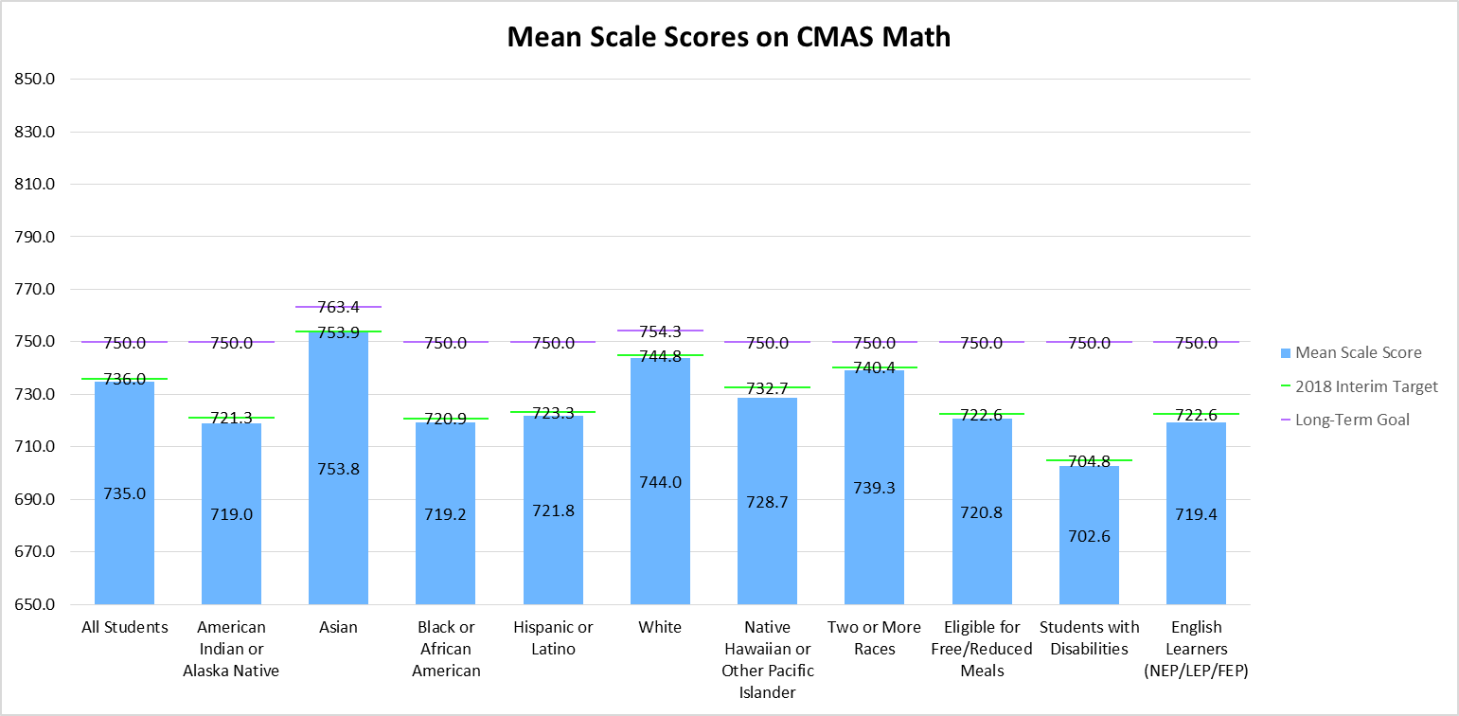

Mean scale scores are presented in Figure 7, along with the 2018 interim targets and the long-term goals, for students in grades 3-8 on the CMAS English language arts assessment. Overall, the mean scale score (MSS) for all students was 743.0, corresponding to Level 3 on the CMAS assessment. By race/ethnicity, MSS were 727.3 for American Indian or Alaska Native students (Level 2), 757.8 for Asian students (Level 4), 728.9 for Black or African American students (Level 2), 729.6 for Hispanic or Latino students (Level 2), 752.1 for White students (Level 4), 736.6 for Native Hawaiian or Other Pacific Islander students (Level 3), and 748.9 for students of two or more races (Level 3). MSS were 728.3 for students who were economically disadvantaged (Level 3), 705.2 for students with disabilities (Level 2), and 725.1 for English learners (Level 3). Overall, mean scale scores were below the 2018 interim targets, with gaps ranging from 0.4 for White students (752.1 compared to 752.5) and students of two or more races (748.9 compared to 749.3) to 5.2 for Native Hawaiian or American Indian students (736.6 compared to 741.8).
Figure 7. Mean Scale Scores and Long-Term Goals, by Student Group, on the CMAS and CoAlt ELA Assessment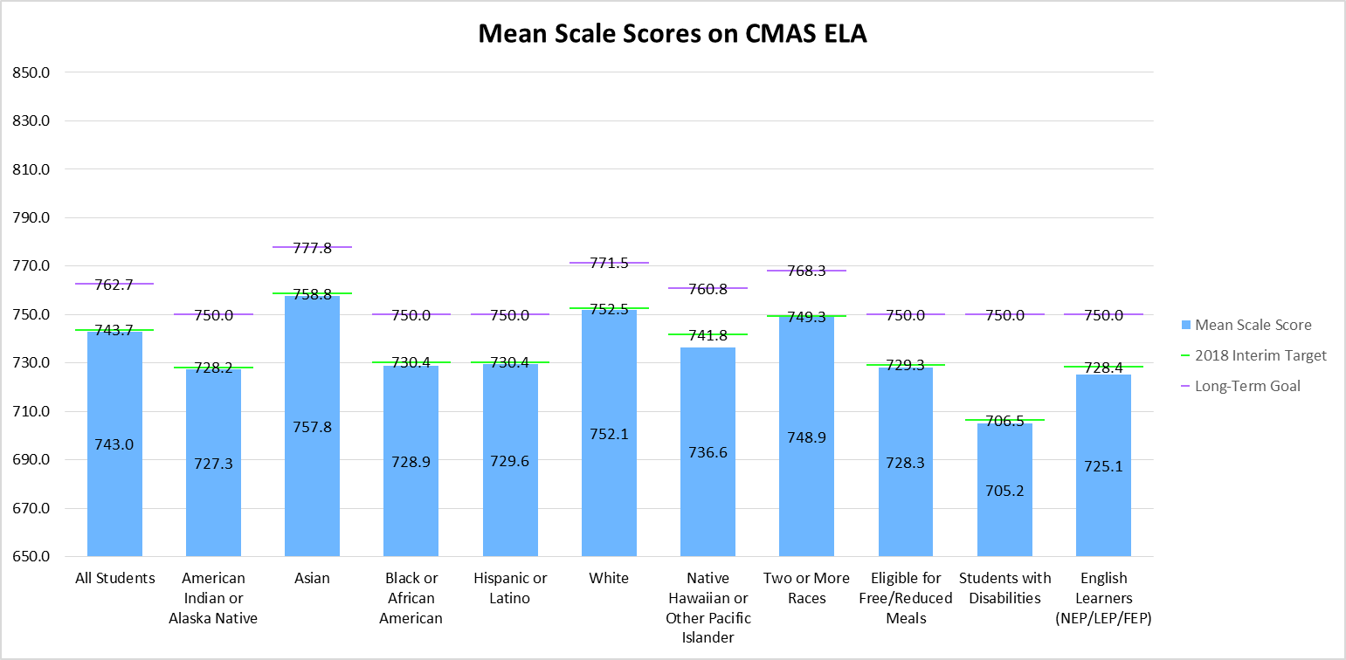
On the SAT math and evidence-based reading and writing assessments, scale scores range from 200 to 800. Mean scale scores are presented in Figure 8, along with the 2018 interim targets and the long-term goals, for students in grade 11 on the SAT math assessment. The SAT math long-term goals establish targets for all student groups that are at or above a MSS of 530, which corresponds to meeting the SAT college and career readiness benchmark, by the year 2037. Long-term goals for student groups that were close to or exceeding a MSS of 530 were set higher based on an expectation that students continue to make yearly growth consistent with historical trends.
Overall, the mean scale score (MSS) for all students in grade 11 was 499.6. By race/ethnicity, MSS were 460.1 for American Indian or Alaska Native students, 562.2 for Asian students, 445.4 for Black or African American students, 450.9 for Hispanic or Latino students, 527.6 for White students, 479.4 for Native Hawaiian or Other Pacific Islander students, and 515.7 for students of two or more races. MSS were 447.2 for students who were economically disadvantaged, 385.0 for students with disabilities, and 417.4 for English learners. Overall, mean scale scores were below the 2018 interim targets, with gaps ranging from 1.1 for students with disabilities (385.0 compared to 386.1) to 10.5 for Native Hawaiian or Other Pacific Islander students (479.4 compared to 489.9).
Figure 8. Mean Scale Scores and Long-Term Goals, by Student Group, on the SAT and CoAlt Math Assessment
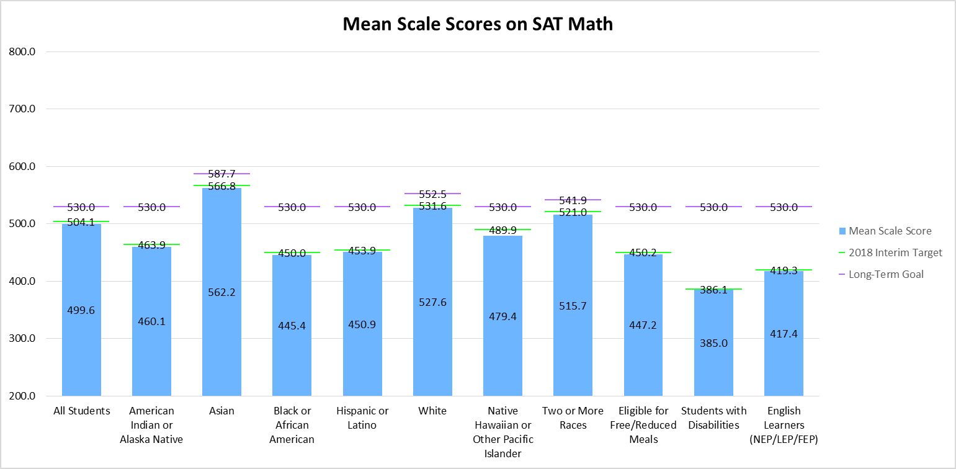

Mean scale scores are presented in Figure 9, along with the 2018 interim targets and the long-term goals, for students in grade 11 on the SAT evidence-based reading and writing (EBRW) assessment. The SAT EBRW long-term goals establish targets for all student groups that are at or above a MSS of 480, which corresponds to meeting the SAT college and career readiness benchmark, by the year 2037. Long-term goals for student groups that were close to or exceeding a MSS of 480 were set higher based on an expectation that students continue to make yearly growth consistent with historical trends.
Overall, the mean scale score (MSS) for all students in grade 11 was 512.0. By race/ethnicity, MSS were 466.3 for American Indian or Alaska Native students, 546.0 for Asian students, 460.9 for Black or African American students, 462.7 for Hispanic or Latino students, 541.7 for White students, 492.9 for Native Hawaiian or Other Pacific Islander students, and 530.1 for students of two or more races. MSS were 460.1 for students who were economically disadvantaged, 410.2 for students with disabilities, and 423.2 for English learners. Overall, mean scale scores were below the 2018 interim targets, with gaps ranging from 0.9 for students with disabilities (410.2 compared to 411.1) to 11.0 for Native Hawaiian or Other Pacific Islander students (492.9 compared to 503.9).
Figure 9. Mean Scale Scores and Long-Term Goals, by Student Group, on the SAT and CoAlt EBRW Assessment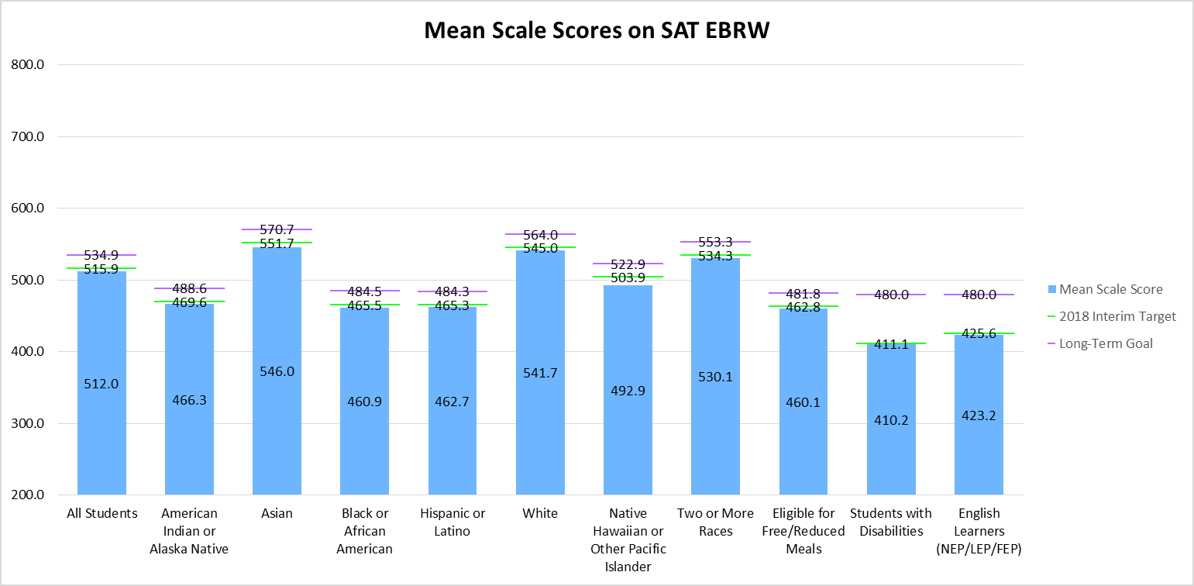
What were the 4-year and extended-year (7-year) adjusted cohort graduation rates?
Figure 10 shows the 4-year graduation rates, in comparison to the 2017 interim targets and the long-term goals established. The graduation rate for all students was 79.0%, which was below the interim target of 80.0%. A number of racial/ethnic groups met the interim targets, including American Indian or Alaska Native students (graduation rate of 64.1% compared to a target of 63.9%), Asian students (89.8% compared to 86.7%), Native Hawaiian or Other Pacific Islander students (76.5% compared to 75.7%), and students of two or more races (80.2% compared to 80.1%). English learners also met the interim targets, with a graduation rate of 64.6%, which was above the target of 63.3%.
Figure 10. 4-Year Graduation Rates, by Student Group, in Comparison to Long-Term Goals
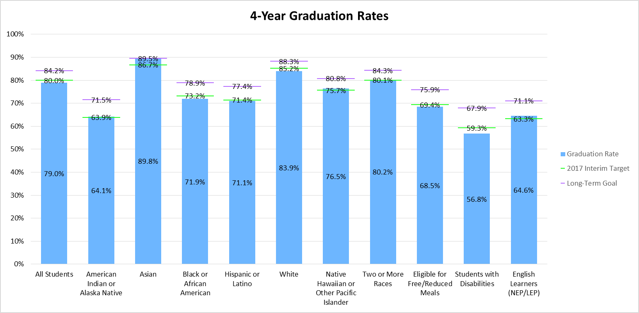

Figure 11 shows the 7-year extended-year graduation rates, in comparison to the 2017 interim targets and the long-term goals established. The 7-year graduation rate for all students was 85.3%, which was below the interim target of 85.8%. All racial/ethnic groups were below the interim targets, except for Hispanic or Latino students, with a graduation rate of 78.5% compared to an interim target of 77.8%. Students with disabilities (75.4% compared to a target of 75.0%) and English learners (74.1% compared to a target of 73.8%) were both above the interim targets. Gaps ranged from 0.3% for economically disadvantaged students (75.9% compared to 76.2%) to 5.2% for Native Hawaiian or Other Pacific Islanders (79.7% compared to 84.9%).
Figure 11. 7-Year Extended-Year Graduation Rates, by Student Group, in Comparison to Long-Term Goals
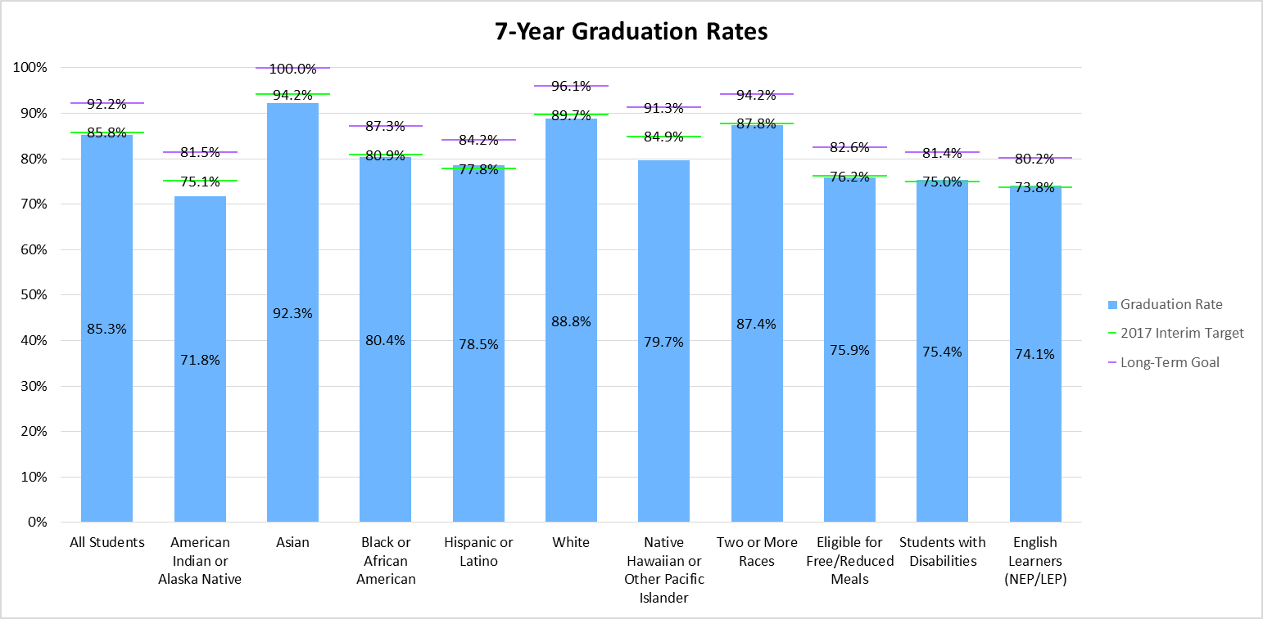

How many English learners were on track to achieving English language proficiency?
Table 16 shows the percent of English learners making progress towards achieving English language proficiency (ELP), in comparison to the 2018 interim targets and the long-term goals established. Different long-term goals were established for students in grades K-5 compared to students in grades 6-12, as data indicates significantly different patterns for students at elementary grades versus students in higher grades. Students not redesignating by 5th grade, or first enrolling in the US in later grades, show longer and more varied patterns of ELP acquisition.
Overall, 76.7% of students in grades K-5 and 53.6% of students in grades 6-12 were on track to achieving English language proficiency. These rates currently exceed the 2018 interim targets and the long-term goals established at the state-level, but not all schools and districts are meeting these expectations.
Table 16. Percent of Students on Track to Achieving English Language Proficiency, in Comparison to Long-Term Goals
Grade Levels | # Valid | # On-Track to Achieving English Language Proficiency | % On-Track to Achieving English Language Proficiency | 2018 Interim Target | Long-Term Goal
Grades K-5 | 46,621 | 35,753 | 76.7% | 68.2% | 70.7%
Grades 6-12 | 30,780 | 16,502 | 53.6% | 43.7% | 52.8%

Participation in the State Assessments
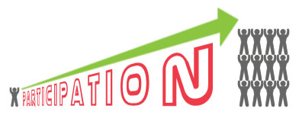
Students in grades 3 through 8 were administered the Colorado Measures of Academic Success (CMAS) assessments in mathematics and English language arts, and students in grade 11 were administered the SAT assessment in mathematics and evidence-based reading and writing. In addition, students in grades 5, 8, and 11 were administered the CMAS assessment in science. Students with significant cognitive disabilities were eligible to take the Colorado Alternate (CoAlt) assessments instead. For more information on the state assessments, and for school- and district-level results, please visit the CDE Assessment Unit webpage (www.cde.state.co.us/assessment).
Under the Every Student Succeeds Act (ESSA), states are required to report the percentage of students assessed and not assessed on the academic assessments, for all students and disaggregated by each major racial and ethnic group, by economically disadvantaged students as compared to students who are not economically disadvantaged, by students with disabilities as compared to students without disabilities, by English proficiency status, by gender, and by migrant status.
How many students tested on the 2018 CMAS, SAT, and CoAlt assessments?
Table 17 shows the percent of students who were not assessed, in comparison to the total number assessed (taking the CMAS, SAT, or CoAlt assessment) on the math assessments. Statewide, approximately 94.0% of students in grades 3 through 8 and grade 11 were assessed. By race/ethnicity, 92.8% of American Indian or Alaska Native students, 96.1% of Asian students, 95.0%% of Black or African American students, 95.9% of Hispanic or Latino students, 92.7% of White students, 94.7% of Native Hawaiian or Other Pacific Islander students, and 93.9% of students of two or more races were assessed. Approximately 95.3% of students who were economically disadvantaged were assessed, compared to 93.1% of students who were not economically disadvantaged. Of the students with disabilities, 89.4% were assessed, compared to 94.6% of students without disabilities. Approximately 97.3% of English learners, 94.1% of male students, 94.0% of female students, and 97.5% of migrant students were assessed.
Table 17. Percentage of Students Assessed, by Student Group, on the CMAS, SAT, and CoAlt Math Assessments
Student Group | % Assessed | % Not Assessed
All Students | 94.0% | 6.0%
American Indian or Alaska Native | 92.8% | 7.2%
Asian | 96.1% | 3.9%
Black or African American | 95.0% | 5.0%
Hispanic or Latino | 95.9% | 4.1%
White | 92.7% | 7.3%
Native Hawaiian or Other Pacific Islander | 94.7% | 5.3%
Two or More Races | 93.9% | 6.1%
Eligible for Free/Reduced Meals | 95.3% | 4.7%
Not Eligible for Free/Reduced Meals | 93.1% | 6.9%
Students with Disabilities | 89.4% | 10.6%
Students without Disabilities | 94.6% | 5.4%
English Learners (NEP/LEP) | 97.3% | 2.7%
Males | 94.1% | 5.9%
Females | 94.0% | 6.0%
Migrant Students | 97.5% | 2.5%

Table 18 shows the percent of students who were not assessed, in comparison to the total number assessed (taking the CMAS, SAT, or CoAlt assessment, or recently arrived English learners exempt from participating) on the English language arts assessments. Statewide, approximately 94.0% of students in grades 3 through 8 and grade 11 were assessed. By race/ethnicity, 93.0% of American Indian or Alaska Native students, 96.2% of Asian students, 95.1% of Black or African American students, 95.8% of Hispanic or Latino students, 92.7% of White students, 95.2% of Native Hawaiian or Other Pacific Islander students, and 94.0% of students of two or more races were assessed. Approximately 95.3% of students who were economically disadvantaged were assessed, compared to 93.1% of students who were not economically disadvantaged. Of the students with disabilities, 89.3% were assessed, compared to 94.7% of students without disabilities. Approximately 97.3% of English learners, 94.1% of male students, 94.0% of female students, and 97.4% of migrant students were assessed.
Table 18. Percentage of Students Assessed, by Student Group, on the CMAS, SAT, and CoAlt English Language Arts Assessments
Student Group | % Assessed | % Not Assessed
All Students | 94.0% | 6.0%
American Indian or Alaska Native | 93.0% | 7.0%
Asian | 96.2% | 3.8%
Black or African American | 95.1% | 4.9%
Hispanic or Latino | 95.8% | 4.2%
White | 92.7% | 7.3%
Native Hawaiian or Other Pacific Islander | 95.2% | 4.8%
Two or More Races | 94.0% | 6.0%
Eligible for Free/Reduced Meals | 95.3% | 4.7%
Not Eligible for Free/Reduced Meals | 93.1% | 6.9%
Students with Disabilities | 89.3% | 10.7%
Students without Disabilities | 94.7% | 5.3%
English Learners (NEP/LEP) | 97.3% | 2.7%
Males | 94.1% | 5.9%
Females | 94.0% | 6.0%
Migrant Students | 97.4% | 2.6%

Table 19 shows the percent of students who were not assessed, in comparison to the total number assessed (taking either the CMAS or CoAlt assessment) on the science assessments. Statewide, approximately 82.8% of students in grades 3, 5, and 11 were assessed. By race/ethnicity, 83.9% of American Indian or Alaska Native students, 83.7% of Asian students, 85.3% of Black or African American students, 88.3% of Hispanic or Latino students, 79.2% of White students, 85.4% of Native Hawaiian or Other Pacific Islander students, and 82.1% of students of two or more races were assessed. Approximately 88.6% of students who were economically disadvantaged were assessed, compared to 79.1% of students who were not economically disadvantaged. Of the students with disabilities, 82.3% were assessed, compared to 82.9% of students without disabilities. Approximately 93.3% of English learners, 83.8% of male students, 81.8% of female students, and 95.5% of migrant students were assessed.
Table 19. Percentage of Students Assessed, by Student Group, on the CMAS and CoAlt Science Assessments
Student Group | % Assessed | % Not Assessed
All Students | 82.8% | 17.2%
American Indian or Alaska Native | 83.9% | 16.1%
Asian | 83.7% | 16.3%
Black or African American | 85.3% | 14.7%
Hispanic or Latino | 88.3% | 11.7%
White | 79.2% | 20.8%
Native Hawaiian or Other Pacific Islander | 85.4% | 14.6%
Two or More Races | 82.1% | 17.9%
Eligible for Free/Reduced Meals | 88.6% | 11.4%
Not Eligible for Free/Reduced Meals | 79.1% | 20.9%
Students with Disabilities | 82.3% | 17.7%
Students without Disabilities | 82.9% | 17.1%
English Learners (NEP/LEP) | 93.3% | 6.7%
Males | 83.8% | 16.2%
Females | 81.8% | 18.2%
Migrant Students | 95.5% | 4.5%

Information Submitted in Accordance with the Civil Rights Data Collection
The U.S. Department of Education (ED) conducts the Civil Rights Data Collection (CRDC) to collect data on key education and civil rights issues. The CRDC collects a variety of information including student enrollment and educational programs and services. The most recent CRDC data available is from the 2015-16 school year, and select data elements are presented below. To learn more about the CRDC, and to access the complete data collection, please visit the U.S. Department of Education’s Civil Right Data Collection webpage (https://www2.ed.gov/about/offices/list/ocr/data.html).

Measures of School Quality, Climate, and Safety
During the 2015-16 school year, Colorado schools reported a total of 31,697 students receiving in-school suspensions, 45,361 students receiving out-of-school suspensions, and 1,715 students receiving expulsions (Table 20). In addition, schools reported a total of 347 students with school-related arrests and 5,182 students receiving referrals to law enforcement.
Table 20. Number of Students Disciplined
In School Suspensions | Out of School Suspensions | Expulsions | Referrals to Law Enforcement | School Related Arrest
31,697 | 45,361 | 1,715 | 5,182 | 347

In the CRDC, schools also report on incidents of violence. Colorado schools reported a total of 3 incidents of rape or attempted rape, 41 incidents of sexual assault, 11 incidents of robbery with a weapon, no incidents of robbery with a firearm or explosive device, and 136 incidents of robbery without a weapon. Schools also reported 229 incidents of physical attacks or fights with a weapon, 4 incidents of physical attacks or fights with a firearm or explosive device, and 10,344 incidents of physical attacks or fights without a weapon. Schools also reported on the number of incidents in which threats of physical attack were made, including 114 incidents of threat with a weapon, 82 incidents of threat with a firearm or explosive device, and 9,788 incidents of threat without a weapon. Lastly, Colorado schools reported 20 incidents of possession of a firearm or explosive device.
Also in the CRDC, schools report on incidents of harassment or bullying. Colorado schools reported a total of 60 allegations of harassment/bullying on the basis of disability, 269 allegations on the basis of race, color, or national origin, 18 allegations on the basis of religion, 708 allegations on the basis of sex, and 105 allegations on the basis of sexual orientation. In addition, Colorado schools reported a total of 85 students as harassed/bullied on the basis of disability, 336 students harassed/bullied on the basis of race, color, or national origin, and 572 students harassed/bullied on the basis of sex. Colorado schools also reported a total of 88 students disciplined as a result of harassment/bullying on the basis of disability, 415 students disciplined as a result of harassment/bullying on the basis of race, color, or national origin, and 1,044 students disciplined as a result of harassment/bullying on the basis of sex.
The CRDC also collects data on the number of students who were chronically absent, having been absent for 10% or more of the days enrolled in the public school year. Chronically absent students include students who are absent for any reason, regardless of whether absences are excused or unexcused. Colorado schools reported a total of 171,035 chronically absent students.
For more information on the CRDC data for Colorado schools, please visit CDE’s ESSA Local Report Cards Webpage (http://www.cde.state.co.us/fedprograms/localreportcards).

Students Enrolled in Preschool Programs
In the 2015-16 CRDC, Colorado schools reported a total of 33,149 students enrolled in preschool programs (Table 21). By race/ethnicity, a total of 249 American Indian or Alaska Native students, 1,356 Asian students, 1,721 Black or African American students, 12,644 Hispanic or Latino students, 15,672 White students, 74 Native Hawaiian or Other Pacific Islander students, and 1,433 students of two or more races were reported as enrolled in preschool programs. In addition, schools reported 6,999 students with disabilities, 728 English learners, 17,782 males, and 15,367 females as enrolled in preschool programs.
Table 21. Number of Students Enrolled in Preschool Programs
Student Group | Total Number of Students Enrolled, Aggregated Across Schools
All Students | 33,149
American Indian or Alaska Native | 249
Asian | 1,356
Black or African American | 1,721
Hispanic or Latino | 12,644
White | 15,672
Native Hawaiian or Other Pacific Islander | 74
Two or More Races | 1,433
Students with Disabilities | 6,999
English Learners (NEP/LEP) | 728
Males | 17,782
Females | 15,367

Students Enrolled in Accelerated Coursework
In the CRDC, schools also reported on the number of students enrolled in Advanced Placement (AP) and International Baccalaureate courses. A total of 256 schools indicated they offer AP courses, with the percent of students enrolled ranging from less than 1% to more than 90%. A total of 53,962 students were reported as enrolled in at least one AP course. A total of 35 schools indicated they offer IB courses, with the percent of students enrolled ranging from less than 1% to more than 60%. A total of 7,282 students were reported as enrolled in at least one IB course.

Per-Pupil Expenditures
Financial data for fiscal years 2015-16 and 2016-17 are available on the Financial Transparency for Colorado Schools webpage (https://coloradok12financialtransparency.com/#/), including school-level and district-level expenditures, but are not currently disaggregated by State/Local and Federal sources. The Financial Transparency webpage will meet ESSA per pupil expenditure reporting requirements beginning with fiscal year 2017-18 financial data. Data collection for fiscal year 2017-18 occurs through March 1, 2019, and data will be available on the Financial Transparent webpage beginning July 1, 2019.

Students Taking Alternate Assessments
Students with significant cognitive disabilities were eligible to take the Colorado Alternate (CoAlt) assessments instead of the CMAS or SAT assessments. Under ESSA, each state must ensure that the total number of students assessed in each subject using the alternate assessment does not exceed 1 percent of the total number of all students. For more information on the state assessments, please visit the CDE Assessment Unit webpage (www.cde.state.co.us/assessment).
Table 22 shows the number and percent (based on the total number of students assessed) of students taking the CoAlt math assessment. Approximately 0.9% of students in 3rd grade, 0.8% in 4th grade, 0.9% in 5th grade, 0.9% in 6th grades, 0.9% in 7th grade, 1.1% in 8th grade, and 0.9% in 11th grade took the alternate math assessment.
Table 22. Number and Percent of Students Taking the CoAlt Math Assessment
Grade | Number (N) Taking Alternate Assessment | Percent (%) Taking Alternate Assessment
Grade 3 | 557 | 0.9%
Grade 4 | 556 | 0.8%
Grade 5 | 589 | 0.9%
Grade 6 | 594 | 0.9%
Grade 7 | 584 | 0.9%
Grade 8 | 628 | 1.1%
Grade 11 | 512 | 0.9%

Table 23 shows the number and percent of students taking the CoAlt English language arts assessment. Approximately 0.9% of students in 3rd grade, 0.8% in 4th grade, 0.9% in 5th grade, 0.9% in 6th grades, 1.0% in 7th grade, 1.1% in 8th grade, and 0.9% in 11th grade took the alternate English language arts assessment.
Table 23. Number and Percent of Students Taking the CoAlt English Language Arts Assessment
Grade | Number (N) Taking Alternate Assessment | Percent (%) Taking Alternate Assessment
Grade 3 | 558 | 0.9%
Grade 4 | 557 | 0.8%
Grade 5 | 590 | 0.9%
Grade 6 | 595 | 0.9%
Grade 7 | 586 | 1.0%
Grade 8 | 630 | 1.1%
Grade 11 | 514 | 0.9%

Table 24 shows the number and percent of students taking the CoAlt science assessment. Approximately 0.9% of students in 5th grade, 1.0% in 8th grade, and 1.3% in 11th grade took the alternate science assessment.
Table 24. Number and Percent of Students Taking the CoAlt Science Assessment
CMAS Science | Number (N) Taking Alternate Assessment | Percent (%) Taking Alternate Assessment
Grade 5 | 588 | 0.9%
Grade 8 | 616 | 1.0%
Grade 11 | 512 | 1.3%

National Assessment of Educational Progress
Students in grades 4 and 8 participate in reading and mathematics assessments of the National Assessment of Educational Progress (NAEP), which are administered at least once every two years. Results from 2016-17 are shown in shown in Tables 24 and 25, along with the national average.
Table 25 shows the average scale score for all 4th grade students in Colorado taking NAEP Math was 241, which was slightly higher than the national average scale score of 240. The average scale score for all 8th grade students in Colorado was 286, which was significantly higher than the national average of 283. Approximately 42% of 4th grade students and 38% of 8th grade students in Colorado were at or above proficient, which was higher than the national averages (40% and 34%, respectively).
Table 25. Performance of Students on the NAEP Math Assessment
Grade | Student Group | Average Scale Score (CO) | Average Scale Score (National) | Percent At or Above Proficient (CO) | Percent At or Above Proficient (National)
Grade 4 | All students | 241 | 240 | 42% | 40%
Grade 4 | White | 250 | 248 | 55% | 51%
Grade 4 | Black | 223 | 223 | 23% | 19%
Grade 4 | Hispanic | 226 | 229 | 24% | 26%
Grade 4 | Asian | 252 | 260 | 53% | 67%
Grade 4 | American Indian/Alaska Native | * | 227 | * | 24%
Grade 4 | Native Hawaiian/Other Pacific Islander | * | 229 | * | 29%
Grade 4 | Two or more races | 249 | 245 | 54% | 45%
Grade 4 | Eligible for Free/Reduced Meals | 226 | 228 | 23% | 25%
Grade 4 | Students with Disabilities | 205 | 212 | 9% | 15%
Grade 4 | English Learners | 212 | 217 | 10% | 14%
Grade 8 | All students | 286 | 283 | 38% | 34%
Grade 8 | White | 298 | 293 | 51% | 44%
Grade 8 | Black | 263 | 260 | 17% | 13%
Grade 8 | Hispanic | 268 | 269 | 19% | 20%
Grade 8 | Asian | 303 | 312 | 55% | 64%
Grade 8 | American Indian/Alaska Native | * | 267 | * | 18%
Grade 8 | Native Hawaiian/Other Pacific Islander | * | 274 | * | 25%
Grade 8 | Two or more races | 295 | 287 | 45% | 37%
Grade 8 | Eligible for Free/Reduced Meals | 268 | 267 | 19% | 18%
Grade 8 | Students with Disabilities | 239 | 244 | 6% | 7%
Grade 8 | English Learners | 241 | 246 | 2% | 6%

Table 26 shows the average scale score for all 4th grade students in Colorado taking NAEP Reading was 225, which was slightly higher than the national average scale score of 222. The average scale score for all 8th grade students in Colorado was 270, which was higher than the national average of 267. Approximately 40% of 4th grade students and 41% of 8th grade students in Colorado were at or above proficient, which was higher than the national averages (37% and 36%, respectively).
Table 26. Performance of Students on the NAEP Reading Assessment
Grade | Student Group | Average Scale Score (CO) | Average Scale Score (National) | Percent At or Above Proficient (CO) | Percent At or Above Proficient (National)
Grade 4 | All students | 225 | 222 | 40% | 37%
Grade 4 | White | 235 | 232 | 51% | 47%
Grade 4 | Black | 206 | 206 | 21% | 20%
Grade 4 | Hispanic | 209 | 209 | 23% | 23%
Grade 4 | Asian | 237 | 241 | 56% | 59%
Grade 4 | American Indian/Alaska Native | * | 202 | * | 20%
Grade 4 | Native Hawaiian/Other Pacific Islander | * | 212 | * | 27%
Grade 4 | Two or more races | 228 | 227 | 42% | 42%
Grade 4 | Eligible for Free/Reduced Meals | 208 | 208 | 22% | 22%
Grade 4 | Students with Disabilities | 173 | 184 | 6% | 11%
Grade 4 | English Learners | 189 | 189 | 8% | 9%
Grade 8 | All students | 270 | 267 | 41% | 36%
Grade 8 | White | 279 | 275 | 50% | 45%
Grade 8 | Black | 250 | 249 | 21% | 18%
Grade 8 | Hispanic | 257 | 255 | 25% | 23%
Grade 8 | Asian | 285 | 284 | 57% | 57%
Grade 8 | American Indian/Alaska Native | * | 253 | * | 22%
Grade 8 | Native Hawaiian/Other Pacific Islander | * | 255 | * | 23%
Grade 8 | Two or more races | 279 | 272 | 51% | 42%
Grade 8 | Eligible for Free/Reduced Meals | 254 | 253 | 22% | 21%
Grade 8 | Students with Disabilities | 230 | 229 | 9% | 8%
Grade 8 | English Learners | 232 | 226 | 5% | 5%

Enrollment in Programs of Postsecondary Education
In coordination with the Department of Higher Education, Colorado calculates matriculation rates, which reflect enrollment rates of graduating students (in the summer/fall of the identified year) in 2-year and 4-year institutions, as well as in postsecondary career and technical education (CTE) programs. Results are currently available overall, for all students. Table 27 shows the number and percentage of high school graduates who, for the first academic year after graduation, enroll in programs of postsecondary education.
Table 27. Performance of Students on the NAEP Reading Assessment
Postsecondary Program Type | Number of Students Enrolled | Percent of Students Enrolled
All | 33,365 | 58.1%
2-Year Institutions | 23,784 | 41.4%
4-Year Institutions | 6,914 | 12.0%
Postsecondary Career and Technical Education Programs | 3,905 | 6.8%

Economically disadvantaged students are defined as those students who are eligible for free or reduced priced meals. For additional information, please visit the CDE Office of School Nutrition’s webpage on Free and Reduced Price Processes (http://www.cde.state.co.us/nutrition/nutrifreeandreducedprocesses).
Please refer to Section 602(3) of the Individual with Disabilities Education Act (IDEA) for a complete definition. Students with disabilities are defined as any student with an Individualized Education Program (IEP) who receives special education and related services. For additional information, please visit the CDE Office of Special Education webpage (www.cde.state.co.us/cdesped), or refer to Chapter 6.
Please refer to Section 8101(20) of the Every Student Succeeds Act (ESSA) for a complete definition. For the purposes of federal reporting on academic achievement, English learners are defined as students who are non-English proficient (NEP) and limited English proficient (LEP). This differs from the state accountability system, in which all students identified as NEP, LEP, FEP (fluent English proficient), and FELL (former English learners) are included in the English Learner student group. For additional information, please visit the CDE Office of Culturally and Linguistically Diverse Education webpage (www.cde.state.co.us/cde_english).
Please refer to Section 1309(3) of the Every Student Succeeds Act (ESSA) for a complete definition. Migrant students are defined as children of migratory agricultural workers and others who are determined eligible on Certificates of Eligibility (COEs). For additional information, please visit the CDE Office of Migrant Education’s webpage on the Migrant Education Program (www.cde.state.co.us/migrant).
Please refer to Section 725 of the McKinney-Vento Homeless Assistance Act for a complete definition. Students experiencing homelessness are defined as children or youth living in a shelter, motel, inadequate trailer or house, staying temporarily with relatives or friends due to economic hardship or loss of housing, or living in any other homeless situation. For additional information, please visit the CDE Office of Dropout Prevention and Student Re-Engagement’s webpage on McKinney-Vento Homeless Education (www.cde.state.co.us/dropoutprevention/homeless_index).
“N/A” indicates the value for this field is not displayed in order to protect student privacy.
“N/A” indicates the value for this field is not displayed in order to protect student privacy.
“N/A” indicates the value for this field is not displayed in order to protect student privacy.
“N/A” indicates the value for this field is not displayed in order to protect student privacy.
“N/A” indicates the value for this field is not displayed in order to protect student privacy.
“N/A” indicates the value for this field is not displayed in order to protect student privacy.
Economically disadvantaged students are defined as those students who are eligible for free or reduced priced meals. For additional information, please visit the CDE Office of School Nutrition’s webpage on Free and Reduced Price Processes (http://www.cde.state.co.us/nutrition/nutrifreeandreducedprocesses).
Please refer to Section 602(3) of the Individual with Disabilities Education Act (IDEA) for a complete definition. Students with disabilities are defined as any student with an Individualized Education Program (IEP) who receives special education and related services. For additional information, please visit the CDE Office of Special Education webpage (www.cde.state.co.us/cdesped), or refer to Chapter 6.
For the purposes of federal reporting on academic growth, English learners are defined as students who are non-English proficient (NEP) and limited English proficient (LEP), as well as fluent English proficient (FEP) students for not more than 4 years after redesignation, which is consistent with the state accountability system. For additional information, please visit the CDE Office of Culturally and Linguistically Diverse Education webpage (www.cde.state.co.us/cde_english).
Economically disadvantaged students are defined as those students who are eligible for free or reduced priced meals. For additional information, please visit the CDE Office of School Nutrition’s webpage on Free and Reduced Price Processes (http://www.cde.state.co.us/nutrition/nutrifreeandreducedprocesses).
Please refer to Section 602(3) of the Individual with Disabilities Education Act (IDEA) for a complete definition. Students with disabilities are defined as any student with an Individualized Education Program (IEP) who receives special education and related services. For additional information, please visit the CDE Office of Special Education webpage (www.cde.state.co.us/cdesped), or refer to Chapter 6.
Please refer to Section 8101(20) of the Every Student Succeeds Act (ESSA) for a complete definition. For the purposes of federal reporting on graduation rates, English learners are defined as students who are non-English proficient (NEP) and limited English proficient (LEP), which is consistent with the state accountability system. For additional information, please visit the CDE Office of Culturally and Linguistically Diverse Education webpage (www.cde.state.co.us/cde_english).
Please refer to Section 725 of the McKinney-Vento Homeless Assistance Act for a complete definition. Students experiencing homelessness are defined as children or youth living in a shelter, motel, inadequate trailer or house, staying temporarily with relatives or friends due to economic hardship or loss of housing, or living in any other homeless situation. For additional information, please visit the CDE Office of Dropout Prevention and Student Re-Engagement’s webpage on McKinney-Vento Homeless Education (www.cde.state.co.us/dropoutprevention/homeless_index).
Economically disadvantaged students are defined as those students who are eligible for free or reduced priced meals. For additional information, please visit the CDE Office of School Nutrition’s webpage on Free and Reduced Price Processes (http://www.cde.state.co.us/nutrition/nutrifreeandreducedprocesses).
Please refer to Section 602(3) of the Individual with Disabilities Education Act (IDEA) for a complete definition. Students with disabilities are defined as any student with an Individualized Education Program (IEP) who receives special education and related services. For additional information, please visit the CDE Office of Special Education webpage (www.cde.state.co.us/cdesped), or refer to Chapter 6.
For the purposes of federal reporting on science achievement within the indicators of school quality or student success, English learners are defined as students who are non-English proficient (NEP) and limited English proficient (LEP), as well as fluent English proficient (FEP) students for not more than 4 years after redesignation, which is consistent with the state accountability system. For additional information, please visit the CDE Office of Culturally and Linguistically Diverse Education webpage (www.cde.state.co.us/cde_english).
Economically disadvantaged students are defined as those students who are eligible for free or reduced priced meals. For additional information, please visit the CDE Office of School Nutrition’s webpage on Free and Reduced Price Processes (http://www.cde.state.co.us/nutrition/nutrifreeandreducedprocesses).
Please refer to Section 602(3) of the Individual with Disabilities Education Act (IDEA) for a complete definition. Students with disabilities are defined as any student with an Individualized Education Program (IEP) who receives special education and related services. For additional information, please visit the CDE Office of Special Education webpage (www.cde.state.co.us/cdesped), or refer to Chapter 6.
For the purposes of federal reporting on the long-term goals for academic achievement, English learners are defined as students who are non-English proficient (NEP) and limited English proficient (LEP), as well as fluent English proficient (FEP) students for not more than 4 years after redesignation, which is consistent with the state accountability system. For the purposes of federal reporting on the long-term goals for graduation rates, English learners are defined as students who are non-English proficient (NEP) and limited English proficient (LEP), which is also consistent with the state accountability system. For additional information, please visit the CDE Office of Culturally and Linguistically Diverse Education webpage (www.cde.state.co.us/cde_english).
Economically disadvantaged students are defined as those students who are eligible for free or reduced priced meals. For additional information, please visit the CDE Office of School Nutrition’s webpage on Free and Reduced Price Processes (http://www.cde.state.co.us/nutrition/nutrifreeandreducedprocesses).
Please refer to Section 602(3) of the Individual with Disabilities Education Act (IDEA) for a complete definition. Students with disabilities are defined as any student with an Individualized Education Program (IEP) who receives special education and related services. For additional information, please visit the CDE Office of Special Education webpage (www.cde.state.co.us/cdesped), or refer to Chapter 6.
Please refer to Section 8101(20) of the Every Student Succeeds Act (ESSA) for a complete definition. For the purposes of federal reporting on academic achievement, English learners are defined as students who are non-English proficient (NEP) and limited English proficient (LEP). This differs from the state accountability system, in which all students identified as NEP, LEP, FEP (fluent English proficient), and FELL (former English learners) are included in the English Learner student group. For additional information, please visit the CDE Office of Culturally and Linguistically Diverse Education webpage (www.cde.state.co.us/cde_english).
Please refer to Section 1309(3) of the Every Student Succeeds Act (ESSA) for a complete definition. Migrant students are defined as children of migratory agricultural workers and others who are determined eligible on Certificates of Eligibility (COEs). For additional information, please visit the CDE Office of Migrant Education’s webpage on the Migrant Education Program (www.cde.state.co.us/migrant).

