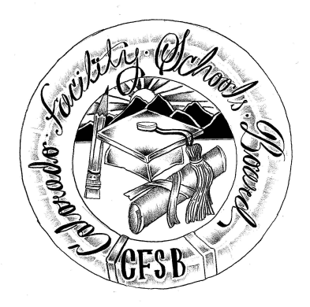
Colorado Facility Schools Board Agenda
September 9, 2021
11:30 a.m. until the completion of the agenda

Virtual – Zoom Meeting

Time | Activity | Presenter
11:30 | Board Meeting will start - Call to Order  Approval of Minutes  Approval of Agenda | Action Item  Action Item
11:35 | Facility Schools Unit Update  - CDE/Facility Internal Updates  - Data Management and Systems Support  - iReady/Tuition Cost  - Monitoring/Updates from the Field  - Frontline/AnLar  - Curriculum/Induction/Kaleidoscope/Out of District Consortium | Judy Stirman  Quinn Enright  Lori Kochevar  Ann Symalla  Annie Haskins  Wendy Dunaway
12:00  1:00  1:10  1:25  1:40  1:45 | Approval Presentation – Poplar Way Academy  BREAK  Allocation to Facility Schools  JBC/Stakeholders Group/Bill  Update – New Programs  Opportunity for the Public to Address the Board  Members of the public who wish to address the board must sign up prior to the meeting. Presentations are limited to 5 minutes. | Deongella Roberts  Judy Stirman  Wendy Dunaway  Judy Stirman
1:55 | Next Steps
2:00 | Adjournment of Meeting

