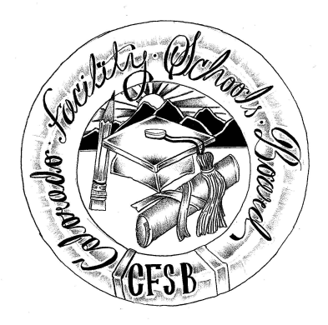
Colorado Facility Schools Board Agenda
March 10, 2021
11:30 a.m. until the completion of the agenda

Virtual – Zoom Meeting

11:30 | Board Meeting will start - Call to Order  Approval of Minutes  Approval of Agenda | Action Item  Action Item
11:35 | Facility Schools Unit Update  - CDE/Facility Internal Updates  - Data Management and Systems Support  - iReady/Tuition Cost  - Monitoring/Updates from the Field  - Frontline/Anlar/State Assessments  - Curriculum/Induction/OOD Consortium  - Update from Attorney General’s Office | Judy Stirman  Quinn Enright  Lori Kochevar  Robin Singer/Ann Singer  Annie Haskins  Wendy Dunaway  Isabel Broer
12:05  1:05  1:15  1:25  1:55  2:05 | Program Approval Presentation  BREAK  Board Elections  JBC/Stakeholders Group/Bill – Update and Feedback  In-Person Meetings  Opportunity for the Public to Address the Board  Members of the public who wish to address the board must sign up prior to the meeting. Presentations are limited to 5 minutes. | Deon Roberts  Judy Stirman  Judy Stirman/Wendy Dunaway/Board  Judy Stirman
2:10 | Next Steps
2:15 | Adjournment of Meeting

