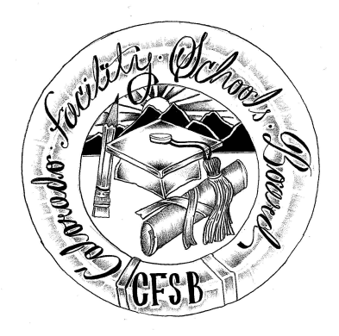
Colorado Facility Schools Board - Work Session Agenda
April 7, 2022
1:30 – 2:45pm
Virtual – Zoom Meeting

1:30 Work Session – Update on electronic IEP system Spring 2021-22 Dr. Foster

1:45 Options for Facility Schools – July 1, 2022 Dr. Foster

2:00 Discuss contingency options Dr. Foster
FS Board
FS Team
2:15 Meeting adjourned

