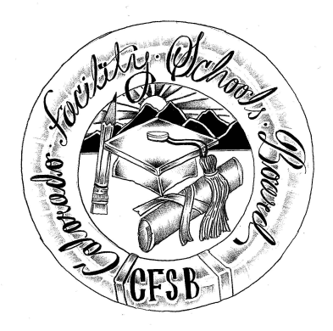
Colorado Facility Schools Board Agenda – Special Meeting
November 2, 2022
3:00 – 4:00 p.m.

Remotely - Zoom

3:00 | Board Meeting will start - Call to Order  Approval of Agenda | Action Item
3:05  4:00 | Board discussion – SB21-274 workgroup report and support for recommendations  Board decision regarding support for recommendations  Adjournment of Meeting | Discussion  Action Item

