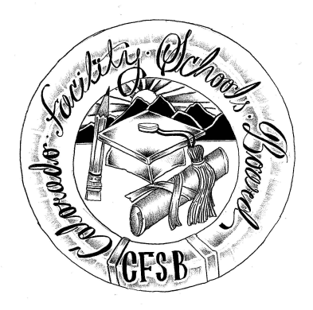
Colorado Facility Schools Board Agenda
November 10th, 2022
11:30 a.m. until the completion of the agenda

Zoom Virtually

11:30  12:00 | Lunch  Board Meeting will start - Call to Order  Approval of Minutes  Approval of Agenda | Action Item  Action Item
12:05 | Facility Schools Unit Update  - CDE/Facility Internal Updates  - Data Management and Systems Support  - iReady/Tuition Cost/December Staff  - Monitoring/Updates from the Field  - IEP System Updates/ State Assessments  - Curriculum/Induction/OOD Consortium  - New Program Support  - Update from Attorney General’s Office | Judy Stirman  Judy/Annie/Lori  Lori Kochevar  Robin Singer/Ann Symalla  Annie Haskins  Judy for Wendy Dunaway  Darren Serrato  Isabel Broer
12:30  12:45  1:00  2:00  2:30  3:00  3:15  3:30 | Facility Board letter to State Board and JBC  SB21-274 JBC/Stakeholders Group/Bill – Update and Feedback  Break  Strategic partners/Strategic plans  December and January Meetings  Opportunity for the Public to Address the Board  Members of the public who wish to address the board must sign up prior to the meeting. Presentations are limited to 5 minutes.  Next Steps  Adjournment of Meeting | Isabel/Board  Board/CDE Team  Ann/Robin/Judy  Action Item

