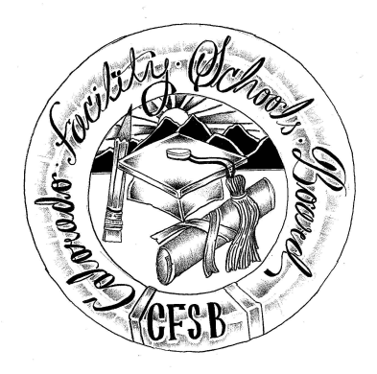
Colorado Facility Schools Board Agenda
October 13th, 2022
11:30 a.m. until the completion of the agenda

Shiloh Family Resource Pavilion In-Person & Zoom Virtually

11:30  12:00 | Lunch  Board Meeting will start - Call to Order  Approval of Minutes  Approval of Agenda | Action Item  Action Item
12:05  12:15 | Board discussion – SB21-274  Facility Schools Unit Update  - CDE/Facility Internal Updates  - Data Management and Systems Support  - iReady/Tuition Cost  - Monitoring/Updates from the Field  - IEP System Updates/ State Assessments  - Curriculum/Induction/OOD Consortium  - New Program Support  - Update from Attorney General’s Office | Action Item  Judy Stirman  Quinn Enright  Lori Kochevar  Robin Singer/Ann Symalla  Annie Haskins  Wendy Dunaway  Darren Serrato  Isabel Broer
12:30  1:00  1:30  2:00  2:30  2:00  2:20  2:30 | Board Candidate Interview #1  Board Candidate Interview #2  Board Candidate Interview #3  Board Candidate Interview #4  Break  FS Board Decision – Board Seat Recommendation  JBC/Stakeholders Group/Bill – Update and Feedback  Opportunity for the Public to Address the Board  Members of the public who wish to address the board must sign up prior to the meeting. Presentations are limited to 5 minutes. | Action Item  Judy Stirman/Wendy Dunaway/Board
2:40 | Next Steps
3:00 | Adjournment of Meeting

