C:\Users\pare_d\AppData\Local\Microsoft\Windows\Temporary Internet Files\Content.IE5\VHZJWIZQ\MC900436161[1].wmf**Evaluation System Overview**

**Note Catcher**

**Critical Effects of S.B. 191**

* Requires statewide minimum standards for what it means to be an “\_\_\_\_\_\_\_\_\_\_\_\_\_\_\_\_\_\_” teacher or principal
* Requires \_\_\_\_\_\_\_\_\_\_\_\_\_ evaluation of all teachers and principals
* Requires that all teachers and principals be evaluated at least \_\_\_\_\_\_\_\_\_\_\_ on the academic \_\_\_\_\_\_\_\_\_\_\_ of their students
* Changes non-probationary status from one that is \_\_\_\_\_\_\_\_\_\_\_ based upon years of \_\_\_\_\_\_\_\_\_\_\_ to one that is \_\_\_\_\_\_\_\_\_\_ based upon three consecutive years of demonstrated\_\_\_\_\_\_\_\_\_\_\_\_\_\_\_\_\_
* Provides that non-probationary status may be \_\_\_\_\_\_\_\_\_\_ based upon two consecutive years of \_\_\_\_\_\_\_\_\_\_\_\_\_\_\_\_\_\_\_\_\_\_\_
* Makes non-probationary status “\_\_\_\_\_\_\_\_\_\_\_\_\_\_\_\_”
* Prohibits \_\_\_\_\_\_\_\_\_\_\_\_\_ placement of teachers

**Key Priorities for Implementation of Colorado’s Educator Evaluation System**

What are the **5 Key Priorities for Colorado’s Educator Evaluation System** the State Council for Educator Effectiveness considered for their work?

1. \_\_\_\_\_\_\_\_\_\_\_\_\_\_\_\_\_\_\_\_\_\_\_\_\_\_\_\_\_\_\_\_\_\_\_\_\_\_\_\_\_\_\_\_\_\_\_\_\_\_\_\_\_
2. \_\_\_\_\_\_\_\_\_\_\_\_\_\_\_\_\_\_\_\_\_\_\_\_\_\_\_\_\_\_\_\_\_\_\_\_\_\_\_\_\_\_\_\_\_\_\_\_\_\_\_\_\_
3. \_\_\_\_\_\_\_\_\_\_\_\_\_\_\_\_\_\_\_\_\_\_\_\_\_\_\_\_\_\_\_\_\_\_\_\_\_\_\_\_\_\_\_\_\_\_\_\_\_\_\_\_\_
4. \_\_\_\_\_\_\_\_\_\_\_\_\_\_\_\_\_\_\_\_\_\_\_\_\_\_\_\_\_\_\_\_\_\_\_\_\_\_\_\_\_\_\_\_\_\_\_\_\_\_\_\_\_
5. \_\_\_\_\_\_\_\_\_\_\_\_\_\_\_\_\_\_\_\_\_\_\_\_\_\_\_\_\_\_\_\_\_\_\_\_\_\_\_\_\_\_\_\_\_\_\_\_\_\_\_\_\_

**S.B. 191 Timeline – Key Understandings**

**2013-14** \_\_\_\_\_\_\_\_\_\_\_\_\_\_\_\_\_\_\_\_\_\_\_\_\_\_\_\_\_\_\_\_\_\_\_\_\_\_\_\_\_\_\_\_\_\_\_\_\_\_\_\_\_\_\_\_\_\_\_\_\_

\_\_\_\_\_\_\_\_\_\_\_\_\_\_\_\_\_\_\_\_\_\_\_\_\_\_\_\_\_\_\_\_\_\_\_\_\_\_\_\_\_\_\_\_\_\_\_\_\_\_\_\_\_\_\_\_\_\_\_\_\_

\_\_\_\_\_\_\_\_\_\_\_\_\_\_\_\_\_\_\_\_\_\_\_\_\_\_\_\_\_\_\_\_\_\_\_\_\_\_\_\_\_\_\_\_\_\_\_\_\_\_\_\_\_\_\_\_\_\_\_\_\_

**2014-15** \_\_\_\_\_\_\_\_\_\_\_\_\_\_\_\_\_\_\_\_\_\_\_\_\_\_\_\_\_\_\_\_\_\_\_\_\_\_\_\_\_\_\_\_\_\_\_\_\_\_\_\_\_\_\_\_\_\_\_\_\_

\_\_\_\_\_\_\_\_\_\_\_\_\_\_\_\_\_\_\_\_\_\_\_\_\_\_\_\_\_\_\_\_\_\_\_\_\_\_\_\_\_\_\_\_\_\_\_\_\_\_\_\_\_\_\_\_\_\_\_\_\_

**2015-16** \_\_\_\_\_\_\_\_\_\_\_\_\_\_\_\_\_\_\_\_\_\_\_\_\_\_\_\_\_\_\_\_\_\_\_\_\_\_\_\_\_\_\_\_\_\_\_\_\_\_\_\_\_\_\_\_\_\_\_\_\_

**Principal and Teacher Quality Standards**

Write one or two words in the blank that best describes the context for each quality standard. The first one is done for you.

|  |  |  |
| --- | --- | --- |
| **Standard** | **Principal** | **Teacher** |
| **1** | Strategy – Vision & Mission | Know Content |
| **2** |  |  |
| **3** |  |  |
| **4** |  |  |
| **5** |  |  |
| **6** |  |  |
| **7** |  |  |

**Educator Evaluation Process**

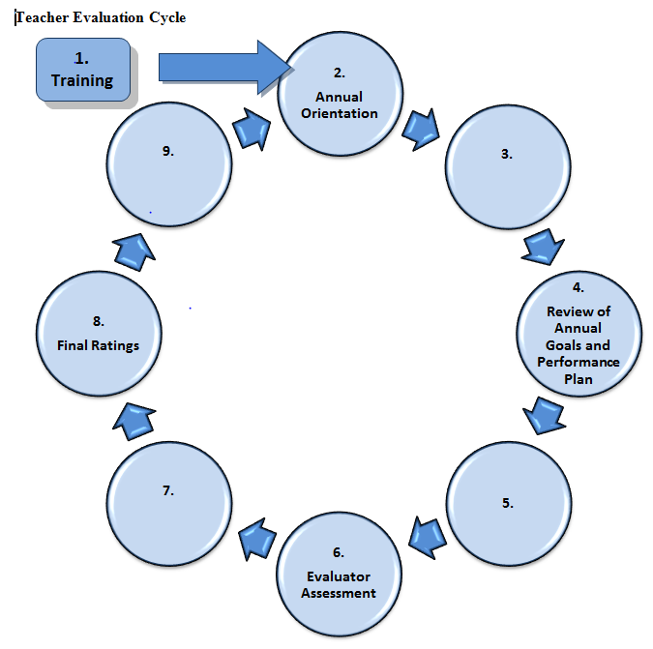Fill in the missing blanks for the Educator Evaluation Process.