Starting the 18-19 Year in the Colorado Performance Management System
Starting the 2018-19 Year in COPMS: Selecting a Rubric and
Enabling the New Year

For the 2018-19 school year, CDE will provide the option for districts/BOCES, that weren’t part of the 2017-18 pilot, to use the former Teacher Quality Standards and Elements for the 2018-2019 school year. Full implementation of the revised Teacher Quality Standards will be expected to be in place for all districts/BOCES for the 2019-2020 school year.

For the next year only, the two options for those districts using the State Model Evaluation System, which were not part of last year’s pilot, are as follows:
- Move to the revised rubric and scoring model that contains the recently State Board approved 4 Teacher Quality Standards, 17 Elements and 165 Professional Practices (Teacher Revised Rubric)
- Continue to use the former rubric and scoring model that contains 5 Teacher Quality Standards, 27 Elements and 309 Professional Practices (Teacher Former Rubric)
Both of these options will be housed in COPMS (RANDA). When you “enable” the new year (as early as July 16), your district will need to select which teacher rubric they are using as part of the district settings process. Resources that have been created in prior years for the previous teacher rubric can still be utilized in the COPMS (RANDA) system by districts who choose to remain on the former version of the teacher rubric, and CDE is working to ensure all resources within COPMS (RANDA) are aligned to the updated Teacher Quality Standards and Elements for the new teacher rubric.

Selecting a Rubric

To start the new year, the Superintendent (SI), Executive Director (AS), or their designee (with one of those roles in identity management) will need to first select a rubric. To do so, they can log in and click on the Administration tabLEA Settings.
- Ensure the Academic Year reads 2018-2019.
- On the General tab, there is a dropdown menu to select a rubric and the choices are for the Teacher Revised Rubric (version 2.2) or Teacher Former Rubric (version 1).
- You will have the opportunity to View Rubric to confirm the rubric you selected is the one would like to choose.
- Make your selection and hit Save.
- There will be a confirmation box to confirm you are confident you would like to move forward. To do so, click on Finalize Rubric Selection. Once this is completed, you will not be able to change the rubric type.

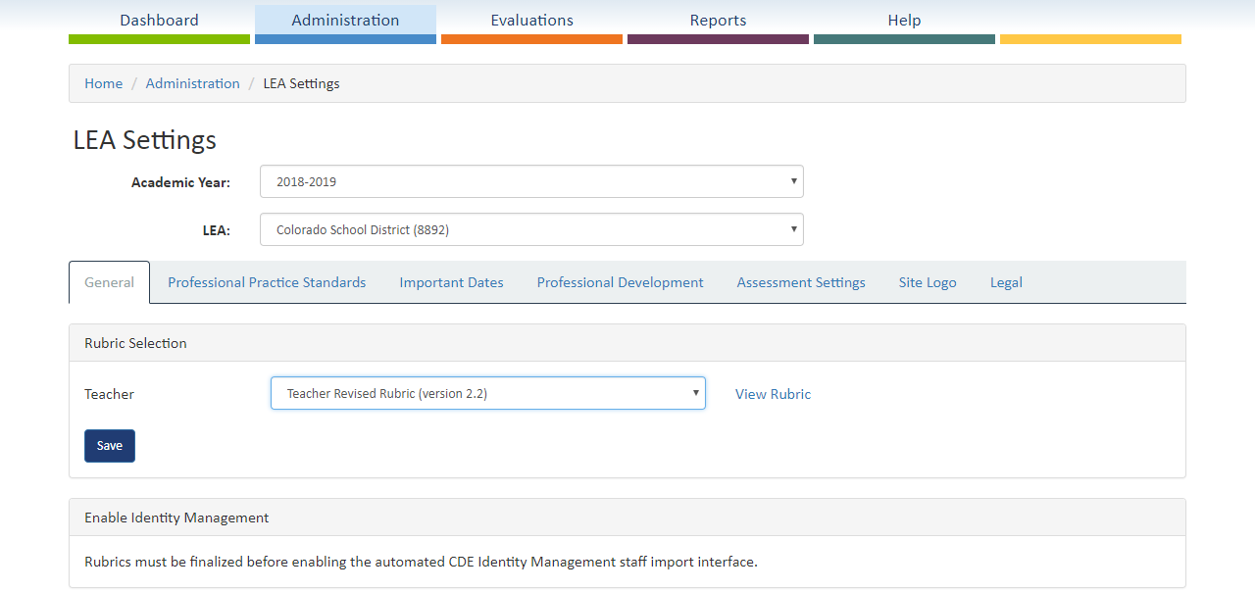

Enabling the New Year

Once the rubric has been selected, you can now enable the new year.
- Ensure your Local Access Manager (LAM) has disabled all accounts and made all role and building updates (e.g., teacher to assistant principal). It is also recommended that as many new staff be added as possible so that your principals can begin working with their full roster; however, you LAM may add new users at any time. If you do not disable accounts for employees no longer within your district/BOCES/charter school, 2018-19 evaluations will be generated and you will need to manually close them in order to have a correct employee roster.
- If the LAM has completed all of their work, the new year may be enabled by checking the box.
- Click on Enable.
- A confirmation box will be displayed to ensure you are confident you would like to move forward. Click on Enable.
- Once this is completed, it will take one day for all users to populate for the 2018-19 school year in the system.

