Colorado’s Student Data Transparency and Security Act
Colorado’s new data privacy law, the Student Data Transparency and Security Act [C.R.S. 22-16-101 et. al.], includes obligations for vendors who provide certain services to Local Education Providers (LEPs). Several definitions within the law raised a number of questions. The Colorado Department of Education (CDE) has worked with stakeholders to get clarity on how to determine what vendors are required to comply with the law and the contractual methods for doing so. The analysis below includes the definitions within the law and an overview of how to determine which vendors fit within these definitions.
Note: This is not intended to be legal advice. It’s recommended that you speak with legal counsel about this and other legal matters. In addition, you should review the actual content of the law prior to making any decisions. View the Student Data Privacy and Security Act.

School Service Definition
First, determine if a vendor is performing a School Service as defined by the law.

"School Service" means an internet website, online service, online application, or mobile application that:
Is designed and marketed primarily for use in a preschool, elementary school, or secondary school;
Is used at the direction of teachers or other employees of a Local Education Provider; and
Collects, maintains, or uses Student Personally Identifiable Information.
"School Service" does not include an internet website, online service, online application, or mobile application that is designed and marketed for use by individuals or entities generally, even if it is also marketed to a United States preschool, elementary school, or secondary school. [C.R.S. 22-16-103 (7)]

Per this definition, all of the listed qualifiers must be true for a service to be considered a School Service. It must be some sort of online or mobile app, service, or website. It must be designed and marketed for use in a school and it cannot be designed or marketed for use by individuals generally. It must be used at the direction of an LEP employee and it must use or maintain Student Personally Identifiable Information (PII). If any of these statements are not true, then the service is not a School Service and is exempt from the requirements of the law.

In addition, LEPs can review the content of the service to determine if the specific types of services are also marketed for general use in other contexts or under another name. If so, then the service would not be a School Service.

Only vendors that provide School Services to LEPs, as defined by the law, are required to comply with the law. Any vendor that is not a School Service is completely excluded. Once you have determined you are dealing with a School Service, you must then determine if the provider is an On-Demand or Contract Provider.

School Service Contract Provider
"School Service Contract Provider" or "Contract Provider" means an entity, other than a Public Education Entity or an Institution of Higher Education that enters into a formal, negotiated contract with a Public Education Entity to provide a School Service. [C.R.S. 22-16-103 (8)]
A Contract Provider is an entity that provides a School Service on a sustained and continuing basis for the term of the contract. That provider would be held to the terms of a formal, negotiated contract with a Public Education Entity. This contract must follow the school district’s procurement processes and cannot be entered into with an employee that does not have signatory authority.
School Service On-Demand Provider
"School Service On-Demand Provider" or "On-Demand Provider" means an entity, other than a Public Education Entity, that provides a School Service on occasion to a Public Education Entity, subject to agreement by the Public Education Entity, or an employee of the Public Education Entity, to standard, non-negotiable terms and conditions of service established by the providing entity. [C.R.S. 22-16-103 (9)]
Unlike a Contract Provider, either the LEP or an employee of a LEP can engage an On-Demand Provider for a School Services. For example, a teacher could download an app and click to agree with the vendor’s Terms of Service. In addition, an On-Demand Provider can provide services only on an occasional, as-needed basis, or provide services just to a single classroom or teacher. These services could be covered by a non-negotiable Terms of Service or a click wrap agreement.
How to determine the kind of provider you are using?
To identify what kind of provider you are looking to engage, you first need to ask yourself some questions. At the end of this document is a decision tree that you can use to ask these questions.
- Is this vendor providing a School Service?
  - If no, there are no obligations under the law for this vendor.
- Is the vendor’s service being used occasionally or by only one teacher or one classroom?
  - If so, it is likely to be an On-Demand Provider.
- Is the vendor’s service being used continually or across the entire LEP or is selected via the LEP’s procurement process?
  - If so, the vendor is likely a Contract Provider.
Once you have determined that the provider is an On-Demand Provider, you can accept the provider’s Terms of Service, their standard contract, etc. You do not need to negotiate a contract with this provider. For a provider that is determined to be a Contract Provider, you must enter into a negotiated contract. The contract must contain the requirements listed in the law.
See the next page for a decision tree that can help you determine the type of provider you’ll be working with.

School Service and Provider Decision Tree
If a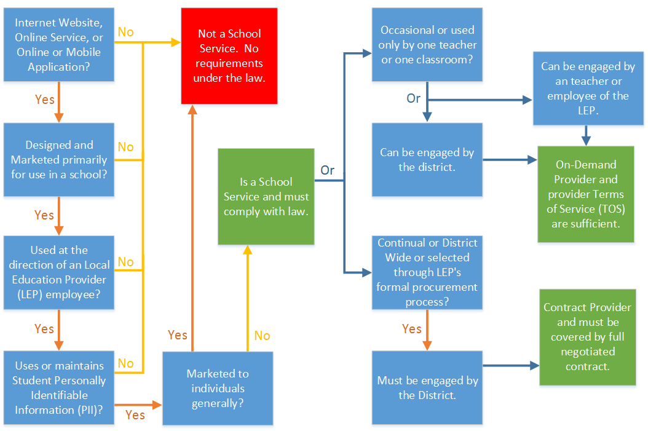

Where can I learn more?
- Data Privacy and Security website
- Resources for understanding the new data privacy law
- Email questions or comments to: dataprivacy@cde.state.co.us
- View all CDE fact sheets

