Steps for how an AU LAM assigns roles in IdM Access Management:
- First go to the Identity Management homepage link: https://cdeapps.cde.state.co.us/index.html#. 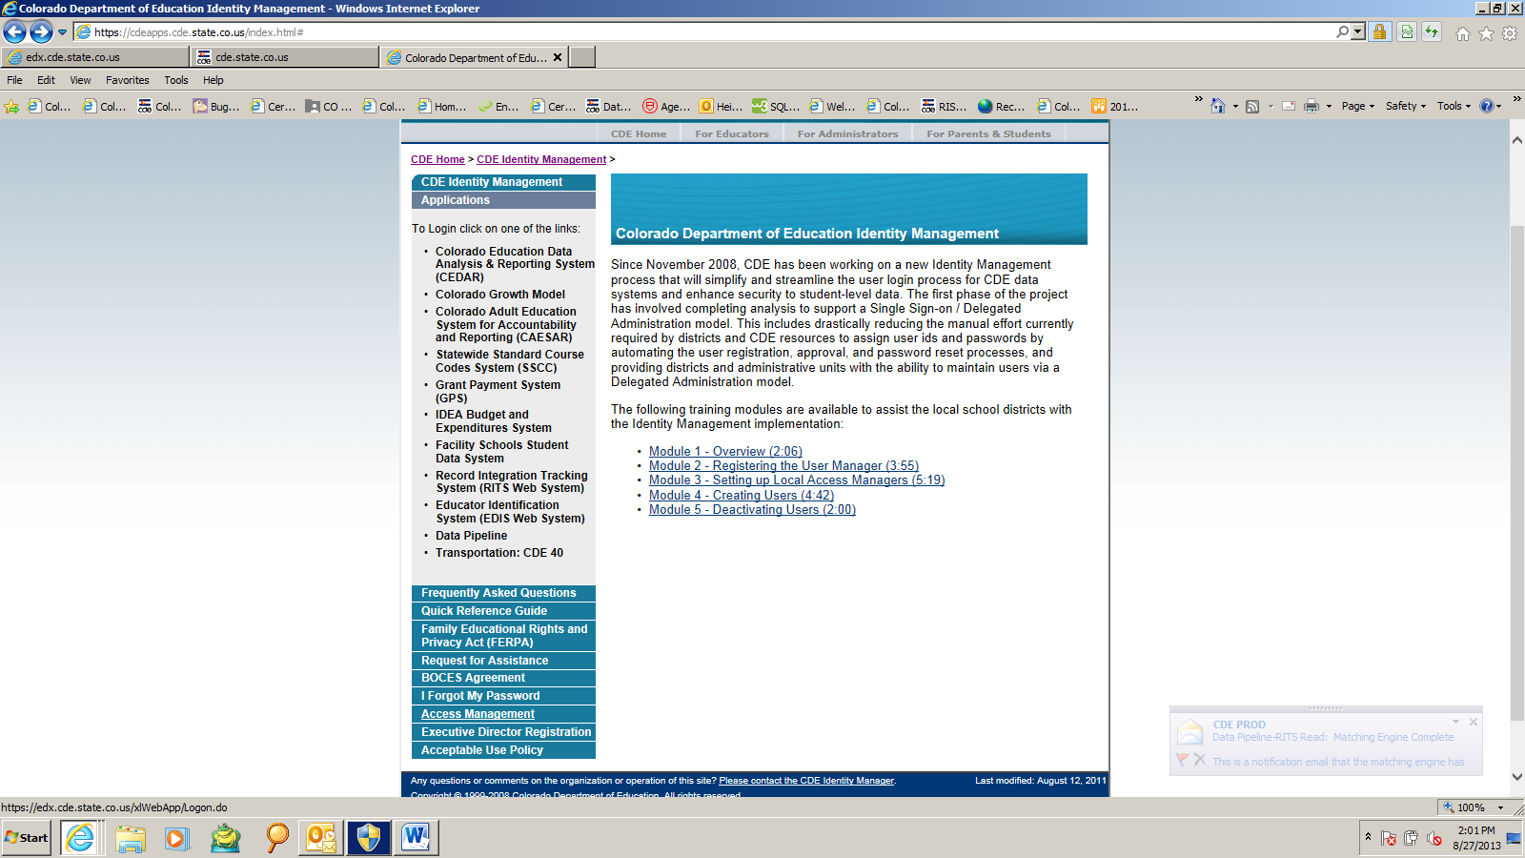

- Click the “Access Management” button in the lower left teal box.

- Next it will prompt you to login. Enter your single sign-on Username (email address) and Password. 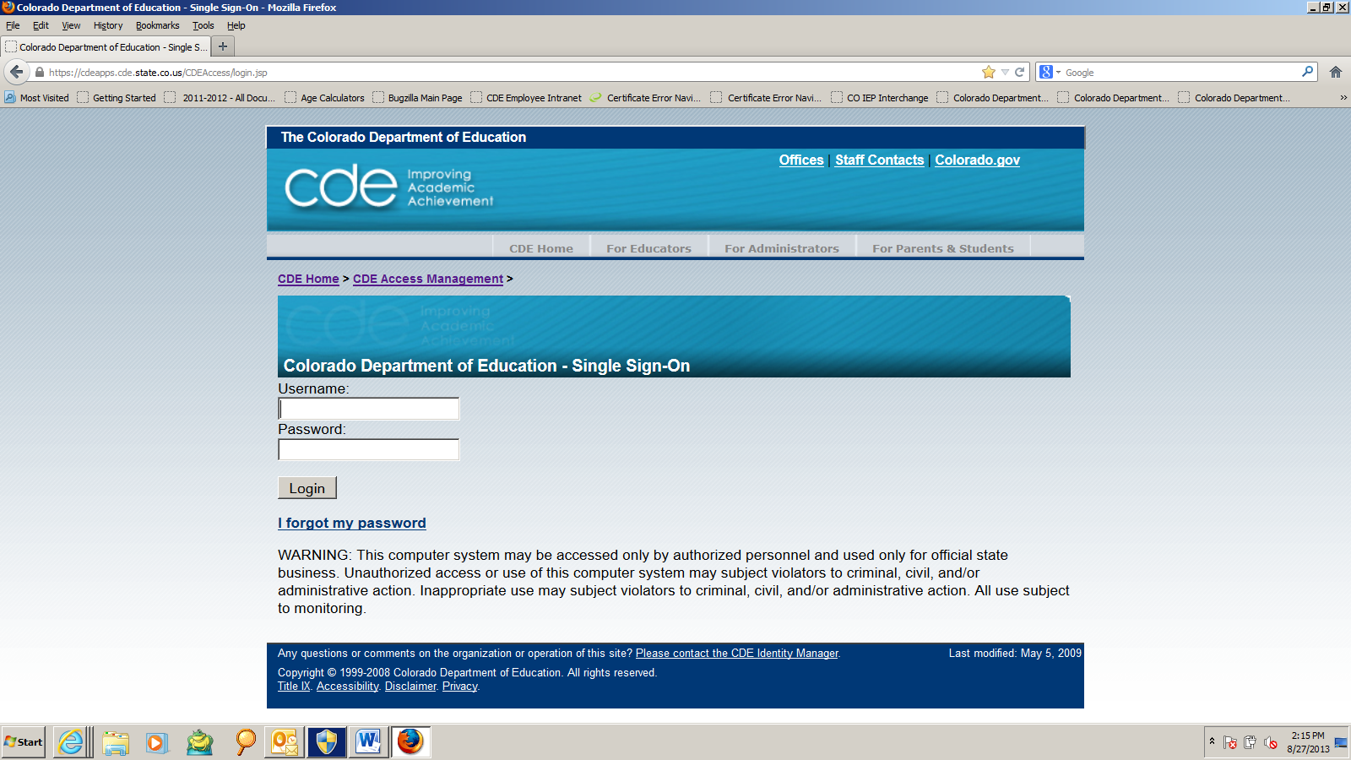

- Once signed in click “Users” from your menu options:

- Then click “Manage” where you will be able to search and bring up your users:
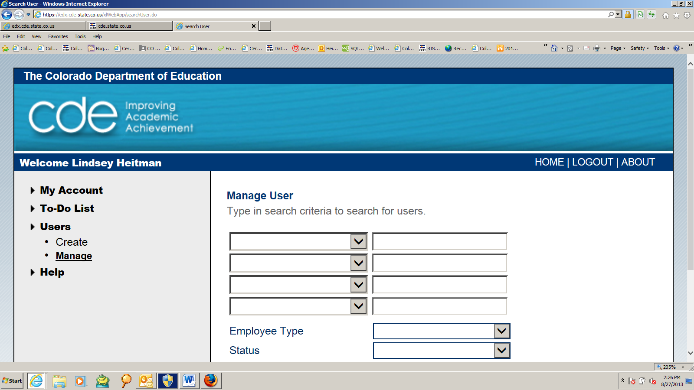

- You can search and filter by any of these options. Click the filter group in the left box and type the criteria in the box to the right of it. Then click “Search User” on the bottom left:
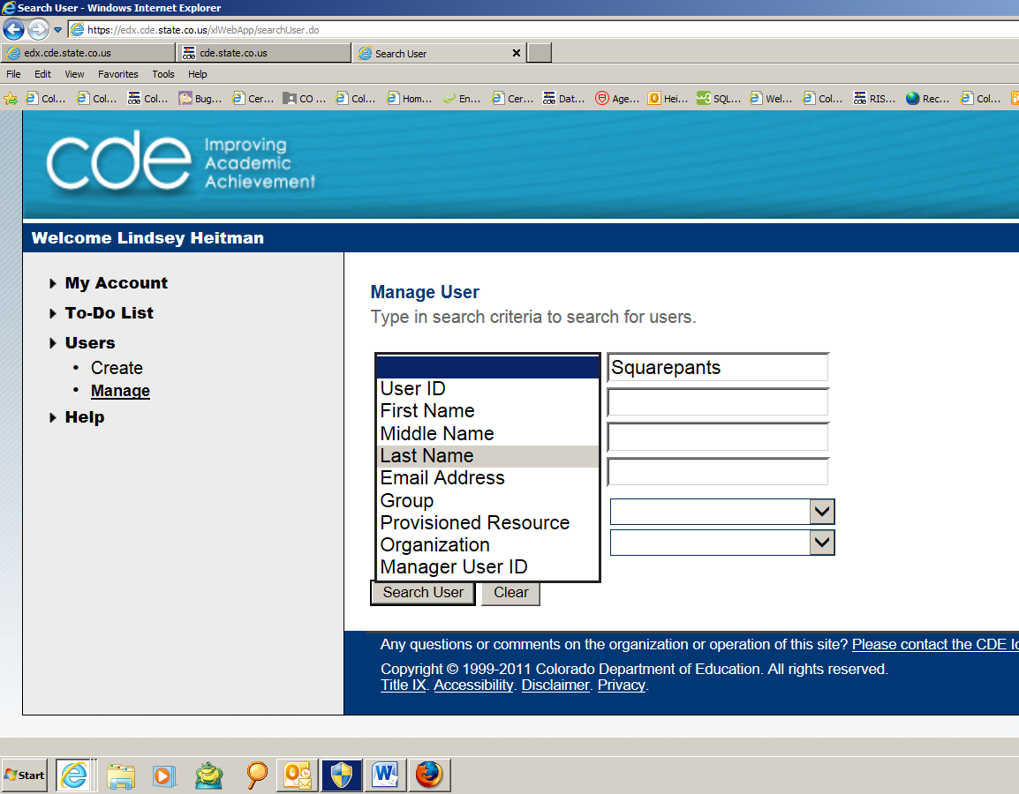

- All users with that criteria will display. Click the appropriate User ID/email address for the respondent. Beware, some individuals may have 2 or 3 email addresses in the system (due to piloting) so make sure you are going into the correct account to assign their roles:
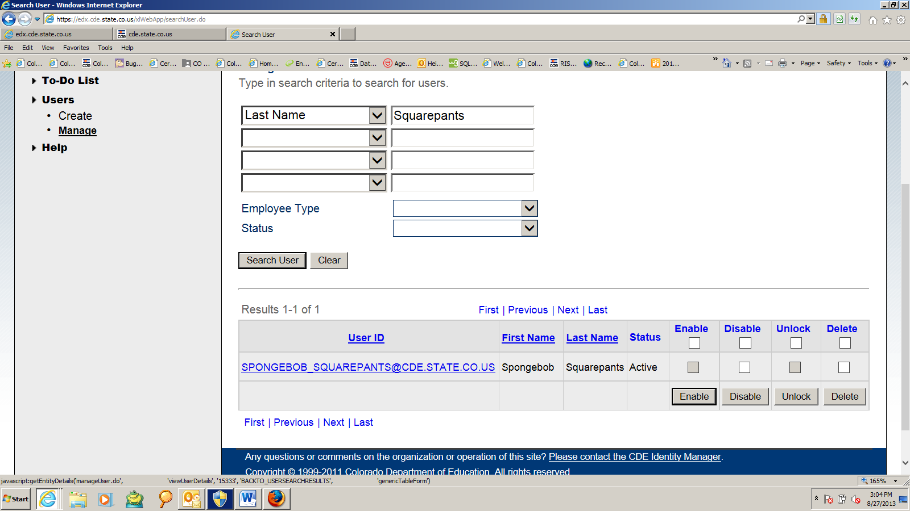

- From this screen select “Group Membership” from the box. This will give you a list of all the roles assigned to the individual.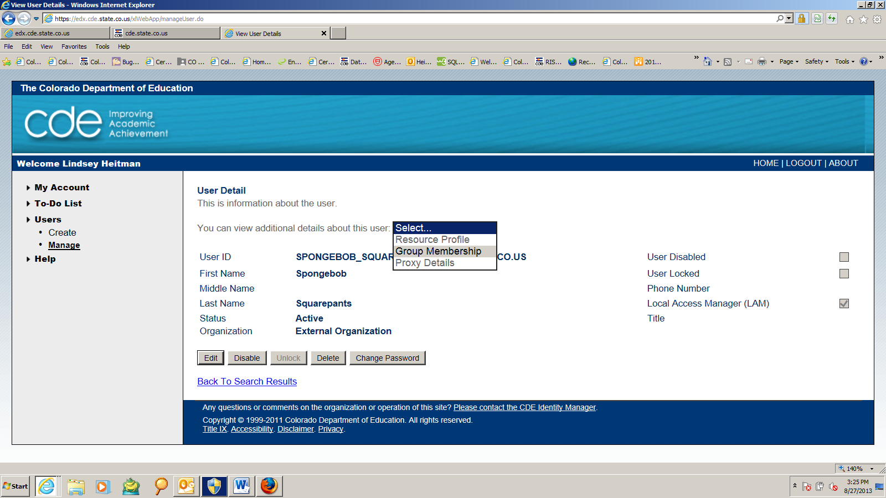

This is where you can assign and un-assign roles.
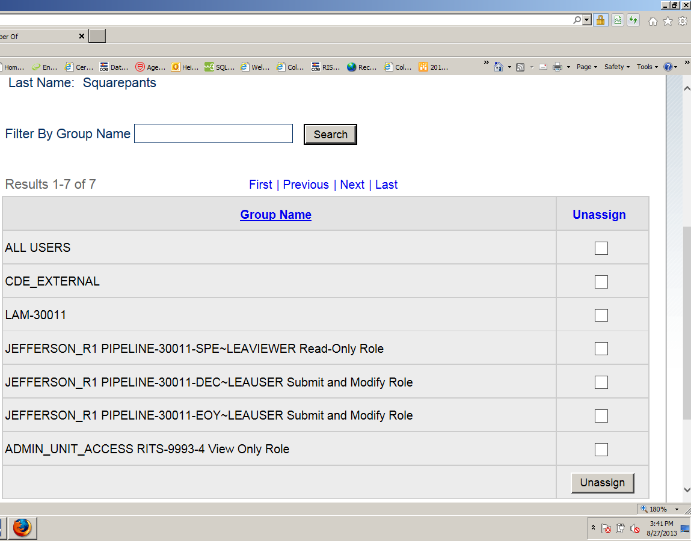
- To assign roles, click “Assign” in the lower left. That screen will then give you a list of every single role that is available for you to assign. 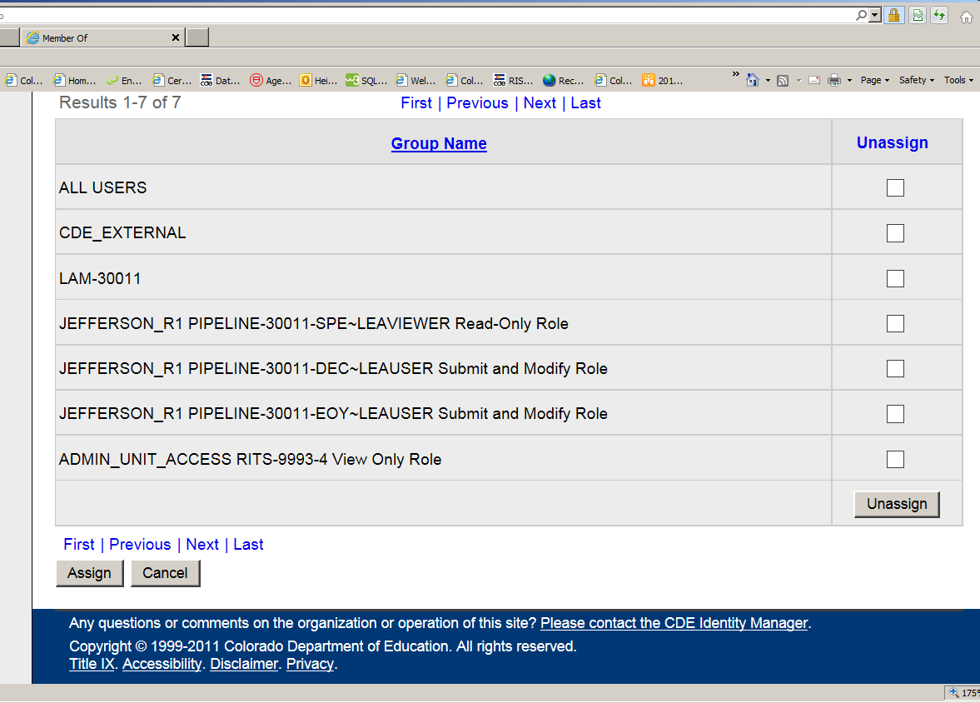

- You will want to filter by the “group name” in the Filter By box at the top left to narrow your options. For example, you could filter by your AU code. You would type *30011* in the group name filter criteria box and then click “Go” to bring up your role options. You could also narrow it down even more and filter by *30011-SPI*. Make sure to put asterisks around everything that you filter by.
These are the options you will see after you filter and click go:

- After narrowing down the options for SPI, which is the code for the Special Education Discipline Snapshot, these are the roles available to assign. Make sure to choose only one role for each dataset. In this case, the dataset is the Sped Discipline snapshot (SPI).
Next click in the “Assign” box to select the appropriate role and then click “Assign Group” in the bottom left:
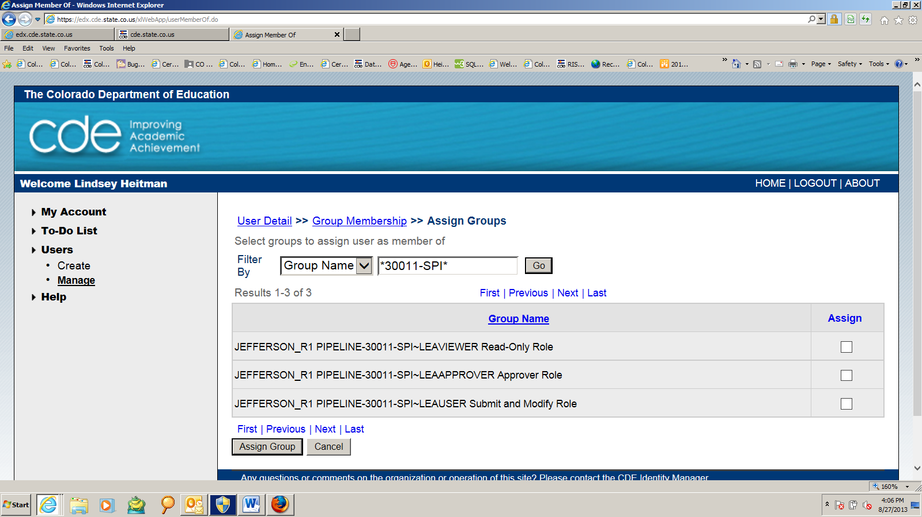

- The below screen will come up and from there click “Confirm Assign”.
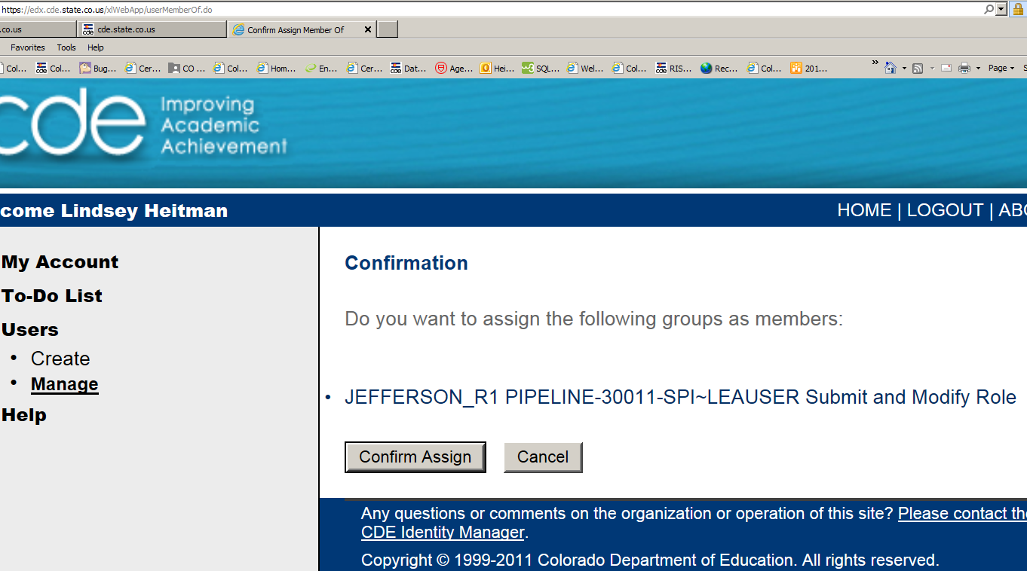

- Complete steps 10, 11, and 12 for each role you need to assign. You should be able to filter broadly and assign several roles at a time but I believe they have to be on the same page. You can tell which roles you are assigning by the confirmation.

