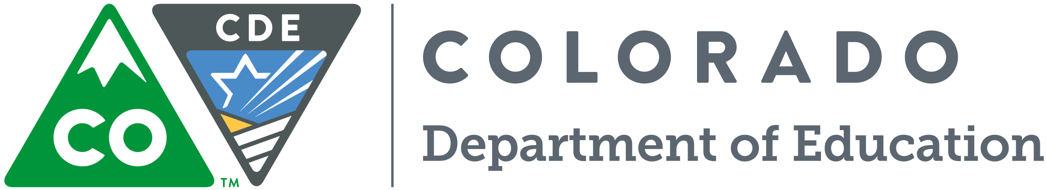

Statewide Data Collections Trainings

WHO: For Data Collection and RITS/EDIS Respondents
WHEN and Where: February 22, Pueblo
February 23, Trinidad (afternoon session only)
February 24, Alamosa
February 25, Durango
February 26, Craig
February 29, Grand Junction
March 1, Frisco

Statewide Tour Agenda
Morning 9:00 a.m. -12:00 p.m.:
- Introduction to Data Collection Systems (what is collected and why)
  - RITS/EDIS
  - Course Codes
  - Data Pipeline
- Website Scavenger Hunt
  - Documentation and Trainings
  - Contacts
  - Familiarity with Navigating the Site
- Data Pipeline Basics
  - Single Sign-On
  - Maneuvering Through Pipeline Menus
  - Snapshots, Periodics, and Interchanges
  - Loading a file and Acceptable Formats
  - Pipeline Reports
  - Cognos Reports
  - Snapshots In More Detail
  - RITS Web
- Q &A and Feedback

Statewide Tour Agenda
Afternoon 1:00 p.m.-4:00 p.m.:

- Quick Review of Collection Systems
  - What Does CDE Do with the Data?
  - Support issues and concerns
  - How to convert CSV to EXCEL as an example
  - Cognos Export to Excel
  - RITS Match Tool
  - Batch Maintenance
  - Status Dashboard
  - Pipeline Reports
- Data Privacy
  - Syncplicity
  - Broad Overview of Privacy Laws and Policies
  - What is PII?
  - Concerns over Data Privacy
- Upcoming Changes
- How Can CDE Help?

