This document contains the steps required to copy the course code mappings from the 2018-2019 school year to the 2019-2020 school year. However, CDE will automatically replicate all course codes from 2018-2019 for 2019-2020 for each district. For districts without courses mapped in 2018-2019, the 2017-2018 courses will be replicated for 2019-2020. To export the course codes and modify, please reference the directions found at: https://www.cde.state.co.us/datapipeline/exportlocalcoursecodes.
- Go to the following link: https://cdeapps.cde.state.co.us/index.html

- Click on the Statewide Standard Course Codes System (SSCC) menu option on the left side of the screen.

- Log into the system using your single sign on. (Note: if you get an error indicating you do not have privileges please contact your local access manager to get the appropriate privileges.)

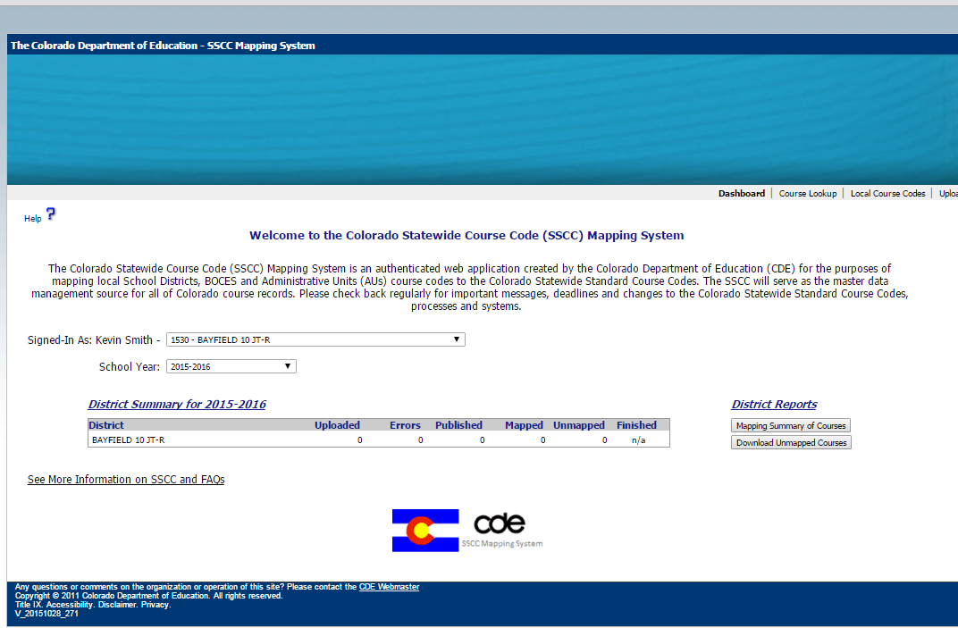

- Make sure you select the 2018-2019 school year.
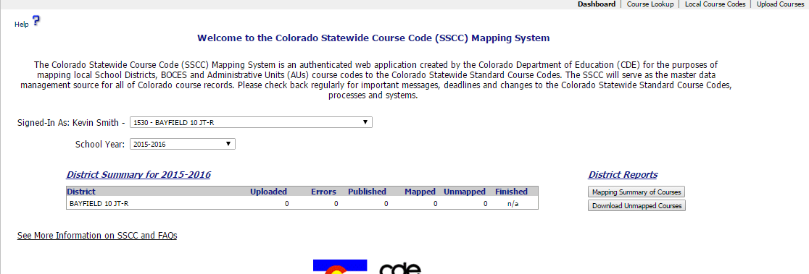

- At the top select the Upload Courses option
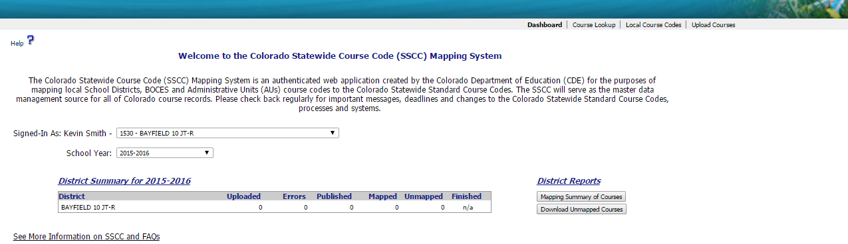
- Select the Replicate Previous Year Courses button in the middle of the screen
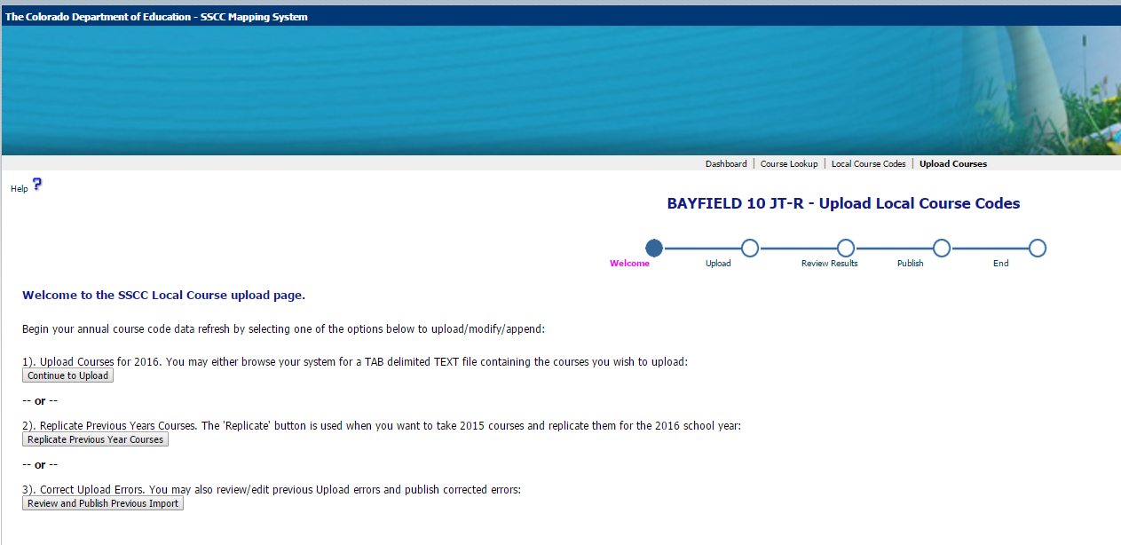

- Notice the number of Courses to Publish. This should match the number of course mappings in the 2018-2019 school year.
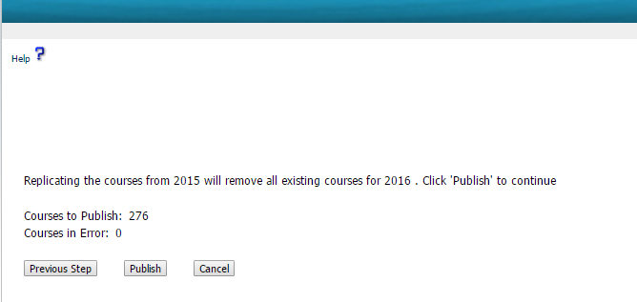
- Click the publish button

- Make sure the number of Published and Mapped courses is correct. Click the Finish button. 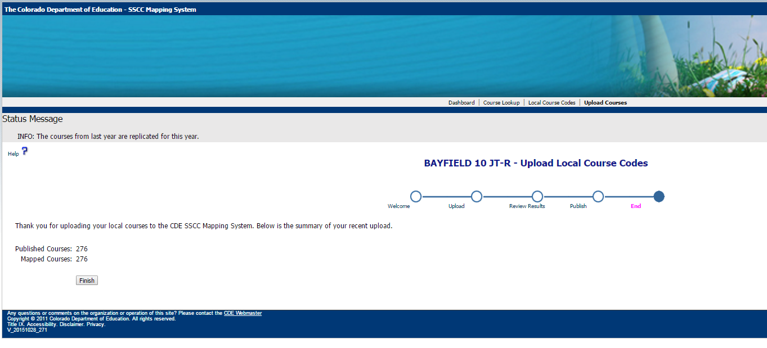

- The system will return to the main dashboard screen and you should see all of the courses in the 2019-2020 school year. 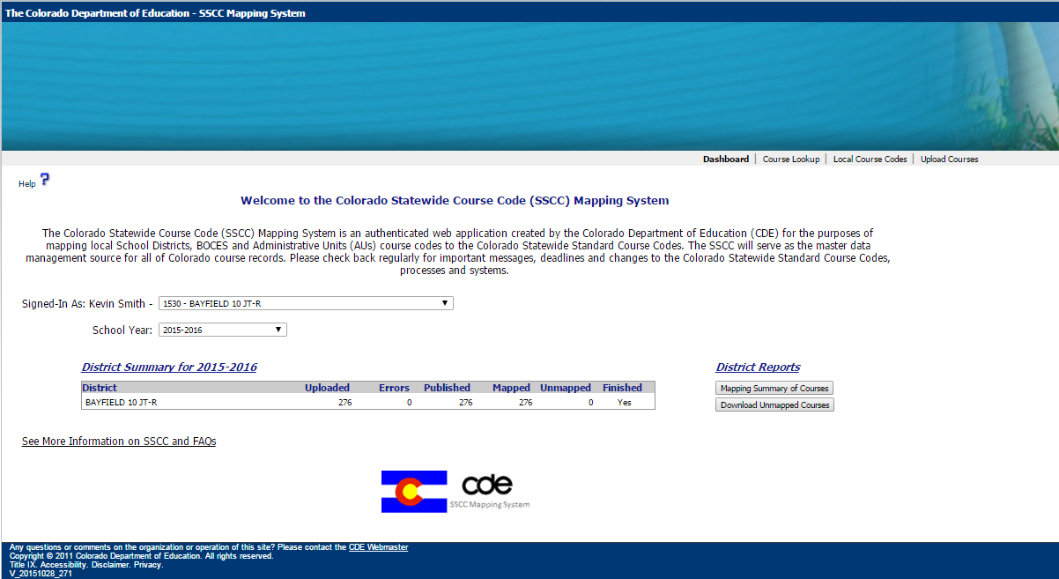

That is it. You have replicated all of the 2018-2019 courses to the 2019-2020 school year. Please feel free to contact Annette Severson at 303-866-6824 or severson_a@cde.state.co.us if you have any questions.

