This document contains the steps required to copy the course code mappings for the 2012-2013 school year to the 2013-2014 school year. The application refers to this process as replicating the course codes. It will take approximately 15 minutes to complete this process.
- Go to the following link: https://cdeapps.cde.state.co.us/index.html

- Click on the Statewide Standard Course Codes System (SSCC) menu option on the left side of the screen.

- Log into the system using your single sign on. (Note: if you get an error indicating you do not have privileges please contact your local access manager to get the appropriate privileges.)
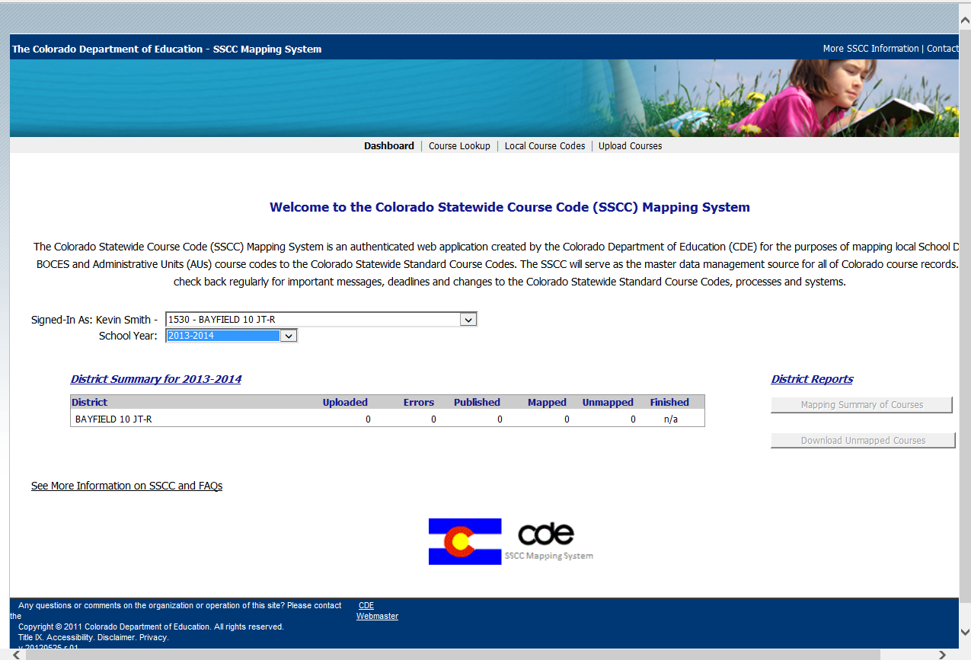

- Make sure you select the 2013-2014 school year.
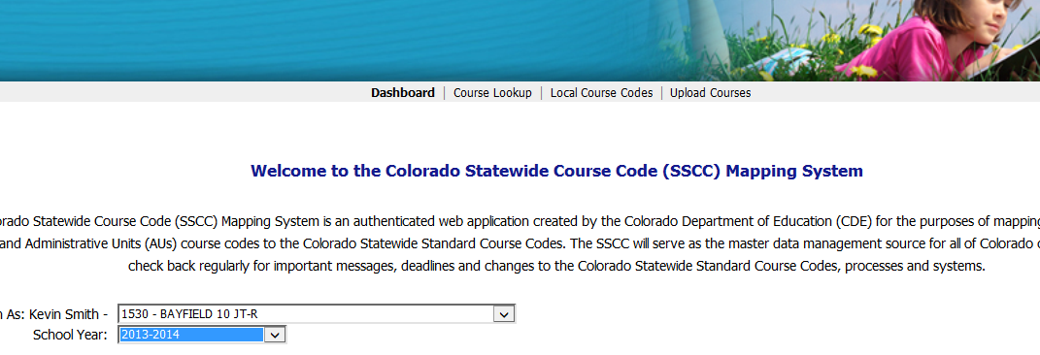

- At the top select the Upload Courses option
- Select the Replicate Previous Year Courses button in the middle of the screen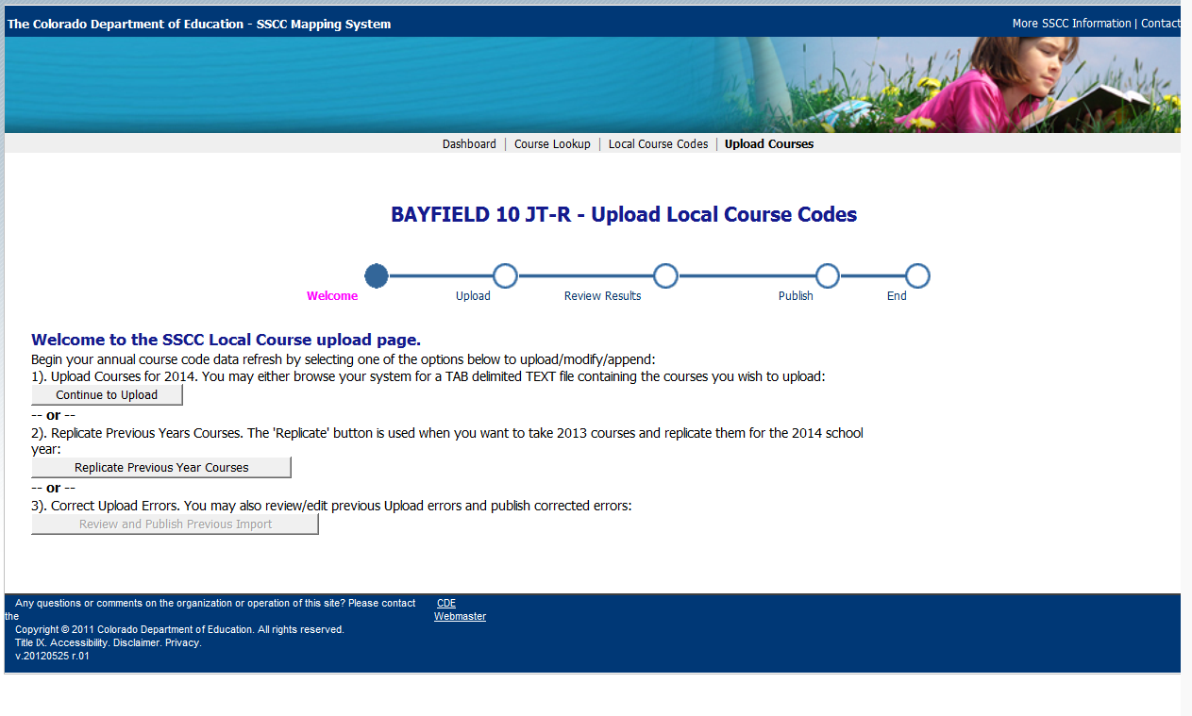
- Notice the number of Courses to Publish. This should match the number of course mappings in the 2012-2013 school year.
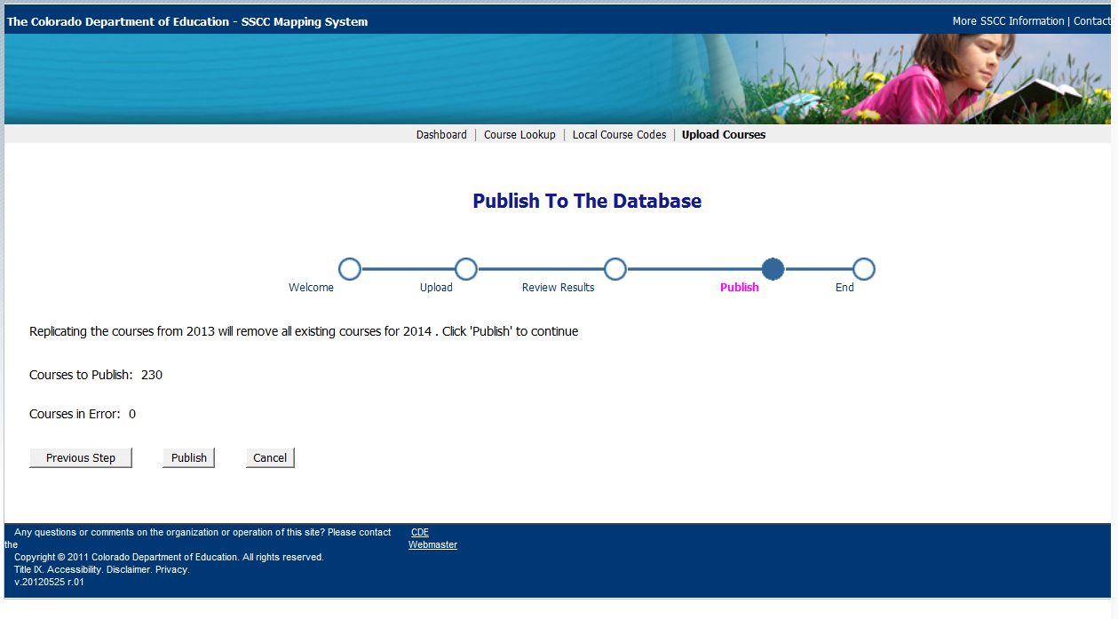

- Click the publish button
- Make sure the number of Published and Mapped courses is correct. Click the Finish button.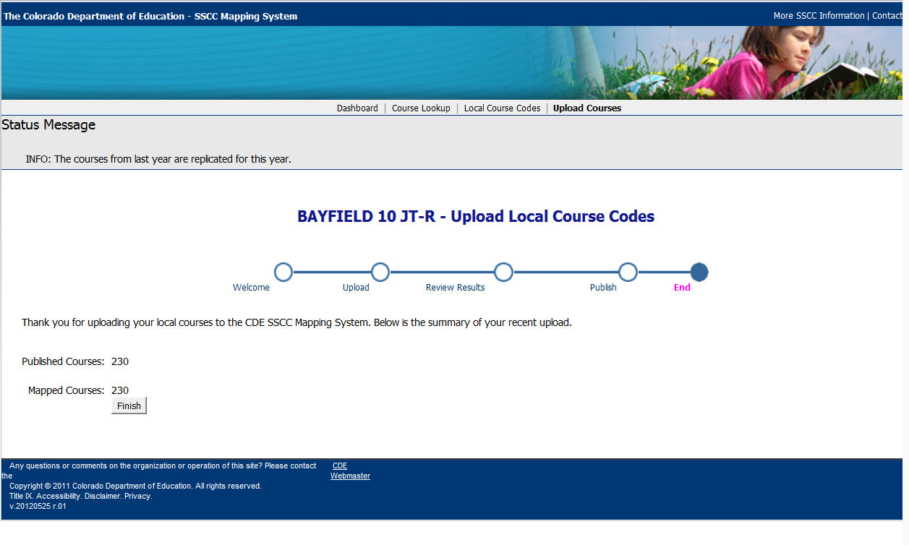

- The system will return to the main screen and you should see all of the courses in the 2013-2014 school year.
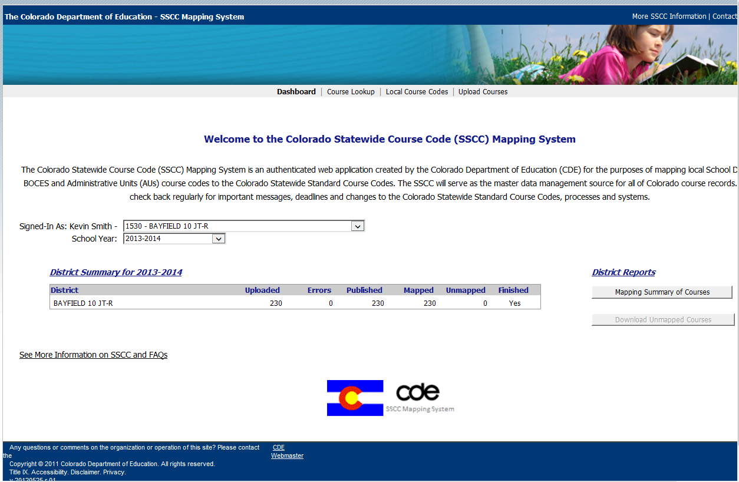
That is it. You have replicated all of the 2012-2013 courses to the 2013-2014 school year.
Please feel free to contact me at 303-866-6723 or smith_k@cde.state.co.us if you have any questions.

