Grade Level:
Elementary /4

Essential Question:
Who were the women who served at Camp Hale during World War II?

Supporting Questions:
- Why did women choose to serve in the army during World War II?
- What role(s) did women play at Camp Hale?

Source 1  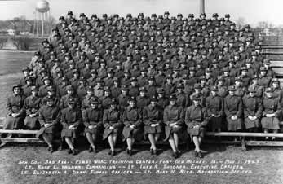  The Women's Army Corps Detachment (1943)  Source: Metropolitan State University of Denver https://www.msudenver.edu/camphale/thewomensarmycorps/camphalewacdetachment/ | Source 2  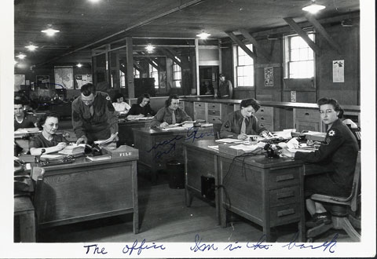  “The Office, I’m in the back”  Source: Photo Courtesy of the Colorado Snowsports Museum and Hall of Fame and the Davis Family.

Background Knowledge / Contextual Paragraph for Teachers:
When the United States entered World War II, American women were called on to serve the nation in many ways. Unprecedented numbers of women entered the ranks of factory workers, helping American industry meet the wartime production demands for planes, tanks, ships, and weapons. It was through this aspect of war work that the most famous image of female patriotism in World War II emerged, Rosie the Riveter.

On May 27, 1943, the first women arrived at Camp Hale. Over 200+ women served at Camp Hale as part of the Women’s Army Corps (WAC). These women were not training to fight but they performed important duties at the camp through their work as secretaries. The women troops worked in finance, communications, nursing, the motor pool, and supply. They enlisted out of patriotism and for independence and adventure. Most members of the Camp Hale WAC Detachment left the service when the war ended. They look back on their experience and acknowledge that because they and other WACs succeeded, they secured a permanent place for women in the military.

Source: https://www.msudenver.edu/camphale/thewomensarmycorps/camphalewacdetachment/

NOTE: Very little has been written about the 200+ women who served at Camp Hale. The most comprehensive site was compiled by Professor Monys Hagen formerly at Metropolitan State University. Her mother served at Camp Hale which is how Monys became interested in researching the stories of the women at Camp Hale. Her research can be found here:

Building Background Knowledge for the Student
- Begin by showing this image:
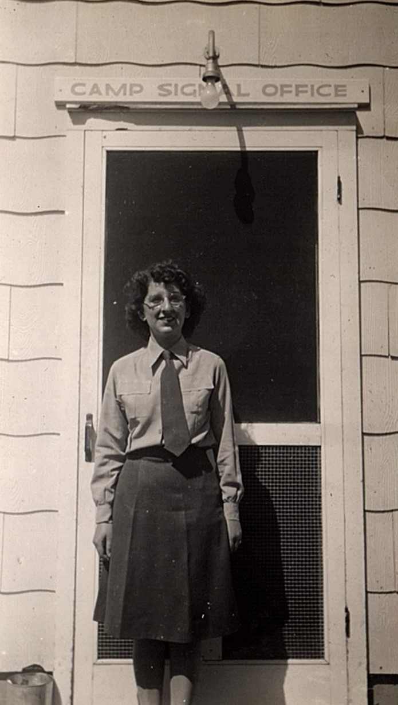
Ask students the following questions:
- What do you see?
- What do you notice about the clothing the person is wearing?
- What words do you see in the photograph?
  - What do you think the words mean?
- When do you think this photograph was taken?
- What questions do you have about this photograph?

- After students have an opportunity to engage with this photograph, explain to them that this is a photograph of Mary Elizabeth (Lanza) Davis (DOB: 3/3/1920) who was a Women’s Army Corps (WAC) soldier stationed at Camp Hale (outside of Leadville, CO) during World War II. The Women’s Army Corps was created to perform a wide variety of non-combat functions within the Army including finance, communications, the motor pool, and supply.
Additionally, Mary's husband Frank Russell Davis (DOB: 10/9/1922) was stationed at Camp Hale, assigned to the Calvary. They met at Camp Hale. Mary grew up in Pittsburgh, PA and Frank in George West, Texas.

Strategy Instruction:

- Students build understanding with the "Images Draw You In" Model Activity by:
● Articulating a connection between responses to differentiated, investigative questions and an idea central to the subject under study.
● Use this activity as a warm-up to the study of the women who served at Camp Hale.
o Print copies of images from this primary source set and the resource set (How many you print is based on how many students you have in your class and/or whether or not you want students to work in groups).
o Ask students to select a photograph that “grabs them”
o Engage students in an investigation of their selected photograph using sample inquiry questions
- Close Reading of Photographs:
- Students build close reading skills when reading photographs instead of focusing on captions. Students generate a list of information they gathered, and questions they have regarding their photograph (or their group’s photograph).
- Following the close reading of their selected photograph(s), have students create a caption for their picture!
- Students take the information from their photograph(s) and construct a narrative about life in Camp Hale.
- Their Voices:
  - Have students read the excerpts of the interviews with Mary Stone & Emily Collinsworth (Extra Sources 7 & 8). Ask the following questions:
    - What impressions do you have about life at Camp Hale?
    - How do you think Mary and Emily felt about being stationed at Camp Hale?
    - If you could ask them 2 questions, what would those questions be?

- Using the questions in the Discussion section below, you can guide students in primary source analysis. To begin with, you can use the primary source worksheets located on the right sidebar of the CDE Elementary Primary Source Sets website. These worksheets are a great way to begin the discussion.

- Another effective strategy to use with primary source images is the Zoom-In primary source strategy. An example of this activity using Buffalo Bill can be seen and adapted here. Feel free to make a copy of this Google Presentation and adapt it for any of the pictures above. Simply import a new image, crop it to your liking for each slide, and adapt the questions to the specific primary source. This strategy is a great way to analyze primary sources in segments so that students are forced to focus on specific parts of the image.

Strategy Instruction Differentiation:
Students should identify vocabulary terms in the interview excerpts that they don’t know. Have students read the sentence containing the vocabulary word for meaning and context. Then, have them define or explain the word based on their reading. Next, as the teacher, lead a discussion of the terms.

Discussion:
- How can primary sources help us learn about the past or create more questions about our state's history?
- Why are some stories “left out” of history?
- Why were the women stationed at Camp Hale so important to the military base?
- What was life like for the women at Camp Hale? What did they do for fun?
- How would you describe the area around Camp Hale?

Assessment:
Design and write a postcard describing life at Camp Hale. Have students describe the location, the buildings, and what they do for fun. (Template: https://olphreunion.org/free-printable-templates-postcards/)

If students are interested, have them investigate more about the role of the 10th Mountain Division in World War II: https://coloradoencyclopedia.org/article/tenth-mountain-division

2020 Colorado Social Studies Standards:
- Standard 1 – History: 4.1.1.a. Draw inferences about Colorado history from primary sources such as journals, diaries, maps, etc.
- Standard 1 – History: 4.1.1.d. Identify cause-and-effect relationships using primary sources to understand the history of Colorado's development.
- Standard 1 – History: 4.1.2.b. Explain the relationship between major events in Colorado history and events in United States history during the same era.
- Standard 2 – Geography: 4.2.1.a. Answer questions about Colorado regions using maps and other geographic tools.
- Standard 2 – Geography: 4.2.2.a. Describe how the physical environment provides opportunities for and places constraints on human activities.

2020 Colorado Reading, Writing, and Communicating Standards:
- Standard 2 - Reading for All Purposes: 4.4.2.a. Refer to details and examples in a text when explaining what the text says explicitly and when drawing inferences from the text.
- Standard 2 - Reading for All Purposes: 4.4.2.a. Explain events, procedures, ideas, or concepts in a historical, scientific, or technical text, including what happened and why, based on specific information in the text.
- Standard 4 – Research Inquiry and Design: 4.10.1.a. Conduct short research projects that build knowledge through investigation of different aspects of a topic.

Extra Source 1  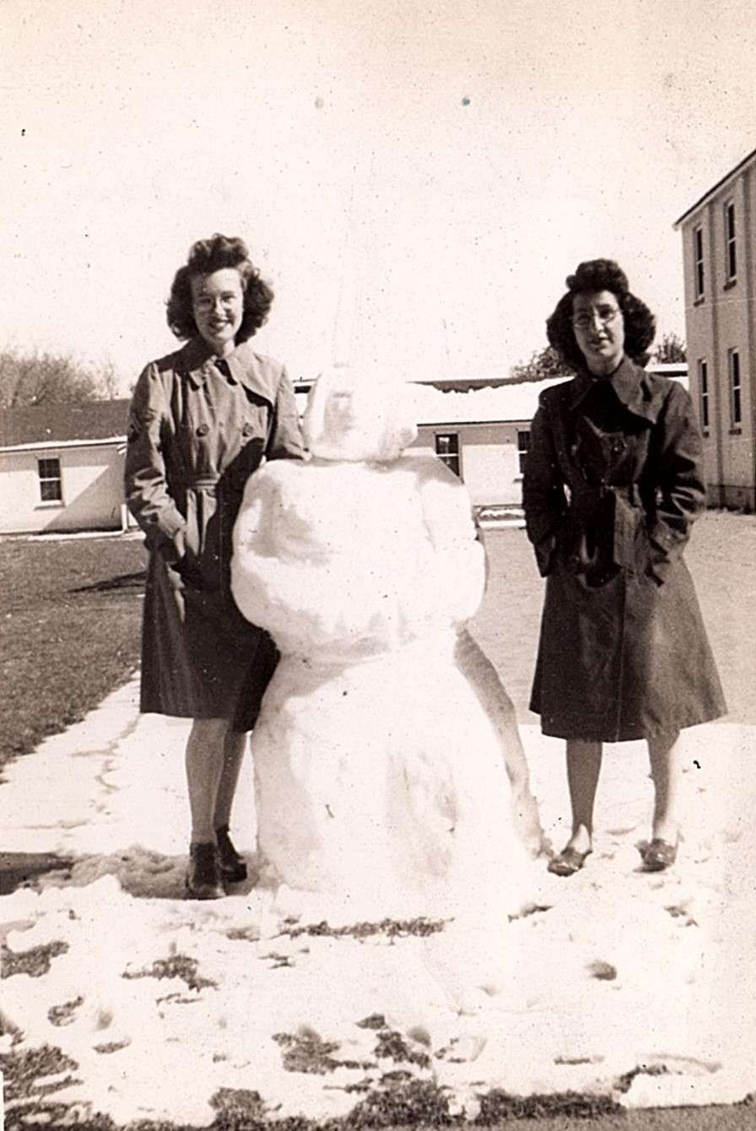  A Friend (L) and Mary Elizabeth S(Lanza) Davis (R)  Source: Photo Courtesy of the Colorado Snowsports Museum and Hall of Fame and the Davis Family. | Extra Source 2  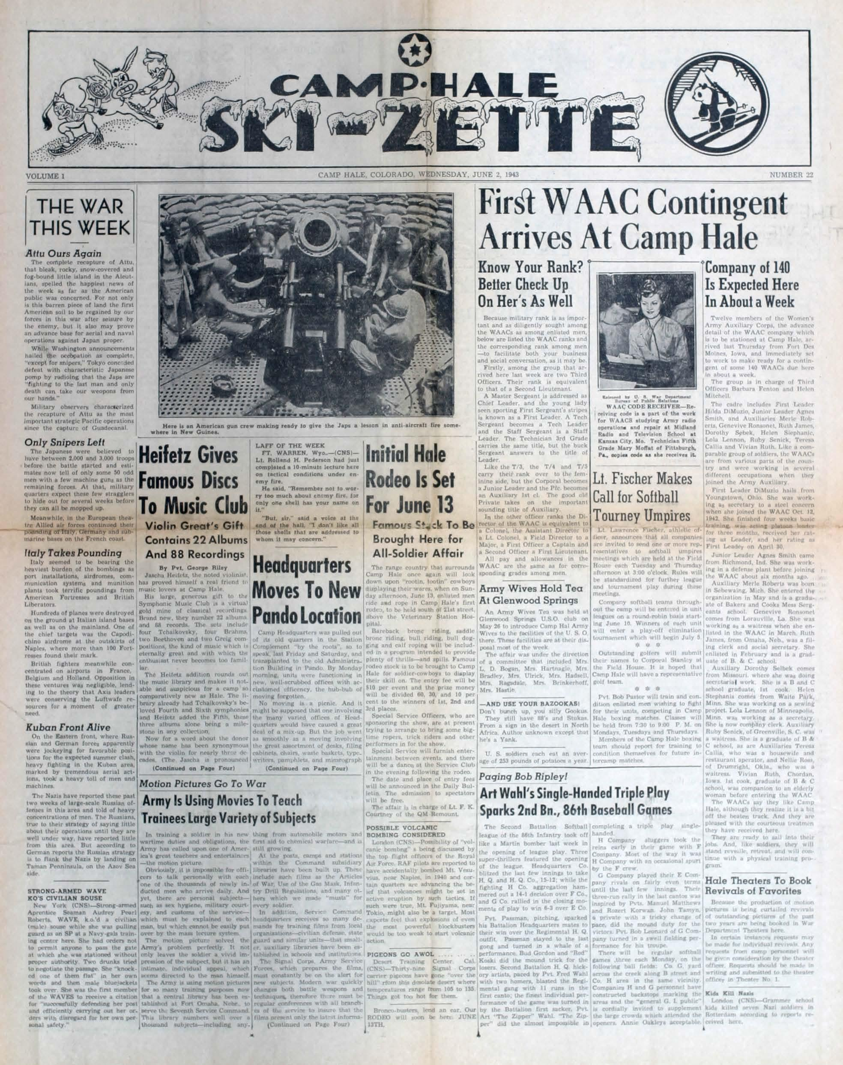  First WAAC Contingent Arrives at Camp Hale, May 27, 1943  Source: https://www.msudenver.edu/media/content/camphale/chh_003_CampHaleSkiZette14.pdf
Extra Source 3  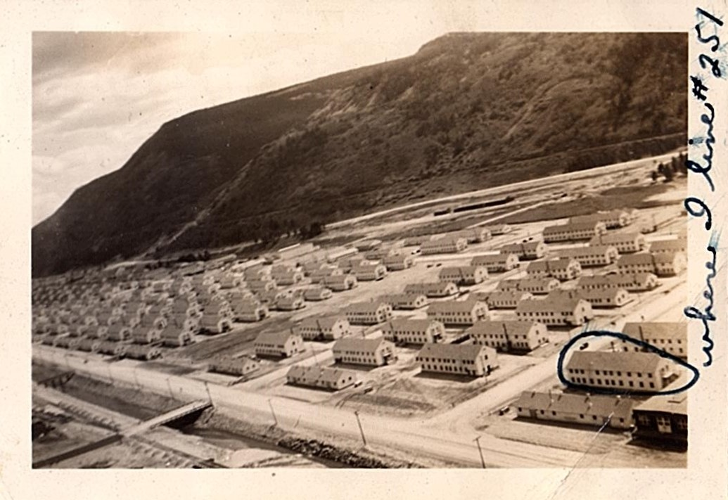  “Where I Live #251”  Source: Photo Courtesy of the Colorado Snowsports Museum and Hall of Fame and the Davis Family | Extra Source 4  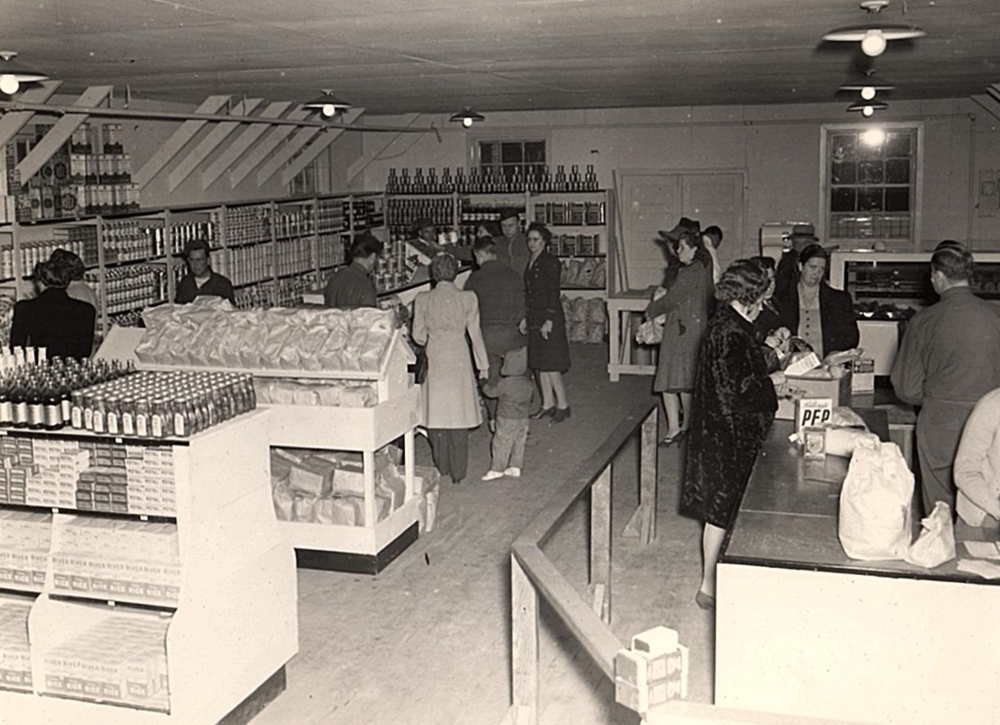  The Commissary at Camp Hale  Source: Photo Courtesy of the Colorado Snowsports Museum and Hall of Fame and the Davis Family
Extra Source 5  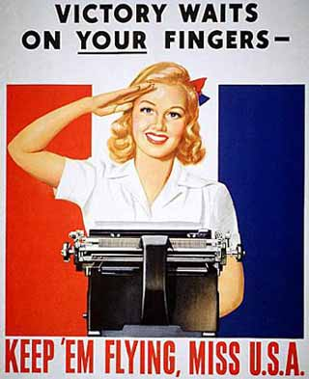  Victory Waits on Your Fingers 1943-1945; Recruiting Poster  Source: National Archives & Records Administration https://www.docsteach.org/documents/document/victory-waits-on-your-fingers | Extra Source 6  10th Mountain Division Gains First Female Brigadier General  (Aug. 7, 2015)  Source: https://www.army.mil/article/153397/10th_mountain_division_gains_first_female_brigadier_general
Extra Source 7  Monys: What were some of the things you did for recreation at Camp Hale?  Mary: Like I said, the fellas would have parties for us - steak dinners and stuff on Saturdays. On Sundays we would just kind of hang around. Sometimes we would take long walks. We would take passes into Denver. Of course, they had those hairpin curves; we were scared stiff; didn't think we would make it back to the camp. We had good times. We didn't go to sleep in hotels. We had good times. I went with Loretta and your mom and Jessica, Irene Finney, Mary Lanza - we all didn't go at the same time…  Source: Excerpt from an interview between Monys A. Hagen, Ph.D. (project coordinator) and Mary Stone (A member of the WAC who served at Camp Hale). https://www.msudenver.edu/camphale/resources/interviews/marystone/ | Extra Source 8  Neal: Do you remember arriving at Camp Hale?  Em: Yeah. It was two really pretty mountains. The train goes along the side of the mountain and then the camp is through this valley. So we all got off and got in formation. We had to march over to our barracks which was about a mile or mile and a half. Of course, We were trying to look at all there was. It was exciting to see where Camp Hale and that we were actually going to be stationed someplace and do a job.  Neal: Were you actually in the mountains? Was it very pretty?  Em: Big mountains on both sides. Camp Hales is situated in a long narrow valley. Then the mountain take right up. The Holy Cross mountain is there. We could see from camp. Big rocky cliffs. On the other sides were big mountains; we were just surrounded by mountains and they were all covered with pine trees. It was beautiful up there.  Neal: Physically, what was the actual camp like?  Em: It was barracks and the hospital was up on one side of the mountain. Rows of barracks. There was a chapel for each section. The motor pool - it was as you came into the camp. Our barracks were the first barracks as you came into camp. There was a big open field and then our barracks. There was a service club. Our mess halls. There was 116 engineers and some mule packers. They had their mules and then at the end of the camp was where the 10th Mountain Ski Division was. It was strictly....  Source: Excerpt from an interview with Emily Collinsworth (A member of the WAC who served at Camp Hale). https://www.msudenver.edu/camphale/resources/interviews/emilycollinsworth/
Additional Resources
- The Women Who Served at Camp Hale Research Project at Metropolitan State University, Denver: https://www.msudenver.edu/camphale/camphalehistory/
- 10th Mountain Division, University of Denver, Camp Hale Exhibit: https://camphale.omeka.net/
- Denver Public Library 10th Mountain Division Resource Center https://history.denverlibrary.org/research/10th-mountain-division
- The Ski-Zette, Camp Hale’s Weekly Newspaper: https://www.msudenver.edu/camphale/militarylife/ski-zette/

