Grade Level:
Kindergarten

Essential Question:
What do toys and games tell us about kids?

Supporting Questions:
- What kinds of toys and games did your grandparents play with?
- What can we learn about kids in the past through toys and games?
- How can we tell if something is old? New?

Source 1: A child with her toys bears ~ 1860  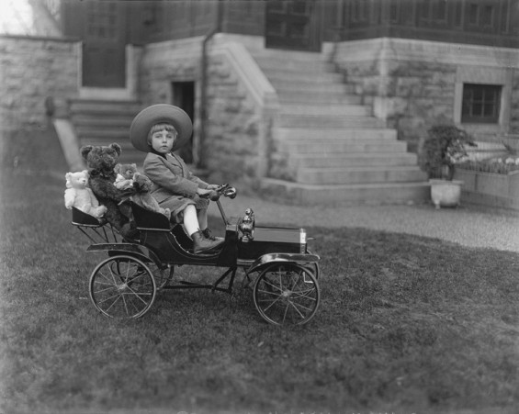  https://commons.wikimedia.org/wiki/File:Children_with_toys4.jpg | Source 2: A view of a group of young children playing in the street c.1890  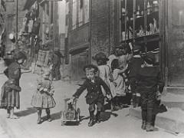  https://www.flickr.com/photos/newcastlelibraries/4086252067
Source 3: Cabbage Patch Doll, 1980s  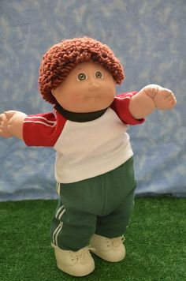  Description: A doll that was invented in 1983 by designer Xavier Roberts. Each doll was made with its own personality and were put up for “adoption”. Trademarked in 1984.  https://i.pinimg.com/236x/92/fe/59/92fe59df85165109538175b3c45a3a3d--cabbage-patch-kids-boy-dolls-for-sale.jpg | Source 4: Girl Doll from the 1920s  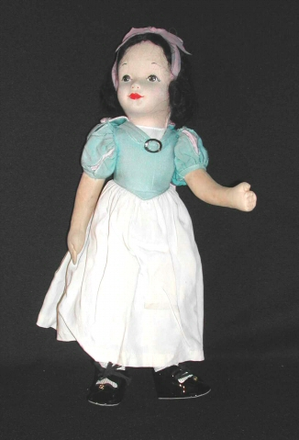  http://5008.sydneyplus.com/HistoryColorado_ArgusNet_Final/ViewRecord.aspx?template=Object&record=9d5cda70-8510-433b-b489-52466cf5b408&displayFields=Attachment&lang=en-US
Source 5: Toy Library, Denver ~ 1920s  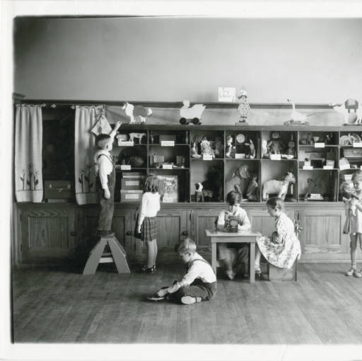  Photo of a Toy Library at Smedley Elementary School, Denver in the 1920s?  From the Denver Public Library  http://cdm16079.contentdm.oclc.org/cdm/singleitem/collection/p15330coll23/id/10350/rec/9 | Source 6: Girl Doll from the 1980s  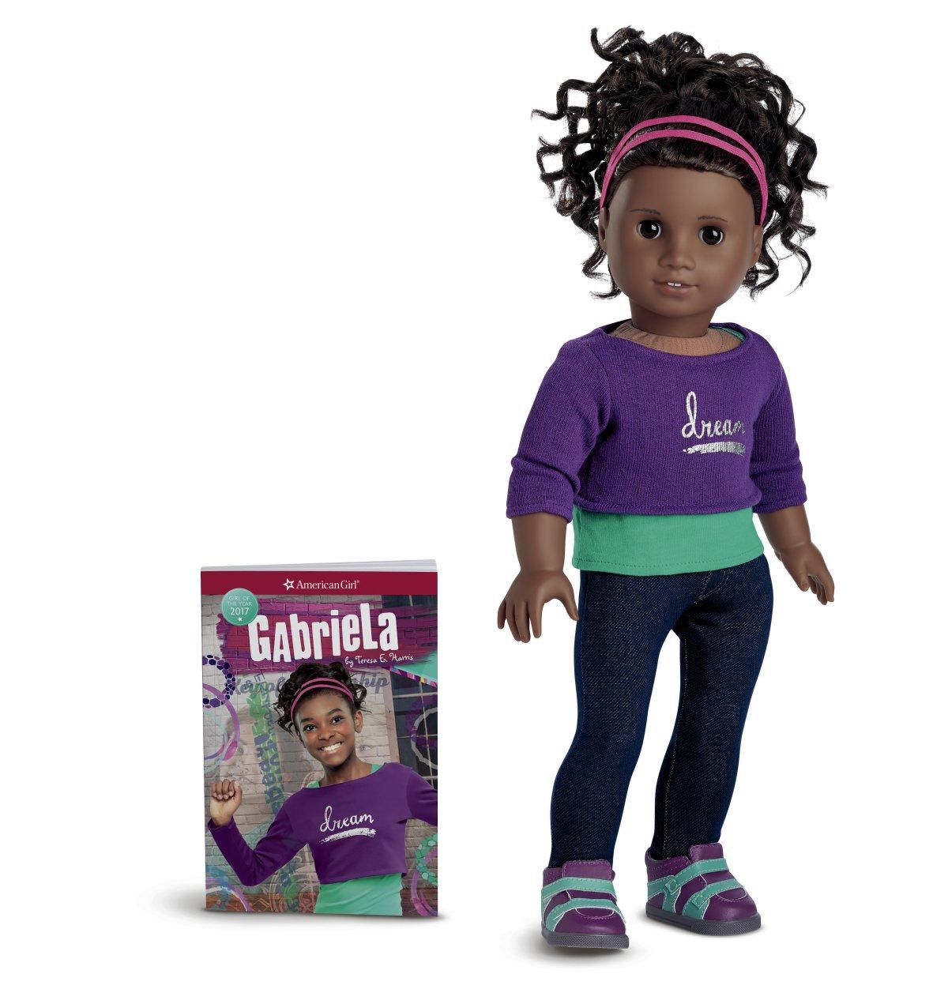  Description: This is a girl doll named Gabriela. The first 3 dolls were produced in 1986 and created by Pleasant T. Rowland, a former educator. In the fall of 1997 an online store opened and in 1998 the company that first made the doll, Pleasant Company, was bought by Mattell, Inc

Background Knowledge / Contextual Paragraph for Teachers:
Toys and games offer interesting artifacts from the past that can teach us about culture, values, and social life. These primary source examples can engage students with artifacts that relate to their own play activities. The primary source set here includes images of historical dolls and games. Students can begin to identify features in photos that tell us about what’s old and what’s new. They can begin to practice building chronology with toys and games from different eras.

Building Background Knowledge for the Student:
- Teacher question: What are your favorite toys? Why do boys and girls play with different toys? Is a new toy better than an old one? Why?
- Teacher question: Do any of you have old toys from a brother or sister? from your Mom or Dad? Grandmother or Grandfather? How were their toys different? Similar?
- Teacher question: Do grown-ups play with toys too? What kinds?
- Teacher question: What can we learn about a person from looking at the toys they play with?

Strategy Instruction:
- Start with Background discussion on toys and games above.
- Project Smedley Elementary Toy Library photo. This is a library. What are kids doing here? What kind of library is this? Why would a school have a toy library? What are toys for? How can we tell this photo is old and not taken yesterday? What toys would you put in a toy library for kids your age today?
- Project the sequence of Doll Images in Sources 2, 3, 4. Ask students about the differences. Teacher questions: why are these dolls different? Who might play with these? How can a doll tell us something about the person who plays with it?
- Project Catalogues and ads for toys in the Extra Sources below. Use position words here (above, below) and also compare this to several other catalogue images so students can sequence them and work to measure which ones are more modern.
- Project game images (Extra Sources below) or let students examine pictures in groups. Continue with questions about similarities and differences and what these games tell us about kids in the past.

Strategy Instruction Differentiation:
These primary sources have little to no text. The images can allow students to practice historical detective work without basic reading.

Discussion:
- Exploring toys are historical artifacts. What can toys tell us about kids in the past?
- What do different dolls tell us about different groups? Indians? African Americans?
- Why do people create new toys and games?
- What makes a toy or game interesting or fun?
- How to video games changes our view of other toys and games from the past?

Assessment:
- Students might consider drawing a picture of their favorite toy or game and then explain what it says about them. How might their grandkids one day learn about them from studying this picture of the toy or game?
- What did we learn as a class about kids in the past? Were your grandparents’ toys similar or different from yours?

Curriculum Standards:
Standard 1: History: GLE 1a: Ask questions about the past using question starters. Questions to include but not limited to: What did? Where? When did? Which did? Who did? Why did? How did?
Standard 1: History: GLE 2a: Order sequence information using words. Words to include but not limited to past, present future, days, weeks, months, years, first, next, last, before, and after.
Standard 1: History: GLE 2b: Explore differences and similarities in the lives of children and families of long ago and today
Standard 3: Economics: GLE 1a: Give examples of ownership of different items.

Reading and Writing Standards:
RWC Standard 1: GLE1a: Describe familiar people, places, things, and events and, with prompting and support, provide additional detail.
RWC Standard 1: GLE1d: Sort common objects into categories to gain a sense of the concepts the categories represent.
RWC Standard 3: GLE 1a: Use a combination of drawing, dictating, and writing to compose opinion pieces in which they tell a reader the topic or the name of the book they are writing about and state an opinion or preference about the topic or book (e.g., My favorite book is…)
RWC Standard 3: GLE 1b: Use a combination of drawing, dictating, and writing to compose informative/explanatory texts in which they name what they are writing about and supply some information about the topic.

RWC Standard 4: Research and Reasoning: GLE 1b: Use a variety of resources to answer questions of interest through guided inquiry.

Sample Activities:
- Discussion of toy and doll images
- Comparing toy catalogues and games.

Extra Source 1: Christmas Postcard, 1910s?  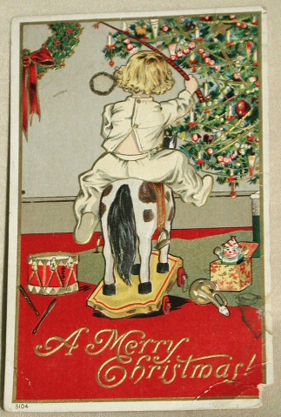  Description: A postcard sometime between 1900-1920  http://5008.sydneyplus.com/HistoryColorado_ArgusNet_Final/ViewRecord.aspx?template=Object&record=3062c19f-e545-4f01-94f9-9caf50299c13&displayFields=Attachment&lang=en-US | Extra Source 2: Toy Catalogue, 1887  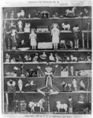  Description: An advertisement for toys published around 1887  https://www.loc.gov/resource/cph.3b17079/?loclr=blogtea
Extra Source 3: Newspaper Ad for Toys, 1958  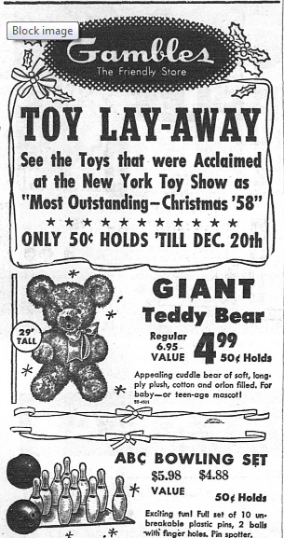  https://www.coloradohistoricnewspapers.org/cgi-bin/colorado?a=d&d=STP19581120.2.63.1&dliv=none&e=-------en-20--1--txt-txIN--------0- | Extra Source 4: Old Maid card game, 1930  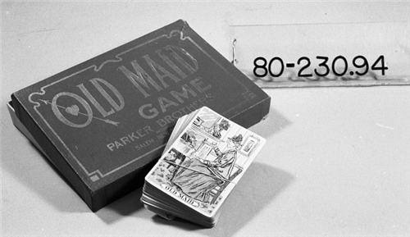  Description: Made by Parker Brothers  http://5008.sydneyplus.com/HistoryColorado_ArgusNet_Final/ViewRecord.aspx?template=Object&record=48a09444-ae8d-4a11-8325-db388336a185&displayFields=Attachment&lang=en-US
Extra Source 5: Whirling Disk, 17th century  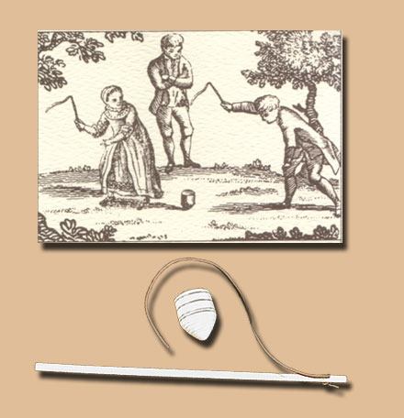  Description: A whip top that first appeared in English literature as early as 1686. It was often called a whirling disk because of the sound it made when spinning.  http://www.historylives.com/images/whiptop1.jpg | Extra Source 6: Ball and Cup, 17th century  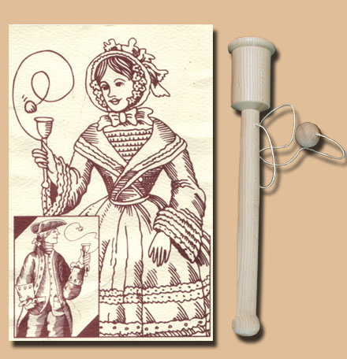  Description: A cup and ball top often called a Bilbo Catcher that was popular years before the English settled in North America.  http://www.historylives.com/images/cupball1.jpg

