Grade Level:
Elementary / 3 or 4

Essential Question:
Why did people from different cultures migrate and settle in Colorado?
Supporting Questions:
- How did the sugar beet industry support immigrants who moved to Colorado?
- What was life like for families that worked in the sugar beet fields?
- How has the technology of farming sugar beets changed over time?
- What was the economic impact of the sugar beet industry in Colorado?

Source 1  - Allison, J., photographer. (1938) Sugar beet worker. Colorado. [Image] Retrieved from the Library of Congress, https://www.loc.gov/item/fsa2000000575/PP/.  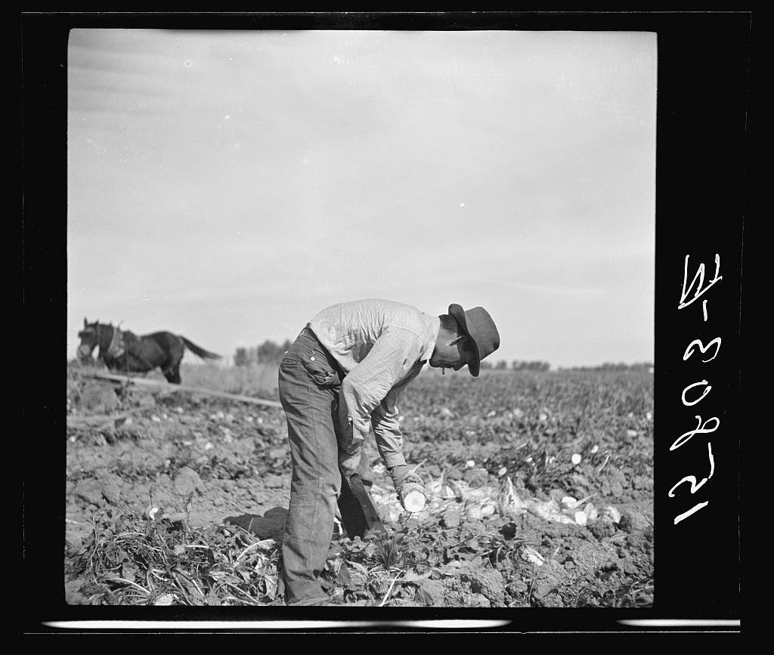 | Source 2  - Allison, J., photographer. (1938) Sugar beet workers' housing. Colorado. [Image] Retrieved from the Library of Congress, https://www.loc.gov/item/fsa2000000574/PP/.  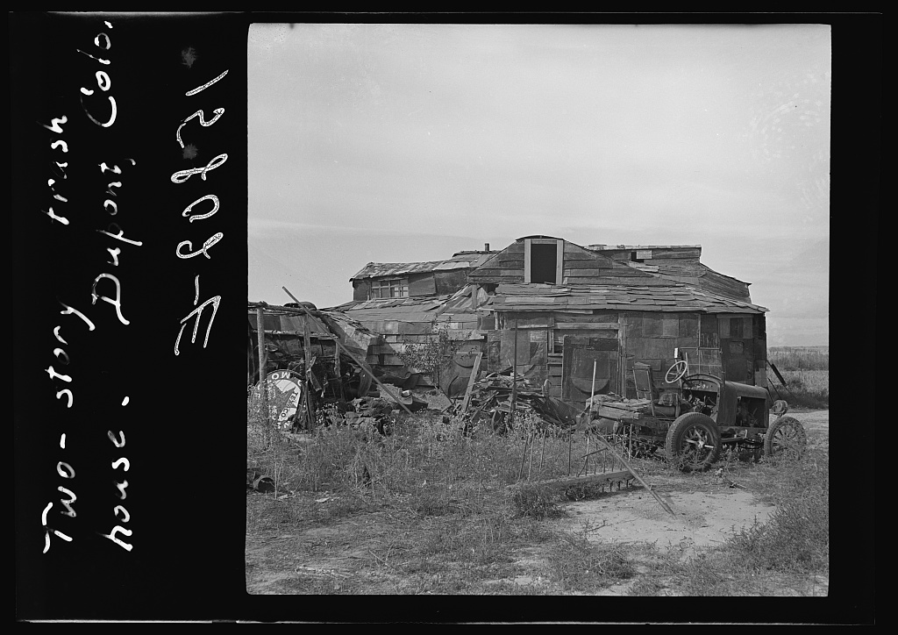

Background Knowledge / Contextual Paragraph for Teachers:
The Sugar Beet Industry - http://coloradoencyclopedia.org/article/sugar-beet-industry#page-title
A history of the Sugar Beet Industry in Colorado: http://lib.colostate.edu/archives/greatwestern/history.html
Another history of the Sugar Beet Industry in Colorado - from the Fort Collins Museum of Discovery http://history.fcgov.com/archive/ethnic/mex-beet.php
The Work of Making Sugar - http://coloradoencyclopedia.org/article/sugar-beet-industry#The-Work-of-Making-Sugar

Building Background Knowledge for the Student
In this lesson, students identify the relationship between resources, and the people who extract or cultivate them. Students will describe how this relationship can create population shifts, migration, and the establishment of different cultural traditions. Within these communities, resources, labor, and a sense of community are intrinsically tied together.

Strategy Instruction:
These are just a couple of the strategy ideas for using this primary source set

Sourcing asks students to consider who wrote a document as well as the circumstances of its creation. When sourcing a document, students should ask:
• Who wrote this?
• What is the author’s perspective?
• Why was it written?
• When was it written?
• Where was it written?
• Is this source reliable? Why? Why not?

Contextualization asks students to locate a document in time and place and to understand how these factors shape its content. When contextualizing a document, students should ask:
• When and where was the document created?
• What was different then?
• What was the same?
• How might the circumstances in which the document was created affect its content?

Corroboration asks students to consider details across multiple sources to determine points of agreement and disagreement. When corroborating documents, students should ask:
• What do other sources say?
• Do the sources agree? If not, why?
• What are other possible sources?
• What sources are most reliable? Why?

What do other pieces of evidence say? • Am I finding the same information everywhere? • Am I finding different versions of the story? (If yes, why might that be?) • Where else could I look to find out about this? • What pieces of evidence are most believable?

Strategy Instruction Differentiation:
Students may work with a partner to complete any of the suggested activities in this lesson ideas document.

Discussion:
See questions above in the “Strategy Instruction” section
Assessment:
Students complete the “What’s the Story” activity and then write a short story based on the “story” depicted in the sources.

Curriculum Standards:
- CO Standard 1 - History
  - 3rd Grade → 3.1.1.c - Compare information from multiple sources recounting the same event
  - 3rd Grade → 3.1.2.d - Describe the history, interaction, and contribution of the various peoples and cultures that have lived in or migrated to a community or region
  - 4th Grade → 4.1.1.b - Analyze primary source historical accounts related to Colorado history to understand cause and effect relationships
  - 4th Grade → 4.1.1.d - Identify and describe how major political and cultural groups have affected the development of the region.
- CO Standard 2 - Geography
  - 3rd Grade → 3.2.1.a - Read and interpret information from geographic tools and formulate geographic questions
  - 3rd Grade → 3.2.2.b - Identify the factors that make a region unique including cultural diversity, industry and agriculture, and land forms
  - 4th Grade → 4.2.1.a - Answer questions about Colorado regions using maps and other geographic tools
  - 4th Grade → 4.2.2.d - Describe how places in Colorado are connected by movement of goods and services and technology
- CO Standard 3 - Economics:
  - 3rd Grade → 3.3.1.a - Describe the difference between producers and consumers and explain how they need each other
  - 4th Grade → 4.3.1.b - Give examples of the kinds of goods and services produced in Colorado in different historical periods and their connection to economic incentives

Reading and Writing Standards:
- CO Standard 2 - Reading for All Purposes
  - 3rd Grade → 3.2.1.a.i - Ask and answer questions to demonstrate understanding of a text, referring explicitly to the text as the basis for the answers. (CCSS: RI.3.1)
  - 3rd Grade → 3.2.2c.i - Use information gained from illustrations (e.g., maps, photographs) and the words in a text to demonstrate understanding of the text (e.g., where, when, why, and how key events occur). (CCSS: RI.3.7)
  - 4th Grade → 4.2.1.a.i - Refer to details and examples in a text when explaining what the text says explicitly and when drawing inferences from the text. (CCSS: RL.4.1)
  - 4th Grade → 4.2.2.a.iii -Explain events, procedures, ideas, or concepts in a historical, scientific, or technical text, including what happened and why, based on specific information in the text. (CCSS: RI.4.3)

Sample Activities:
- Students may choose an image and create a caption for it.
- Students could select one source that they would like to research further to learn more about the place, person, or event depicted in the source.
- Students may write a short story about an individual depicted in an image.
- Questions/Ideas for the sugar beet production & processing plant data sets (Extra sources 8 and 10):
  - What information is provided in these charts?
  - Students may use the data to create a bar graph or other visual display to describe the data.
  - Do you see any patterns in the data?
  - From a producer’s perspective, why would production change from year to year and decade to decade?
  - From a consumer’s perspective, why would consumption of an agricultural product change from year to year?
  - What conclusions can you draw about sugar beet production over the past 120 years?

Extra Source 1  - Rothstein, A., photographer. (1939) Sugar beets. Adams County, Colorado. Oct. [Image] Retrieved from the Library of Congress, https://www.loc.gov/item/fsa2000010107/PP/  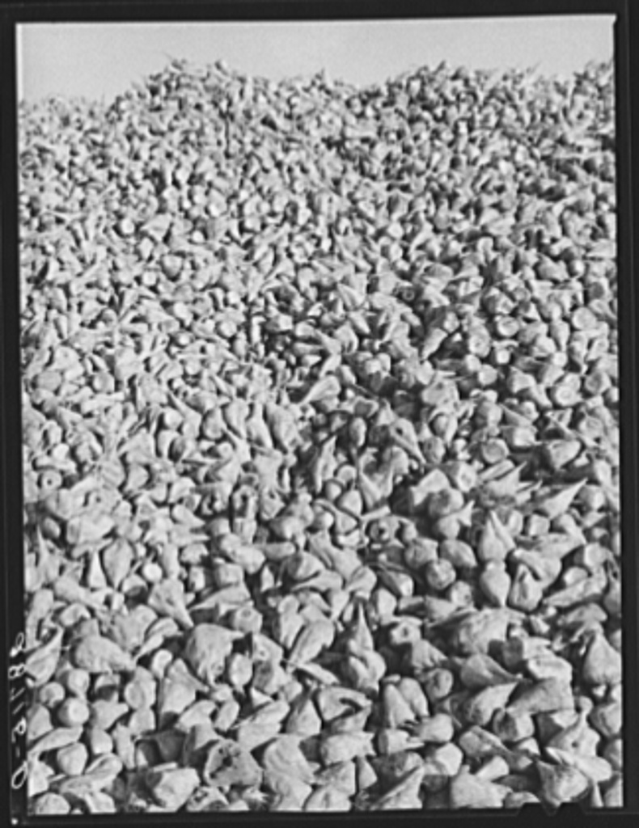 | Extra Source 2  - Rothstein, A., photographer. (1939) Spanish-American woman topping sugar beets, Adams County, Colorado. Nov. [Image] Retrieved from the Library of Congress, https://www.loc.gov/item/fsa1997012673/PP/  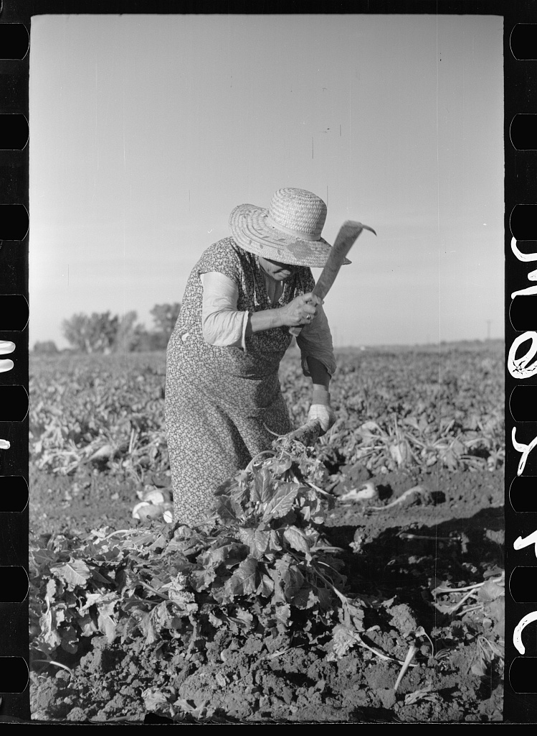
Extra Source 3  - Rothstein, A., photographer. (1939) Farmer's truck driving into scale house at sugar beet dump. Adams County, Colorado. Oct. [Image] Retrieved from the Library of Congress, https://www.loc.gov/item/fsa2000010066/PP/  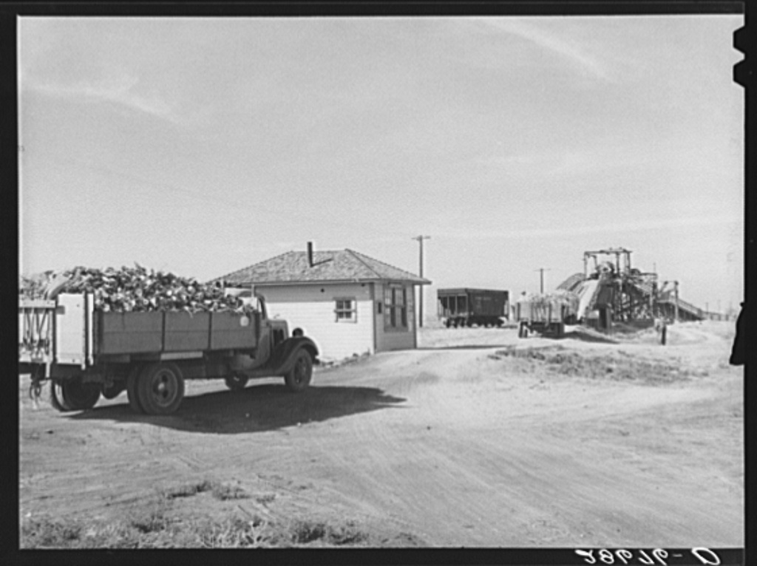 | Extra Source 4  - Rothstein, A., photographer. (1939) [Untitled photo, possibly related to: Topping sugar beets, Adams County, Colorado]. [Nov] [Image] Retrieved from the Library of Congress, https://www.loc.gov/item/fsa1997012675/PP/  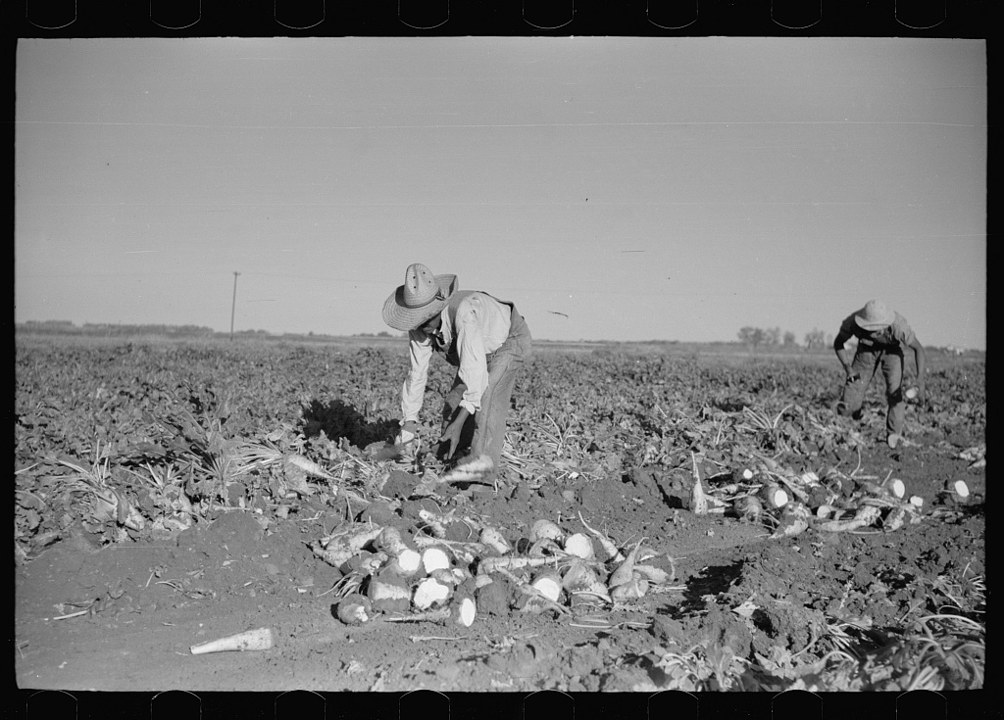
Extra Source 5  CHILDREN IN SUGAR BEET FIELDS  "Here was a farm chores seemingly designed exactly for us. Every June for years to come was devoted to the thinning of sugar beets. The timing was correct for parents who valued the schools and would not keep their chidden out on the slightest excuse. By the time the green rows were large enough for thinning, school was over and the long summer holiday had begun."  Source: Clara H. Ehrlich, "My Childhood on the Prairie," Colorado Magazine, 51 (1974): 2. http://hewit.unco.edu/dohist/teachers/plans/farmers/farmpack.doc | Extra Source 6  DELIVERING SUGAR BEETS TO THE FACTORY  “[Farmers] would come in with their wagons, their trucks, weigh the trucks full, dump their [sugar] beets in a hopper. There was a funneled hopper. It had a belt, and it would take [the sugar beets] up to the top of the little house on the top where they would be screened. The beets would go out the side and drop into a railroad car. . . . Then all the dirt that was on ‘em would fall in another little hopper underneath this building, so when you dumped your beets you waited till they went up the belt, over the screen into the car, and then you pulled underneath this little building, pulled another lever and you got your dirt back. . . . All you were selling was the beets!”  Source: Charles Waneka quoted in Maria M. Rogers, ed., In Other Words: Oral Histories of the Colorado Frontier (Golden, CO: Fulcrum Publishing, 1996): 26. http://hewit.unco.edu/dohist/teachers/plans/farmers/farmpack.doc  A few questions to ask about this source:  - What do you think a hopper is?  - Why do you think it’s called a hopper?  - Why would the farmers want their dirt back?
Extra Source 7  The U.S. Sugar beet and Corn Industry  - Source: This map was created from a map distributed by the American Sugar Alliance  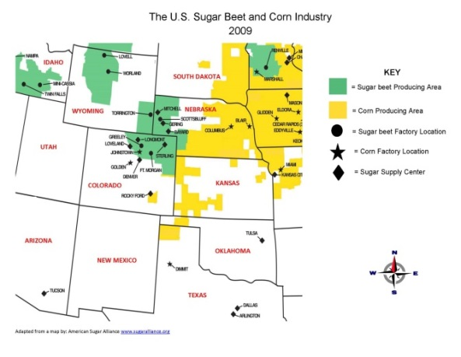  https://drive.google.com/file/d/0B0igz4Gubvy9bUJrRlZYWi1uREU/view?usp=sharing | Extra Source 8  Production Data Set Illustrating the Rise and Decline of the Sugar Beet Industry in Weld County  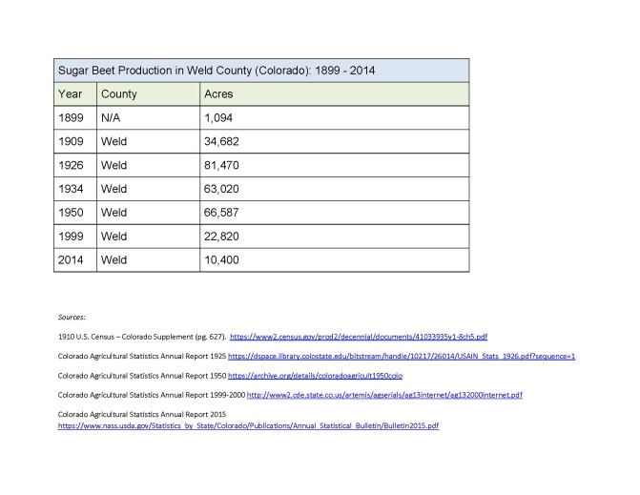  https://drive.google.com/file/d/0B0igz4Gubvy9b2stNTJBbDRsUEk/view?usp=sharing
Extra Source 9  A Sugar Beet  - Source: http://longmontian.blogspot.com/2009/01/loveland-colorado-sugar-factory.html  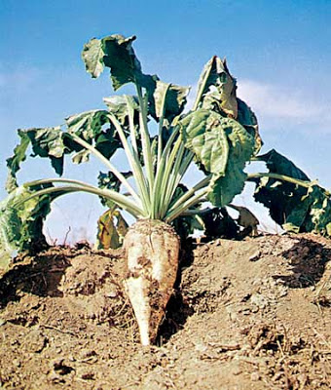 | Extra Source 10  Sugar Beet Processing Plant Openings and Closings  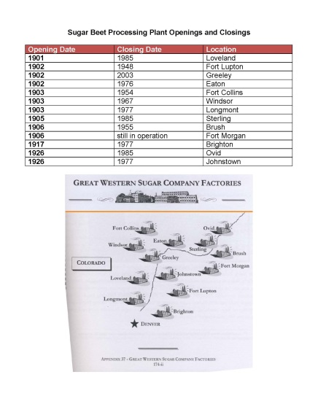  https://drive.google.com/file/d/0B0igz4Gubvy9Q0pSQnZTSHRfRmc/view?usp=sharing

