Grade Level:
Elementary / 3 or 4

Essential Question:
- What are the stories of the Spanish speaking peoples in the West?

Supporting Questions:
- What was the role of the Hispanos in the San Luis Valley in developing Colorado?
- How is history made?
- How does perspective influence the stories of history?
- How do historians build stories of the past?

Source #1  Trujillo House before preservation  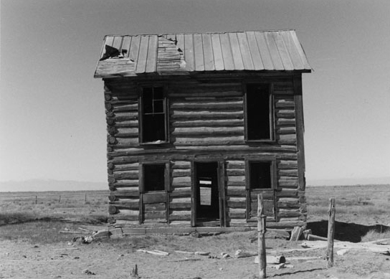  https://www.historycolorado.org/location/trujillo-homestead | Source #2  Pedro Trujillo on horseback  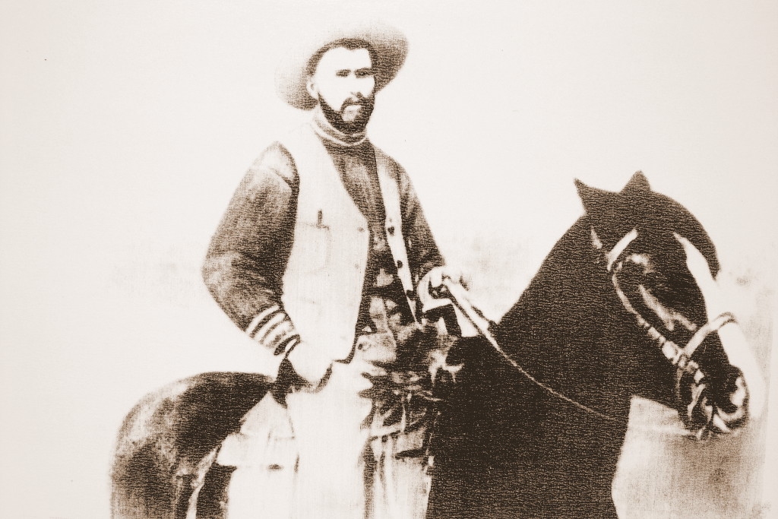  https://www.historycolorado.org/story/preservation/2015/06/08/privately-funded-preservation

Source #3  Trujillo House after preservation  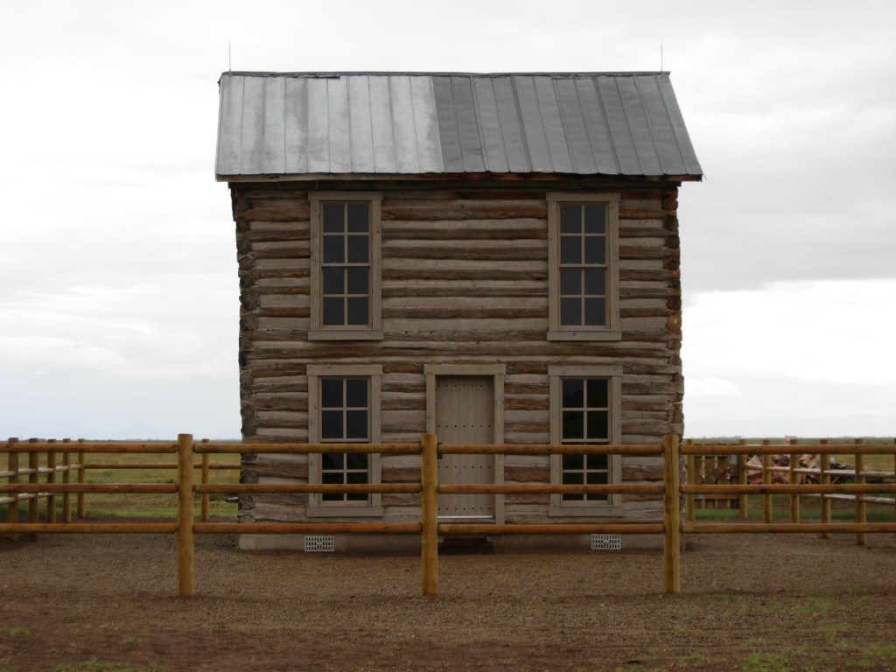  https://www.historycolorado.org/story/preservation/2015/06/08/privately-funded-preservation | Source #4  Colorado Transcript Newspaper, Jan. 29, 1902  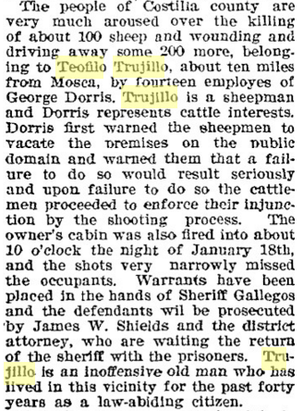  Describes the Trujillo event where white ranchers destroyed their property showing the bullying occurring in the area.  https://www.coloradohistoricnewspapers.org/cgi-bin/colorado?a=d&d=CTR19020129.2.21&dliv=none&e=-------en-20--1-byDA-img-txIN-Teofilo+Trujillo-------0-
Source #5  Political map of the San Luis Valley and Surrounding Area  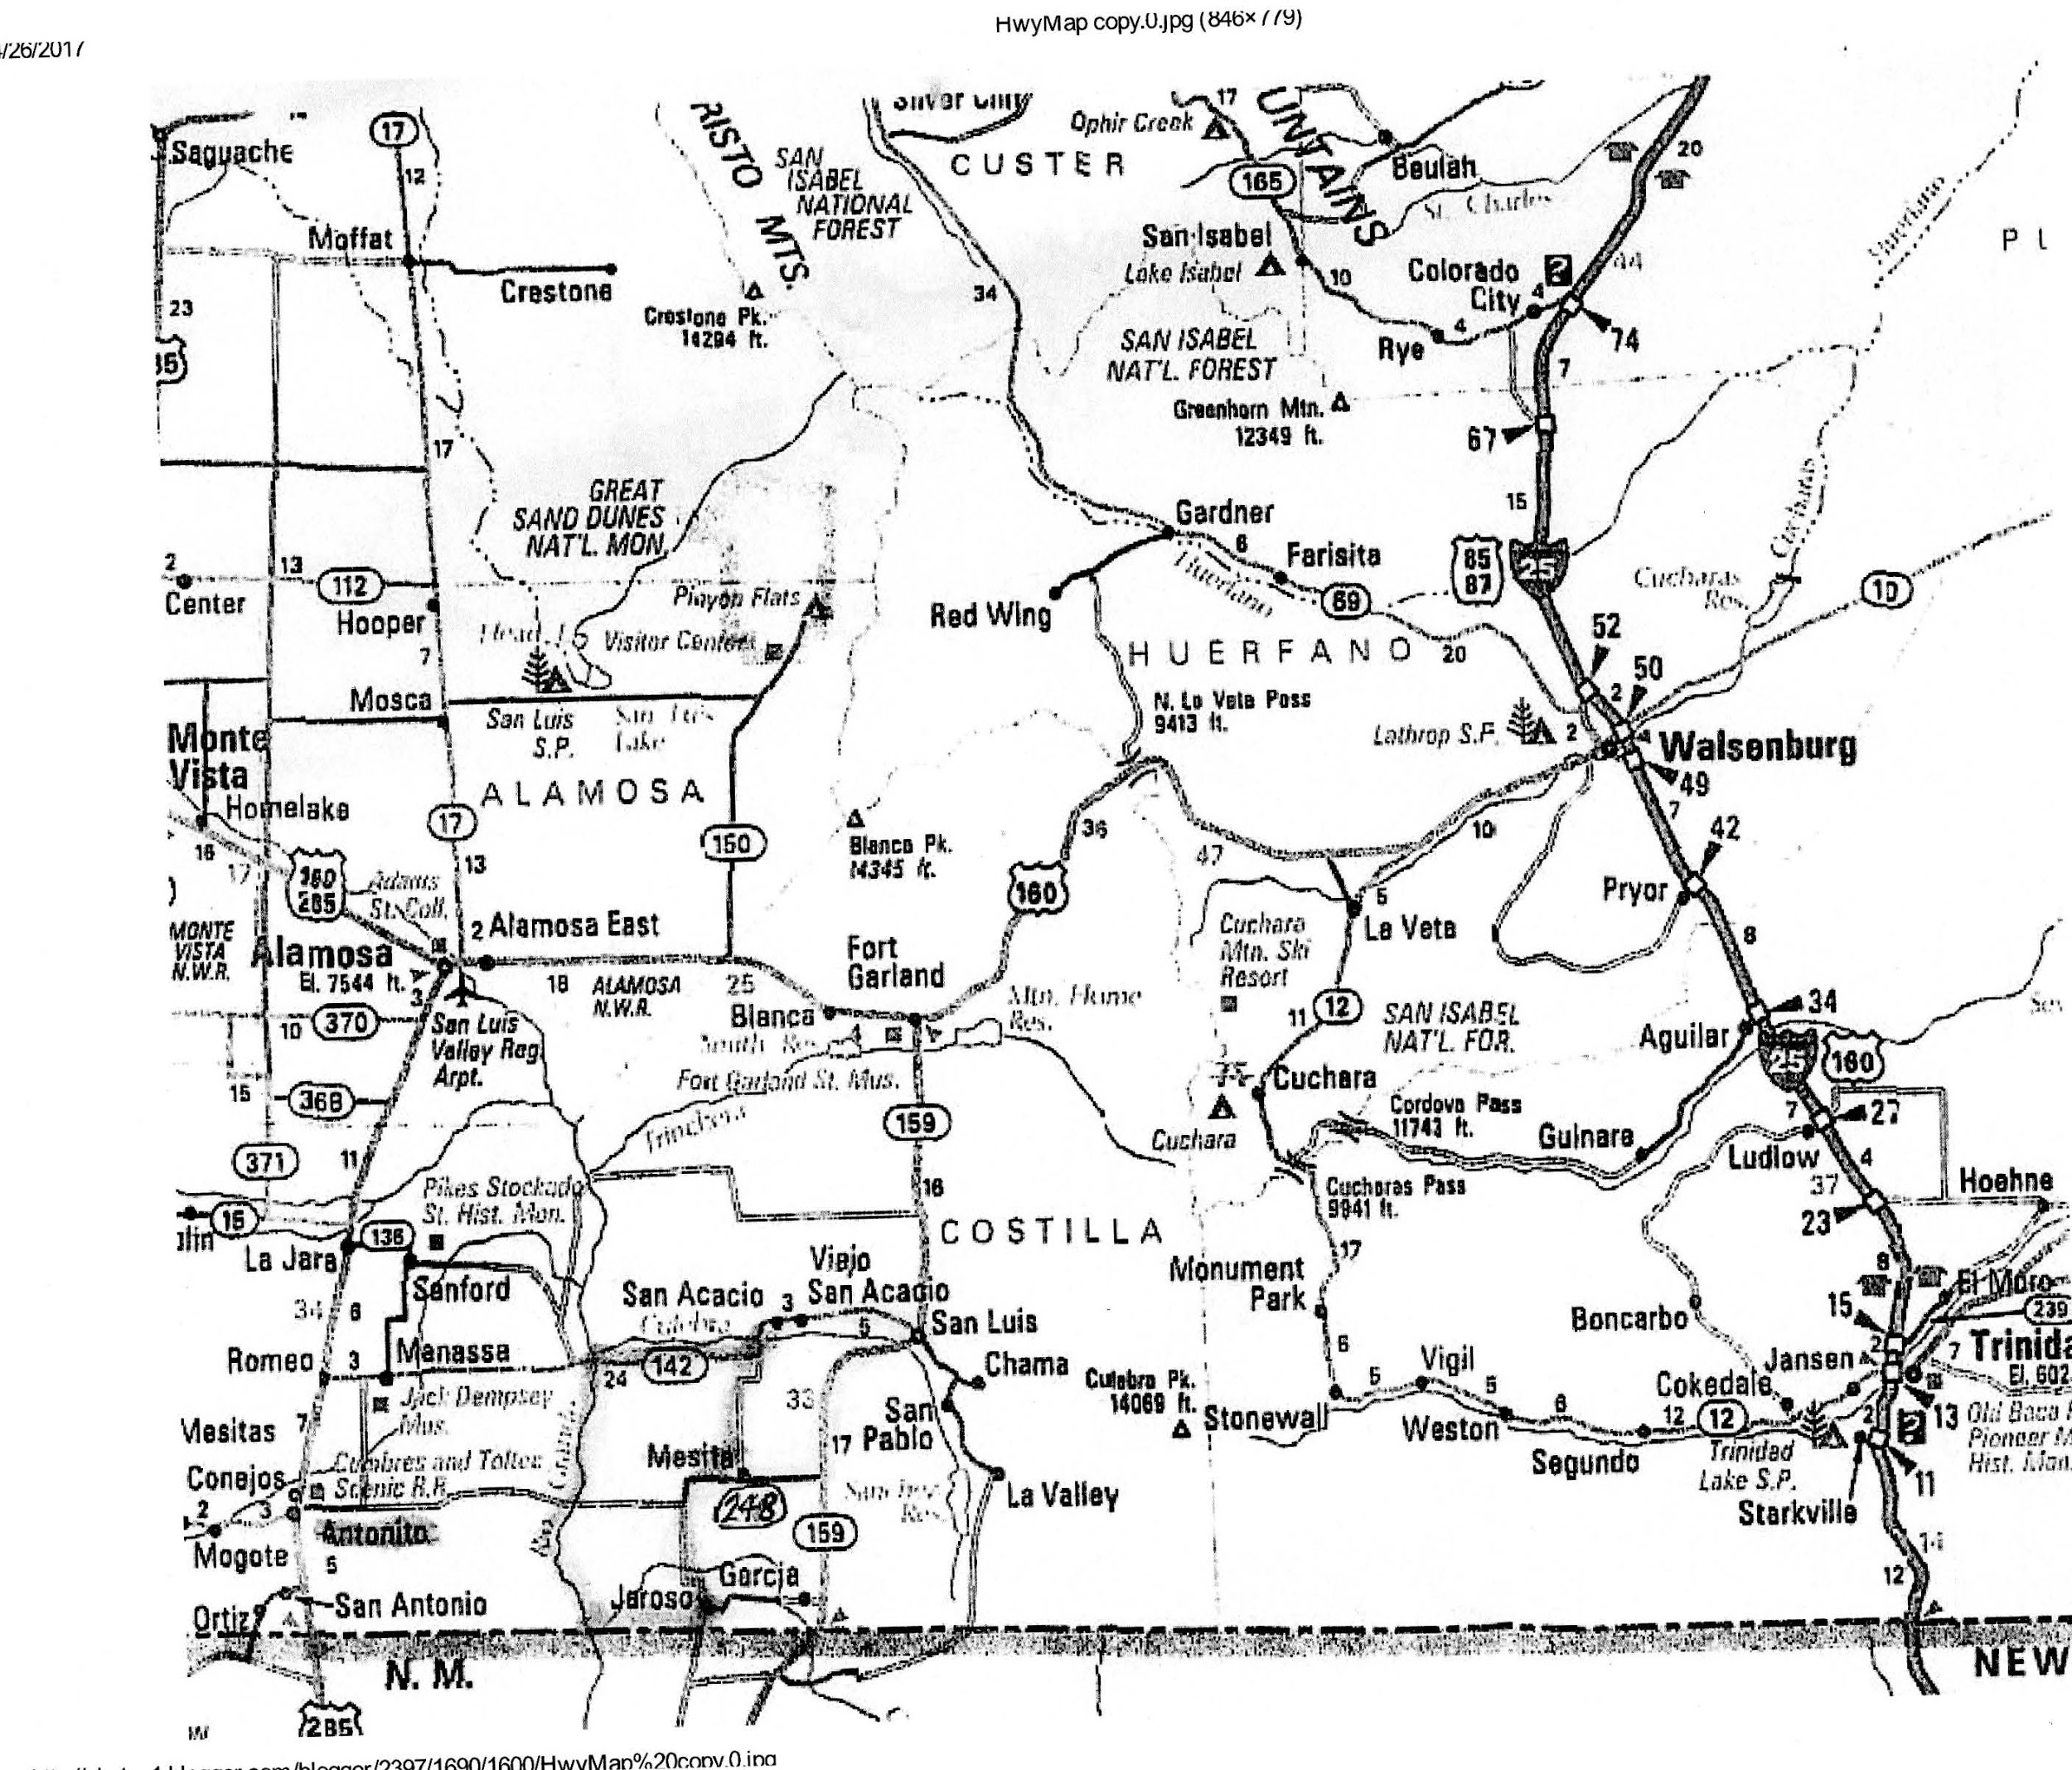  http://photos1.blogger.com/blogger/2397/1690/1600/HwyMap%20copy.0.jpg | Source #6  Map Illustrating the Political Changes to the San Luis Valley (Colorado)  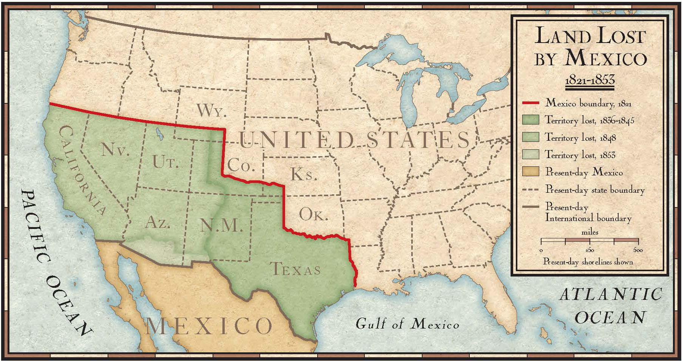  https://media.nationalgeographic.org/assets/photos/000/315/31517.jpg
Source # 7  Teofilo Trujillo  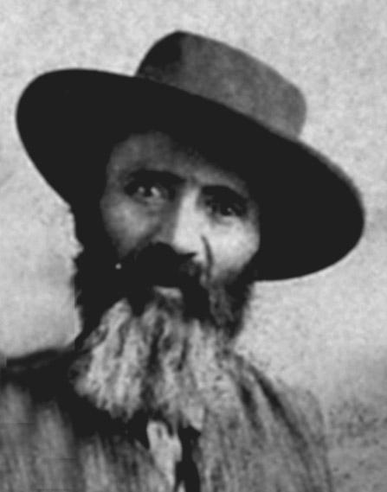  https://www.nps.gov/grsa/learn/historyculture/trujillo-homesteads.htm | Source #8  Video: Descendants of Teofilo and Pedro Trujillo share stories and thoughts about their family's history  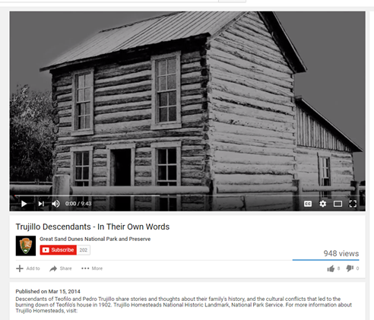  https://www.youtube.com/watch?v=xSqRryu57IQ&feature=youtu.be
Source #9  Maps Illustrating the Changes to Ute Territory in Colorado  Original Ute Territory  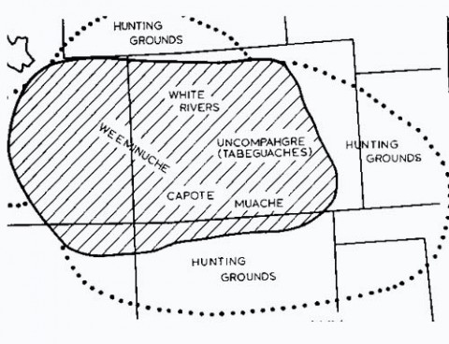  Ute Lands - 1868  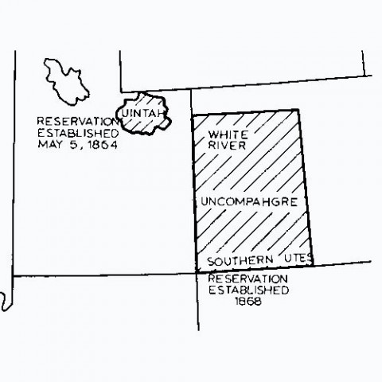  Ute Lands 1873  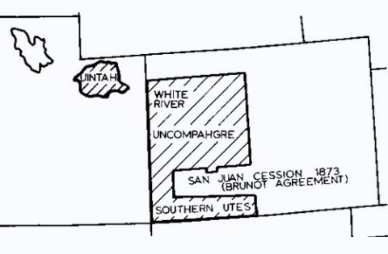  Ute Lands - Present Day  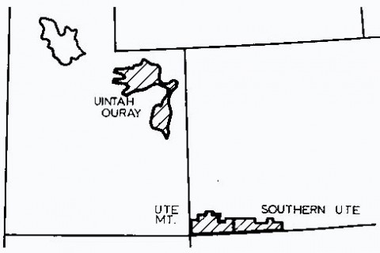  https://www.southernute-nsn.gov/history/chronology/ | Source #10  The Colorado Experience: The San Luis Valley (30 min video)  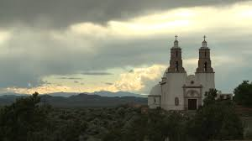  http://video.rmpbs.org/video/2365603249/

Background Knowledge / Contextual Paragraph for Teachers:
The period from 1851-1878 can be referred to as the Formative Period. This was a period of early migration of Hispanos. This period was influenced heavily by the presence of the United States military. In 1852, the U.S. Army built Fort Massachusetts. Then in 1856 the army relocated the fort to a larger compound that was closer to the villages. This was called Fort Garland. The military presence at this time helped bring a peace between settlers and Ute, which eventually led to a military treaty that moved the tribe to western Colorado (1868) by giving them 33,000, land on the Western slope and western Utah, and livestock. The military presence also affected the economy as settlers were able to move from a bartering economy of trading goods to a cash economy. Many settlers began selling agricultural surpluses to the fort and early mining camps. The fort also brought protection for Hispanos from Native American tribes, especially the Utes. And once the Ute were no longer a threat the homes changed in the following ways:
- Window openings were added
- Gates to plaza were no longer needed
- Personalized the front entrances to their jacals by adding patio or enclosed fence-like adobe wall 4-5 ft. tall called a tapia
- Wall thickness decreased to 16 inches
- Homes began to be built outside of a plaza. Corrilleras were houses and farms on opposite sides of the road.

Gwinn Harris Heap wrote this down when he was on a reconnaissance mission to locate railroad routes through San Luis Valley in 1853. (p. 14) “Numerous farms [are] skillfully irrigated [with] corn, wheat, oats, and other usual crops of a New Mexican farm.” “lambs, kids, pigs […] and numerous herds of cattle and horses.” A variety of crops were grown in the San Luis Valley including the following:
  - Frijol bolita (beans), havas (fava beans), maiz blanco white corn), cebolla (onions), aberjon (field peas), and calabaza (pumpkins)
  - Potatoes, lentils, and chili was also grown by families and considered subsistence crops or farming.
  - Staple food supply was chicas (white corn) that was smoked, husked, sundried for a week, and kernels removed from the cob and cooked. This was eaten throughout the year like frijol (beans).
  - Manazana de agosto (apples) and ciruelo de indio (plums) were carried from Taos and were adapted to this climate to grow.

Other sources of food included the gathering of verdolagas (pinon nuts), champe (rosehip), capulin (choke cherry), and garembullo (gooseberry) usually by the women. Many settlers dried herbs, vegetables, and meats in dispensas (outbuildings), soterranos (adobe cellars), or Granados (granaries).

Settlers used hand mills (manos) to grind corn. However, once a village was established they used gristmills near rivers. Carlos Beaubien built a flourmill in San Luis helping to establish it as a village. Ceran St. Vrain was a flour contractor for the military and he helped modernize the flourmill in San Luis in 1859. This allowed him to deliver over 1000 lbs. of flour to Auraria and to the Denver gold fields. All of this led to growing wheat for profit.

According to the 1860 census data collected, by 1860 96% of the settlers had Spanish surnames. Most of these settlers were farmers or herders. Other occupations included hunters, blacksmiths, silversmiths, shoemakers, millers, millstone makers, adobe masons, carpenters, masons, and fiddlers. Peons or servants were indicated on the census demonstrating that Hispanos did have indentured laborers (approximately 65 between 1858-1860 raised in Hispanos households in Costilla County).

The period from 1879-1918 can be referred to as the Railroad Period. During this time the railroad came and brought manufactured goods and eastern emigrants with differing cultures to the area. The railroad connected Denver and Pueblo to Fort Garland in 1878, which was about 16 miles north of San Luis. The railroad also helped sheep herders earn a profit because for the first time they could easily and cheaply get their wool to market and make a profit off of it. So the wool production offset the cost of raising sheep with the introduction of the railroad to the San Luis Valley.

SOURCE: http://www.historycolorado.org/sites/default/files/files/OAHP/crforms_edumat/pdfs/614.pdf

The building of adobe homes required the following steps:
- Adoberos (adobe masons) mixed clay, sand, water, and straw together into a stiff mud and then poured it into rectangular wooden forms. They thin dried them in the sun and wind for two weeks.
- Simple foundation created from rocks firmly packed into the earth.
- Adobe bricks stacked with mud used as mortar
- A thick clay was applied as a smooth plaster-like finish.
- Wooden frames were inserted to create door and window frames.
- Pergamino (translucent sheep membrane) was sometimes stretched around window openings to bring light into the interior.
- Latillas (thin sticks) were laid in a pattern across the ceiling to create a roof. Then earth was filled in.
- Jergas (animal hides and woven cloth rugs) were put on the floors.
SOURCE: http://www.historycolorado.org/sites/default/files/files/OAHP/crforms_edumat/pdfs/614.pdf

The Pedro Trujillo Homestead
In 1866 Pedro Trujillo’s father established a homestead on the range west of the Great Sand Dunes National Park and soon became one of the most prosperous homesteaders in the county. He had seven children, but only one, Pedro, survived to adulthood. At age 13, Pedro moved about three quarters of a mile from his father’s homestead to stake his own 160-acre claim, and in 1885 he married. The main portion of his house probably dates from that time. Instead of the adobe structure typical of Hispanic homesteaders, Pedro erected a two-story Anglo-American style log home with great mullioned windows facing out over the sand dunes. He and his wife raised nine children in the house.
In 1902 Pedro’s father’s house was burned to the ground. The elder Trujillo had begun to raise sheep in recent years and got caught in a range war then flaring across the valley. Pedro wasn’t a sheep man himself—he raised cattle and horses—but as the perpetrators of violence (even murder) were charged in nearby locales and exonerated by juries of their peers, it became clear that Hispanic homesteaders would receive no protection from the powerful Anglo cattlemen. So Pedro and his father resettled elsewhere in the valley.

The old Medano Ranch headquarters, some distance away, was a hub of activity at the dawn of the 20th century. Raised wooden sidewalks connected a maze of barns, bunkhouses, and other log structures, including a post office. Many of the buildings originally belonged to homesteaders who had failed or were otherwise driven from their land. Their structures were then dragged to the ranch headquarters. Only the Trujillo house was left in its original setting. Did the ranch owners find it advantageous to station a hand out there? Was the striking beauty of the homestead a factor? Whatever the reason, Pedro’s house remains, today, a singular example of Hispanic homesteading and the last vestige of that historic range war.

Building Background Knowledge for the Student
Introduce students to the concept of perspective using the SHEG Lunchroom Fight simulation. In this scenario, a fight breaks out in the lunchroom and the principal needs to figure out who started it. But when she asks witnesses what they saw, she hears conflicting accounts. Why might these accounts differ? As students wrestle with this question, they will hone the ability to reconcile conflicting claims, consider multiple perspectives and evaluate the reliability of sources.

Strategy Instruction:
- Introduce students to the geography of the San Luis Valley using various types of maps, including, political, county, changes to the San Luis Valley region, changes to Ute territory, and place names.
- Google Map “journey” to the San Luis Valley to show students what the valley looks like. This gives students a visual context for the great expanse of the valley and its significance as a farming and ranching region of Colorado.
- Presentation of the historical development of the San Luis Valley (Supplemental Material #1)
- Use the photographs and newspaper excerpts to construct the Trujillo family’s past
  - Students use visual literacy skills to analyze the primary sources on the Trujillo family.
- Develop questions for family interviews

Strategy Instruction Differentiation:
Throughout the activities in this primary source set, students can be working in pairs and groups to complete the tasks.

Discussion:
How is history made?
What are the stories of the Spanish-speaking people in the west?
What is the story of the people who lived on the land?
What happened in the San Luis Valley?
Whose story is being told?
How do we know we have the “whole” story? (perspective)
How do you think the geography helps historians tell the story?

Assessment:
What’s Your Story? The Aurora History Museum has asked for your help in developing the stories of the families in your community. As a historian, you are tasked with building the story of your family. You will need to interview family members, collect photographs and artifacts, and any other items that help you to tell the story of your family.
How will you tell the story of your family? You may choose one of the following options: a historical paper, a museum exhibit, a documentary, a play, or a website.
https://www.youtube.com/watch?v=xSqRryu57IQ&feature=youtu.be This YouTube video has the family talking about their history at the historic site of Pedro Trujillo’s home in 2014. It may be a great video to show before students tell their own family history.

Colorado Academic Standards - Social Studies :
- CO Standard 1 - History
  - 3rd Grade → 3.1.1.c - Compare information from multiple sources recounting the same event
  - 3rd Grade → 3.1.2.d - Describe the history, interaction, and contribution of the various peoples and cultures that have lived in or migrated to a community or region
  - 4th Grade → 4.1.1.b - Analyze primary source historical accounts related to Colorado history to understand cause and effect relationships
  - 4th Grade → 4.1.1.d - Identify and describe how major political and cultural groups have affected the development of the region.
- CO Standard 2 - Geography
  - 3rd Grade → 3.2.1.a - Read and interpret information from geographic tools and formulate geographic questions
  - 3rd Grade → 3.2.2.b - Identify the factors that make a region unique including cultural diversity, industry and agriculture, and land forms
  - 4th Grade → 4.2.1.a - Answer questions about Colorado regions using maps and other geographic tools
  - 4th Grade → 4.2.2.d - Describe how places in Colorado are connected by movement of goods and services and technology

Colorado Academic Standards - Reading, Writing, Communicating:
- CO Standard 2 - Reading for All Purposes
  - 3rd Grade → 3.2.1.a.i - Ask and answer questions to demonstrate understanding of a text, referring explicitly to the text as the basis for the answers. (CCSS: RI.3.1)
  - 3rd Grade → 3.2.2c.i - Use information gained from illustrations (e.g., maps, photographs) and the words in a text to demonstrate understanding of the text (e.g., where, when, why, and how key events occur). (CCSS: RI.3.7)
  - 4th Grade → 4.2.1.a.i - Refer to details and examples in a text when explaining what the text says explicitly and when drawing inferences from the text. (CCSS: RL.4.1)
  - 4th Grade → 4.2.2.a.iii -Explain events, procedures, ideas, or concepts in a historical, scientific, or technical text, including what happened and why, based on specific information in the text. (CCSS: RI.4.3)

Sample Activities:
- Highlight Spanish place names on the map (Source #5)
- What do you notice about the names on this map of the San Luis Valley?
- Why do you think there are so many Spanish names on the map?
2. Create a timeline of the changes to the Valley
3. Using the Photograph Analysis Worksheet, introduce students to the Trujillo family - the photographs in this set to construct a story of the Trujillo family’s past.
4. Interview family members to construct their own history.

Extra Source #1  Interview with Pete Trujillo  Alamosa in the Earliest Boom Days by C. E. Gibson Jr. CWA Pioneers Interviews done in 1933-1934. Transcribed interview with Pete Trujillo who at the time was bed-ridden and had been for four years and was very deaf. He recalled information and what he couldn’t his son (grandson to Teo) recalled for him—Fred Trujillo.  Retyped version of p. 35-37 of above document:  In 1864, Teofilo Trujillo came up from Taos, and bought a small place near San Pablo. He lived here a year and married, buying in 1865 from George Crist, a place known as ‘Rancho de los Ojitos’, about nine miles northwest of Fort Garland. From here the Trujillo family moved to Medano Springs, being the first to locate in that part of the country, and here Pedro was born in the latter part of 1866.  As a boy he herded his father’s cattle, and many was the time, that spying an approaching dust cloud, he and his small helper ran and hid among the big chicos.  In those first years, a dust meant Indians, and though the boys were never harmed, the Indians always arrogantly helped themselves from the herd to what beef they wanted. Occasionally they stopped at the ranch and took anything they fancied, as Teofilo, the lone settler, did not dare to antagonize them.  The whole country was a favorite hunting ground of the Indians, and still is one of the most fertile fields for arrow-head hunters. Pete and the other boys used to visit places where the Indians had camped, and he said they always had their pockets full of arrow and spear points…For years Teofilo raised cattle, having a herd of about eight hundred head, which grazed in the natural meadows and vegas around the lakes. Major Lafayette Head’s main cow camp was south of the big lake, and in the early 70s, the Dickey Brothers located at the site of the present Medano Ranch. These men were big operators, bringing in large herds of cattle form Texas which were grazed in the valley for a time and then taken on to market or driven to Leadville where the Dickeys owned a large meat market.  Salazar and Gallegos, two of San Luis’ prominent men, had cattle camps in the vicinity of the Trujillos and Juan Maria Lopez was their boss for fifteen years….As Teofilo prospered, he added a band of sheep to his holdings of cattle and horses, and trouble developed between him and his son Pete. The boy was extremely fond of horses, and was a wonderful horseman. His friends claim he could ride anything on four legs, and he says now that his years of bronco busting is probably the cause of his present crippled condition. Pete refused to become a sheep herder and argued with his father that the sheep would cause him trouble, as that had always been a cattle country.  Before he was of legal age, Pete filed on a homestead three-quarters of a mile west of his father’s place, and set up his own establishment, confining his efforts to the raising of horses and cattle.  True to the prophecy of his son, the surrounding cow-men objected to Teofilos [sic] bringing sheep into that country, and he was warned to get rid of them. He paid no attention to the threats, and one day during the absence of the family, the cowboys swooped down on the ranch and burned the buildings, and riding to the sheep camp well supplied with ammunition, they shot and killed or crippled over half of the band in plain sight of the herders. This culmination of the bad feeling which had been growing between Teofilo and the cattlemen either discouraged him or intimidated him, so that shortly after, he sold out and moved to San Luis. Pete also disposed of his holdings and moved to Monte Vista.  L.B. Sylvester was the buyer, and took over all the small ranches in that country, putting together a ranch which was the nucleus of the present huge Linger Bros., Medano-Zapato holdings.  CITATION: Trujillo, Pedro. Interview, Civil Works Administration. Charles E. Gibson, Jr., interviewer. 1933- 34. In the files of the Colorado Historical Society, Denver, Colorado.  http://www.historycolorado.org/sites/default/files/files/Researchers/CWAPioneerInterviews_349.16-30.pdf | Extra Source #2  Colorado Weekly Chieftan Newspaper, Oct. 18, 1877  Describes Dickey Bros. operation.  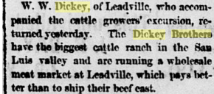  https://www.coloradohistoricnewspapers.org/cgi-bin/colorado?a=d&d=CCF18771018.2.47&dliv=none&e=-------en-20--1-byDA-img-txIN-Dickey+Brothers-------0-
Extra Source #3  Zapato Ranch Chuck Wagon.  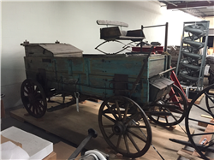  The Dickey Bros. joined their Medano Ranch to new areas of land (50,000 acres) and then renamed it the Zapata Ranch @ 1870.  http://5008.sydneyplus.com/HistoryColorado_ArgusNet_Final/Portal/Portal.aspx?component=BasicSearchResults&record=9521ae4f-d67b-42f6-b3a8-1b30c772cfb4 | Extra Source #4  Colorado Weekly Chieftan, April 3, 1879  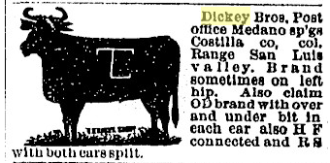  Shows cattle marks for the Dickey Bros. and other ranchers at the time.  https://www.coloradohistoricnewspapers.org/cgi-bin/colorado?a=d&d=CCF18790403.2.167&dliv=none&e=-------en-20--1-byDA-img-txIN-Dickey+Brothers-------0-
Extra Source #5  SOURCE: Gibson, C. E., Jr. Civil Works Administration Interviews. 1933- 34.  They told of an Indian attack which took place in 1855, in which Juan Angel Vigil and Ramon Martinez were killed and a small boy was stolen. The settlers gave chase, catching up with the Indians…The [Indian] who was carrying the child on his horse dropped him, and then whirled back and made a thrust at him with his spear. Luckily his aim was poor and the weapon only grazed the boy’s side. (p. 46).  In the files of the Colorado Historical Society, Denver, Colorado. *Gibsons reflection on his interviews.  http://www.historycolorado.org/sites/default/files/files/Researchers/CWAPioneerInterviews_349.16-30.pdf | Extra Source #6  SOURCE: Valdez, L. Interview, Civil Works Administration. Charles E. Gibson, Jr., interviewer. 1933- 34.  Luis was an Indian who was stolen on a raid into the Navajo country for the purpose of capturing slaves. He was born in 1854 and is owned by the Valdez family all his life. He herded sheep for Don Seledonio and the Indians bothered him.  They would hid in a willow thicket along a stream where the sheep were grazing, reach out within a long stick having a fork on the end of it, twist it into the wool of a sheep and draw it to their hiding place. Other times an Indian would come along to where Luiz was watching the flock and sit down for a visit. When Luiz returned to his camp he would find it had been rifled by unobserved companions of his affable conversationalist…another bothersome trick of the Indians was the digging of pits on the trails…The pits were covered with willows and a little dirt through which three or four unsuspecting sheep would fall. (p. 38)  In the files of the Colorado Historical Society, Denver, Colorado.  http://www.historycolorado.org/sites/default/files/files/Researchers/CWAPioneerInterviews_349.16-30.pdf
Extra Source #7  SOURCE: Gallegos, G., Valdez, J. C. L., Valdez, J. Interview, Civil Works Administration. Charles E. Gibson, Jr., interviewer. 1933- 34.  *This can be used to show the heritage of those that moved here (all of Spanish or Mexican descent).  A list of men who came and settled the country in 1852-1853  Antonio Jose Vallejos  Mariano Vallejos  Miguel Vallejos  Juan Miguel Vigil  Nacasio Gallegos  Antonio Vigil  Jose Anto. Martinez  Mariano Pacheco  Juan Ignacio Jacques  Juan Pacheco  Ricado Vigil  Salme Jacques  Desiderio Valencio  Juan Julian Martizez  Jose Maria Martinez  Juan Oeracio Jacquez  Jose Ilario Valdez  In the files of the Colorado Historical Society, Denver, CO.  http://www.historycolorado.org/sites/default/files/files/Researchers/CWAPioneerInterviews_349.16-30.pdf | Extra Source #8  SOURCE: Gibson, C. E., Jr. Civil Works Administration Interviews. 1933- 34. In the files of the Colorado Historical Society, Denver, Colorado. *Gibsons reflection on his interviews.  Alcario (10 years old) made an agreement with Teofilo Trujillo to herd sheep for a year in return for groceries for his mother. The sheep were taken early to the mountains, and during a severe March storm, wandered from the park where they were being pastured. After the storm Teofilo came to see the sheep and it took a couple of days to find them. He became angrey, and thought Alcario had stayed with his charges without food or shelter and was trying to bring them back to camp. He was given a sound whipping. He them told Teofilo that he would no longer work for him, but on learning that his mother had not received her supplies and would not, if he quit, he stayed on and finished his year.  http://www.historycolorado.org/sites/default/files/files/Researchers/CWAPioneerInterviews_349.16-30.pdf
Extra Source #9
The Trujillo family homestead by Joshua Pilkington La Voz Bilingue. Sept. 9, 2014.

“Our story is one of courage, trailblazers and how they had to deal with the greed of the Anglo against anyone who they could not compete with fairly…I grew up hearing the stories of the Trujillo valor, their challenges in being one of the first founding Spanish settlers in the state.” –Deborah Quintana, great-great granddaughter of Teofilo

http://www.lavozcolorado.com/detail.php?id=7720

