Grade Level:
Elementary /1

Essential Question:
Who are some notable (famous) people from Colorado?

Supporting Questions:
- What does it mean to be famous?
- Why are these people famous?

Source 1  Astronaut Scott Carpenter, 1964  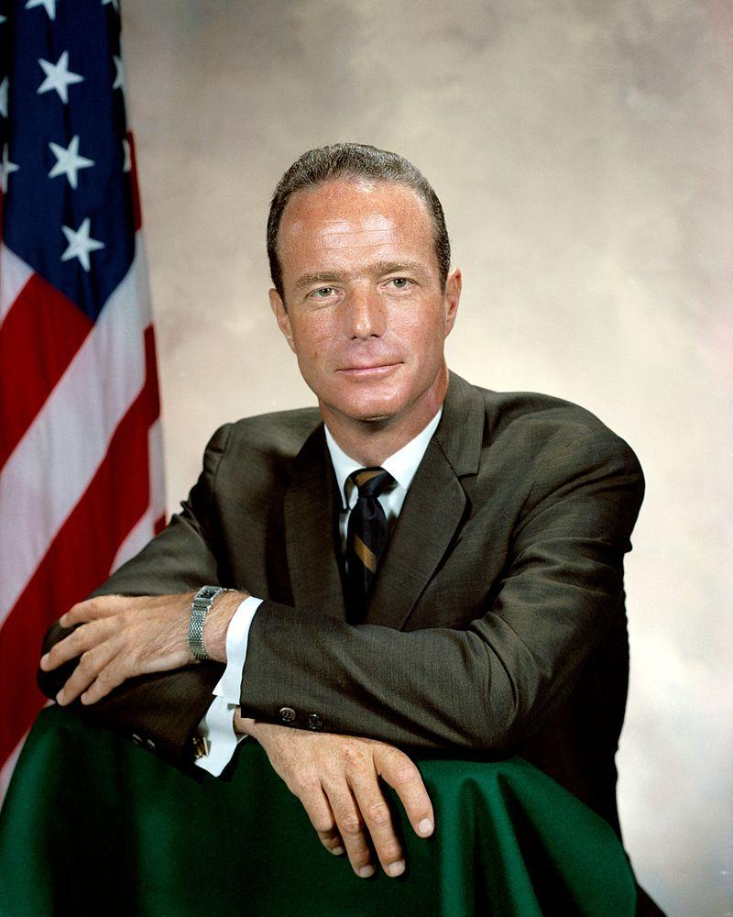  https://en.wikipedia.org/wiki/Scott_Carpenter#/media/File:MalcolmScottCarpenter.jpg | Source 2  Astronaut Scott Carpenter, 1962  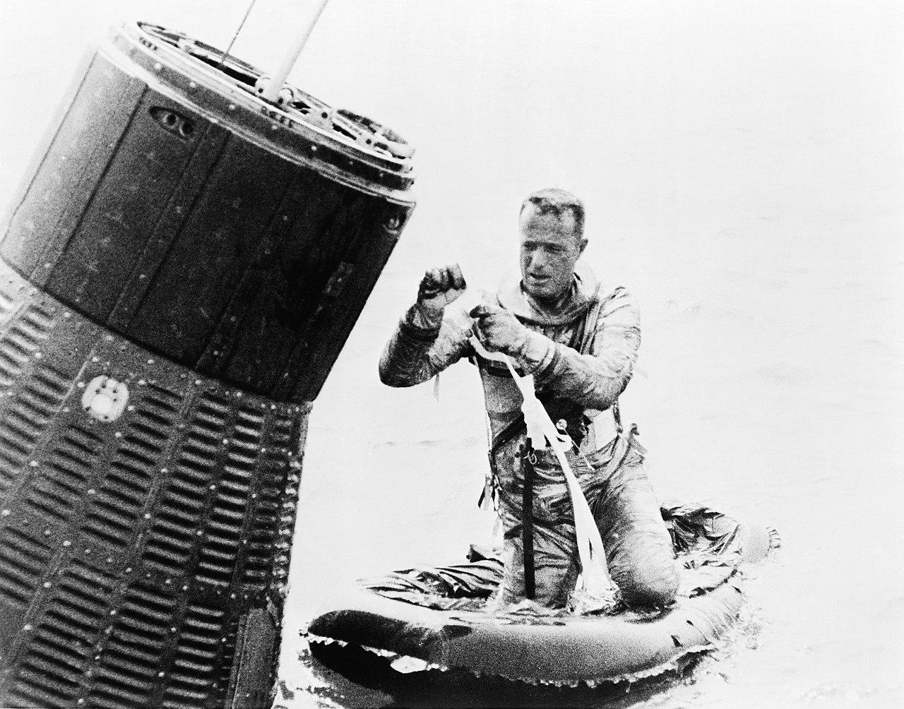  https://en.wikipedia.org/wiki/Scott_Carpenter#/media/File:Scott-Carpenter_recovery_NASA.jpg

Background Knowledge / Contextual Paragraph for Teachers:
- Scott Carpenter - https://www.jsc.nasa.gov/Bios/htmlbios/carpenter-ms.html
- Missy Franklin - https://www.biography.com/people/missy-franklin-20903291
- Ben Nighthorse Campbell - http://www.coloradovirtuallibrary.org/digital-colorado/colorado-histories/20th-century/ben-nighthorse-campbell/
- Rick “Goose” Gossage - https://sabr.org/bioproj/person/0871f3e2
- Honorable Christine M. Arguello - http://www.cogreatwomen.org/project/christine-marie-arguello/

Building Background Knowledge for the Student
- Post images of the 5 Coloradans in front of the class.
  - Ask: Do you know any of these people? If so, what do you know?
  - Is there any evidence in the pictures that might give you a clue as to what the person does (did) for a living?
  - If you could interview them, what questions might you ask?

Strategy Instruction:
- Read a biography such as the “Unsinkable” Molly Brown by Frances E. Ruffin.
- Ask students what they learned about Molly Brown (or whomever the biography is about).
- Have students choose 1 individual that they would like to learn more about (Students may decide they would like to learn about an individual that has not been discussed in class).
- Ask:
  - What do you want to know about that person?
  - Where might you find out more about that person?
- Distribute Biography Organizer worksheet for students to complete.

Strategy Instruction Differentiation:
Students may work in pairs to complete the biography organizer.
Students may be given a partially completed biography organizer.
Have students include a new vocabulary word in their biography.

Discussion:
- What is a biography?
- What makes a good biography?
- How do you decide what is “interesting” about your chosen person (to include in the biography)?
- What do you admire about the person you chose to write your biography on?

Assessment:
Students will research and complete a short biography of their chosen Coloradan.

Colorado Academic Standards ~ Social Studies:
- SS1. GLE 1. EOd. Use words related to time, sequence, and change.
- SS1. GLE2. EOc. Identify famous Americans from the past who have shown courageous leadership.

Reading and Writing Standards:
- RWC1. GLE 1 EOa. Describe people, places, things, and events with relevant details, expressing ideas and feelings clearly. (CCSS: SL.1.4)
- RWC1. GLE 1 EOc. Produce complete sentences when appropriate to task and situation. (CCSS: SL.1.6)
- RWC3. GLE 1. EOb. Write informative/explanatory texts in which they name a topic, supply some facts about the topic, and provide some sense of closure. (CCSS: W.1.2)
- RWC3. GLE 1. EOe. Use pictures or graphic organizers to plan writing.
- RWC4. GLE 1. EOb. With peers, use a variety of resources (direct observation, trade books, texts read aloud or viewed) to answer questions of interest through guided inquiry.

Sample Activities:
- Students may share what they learned about their notable Coloradan in a short presentation.
- Students may interview a family member about someone they are interested in and would like to know more about. Have parents work with their student to research more about a notable Coloradan.

Source 3  Missy Franklin, 2016  http://www.zwemza.com/?p=28781 | Source 4  Missy Franklin, 2016  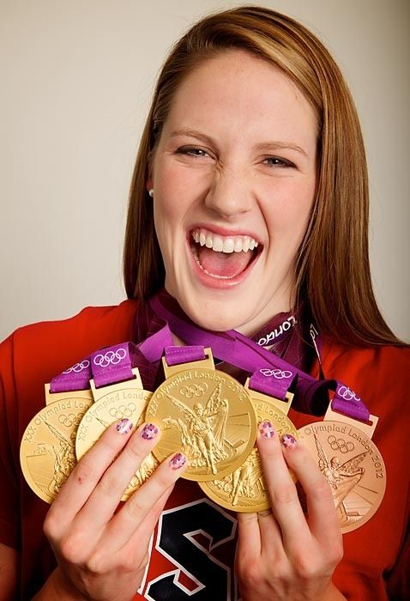  https://i.pinimg.com/736x/3c/d4/9f/3cd49fec5bdbf575feec6195f5086437--missy-franklin-olympic-swimmers.jpg
Source 5  Ben Nighthorse Campbell, Colorado Senator, n/d  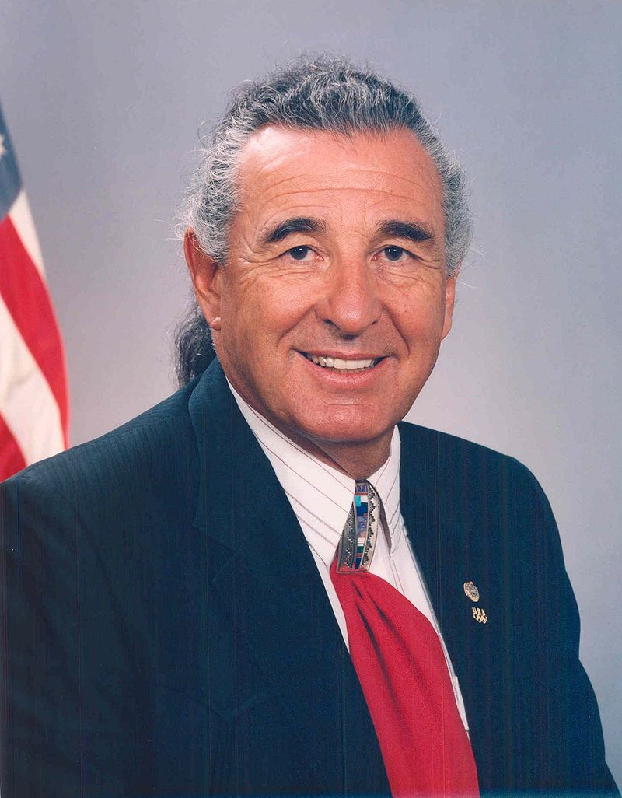  https://en.wikipedia.org/wiki/Ben_Nighthorse_Campbell#/media/File:BenNCampbell.jpg | Source 6  Ben Nighthorse Campbell, 2004  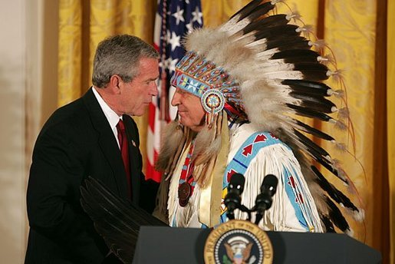  https://georgewbush-whitehouse.archives.gov/news/releases/2004/09/images/20040923-2_d092304-1-515h.html
Source 7  Richard “Goose” Gossage, Relief Pitcher, 2007  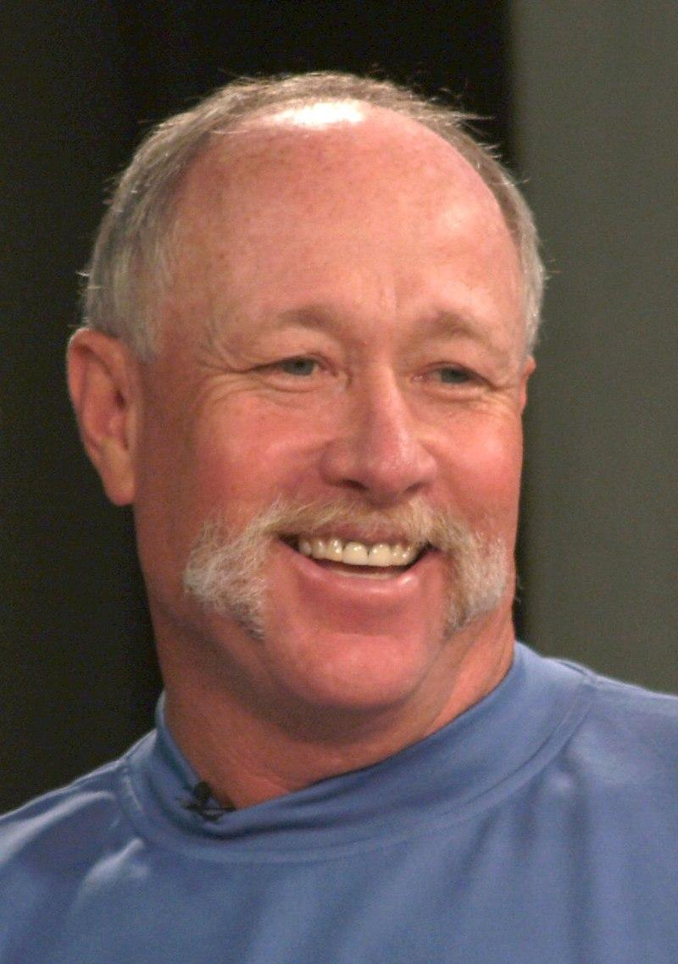  https://en.wikipedia.org/wiki/Goose_Gossage | Source 8  Richard “Goose” Gossage, Baseball Card from the 1990’s  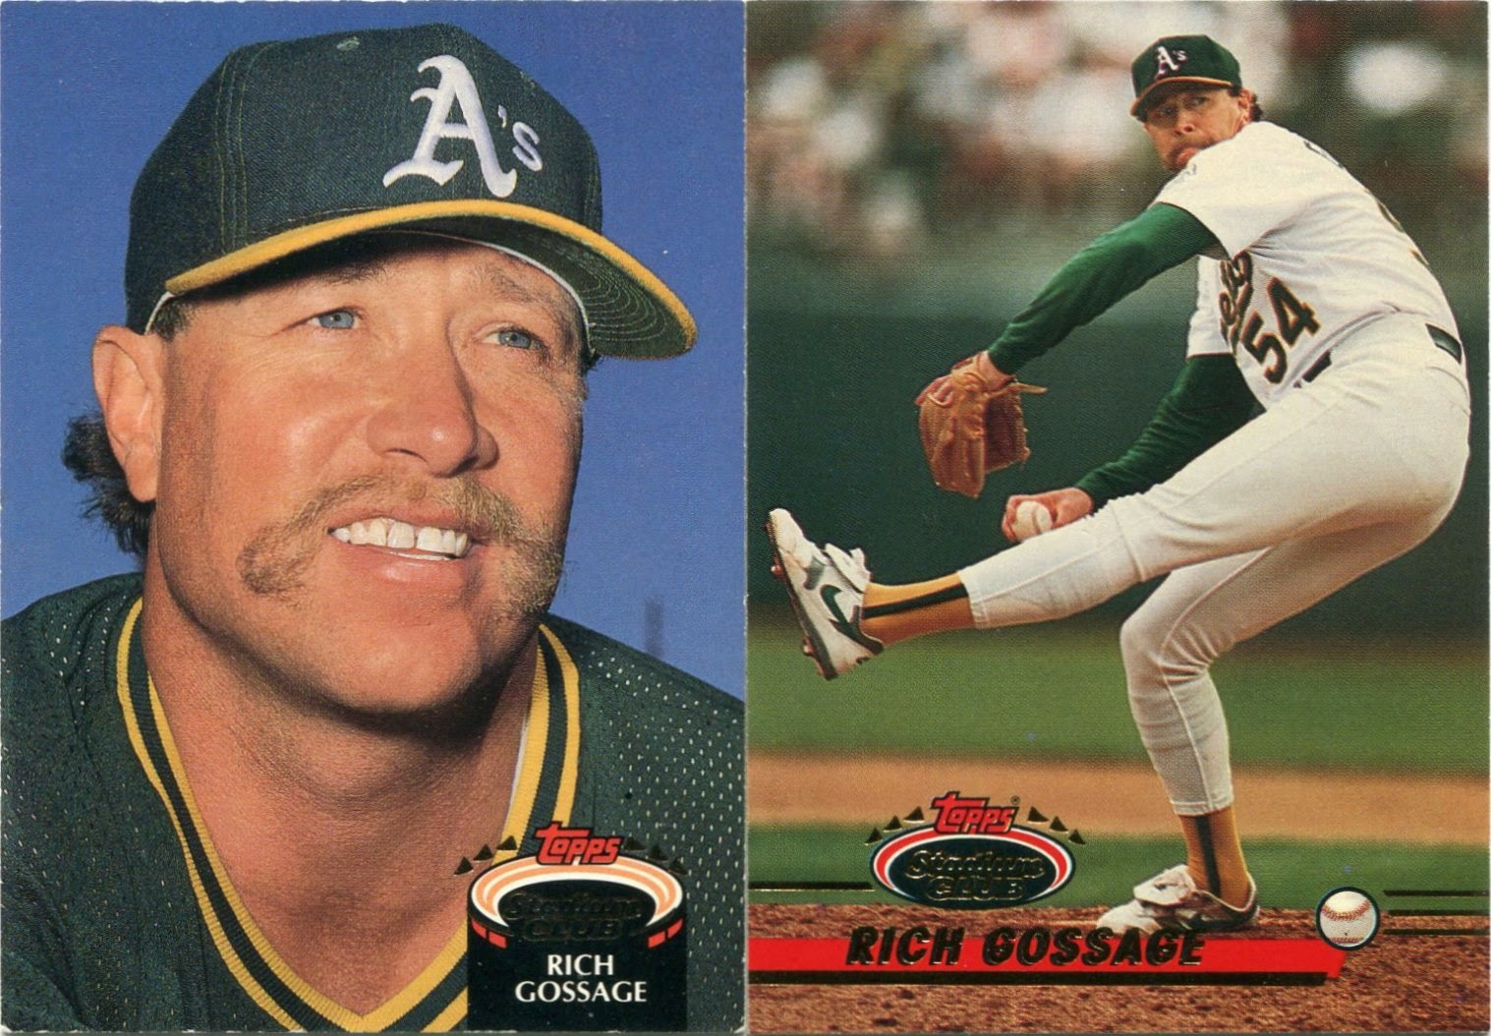  http://baseballdimebox.blogspot.com/2014/11/into-sunset-pt-28-goose-gossage.html
Source 9  Honorable Christine Arguello, U.S. District Court Judge, 2013 ~ Inducted to the Colorado Women’s Hall of Fame, 2014  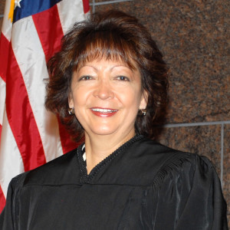  http://www.cogreatwomen.org/project/christine-marie-arguello/ ; http://latinasfirstfoundation.org/profile/honorable-christine-arguello-trailblazer-2013/ | Source 10  Honorable Christine Arguello, U.S. District Court Judge, 2009  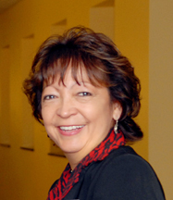  http://www.macwebguru.com/2009/12/23/great-speech/

