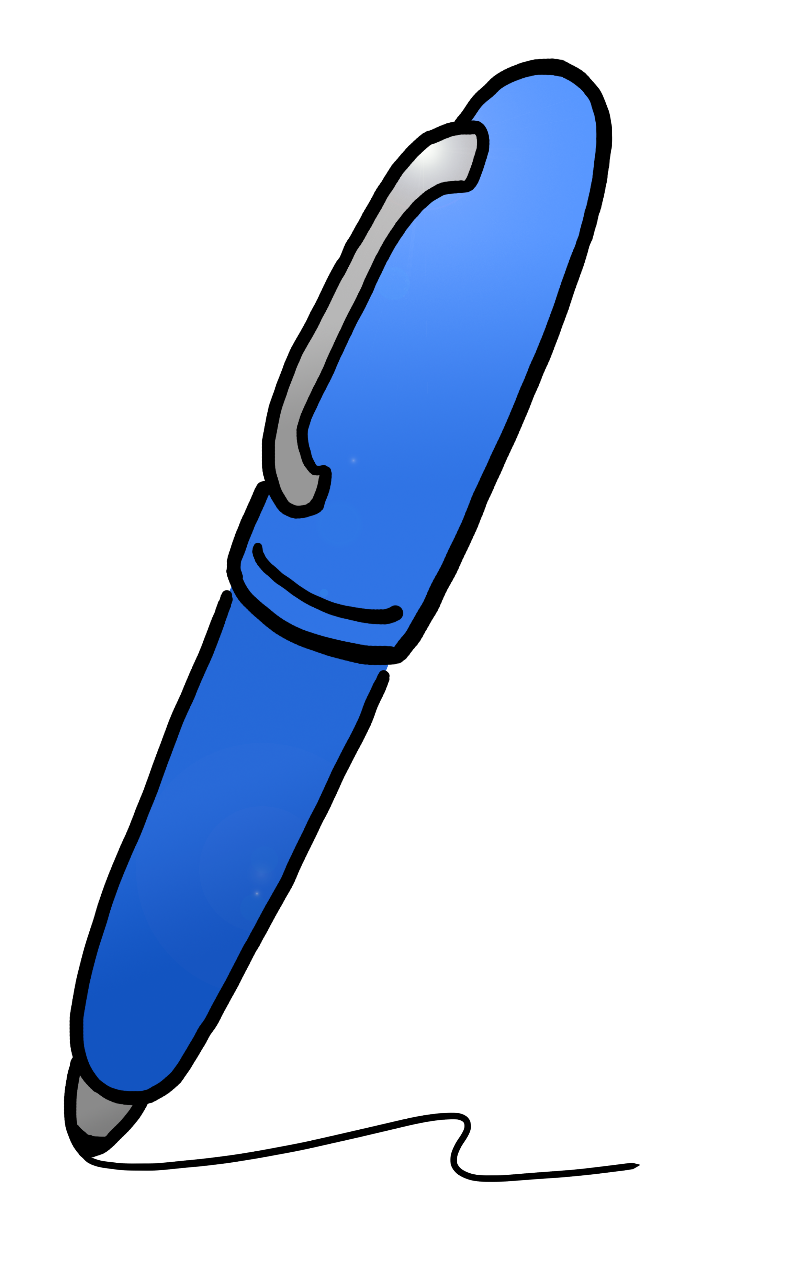



Newspaper Analysis Sheet

Name: ___________________________

Are there any words that you don’t know?

If so, look them up in the dictionary to learn what they mean.

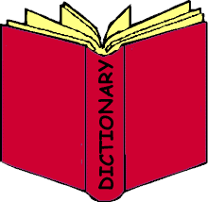

Who wrote the article?

Who do you think was the audience for this article?

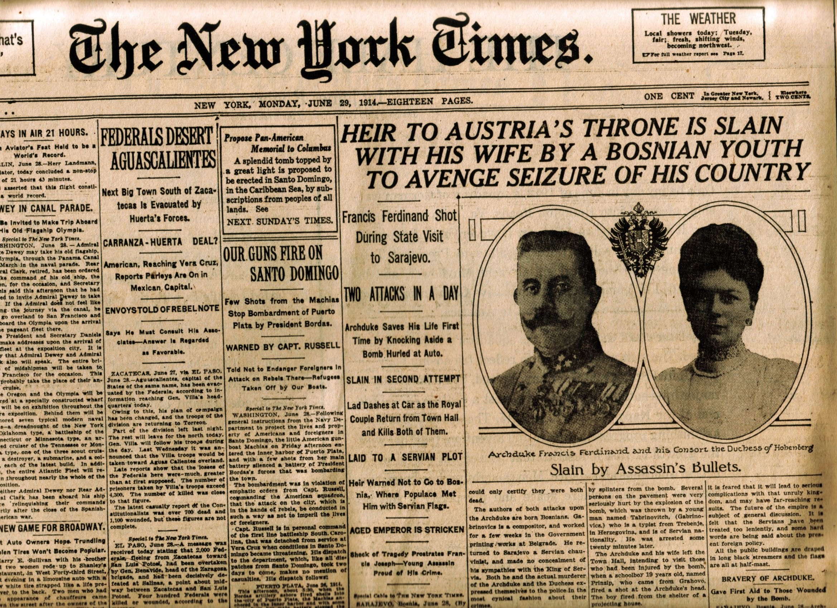

What questions do you have about the article?







How important is this article in telling about our history?

Cite Evidence

List 2 quotes from the article that supports the main idea:

1.

2.



What is the main idea/topic of the article?

What is the date of the article?

Describe what you see.

What text do you notice first?