Grade Level:
Elementary / 4

Essential Question:
What was life like for the families of Colorado’s miners during the Gold Rush?

Supporting Questions:
- What was the role of women in early Colorado mining camps and towns?
- How was life different/similar between the mining towns and life today?

Source 1  - Source: http://hewit.unco.edu/dohist/mining/family/class/three.htm  - A Classroom in Leadville High School  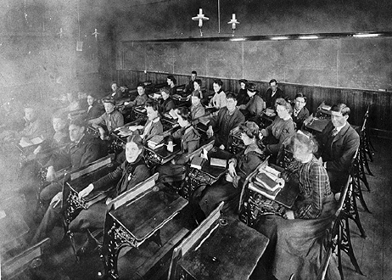  NOTE: The students in this photo were eighth grade students at Leadville High School. These students are attending a mathematics class. | Source 2  - Source: Ivan C. Crawford, “School Days in Leadville,” Colorado Magazine, 36 (July 1959): 224. http://hewit.unco.edu/dohist/mining/family/class/words3.htm  - “The 1901 graduating class of the Leadville High School counted fifteen girls and four boys; for 1902 the figure was eight girls and six boys; for 1903, fourteen girls and one male. In 1904 more boys were present, the figures being twelve to seven, while in 1905 the girls shot ahead again—sixteen to four. In the writer’s class, that of 1906, there were eighteen girls and two boys. Boys left the High School before graduation, usually, to go to work in the mines and become breadwinners for their families. At the time, as the Superintendent so clearly and softly wrote, ‘Community ideas do not tend to the fostering of an educational spirit.’ This point is emphasized by the fact that from 1883 to 1894 there were only thirty-three graduates of the High School.”

Source 3  - Source: http://hewit.unco.edu/dohist/mining/family/class/photo2.htm  - Classroom in a Silver Plume School  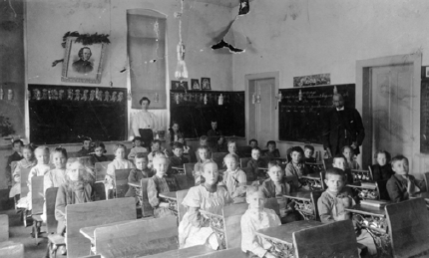  NOTE: This photo was taken in a classroom at Silver Plume about 1905. The students are seated at desks lined up in rows. | Source 4  - Source: Elizabeth Aiken, “Garland School,” in Margaret J. Lehrer, ed., Up the Hemline (Colorado Springs, Williams and Field, 1975): 74. http://hewit.unco.edu/dohist/mining/family/class/words2.htm  - “The schoolroom contained desks and seats of various sizes, two long benches, a table and chair for the teacher, a table piled with books and a Coles Hot Blast heater in the center of the room. I paused a few moments as I looked around the room and thought with a thrill—this is my very own domain for the next eight months.”

Source 5  - Source: Denver Public Library Western History Digital Collections http://digital.denverlibrary.org/cdm/singleitem/collection/p15330coll22/id/9490/rec/5  - Rutter and Hankins store 15th and Pearl, Boulder, CO  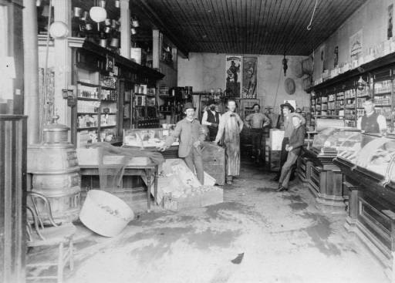  This photograph is estimated to be between 1880 and 1890  NOTE: Shelved canned goods line interior walls of this store in Boulder, Colorado. Posters depict a man and a woman and read: "Bartlett's Blue." Crates of fruit are displayed (some with netting), and baskets hang on the wall. Hardwood cases with curved glass tops and a potbellied parlour stove flank the floor, on which men pose in a suit, apron, vest, and bowler hat. | Source 6  - Source: Diary of a unidentified young man, Central City, December 10, 1865; from The New Mexico Sentinel, July 3, 1938. http://hewit.unco.edu/dohist/mining/food/food/words1.htm  - "I stabled the team and went around to get the supplies. I had difficulty in getting all the machinery that Mr. Austin wanted, but we got some ox chains and dried beef, sardines, beans and coffee and several sides of salt pork. I did not have funds enough with me to get the sugar, molasses, cheese, crackers, dried fruit and other delicacies on his list--as the machinery and provisions have advanced in price above what he had calculated on paying."
Source 7:
- Rocky Mountain PBS – The Colorado Experience: Ladies of the Mines

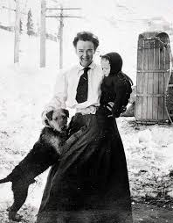

http://video.rmpbs.org/video/2365638998/
NOTE: At 4:43, there is a brief mention of bars, alcohol, and bordellos; advise stopping the video at 22:50, at which point they begin discussing a topic that is not appropriate for 4th graders.

Background Knowledge / Contextual Paragraph for Teachers:
Background information on life in Colorado’s mining towns http://hewit.unco.edu/dohist/teachers/essays/miners.htm

Elizabeth “baby Doe” Tabor, Clara Brown http://www.coloradovirtuallibrary.org/digital-colorado/colorado-histories/boom-years/elizabeth-baby-doe-mccourt-tabor-colorados-silver-queen/

Building Background Knowledge for the Student
- “The discovery of gold near present-day Denver in 1858–59 drew thousands of people to present-day Colorado, prompting the political organization of first a US territory and later a state. Many current cities and towns, including Denver, Black Hawk, Breckenridge, and Central City, were founded during the Colorado Gold Rush, and its associated activities produced tremendous social and environmental changes, including the displacement of Native Americans and the pollution and large-scale manipulation of the Colorado environment.” Source: Colorado Encyclopedia

Strategy Instruction:
- Students build understanding with the "Images Draw You In" Model Activity by:
- Articulating a connection between responses to differentiated, investigative questions and an idea central to the subject under study.
- Use this activity as a war up to the study of family life in Colorado's Mining Towns.
  - Print copies of images from this primary source set and the resource set (How many you print is based on how many students you have in your class and/or whether or not you want students to work in groups).
  - Ask students to select a photograph that “grabs them”
  - Engage students in an investigation of their selected photograph using sample inquiry questions
- Give students an opportunity to read and react to Sources 2, 4, and 6 in this primary source set.
- What glimpses into family life in Colorado’s mining towns do these quotes give you? Ask students to provide specific details.
- Based on the quotes, what “pictures” do they have in their minds about what life is like in the mining towns?
- Next distribute Sources 1, 3, and 5. Give students the photograph analysis sheet to guide their viewing of the photographs
- How are the photographs similar or different than what they were imagining life to be like?
- Have students discuss ways in which their lives today are different than the lives of children in the mining towns?
- Use the Rocky Mountain PBS Colorado Experience video Ladies of the Mines (approx. 26min) to introduce students to the role of women in Colorado’s mining towns. NOTE: At 4:43, there is a brief mention of bars, alcohol, and bordellos; advise stopping the video at 22:50, at which point they begin discussing a topic that is not appropriate for 4th graders.
- What were some of the challenges that women faced in the mining towns?
- Was life easy or difficult for women in the mining towns? What evidence do you have to support your answer?
- If given the chance, would you go back in time to live in a mining town? Why or why not?
- Close Reading of Photographs:
- Students build close reading skills when reading photographs instead of focusing on captions. Students generate a list of information they gathered, and questions they have regarding their photograph (or their group’s photograph). Students take the information from their photograph and construct a narrative about life in a Colorado Mining town.
- Following the close reading of their selected photograph, have students create a caption for their picture!

Strategy Instruction Differentiation:
Students may work in partners. Students may also be provided with a graphic organizer to help with writing their narrative.

Discussion:
What were miners' families and children like?
What were the schools miners' children attended like?
What were classrooms in these schools like?
What types of food did the miners and their families eat?
What types of roles did women in the mining towns have?
How were holidays celebrated in the mining towns?

Assessment:
Construct a narrative
- After looking at an image that tells a story, students brainstorm about the possible events and characters the image illustrates. Students then write from the point of view of one of the characters in the image, sharing the character's thoughts and feelings, describing the events that led up to the picture, or imagining the events that followed.
- Source: http://www.readwritethink.org/classroom-resources/lesson-plans/picture-worth-thousand-words-116.html (This assessment can be adapted to 4th grade)
- Resource: http://penandthepad.com/construct-narrative-3658.html

Colorado Social Studies Standards:
- CO Standard 1 - History : 4.1.1b - Analyze primary source historical accounts related to Colorado history to understand cause-and-effect relationships
- CO Standard 1 - History : 4.1.2a - Analyze various eras in Colorado history and the relationship between these eras and eras in United States history, and the changes in Colorado over time

Colorado Reading and Writing Standards:
- CO RWC Standard 2 - Reading for All Purposes: 4.2.2a - iii. Explain events, procedures, ideas, or concepts in a historical, scientific, or technical text, including what happened and why, based on specific information in the text.
- CO RWC Standard 3 - Writing and Composition: 4.3.3a - Produce clear and coherent writing in which the development and organization are appropriate to task, purpose, and audience.
- CO RWC Standard 3 - Writing and Composition: 4.3.1b - Write narratives to develop real or imagined experiences or events using effective technique, descriptive details, and clear event sequences
  - iii. Use dialogue and description to develop experiences and events or show the responses of characters to situations

Sample Activities:
Images Draw You In
Close Reading of Photographs
Constructing a Narrative

Extra Source 1  - "There is quite a number of Ladies here now which make things look so much more comfortable. There is one family lives close to us that have a cow, chickens &c. Every morning my ears are Saluted by the crowing of a big Shanghai Rooster that they have."  Source: David F. Spain to his wife, Arapahoe City, April 30, 1859; in John D. Morrison, ed., "The Letters of David F. Spain," Colorado Magazine, 35 (April, 1958): 110. | Extra Source 2  - "The coal miners as a rule all had big families. The family of five was a small family. But they went from there, but I wouldn't say how high they went. I don't really know. I've heard of families of 12 and 15 children . . . There were no child labor laws in those days and the boys were taken into the mine, 11, 12, 13 years old. And the girls, just as soon as they were able to take care of a baby, were kept at home. They didn't get to go to school much."  Source: Martha Todd, in Eric Margolis, "Western Mining as a Way of Life," Journal of the West (July 1985): 54.

