Grade Level:
Elementary / 3-4

Essential Question:
How was the introduction of the train instrumental in the movement of people and goods in Colorado?

Supporting Questions:
- How did the technologies developed for train travel such as the telegraph, standard time, and the gauge (width) of the tracks improve the way people communicated and traveled?
- In what ways was the railroad a “social affair?”

Source 1  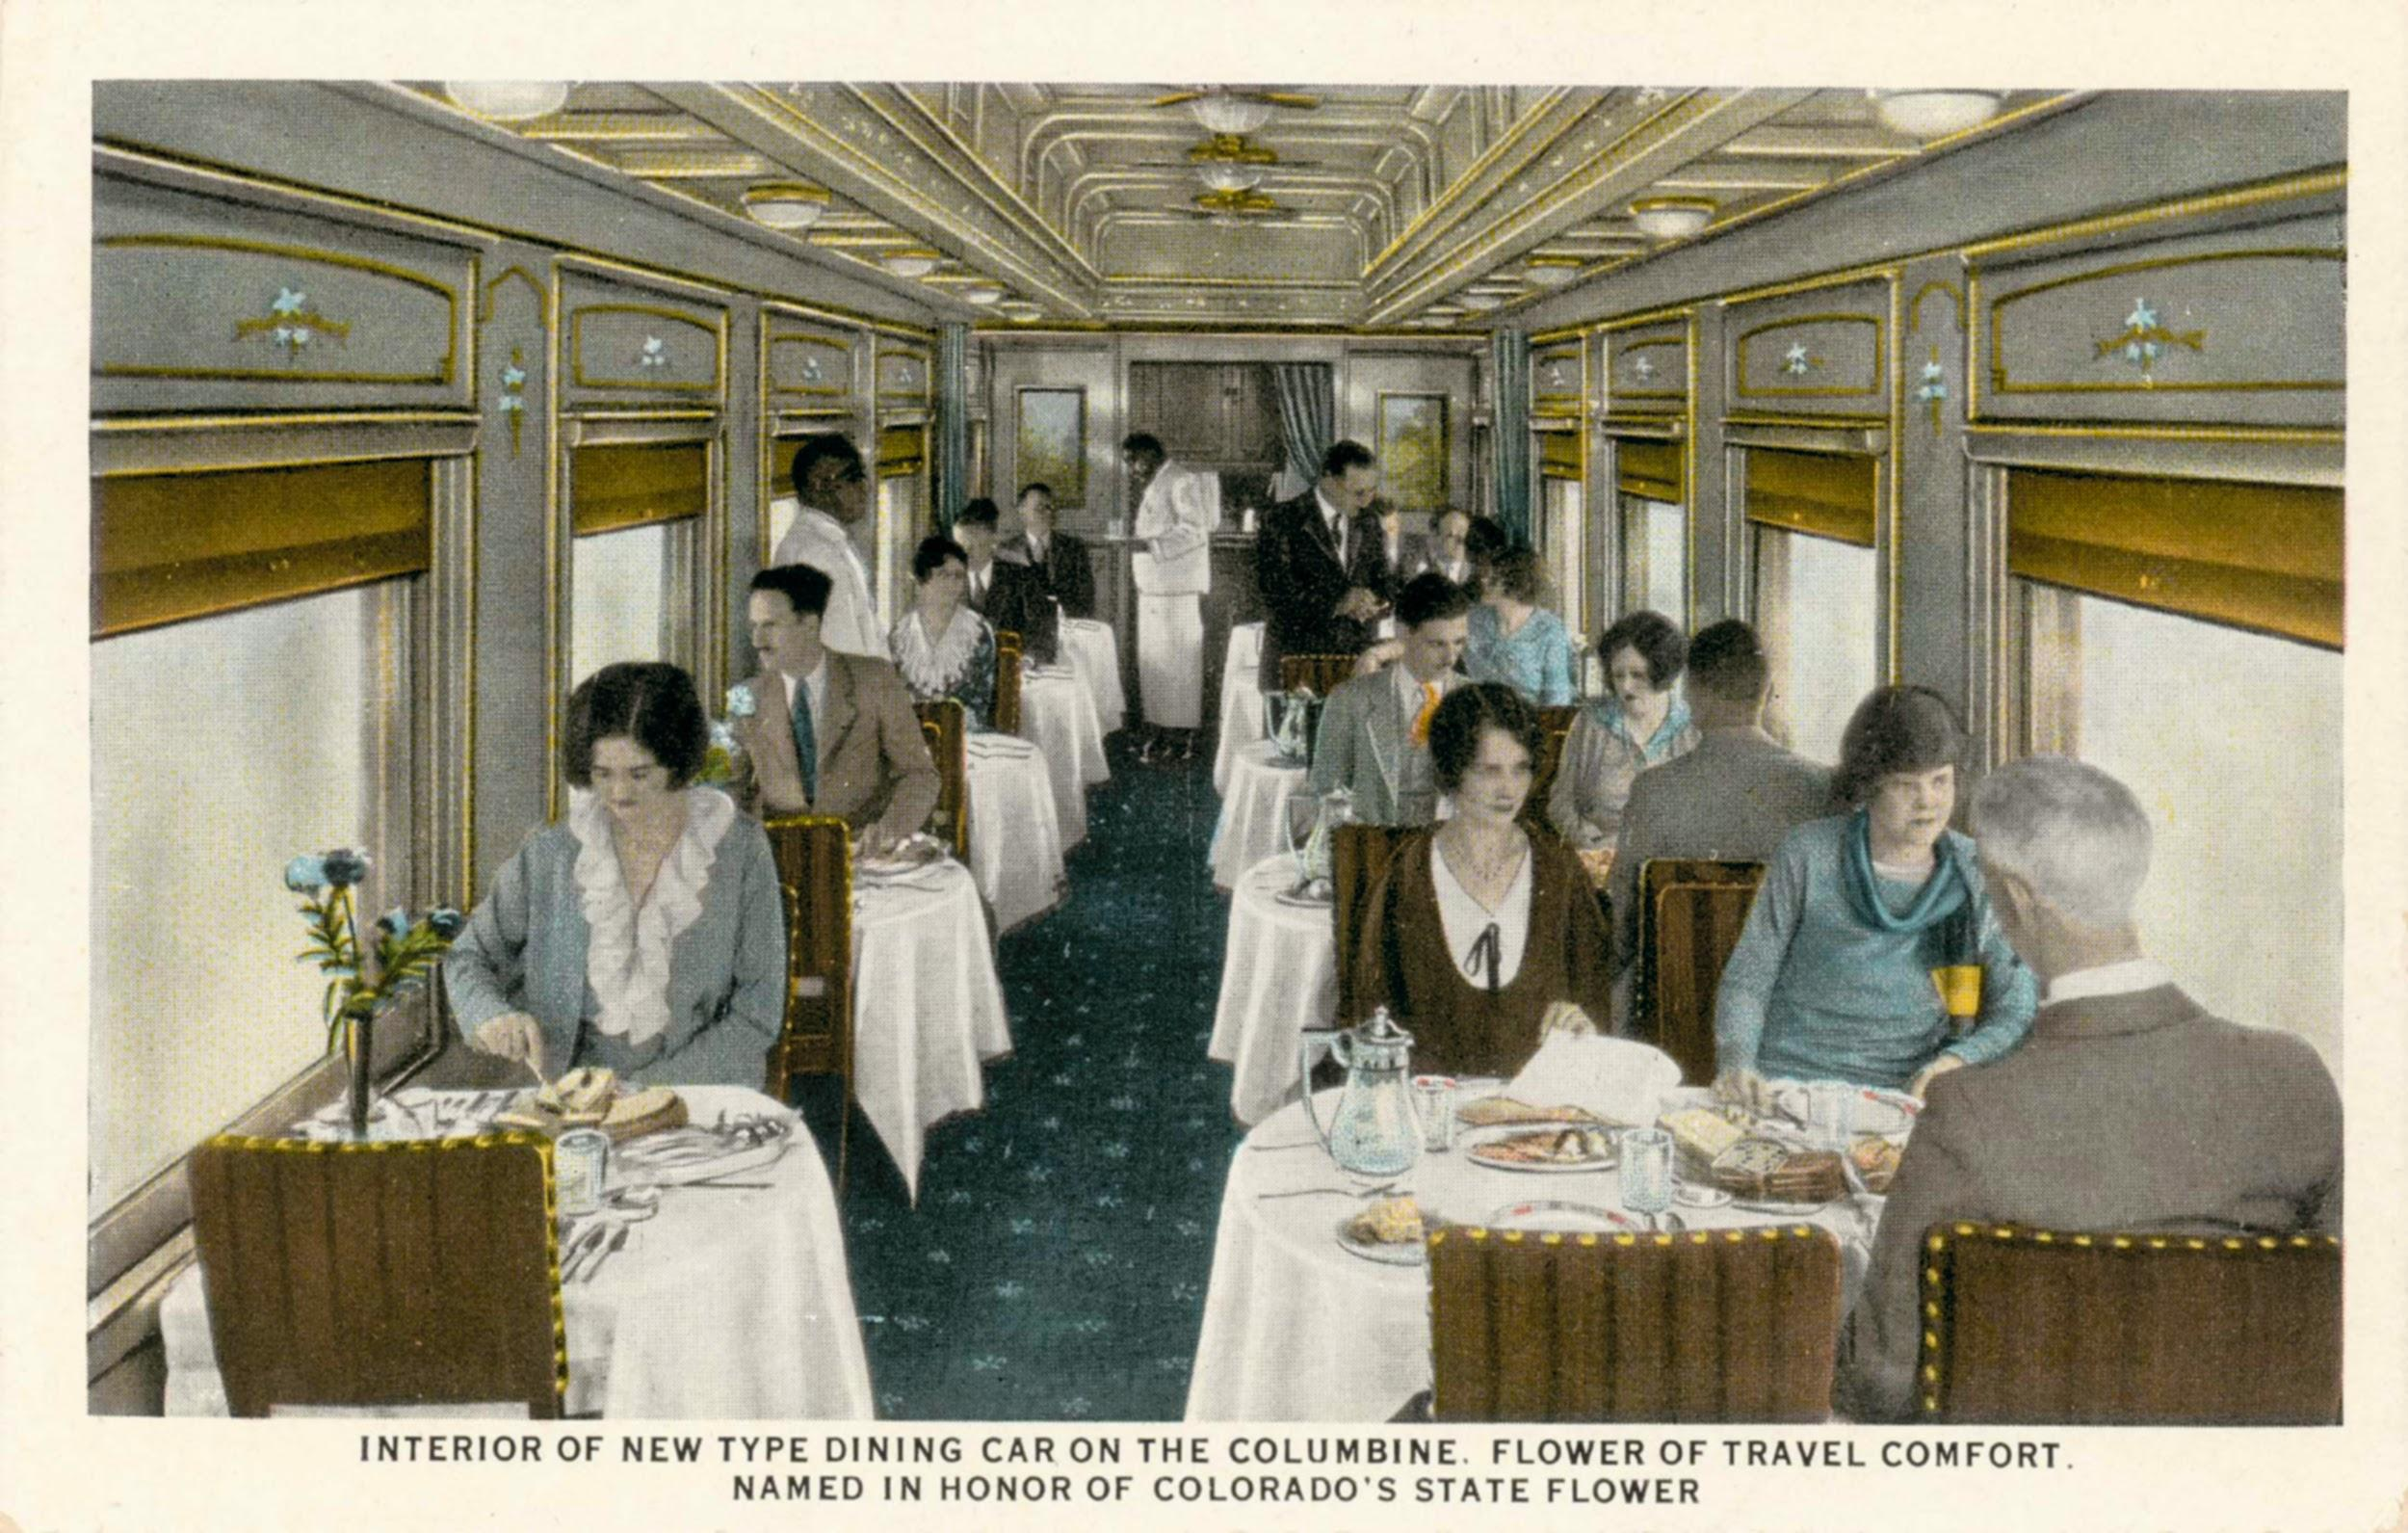  Interior of New Type of Dining Car on the Columbine.  Image Courtesy of the Denver Public Library, Western History Room | Source 2  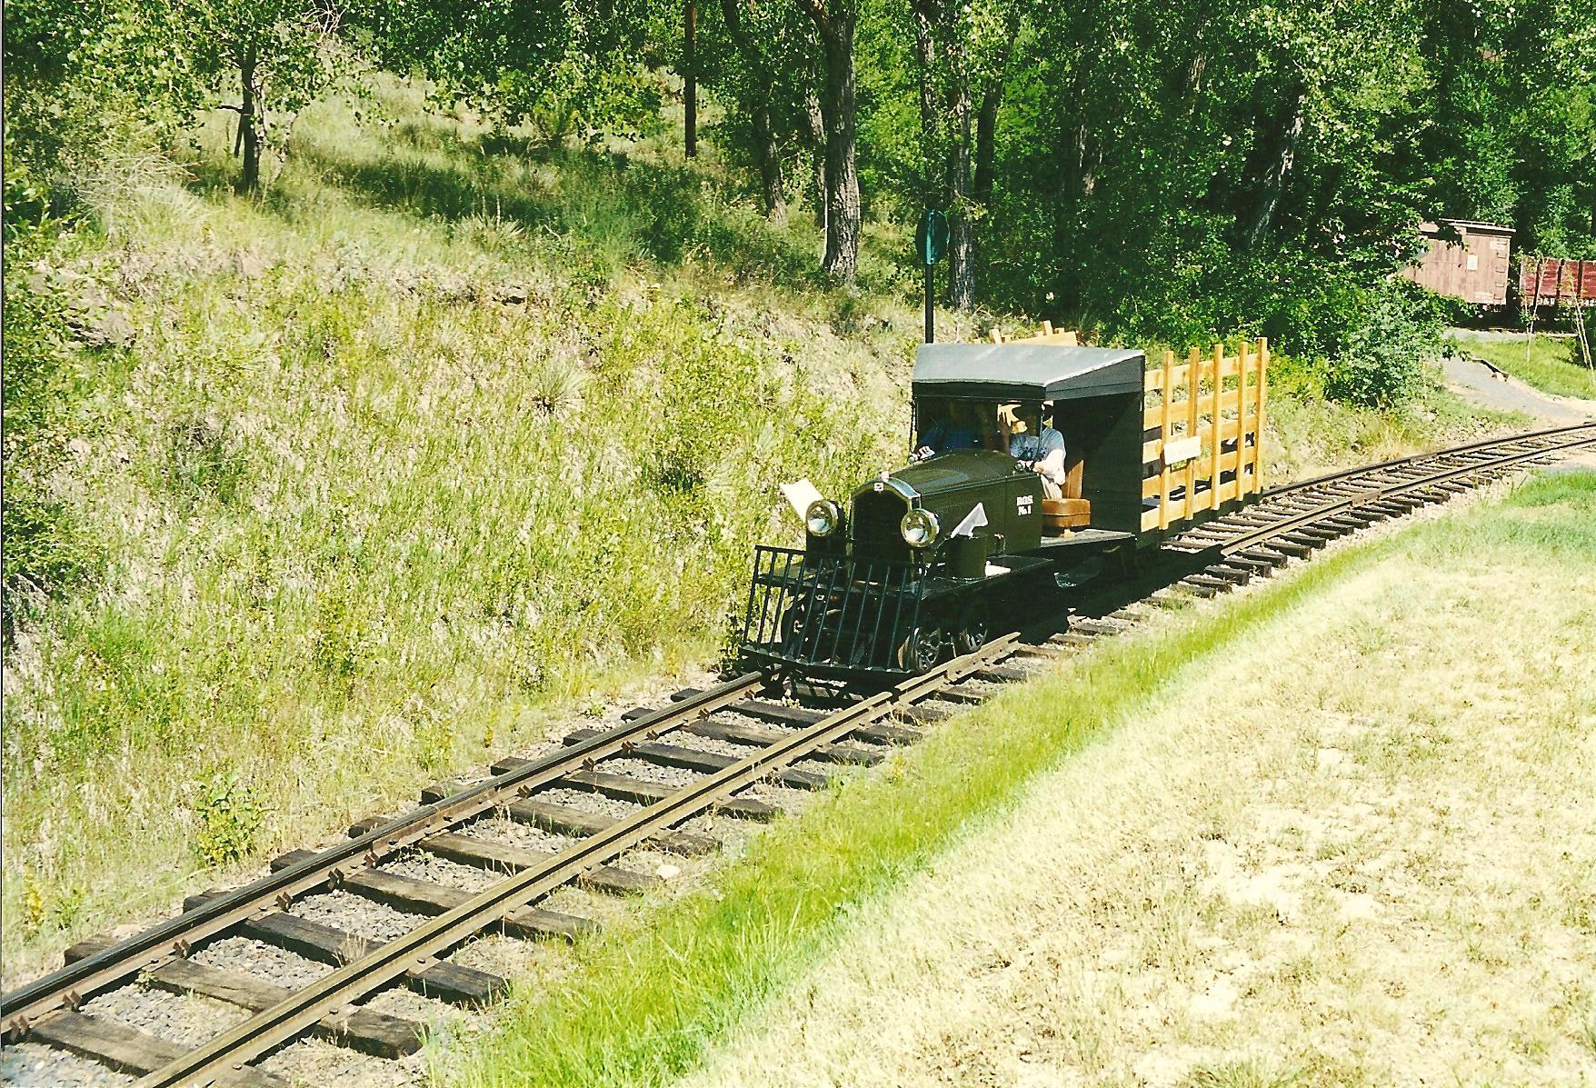  The Galloping Goose  Image Courtesy of the Colorado Railroad Museum
Source 3  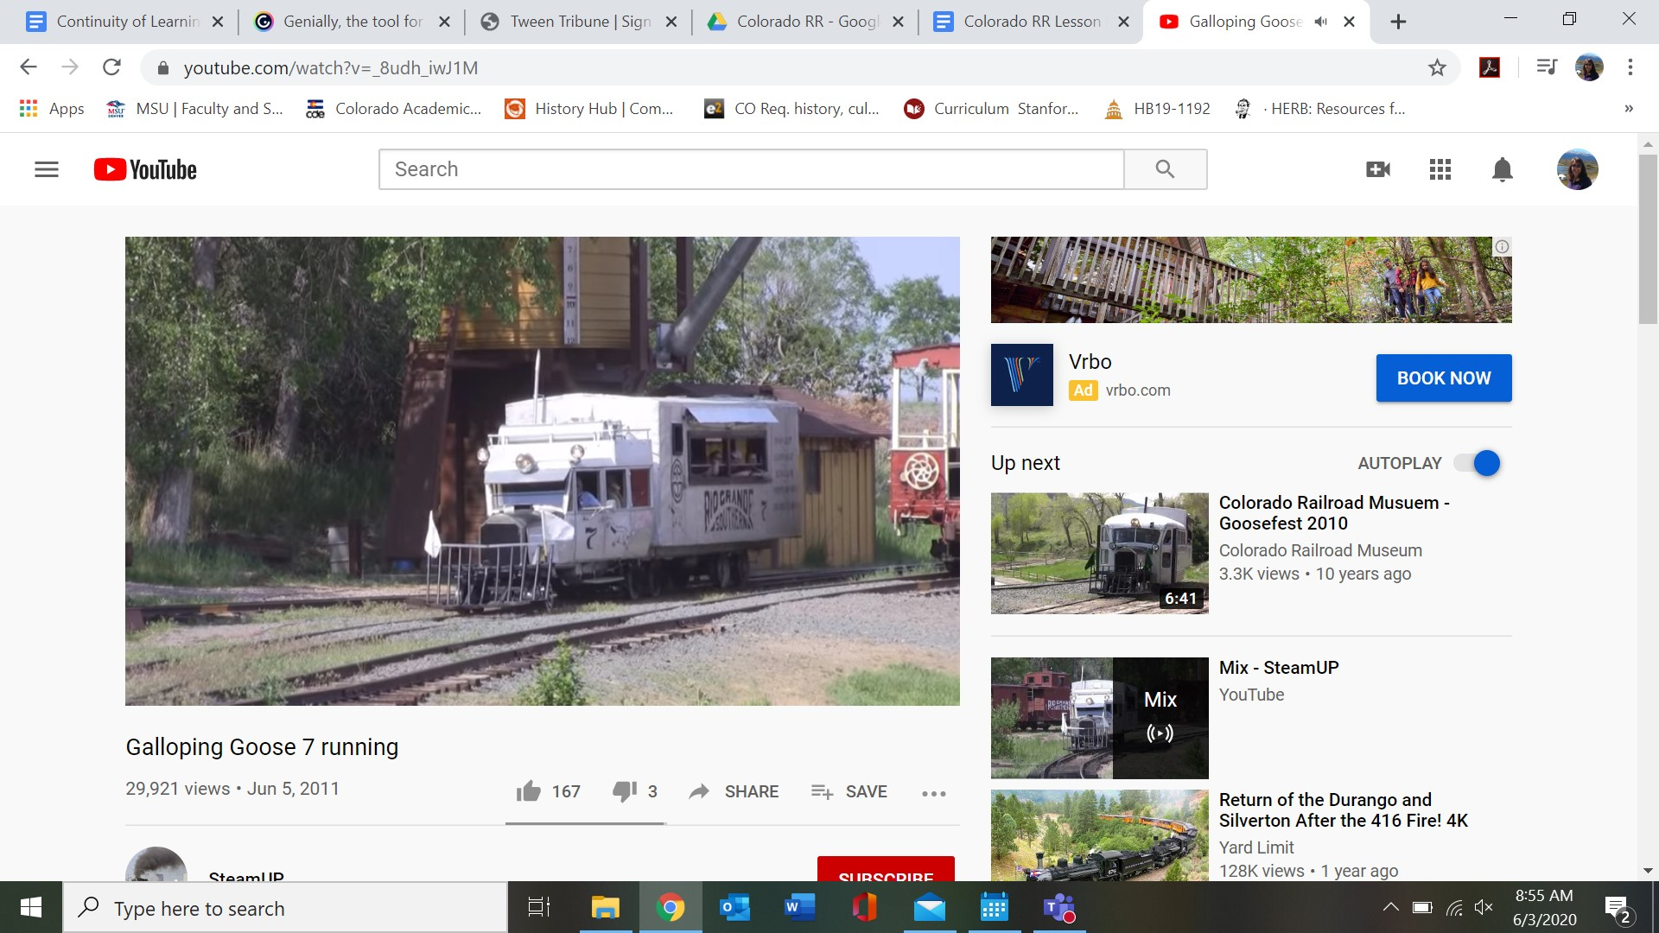  Video of the Galloping Goose #7 Running at the Colorado Railroad Museum  Source: https://www.youtube.com/watch?v=_8udh_iwJ1M | Source 4  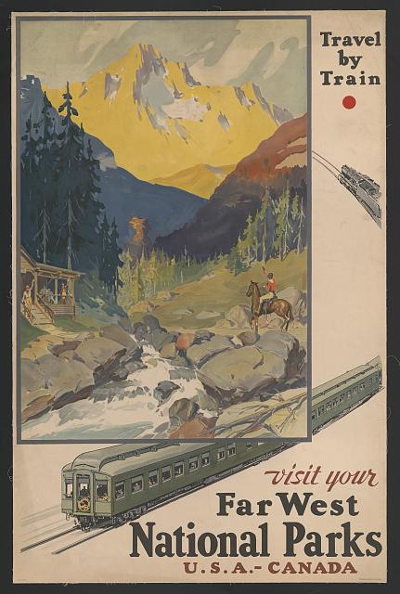  Poster advertising travel by train (1920s)  Source: The Library of Congress https://www.loc.gov/resource/ds.11688/

Background Knowledge / Contextual Paragraph for Teachers:
The overland journey from Independence, Missouri, to Oregon or California meant a six-month trip across 2,000 miles of hard country. It was costly—as much as $1,000 for a family of four. That fee included a wagon at about $100. Usually four or six animals had to pull the wagon. Oxen were slower but held up better than horses or mules. They were also cheaper, costing about $25 each compared to $75-$100 for a horse or mule.

You also needed food supplies, cooking equipment, water kegs and other sundry items. Most folks viewed a trip to the West as an investment in their futures.

Prior to 1869, the majority of people stayed relatively close to where they were born and raised. Travel across any distance was costly and time consuming. Generally, people who travelled great distances did so because they were moving (think Homestead Act and the Gold Rush). However, with the completion of the Transcontinental Railroad, opportunities opened for both immigrants and leisure travel. Tickets costs in the late 1870s were $136 for first class in a Pullman sleeping car, $110 for a second-class ticket and $65 for third, or “emigrant” class seats. It took approximately 7 days to travel from New York to San Francisco. It was a game changer with many immigrants choosing to travel West by the less expensive railroad than the traditional wagon train.

Not only was it faster and less expensive to go west by rail but railroads were given land grants by the government to help pay for building these cross-country routes. Immigrants could not just travel west by train but could purchase farm and ranch land from them as well!

With the expansion of the railroads, numerous technologies were developed to support the rail industry. On Nov. 18, 1883, standard time was instituted so that all cities and towns were on a “standard” time. Prior to 1888, all towns and cities set their own times based on the local solar time maintained by a well-known clock such as a church steeple - North America had 144 official time zones.

In order for the rail companies to communicate schedules, etc., the telegraph and Morse Code were used to send messages long distances. In addition, the railroad was instrumental in the transportation of mail. Writing letters to loved ones who lived far away was now a reality. Finally, since most trains were local (east coast), rail companies built their own rail lines (laid tracks) to fit the locomotive and cars. There were numerous widths of rail lines. The width of a track was standardized to 4ft. 8 ½ inches by 1886.

Building Background Knowledge for the Student
- Ask: How did people and goods travel from the east coast to the west coast prior to the completion of the Transcontinental Railroad? (Show a map of the United States in 1860 – https://commons.wikimedia.org/wiki/File:United_States_1859-1860.png)
- How long might it have taken to travel across the country in a wagon or stagecoach? (About 5 months and 25 days by wagon from Missouri to San Francisco; by train it was 7 days from New York to San Francisco)
- How much did it cost to travel by stagecoach? (It cost quite a lot of money to transport goods before railroads. In 1867, it would have cost $300 ($5,933 in 2020 dollars) to ride the stagecoach from Sacramento to Omaha. The overland journey from Independence, Missouri, to Oregon or California was costly—as much as $1,000 for a family of four. Three years later, train travel made the trip for less than half the cost - $135 for a Pullman sleeper car, $110 for a second class ticket, and $65 from a ticket on an emigrant car.*
  - How do these prices equate to 2020?
    - $300 (1867) = $5,933.61 (2020) wagon train
    - $135 (1870) = $2,670.12 (2020) first class Pullman sleeper
    - $110 (1870) = $2,175.66 (2020) second class
    - $65 (1870) = $1,285.61 (2020) 3rd class, emigrant car
*Bureau of Labor Statistics Price Index
- Why might travel by train be more efficient and economical? (Not only was it less expensive to take the train west but you could ship your household belonging by rail much less expensively as well. Trains were also faster than wagons or horses traveling an average of 25 mph.)

Strategy Instruction:
Students will engage in 7 learning stations as they learn about how the introduction of the railroad to Colorado changed the way people traveled and communicated, and how goods were transported.
Create a folder for each learning station to include the primary sources for each station, and develop guiding questions for each station that will help students to gather evidence from the sources to aid them in answering the essential question(s).
Consider using the elementary primary source analysis sheets to help students analyze the photographs or artwork (https://www.cde.state.co.us/cosocialstudies/pssets)
Station #1: Travel By Train
Station #2: Communication
Station #3: Technology
Station #4: Mail Delivery
Station #5: Artwork
Station #6: The “Art” of Dining
Station #7: Setting Standards

Strategy Instruction Differentiation:
Teachers may develop graphic organizers to provide students with support while rotating through the learning stations.

Discussion:
- How can primary sources help us learn about the past or create more questions about our state's history?
- How did the railroad contribute to the growth of the cities in Colorado?
- How did farmers benefit from the railroads?
- How did miners benefit from railroads?

Assessment:
- Create a message using Morse Code.
- Use the Morse Code guide from Station #3
- Review the history of Morse Code in terms of its impact on society's ability to communicate across large distances.
- Ask students to imagine themselves as a traveler on the Railroad.
- Guiding questions:
  - Where might you be going? Are you traveling with anyone? Who are you writing to? Why?
- Design and write a postcard describing travel by train. (Template: https://olphreunion.org/free-printable-templates-postcards/)

2020 Colorado Social Studies Standards:
- Standard 1 – History: 4.1.1.d. Identify cause-and-effect relationships using primary sources to understand the history of Colorado's development.
- Standard 1 – History: 4.1.2.b. Explain the relationship between major events in Colorado history and events in United States history during the same era.
- Standard 1 – History: 4.1.2.d. Describe the impact of various technological developments.
- Standard 2 - Geography: 4.2.2.d. Describe how places in Colorado are connected by movement of goods, services, and technology.

2020 Colorado Reading, Writing, and Communicating Standards:
- Standard 2 - Reading for All Purposes: 4.4.2.a. Refer to details and examples in a text when explaining what the text says explicitly and when drawing inferences from the text.
- Standard 2 - Reading for All Purposes: 4.4.2.a. Explain events, procedures, ideas, or concepts in a historical, scientific, or technical text, including what happened and why, based on specific information in the text.
- Standard 4 – Research Inquiry and Design: 4.10.1.a. Conduct short research projects that build knowledge through investigation of different aspects of a topic.

Learning Stations

Station #1: What was it like to travel by train?

1A: Map Illustrating Travel Times by Train from NY to the West Coast in 1930
In the 1800s, traveling from coast to coast, which now takes less than a day, could take weeks. However, as early as 1870, it took just 7 days by railroad and by 1930, travel across country on a train took just 3 days from New York City to the west coast.

Take a look at the map. How long would it take to get from New York City to Colorado?

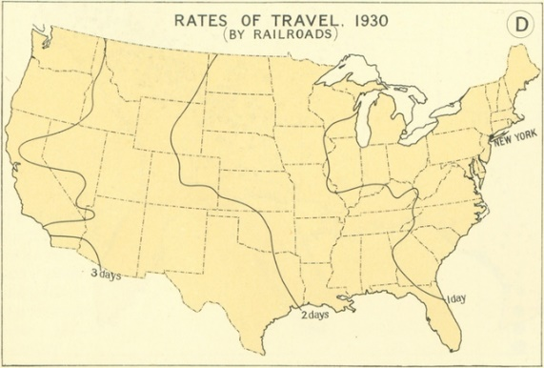
Source: https://www.mnn.com/green-tech/transportation/stories/how-fast-could-you-travel-across-the-us-in-the-1800s

1B: D&RGW Parlor Car c. 1925
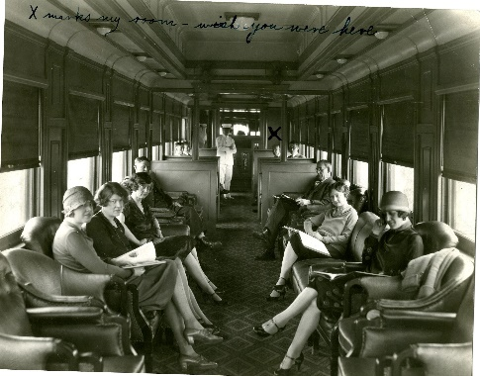
The parlor car is where most people sat during their train trip. The parlor car had large windows so the passengers could look out and see the passing scenery.

Look at what the ladies are wearing. What do you notice about their outfits?

Image Courtesy of the Colorado Railroad Museum

1C: Union Station, Denver ~ 1970
This is a picture of Union Station in Denver. Almost every city and town built along the train tracks had a train station though not always quite so grand as the one in Denver. People traveling by train would wait for the train in the station. Many stations had restaurants.
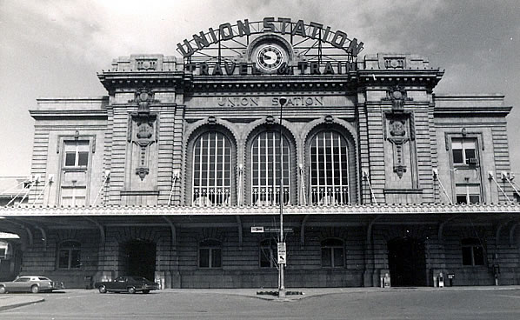
Image Courtesy of the Colorado Railroad Museum

Station #2: A True Dining Experience

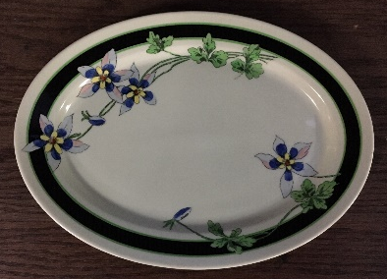
2A: The Columbine Dining Car & china
Images Courtesy of the Colorado Railroad Museum
Every dining car had waiters who worked hard to provide drinks and food to all the train’s passengers. In the dining car, a special china pattern
was used.

Look closely at the china. What do you see?

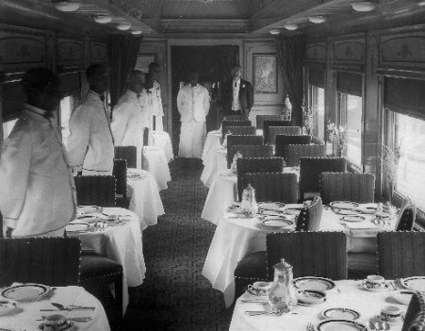
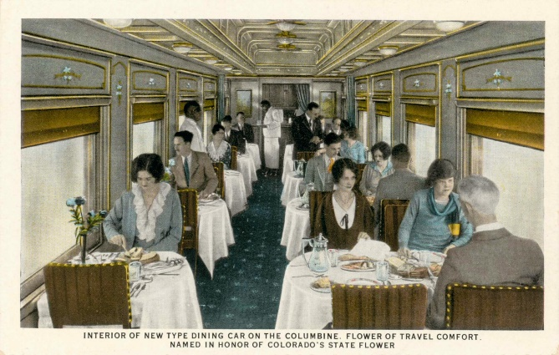
2B: Interior of New Type of Dining Car on the Columbine.
Riding the train was very much a social event. Women wore their Sunday best. The dining car is where people visited and ate. People ate very fancy and delicious food prepared by chefs.

Why do you think taking a trip on the train was so important to people?

Image is courtesy of the Denver Public Library, Western History Room.

2C: Cover of the AT&SF Menu
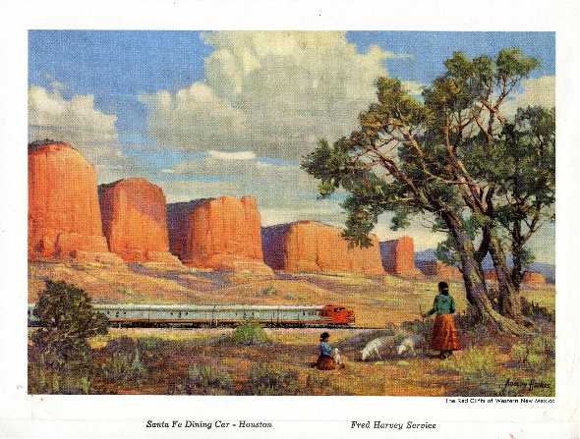
Passengers who traveled a long distance had the chance to eat in the dining car on the train. The menus often used beautiful art on their covers.

Why do you think the menus had beautiful pictures on the front?

Image Courtesy of the Colorado Railroad Museum

2D: The AT&SF Dinner Menu
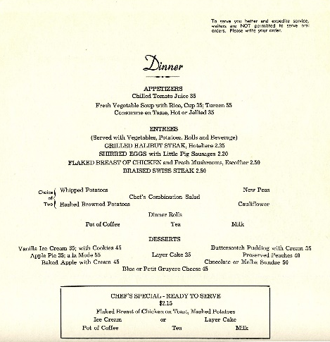
Train chefs prepared food from scratch, from the turtle soup to spiced nuts.

Look closely at the menu. How much does the food cost? What food don’t you recognize? What food would you order from this menu?

Image Courtesy of the Colorado Railroad Museum

Station #3: Let Them Know You’re Coming!

3A: Cripple Creek Short Line - Postcard Front
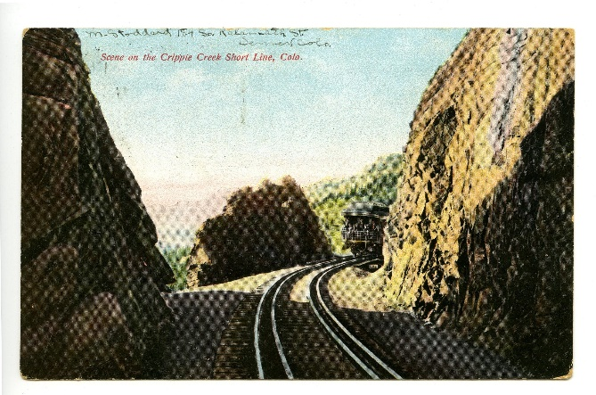
Postcards were created by the railroad companies so that passengers could tell their family and friends about their travels on the train.

Who would you send a postcard to?
Image Courtesy of the Colorado Railroad Museum

3B: Cripple Creek Short Line - Postcard Back
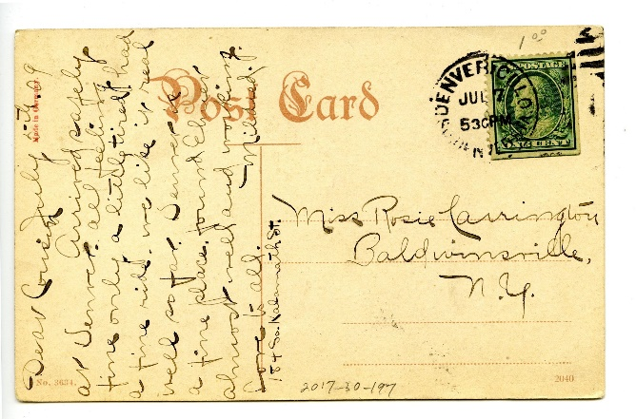
The postcards were then sent in the mail to family and friends across the country. In the early 1900’s, a lot of mail was carried by train to its final destination!

Can you read what this postcard says?

Image Courtesy of the Colorado Railroad Museum

The first telegraph key used in Colorado was at the Julesburg telegraph station in 1861. Julesburg, the only city in Colorado to be part of the transcontinental railroad also had the honor of connecting telegraph operators to the east and west. It was the telegrapher (telegraph operator) who first reported events like the Sand Creek Massacre to the rest of the country.

What news would you send by telegraph?

3C: A Telegraph Key
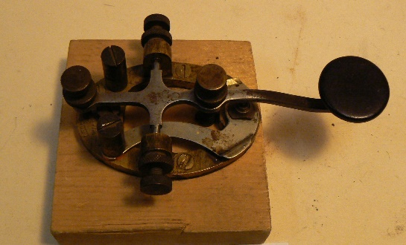
Image Courtesy of the Colorado Railroad Museum

3D: A Telegraph Ready for Transmission (to be sent), 1895
Telegraphs were used to communicate a variety of information. Railroads sent messages about important family happenings like births, deaths and marriages. Businesses used the railroad telegraph to send business orders like the one pictured on our left. Most importantly, railroads used telegrams to make sure trains traveled safely from town to town.

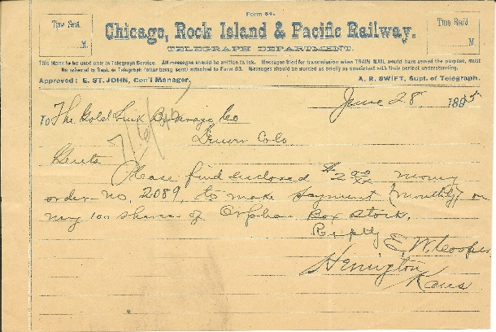
Image Courtesy of the Colorado Railroad Museum

3E: Morse Code - Used to Transmit Telegraphs
Morse code, a system of dots and dashes used to communicate messages across long distances was invented by Samuel Morse around 1840. Railroads in the United States used the 1844 version of Morse’s code. It became known as the American Morse Code and was important in making sure that time schedules, and work orders arrived in a timely fashion for everyone’s safe travel.

Can you create your own message using Morse Code?

Image Courtesy of the Colorado Railroad Museum
Station #4: Railroad Technology

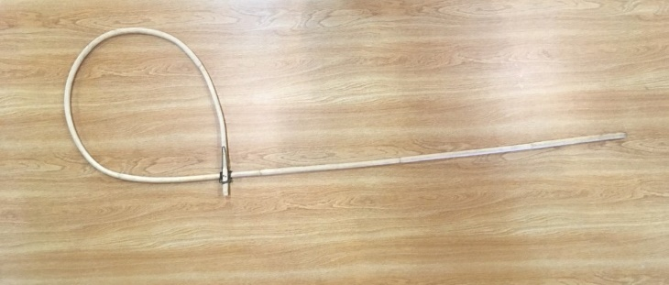
4A: Order Hoop for Grabbing Items from a Moving Train
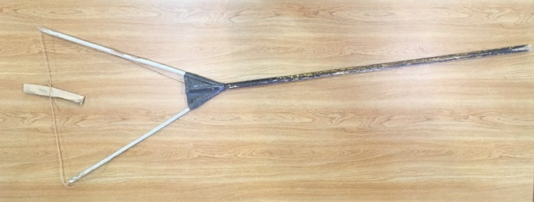
Communication has always been important on the railroad. “Orders” handed up to the train crew from 1840 to the 1980s helped avoid collisions. For many years a bamboo hoop with a metal clip holding the orders was used. The crew returned it by throwing the hoop along the right of way for an operator to retrieve. Inventions like the radio and computer finally made the simple hoop obsolete after 140 years.

Images Courtesy of the Colorado Railroad Museum

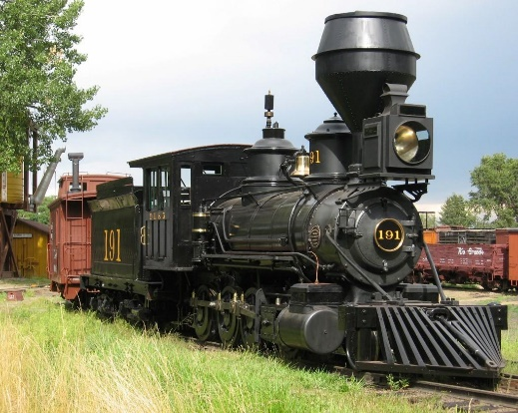
4B: The Steam Engine – Engine #191
The Denver, Leadville and Gunnison Railway (DL&G) locomotive No. 191 is the oldest steam locomotive in existence in the state of Colorado. It was built by the Baldwin Locomotive works in Philadelphia in early 1880 for the Denver South Park & Pacific Railroad. Throughout its working life railroads used this locomotive to move gold and silver ore, coal, timber, and goods for the many mountain communities in central and southwestern Colorado.

Images Courtesy of the Colorado Railroad Museum

4C: Shoveling Coal into a Firebox
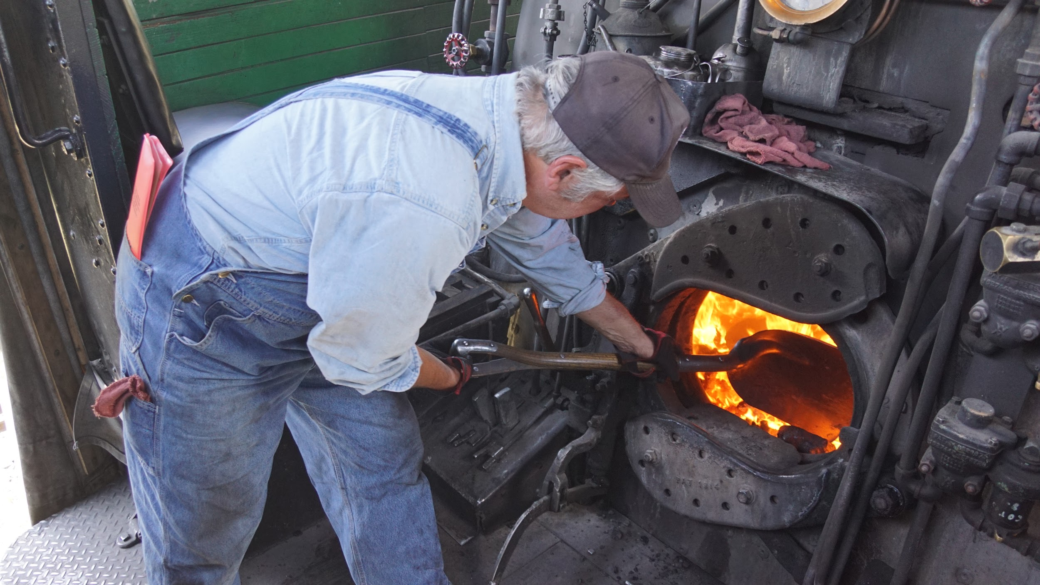
The firebox is the area in a steam locomotive where the fuel is burned. It produces the heat to boil the water in the boiler. Because most are somewhat “box shaped” they are called fire boxes.

What do they burn in a locomotive’s fire box?
Images Courtesy of the Colorado Railroad Museum

4D: The Lantern
Images Courtesy of the Colorado Railroad Museum

The first trains ran only during daylight hours. By the time the railroad came to Colorado in the 1870s, lamps and lanterns had been used on railroads for over 30 years enabling trains to run at night and in all types of weather. Engineers, firemen, conductors and car inspectors even had distinctive lights to help them in their work. Light not only let workers see what they were doing, railroads soon developed signals that allowed them to communicate with each other over long distances.

What types of messages do you think workers would need to use the lantern to communicate?

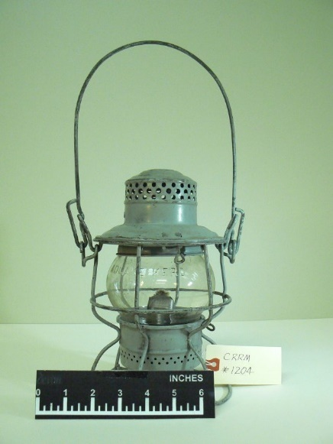
Station #5: The “Art” of Trains

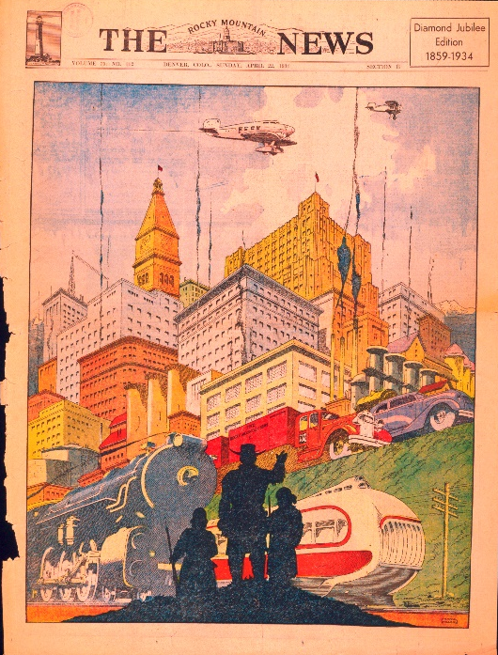
5A: The Rocky Mountain News (1934)
This is the cover page for the Rocky Mountain News’ Diamond Jubilee Edition, 1859-1934. It is no surprise that they chose to show the many technological changes that the Denver area had been through in their 75 years. Top amongst items identified were forms of transportation: airplanes, automobiles and of course, trains!

Look at the illustration and discuss:
- Why did the artist choose the two trains that he did?
- What difference did trains, automobiles and airplanes make in Denver’s history?

Images Courtesy of the Colorado Railroad Museum

5B: Poster advertising travel by train (1920s)
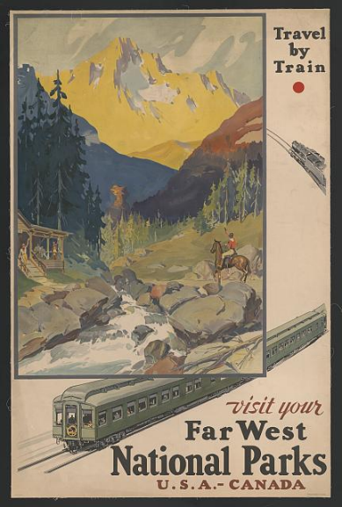
One way to interest people in traveling by train was through advertising. This 1920 poster encourages people to take the train to visit national parks out west!

Would this poster make you want to take the train? Why or why not?

Source: The Library of Congress https://www.loc.gov/resource/ds.11688/

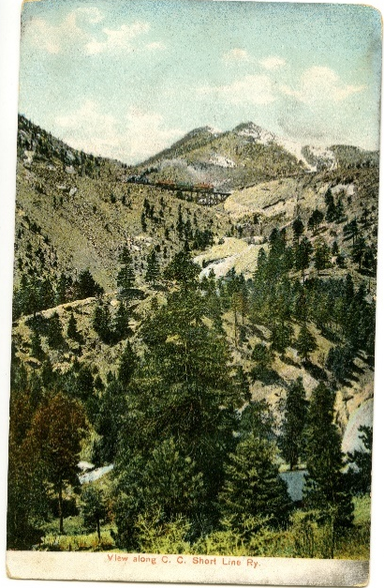
5C: Cripple Creek Short Line Postcard
The Cripple Creek Short Line was a standard gauge railroad that operated a 6.25 mile route with an overhead line between Cripple Creek and Victor, Colorado. It brought tourists up the mountain and took ore down for delivery to the mills.

Tourists riding the train would purchase postcards picturing the beautiful scenery as a reminder or a way to share their experience with friends and family.

How do you share experiences with your friends and families? Postcards, selfies, or in real time with facetime?

Images Courtesy of the Colorado Railroad Museum

Station #6: What time is it?

6A: Denver and Rio Grande Railroad Timetable, 1894 (Cover)
Timetables provided a schedule of the movements of trains. They included a list of trains, locations along railroad lines, and times of arrivals and departures at stations.

Overtime, timetables changed as guidebooks for crossing the country with advertisements suggesting places to stay, eat, and even where a person could buy good land. Today, they are among the most popular railroad collectibles, known mostly for their artwork.

How do you find out a train, bus, or plane schedule today?

Image Courtesy of the Colorado Railroad Museum

6B: Denver and Rio Grande Railroad Timetable, 1894
Timetables provided a schedule of the movements of trains. This timetable shows the times when the train visits Denver, Colorado Springs, and Pueblo.

What other towns and cities did the Denver and Rio Grande go through?
Image Courtesy of the Colorado Railroad Museum

6C: Standard Time
Watch a short video about Standard Time: https://www.brainpickings.org/2014/03/19/standard-time-ted-ed/
Standard time: Why was it important for the railroads to standardize time?

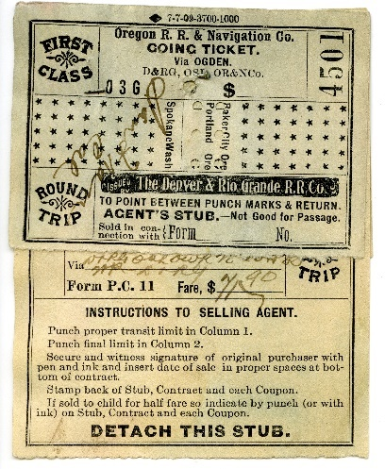
6D: Oregon R.R. & Navigation CO Ticket
Image Courtesy of the Colorado Railroad Museum

This Denver & Rio Grande Western Railroad ticket took its passenger from Denver, CO to Boulder, CO. The final destination of this train was Durango, CO.

If you look closely you will be able to determine the month, date and year the passenger traveled by looking at where holes were punched into the ticket. The train conductor did this. The railroad could even tell you who punched a ticket by the shape of the holes. Each conductor had a specially shaped punch.

If we look carefully, what else can this ticket tell us?

Station #7: Mail Delivery

7A: A Train Picking Up a Mailbag
This short movie is from 1903. Watch it closely. How was mail delivered by train as shown in this movie?

How is mail delivery different today?

In the 1930s many railroads struggled to keep from going bankrupt. The Rio Grande Southern (RGS) came up with a rather clever solution – a car modified to operate on rails called the Galloping Goose.

The first goose was built from a Buick. It could easily carry mail, a small cargo, and a small number of passengers needing to travel between the mountain communities. It also took fewer crew members (just 1) than the 5 needed to operate a steam powered passenger train. All of this made the Goose much less expensive to run than a steam locomotive. It is not surprising that the RGS built six more and used them into the 1950s.

Train Picking Up Mailbag, 1903 (Video)
Library of Congress
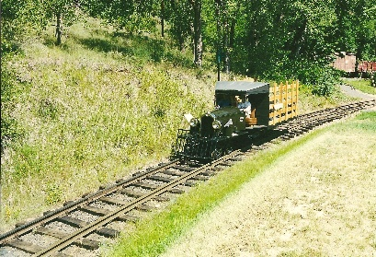
7B: The Galloping Goose

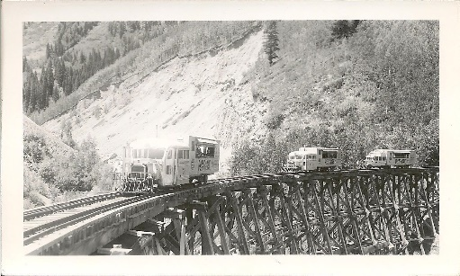
This picture shows 3 of the Galloping Geese crossing a train trestle (bridge). The Rio Grande Southern Railroad made a total of 7 Galloping Geese.

Images Courtesy of the Colorado Railroad Museum

Extra Source 1  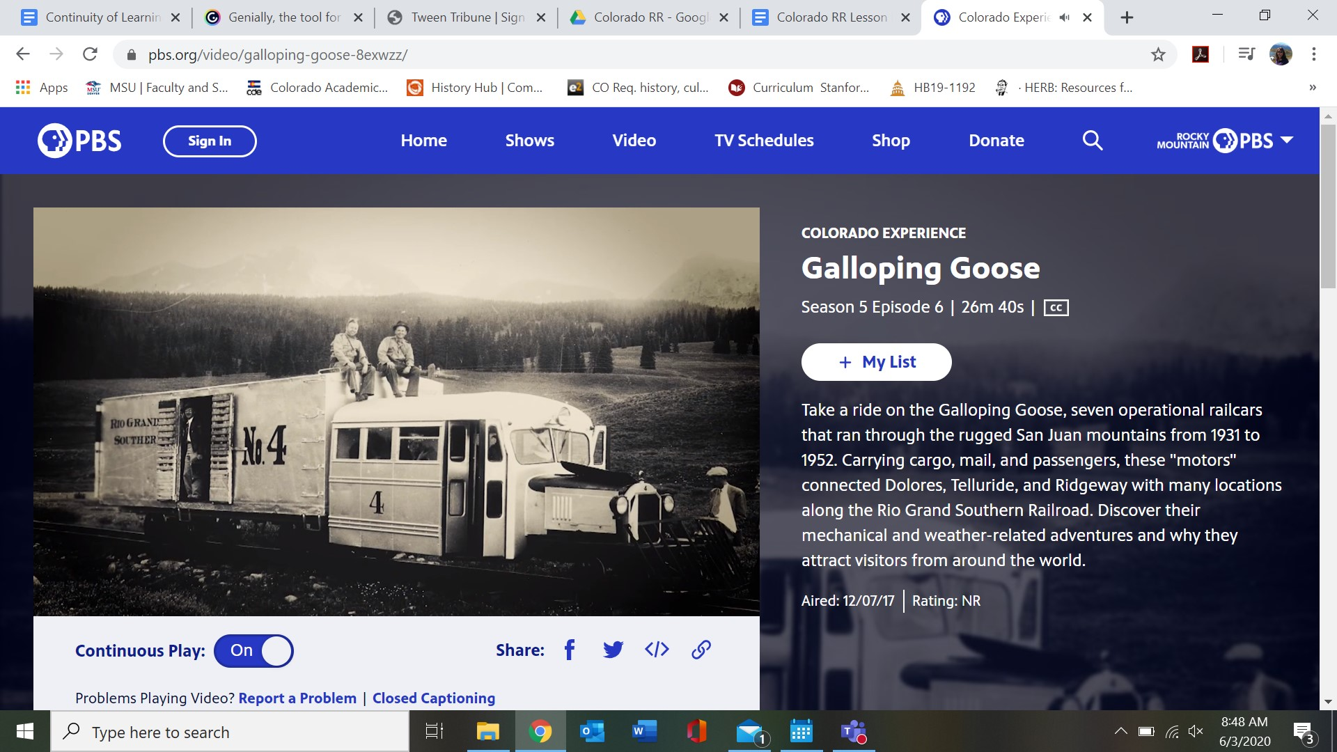  The Colorado Experience: Galloping Goose  https://www.pbs.org/video/galloping-goose-8exwzz/ | This video from Rocky Mountain PBS gives a look into the Rio Grande Southern Railroad and the work of the Galloping Goose.

