Grade Level:
Elementary / 3

Essential Question:
How does do Colorado’s geographic regions influence the development of rural, urban, and suburban areas?

Supporting Questions:
- What are geographic characteristics of a region?
- What physical features make a region unique?
- How do the characteristics of a region influence how we live?

Source 1  - Albert Bierstadt, Wind River, Wyoming, c.1870.  - https://www.anschutzcollection.org/museum/anschutz-collection/hudson-river-rocky-mountain-schools/  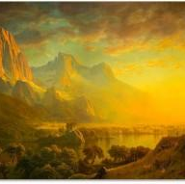 | Source 2  - First home of Mrs. Margaret Schneider, Seibert, CO, c. between 1889-1900  - http://digital.denverlibrary.org/cdm/singleitem/collection/p15330coll21/id/10356/rec/1  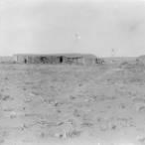

Background Knowledge / Contextual Paragraph for Teachers:
Colorado is typically divided into five regions: The Great Plains, The Southern Rocky Mountains, The Colorado Plateau, the Wyoming Basin, and the Middle Rocky Mountains. The characteristics of the various regions influence the way people live: what materials they used to build their homes; what industries developed in the region; and what cultural traditions emerged, etc.

Building Background Knowledge for the Student
- KWL chart - what do you want to know about the geography of Colorado?
- Handout a landform map (http://tmjackson.pbworks.com/f/Scan_Pic0006.jpg) 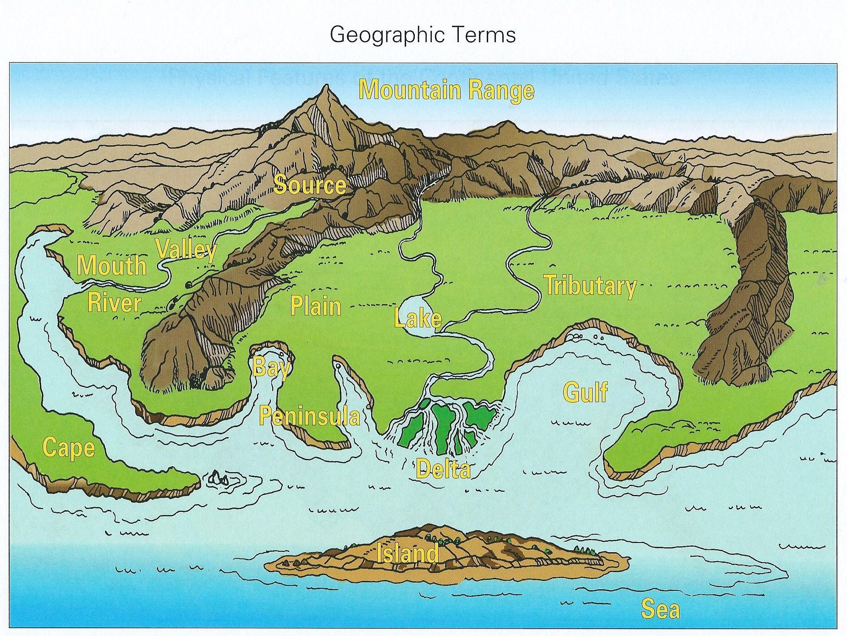
- Have students circle the geographic features found in Colorado
- Students can then brainstorm definitions for the terms: region, characteristic. Ask how Colorado’s geographic features form different regions.

Strategy Instruction: Modified Jigsaw
- Divide students into 5 groups. Each group should receive a primary source.
- Ask students to complete a primary source analysis sheet for their source.
- One student from each of the 5 groups then moves into a group that contains each of the 5 sources.
- Students share their discoveries from each source.
- Ask students to discuss how their source reflects a particular region of Colorado.
  - What are the characteristics of that region based on their source?
  - What evidence in the source illustrates that region’s characteristics (e.g., a sod house in the plains)

Strategy Instruction Differentiation:
N/A

Discussion:
- How does the geography of where we live influence how we live?
- How do physical features provide opportunities and challenges to regions?
- What are the characteristics of the region surrounding our community?
- What are the similarities and differences among the regions of Colorado?
- How has the region changed and yet remained the same over time?

Assessment: Compare/Contrast (http://timvandevall.com/wp-content/uploads/2013/10/Compare-and-Contrast-Graphic-Organizer-1.jpg )
Students complete a compare/contrast graphic organizer comparing the characteristics of their community’s region to that of another community.

Curriculum Standards:
- CO Standard 1- History: 3.1.2.c - Give examples of people and events, and developments that brought important changes to a community or region
- CO Standard 2 - Geography: 3.2.2.d - Characterize regions using different types of features such as physical, political, cultural, urban and rural

Reading and Writing Standards:
- CO Standard 4 – Research and Reasoning: 3.4.4.b - Recall information from experiences or gather information from print and digital sources; take brief notes on sources and sort evidence into provided categories.

Sample Activities:
Create a caption - Students could create a caption for either “dust storm” or “Colorado, our wonderful mineral production…”

Extra Source 1  - Birds eye view of Colorado Springs, Colorado, c. 1888  - http://digital.denverlibrary.org/cdm/singleitem/collection/p16079coll39/id/3/rec/48  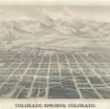 | Extra Source 2  - Dust storm, c. 1934  - http://digital.denverlibrary.org/cdm/singleitem/collection/p15330coll22/id/4962/rec/2  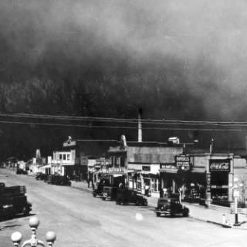
Extra Source 3
- Colorado, our wonderful mineral productions a view of the new city of Leadville, 10,500 feet above the level of the sea -from a sketch by E. Jump, c. ~ 1875-1880
- http://digital.denverlibrary.org/cdm/singleitem/collection/p15330coll22/id/12097/rec/45
