Grade Level:
4th Grade

Essential Question:
Why is it important to learn what happened to all of the buffalo?

Supporting Questions:
- What happened to all of the buffalo?
- How and why were the buffalo so important to Indians?
- Who hunted the buffalo and why were they hunted to such a degree?
- How did the Euro Americans and Native Americans contribute either together or separately to hunt buffalo?

Source 1  1907 postcard photograph of buffalo titled “Adam and Eve of America”  In 1907 the Ridgley Calendar Company of Great Falls, Montana printed postcards with this picture on the front. They called this picture the “Adam and Eve of America.”  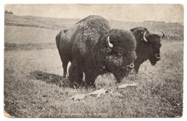  Source: online image available at: http://www.thegalerii.com/historic%20photos/miscellaneous/buffalo/buffalo.htm | Source 2  Kiowa Indian, Old Lady Horse, talking about the buffalo, around 1900 and from a current Kiowa novelist, N. Scott Momaday.  The Kiowa Indians moved around to follow buffalo herds before Euro-American settlers came to the area that became Kansas and Colorado. In this quote from around 1900, a Kiowa Indian woman described what the buffalo meant to her people:  “Everything the Kiowas had came from the buffalo. Their tipis were made of buffalo hides, so were their clothes and moccasins. They ate buffalo meat.... Most of all, the buffalo was part of the Kiowa religion.... The buffalo were the life of the Kiowas.”  -Old Lady Horse  “The buffalo, which was the animal representation of the sun, was the sacrificial victim of the sundance. The Sun Dance was a great celebration, a great social occasion. And the Sun Dancers were expressing their spirit in order to gain certain power. They wanted to be victorious in war. They wanted to give thanks for something good that had come to them. A buffalo bull is sacrificed, and its head is impaled in the Sundance lodge or near it. And it's part of the ritual; you can't have a Sundance without the buffalo.”  -N. Scott Momaday  Source: Ken Burns video, “The West: Episode 5, The Grandest Enterprise Under God,” Available online at: http://www.pbs.org/weta/thewest/program/episodes/five/whitemanspipe.htm
Source 3  On the Trail - Buffalo hunt  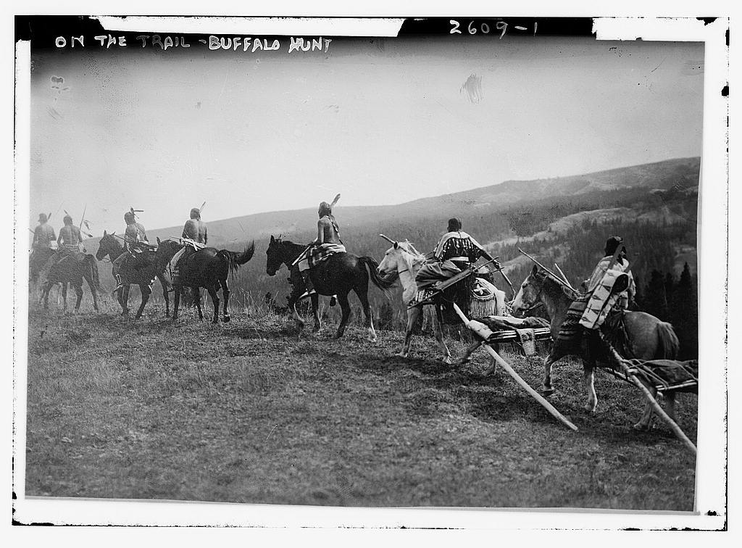  Source: https://www.loc.gov/item/ggb2005012290/ | Source 4  “The Gathering of the Herds” from the American Museum of Western Art  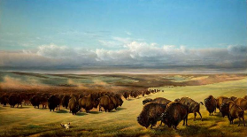  "William Jacob Hays, Sr. (August 8, 1830-1875). The Gathering of the Herds, 1866" [Source - Located at the American Museum of Western Art in downtown Denver.  Available Online: http://education.anschutzcollection.org/artists-and-nature/

Source 5:  The Buffalo Hunter - Buffalo Bill overview, Edison video, connection with buffalo.  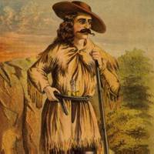  Source: Library of Congress https://lccn.loc.gov/94507313  Buffalo Dance movie: https://www.loc.gov/item/00694114/ | Source 6  The far west - shooting buffalo on the line of the Kansas-Pacific Railroad  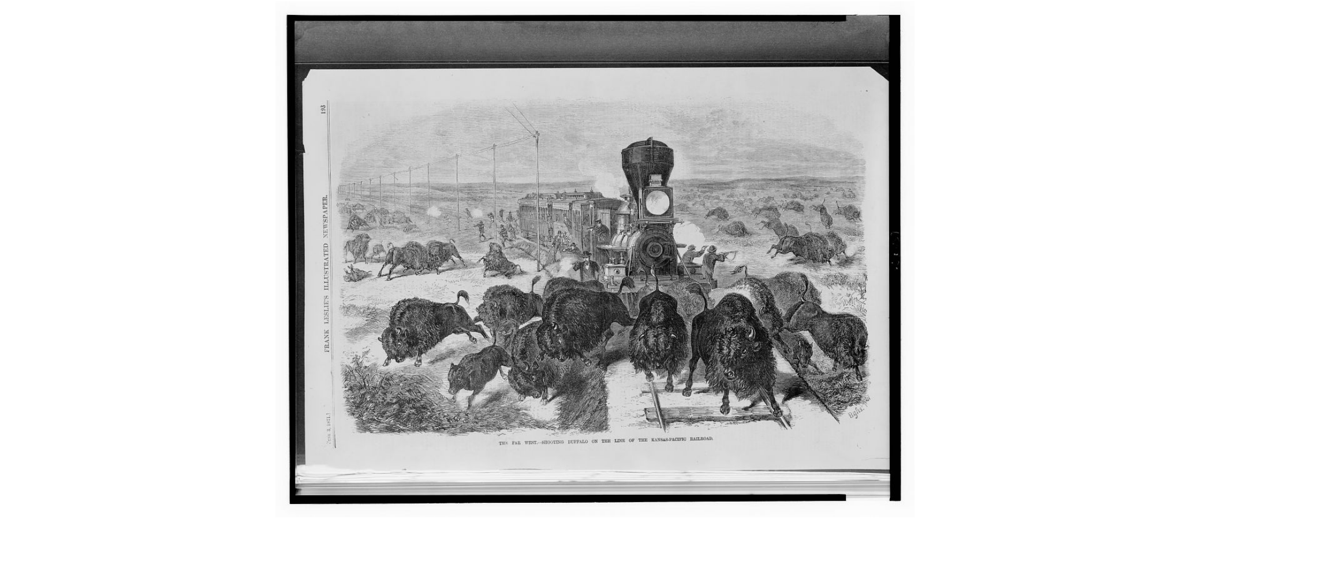  Source:  https://www.loc.gov/resource/cph.3c33890/
Source 7:  Buffalo hunt in the wild west  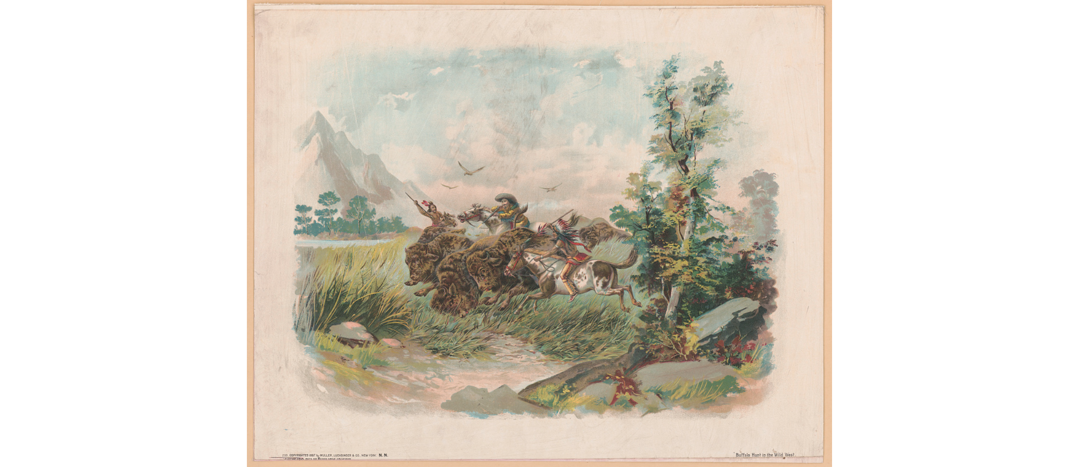  Source: Library of Congress https://www.loc.gov/resource/pga.07732/ | Source 8:  J. Klima photograph, Buffalo Skulls Michigan Carbon Works, Detroit, Michigan. (n.d.)  This photograph shows two men and lots of buffalo skulls piled up in Detroit in what was called a “Bone Yard.”  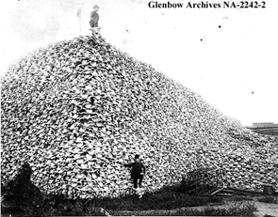  Source: National Parks Service https://www.nps.gov/articles/bison-bellows-11-12-16.htmv

Background Knowledge / Contextual Paragraph for Teachers:
This set of primary sources helps students understand why the buffalo mattered so much to Plains Indians. Less clear is why Euro Americans chose to hunt the buffalo so aggressively and nearly wipe out these herds. The discussion of these sources can help students understand the buffalo’s importance to Native Americans and the effect it had on those who relied on buffalo for shelter, food, and their cultural rituals.

This lesson can be linked to a lesson on the expansion of the railroad throughout Colorado and the rest of the United States. Also, this lesson could be linked to a further discussion on Buffalo Bill and his Wild West Show and the Buffalo Soldiers. This lesson is a great starting point for many lessons relating to Native Americans and the American West in general.

Special Note: In 2016, the Bison became the official mammal of the United States - http://time.com/4311574/bison-national-mammal/

Building Background Knowledge for the Student:
Also called the bison, the buffalo lived for thousands and thousands of years along the eastern plains that became Colorado. They moved in giant herds across the grass-covered plains of North America. Some historians estimate there were once as many as 50 million buffalo roaming the Great Plains. Native American tribes like the Cheyenne, Arapaho, Kiowa, and Ute all relied on the buffalo for their survival.

When white, Euro-Americans started moving to the territory that became Colorado, life for the buffalo began to change. New settlers preferred to raise cows for milk and beef. They also brought pigs that needed to be fenced into pens so they would not wander off. Buffalo hunters and Native Americans were encouraged to hunt the buffalo in excessive waves of attacks. By 1900, these magnificent animals were nearly extinct due to mass hunting as well as diseases that were introduced by domestic cattle.

In many Native American tribes, their culture, rituals, and daily life relied on buffalo. For them, the buffalo were used as shelter, for food, and as an important symbol of their belief systems.

Strategy Instruction:
Using the questions in the Discussion section below, you can guide students in primary source analysis. To begin with, you can use the primary source worksheets located on the right sidebar of the CDE Elementary Primary Source Sets website. These worksheets are a great way to begin the discussion.
Another effective strategy to use with primary source images is the Zoom-In primary source strategy. An example of this activity using Buffalo Bill can be seen and adapted here. Feel free to make a copy of this Google Presentation and adapt it for any of the pictures above. Simply importance a new image, crop it to your liking for each slide, and adapt the questions to the specific primary source. This strategy is a great way to analyze primary sources in segments so students are forced to focus on specific parts of the image.
For the quotes in Source 2, use an adaptation of the Sentence, Phrase, Word activity. This literacy activity encourages students to focus on important parts of a passage and allows them to connect a sentence, phrase, and word to their own lives and passions.

For any of the resources, utilize the Four Fold Concept and Vocabulary Building activity to help students understand these historical concepts and terms. This literacy and historical thinking activity allows students to collaborate and dive into a topic that interests them in order to gain a deeper understanding of it. Students will list, rank, compare, and illustrate what the concept means.

Have students read the Colorado Encyclopedia’s article on Buffalo Bill that is leveled for 4th graders. Ask students to write a summary of Buffalo Bill and how he gained the nickname. How does his legacy give insight into how the buffalo were hunted and his relationship with Native Americans.

Strategy Instruction Differentiation:
Students will view different forms of images, including a painting, drawings, image from a newspaper, and photographs. Students will also read passages from Kiowa Indians from a documentary.

Discussion:
Students can study the individual images, a video, and a short reading to begin to answer the essential question about the buffalo. Each source has useful clues for thinking about why buffalo mattered so much to the Native Americans.

Source 1: This photograph of buffalo was titled, “The Adam and Eve of America.” Who were Adam and Eve? Why might the photographer have given a picture of two buffalo that name? Do these animals look dangerous? How big do you think they were? Have you ever seen a buffalo in real life before?

Source 2: This quote is from a Kiowa Indian and a Kiowa novelist who describes the importance of buffalo in their culture. In what different ways did the Kiowa use the buffalo? Why were buffalo so important to them? What would life for the Kiowa be like if all the buffalo were killed?

Source 3: This image shows a photograph of Native Americans on a buffalo hunt. How do you think the Native Americans hunted buffalo? How is this different from how you might think Euro Americans hunted buffalo? What do you think the objects they are carrying and dragging by their horses are for? What do you think the significance of how the Native Americans and their horses are dressed?

Source 4: This painting was created in 1866. This was about the same time that the photograph of buffalo skulls was taken. How do you think this image was actually painted? Why might the artist want to paint the buffalo like he did? What is the significance of the buffalo skull found at the bottom of the painting?

Source 5: This resource is a short summary and picture of Buffalo Bill, and an Edison video of a Buffalo Dance performed by Sioux Indians in Buffalo Bill’s Wild West Show. Why was he named Buffalo Bill? What is the significance of the story about the Grand Duke? Why do you think the Sioux Indians performed the dance in the way that they did? What do you think the music sounded like?

Source 6: This print shows hunters shooting at a herd of bison from a train and along the tracks from 1871. Why were they shooting all of these buffalo? Were they shooting them for a purpose? Once the buffalo were killed, what do you think happened to them?

Source 7: This image shows a white man shooting a buffalo with a gun and two Native Americans using spears from 1897. How do the hunting styles differ? Why do you think they are hunting together? How and why do you think the Native Americans and white people worked together when hunting? How do you think they worked together in general?

Source 8: Here is photograph from Detroit, Michigan. What is the man in the middle standing on? What could have happened to create this giant pile? Why might it be in Detroit instead of Colorado or Kansas where the buffalo lived in such great numbers? What motivated Euro Americans to make a pile like this?

Assessment:
Ask students to answer the essential question and supporting questions each in a short paragraph. Assess them on their ability to synthesize the information presented.

You can also ask students to do further research in order to create a presentation in groups that will be presented to the rest of the class on a topic from the from this lesson, including buffalo hunting, Native Americans, buffalo bill, Euro-American migration, etc.

Colorado Academic Standards: Social Studies
- SS4. S1. GLE1. EOb: Identify cause-and-effect relationships using primary sources to understand the history of Colorado’s development.
- SS4. S1. GLE4. EOc: Explain, through multiple perspectives, the human interactions among people and cultures that are indigenous to or migrated to present-day Colorado. Including but not limited to: historic tribes of Colorado, the Ute Mountain Ute, Southern Ute, Spanish explorers, trappers, and traders.
- SS4. S2. GLE2. EOc - Analyze how people use geographic factors in creating settlements and have adapted to and modified the local physical environment.

Reading and Writing Standards:
- RWC Standard 2 - Reading for All Purposes: 4.2.2a - iii. Explain events, procedures, ideas, or concepts in a historical, scientific, or technical text, including what happened and why, based on specific information in the text.
- RWC Standard 3 - Writing and Composition: 4.3.3a - Produce clear and coherent writing in which the development and organization are appropriate to task, purpose, and audience.

Sample Activities:
- Create a timeline of the American West and the buffalo hunts.
- Have students create short stories from a person, animal, or object in one of the primary sources.

