Grade Level: 2

Essential Question:
How has the Auraria neighborhood changed over time?

Supporting Questions:
How do communities change over time?
How do different cultures and beliefs influence a community?
What are the various groups in a community and how are they alike and different?

Source 1  Photo Slideshow  https://docs.google.com/presentation/d/1MfsUv1P3Cy1oNddaYaK4kNkNwOSlwIRJP-XvUD3PSL4/edit#slide=id.g216fdcaa93_0_76 | Source 2  Book Title: A Brief History of Auraria: Celebrating 20 Years of Innovation in Higher Education Chapter Title: Auraria’s Ethnic Communities and Their Legacy (Used for sources 2-4)  The German Settlers  Campus Landmark: St. Elizabeth’s Church  “Auraria housed many ethnic groups during the next century… a large German population also immigrated to Denver in the 1860s, and many of these newcomers settled in Auraria…  The church [St. Elizabeth’s] played a central role in the lives of German immigrants and other ethnic groups at Auraria…  Campus Landmark: The Tivoli Student Union  In 1859, German-born Moritz Sigi opened Denver’s second brewery on Tenth Street between Larimer and Market… Under the brewery’s second owner, Max Melsheimer, the prominent mansard tower was constructed that still dominates the campus today… In 1900 John Good bought the building and renamed it Tivoli, after the world famous gardens in Copenhagen, Denmark.  The Tivoli prospered until the 1960s, when the 1965 South Platte flood and a subsequent labor strike forced closure on April 25th, 1969. The building was slated for demolition in 1972, when the Denver Landmark Preservation Commission convinced City Council to landmark the structure. The Denver Urban Renewal Authority purchased Tivoli with the help of federal funds, and transferred the property to the Auraria Higher Education Center…  In 1991, students at Auraria voted to assess themselves $3 per semester to reacquire the building and remodel it as a combination student union/retail center…” (pg. 8-9)  Fetter, R. (1997). The German Settlers. In A Brief History of Auraria: Celebrating 20 Years of Innovation in Higher Education (pp. 8-9). Denver, CO: Office of the Executive Vice President for Administration at the Auraria Higher Education Center.
Source 3  The Auraria Irish  “Auraria’s substantial Irish Catholic population originally attended services with the Germans at St. Elizabeth’s, but cultural barriers and the emphasis on German language soon threatened to split the parish…  John K. Mullen, a millionaire milling mogul who got his start in the Auraria neighborhood, donated land at Tenth and Colfax for St. Leo the Great, the second Catholic Church in the tiny Auraria community… In May, 1891, its pastor, community leader Father William O’Ryan, had to raise $11,200 to save the church from foreclosure. Mullen provided $10,000, which was supplemented by Sunday collections.  In the 1920s immigrants from Mexico began moving into Auraria. Once again, cultural differences arose between two ethnic groups using the same church. In 1923 John K. Mullen helped finance the construction of St. Cajetan’s for Auraria’s Hispanic residents – the third Catholic Church in a six-block radius.  By 1965 most of the Irish families who had supported St. Leo’s had moved out of the neighborhood and, of course, the Spanish-speaking Catholics had their own church. After three quarters of a century, St. Leo’s was torn down just four years before historic preservation efforts associated with construction of the campus might have saved it…” (pg. 10-11)  Fetter, R. (1997). The Auraria Irish. In A Brief History of Auraria: Celebrating 20 Years of Innovation in Higher Education (pp. 10-11). Denver, CO: Office of the Executive Vice President for Administration at the Auraria Higher Education Center. | Source 4  Hispanic Auraria  Campus Landmark: St. Cajetan’s Center  “To serve Hispanic Catholics, St. Cajetan’s Church was constructed in 1925 on land donated by J.K. Mullen at Ninth St. and Lawrence…  …Many of the buildings were designed by Temple Hoyne Buell, a regular visitor to the neighborhood’s famous Mexican restaurant, the Casa Mayan.  St. Cajetan’s parish served as both a spiritual and social center for the Hispanic community. Says former Auraria resident Magdalena Gallegos, ‘The lives of the Spanish-speaking people in Auraria revolved around their church. This was the place where the met weekly, made friends, and watch the children of other families grow.’  Over the decades, Auraria slowly changed from a residential area to an industrialized district. From 823 homes and apartments in 1940, the number dropped to 134 in 1968. In the late 1960s, Denver’s prime era of urban renewal, the neighborhood was chosen as the future location for the new Auraria Higher Education Center. Although many long-time neighborhood residents protested, the City passed a $6 million bond issue to help fund the Auraria renaissance in 1969.  Auraria residents were given funds for relocation, even if they were renters. Homeowners could be paid as much as $15,000 over market value of their property, and tenants were eligible for up to $4,000 in rent supplements as a down payment toward home ownership… For others it meant leaving a neighborhood that had been home for generations.  In June 1975 the congregation moved from the old St. Cajetan’s to a new church in southwest Denver. They took along the church bell, the circular stained glass windows above the front doors and for some, memories of many happy years together. In the 1980s the Displaced Aurarians organization was founded by former residents, who occasionally hold neighborhood reunions on the campus.” (pg. 14-15)  Fetter, R. (1997). Hispanic Auraria. In A Brief History of Auraria: Celebrating 20 Years of Innovation in Higher Education (pp. 14-15). Denver, CO: Office of the Executive Vice President for Administration at the Auraria Higher Education Center.
Source 5:  A.P. Mine (Between 1890 & 1900?)  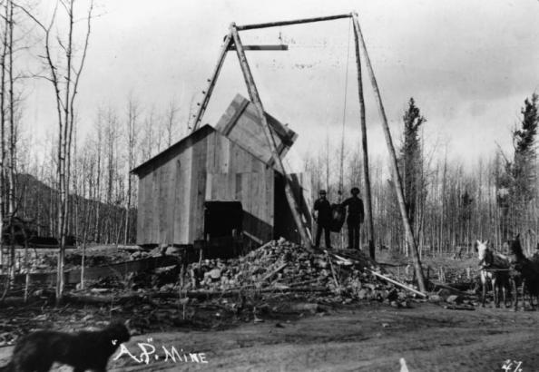  https://history.denverlibrary.org/sites/history/files/cdm_21766_0.jpg | Source 6:  St. Cajetan’s  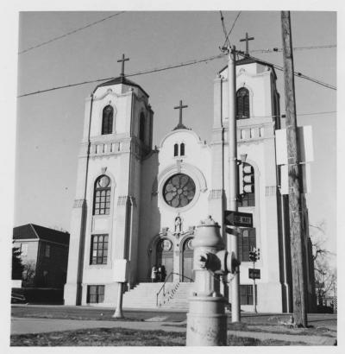  https://history.denverlibrary.org/sites/history/files/cdm_20.jpg
Source 7: Aerial view of Auraria/Lincoln Park before 1977 - prior to the construction of the Auraria campus  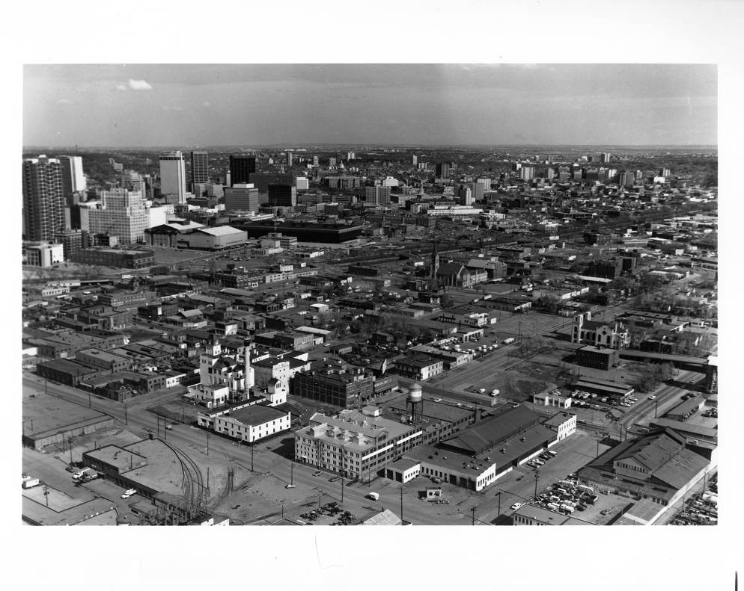  http://digital.denverlibrary.org/cdm/singleitem/collection/p15330coll6/id/45/rec/33 | Source 8: Robinson Atlas of the City of Denver (Plate 01)  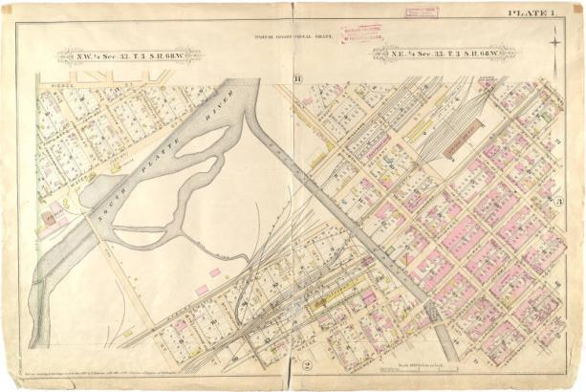  Auraria, Denver’s oldest neighborhood, predates the city’s establishment, and its history neatly encompasses the city’s founding, its development, and its redevelopment as a modern urban center.  https://history.denverlibrary.org/auraria-neighborhood

Background Knowledge / Contextual Paragraph for Teachers: Auraria began as one of Denver’s first neighborhoods (1858) with multiple ethnic immigrant groups settling in the area. The stories provided in this text set provide details on German, Irish, and Hispanic groups that played a role in the changing of Auraria. The Germans were the first to settle in Auraria bringing a church, St. Elizabeth’s, and the Tivoli Brewery. Today both of these landmarks can still be found and are in use for different reasons on the Auraria Higher Education campus. The Irish were the next group of immigrants to settle in Auraria. After cultural differences arose while sharing St. Elizabeth’s, the Irish opened their own catholic church, St. Leo’s, in the small town of Auraria. After the Irish found themselves successful in Auraria, they began to move from the working-class neighborhood into middle class neighborhoods. The Hispanic immigrants were the last to live in and bring cultural history to Auraria before it would become a college campus in 1965. St. Cajetan’s is the third catholic church to be built within a 6 block radius of the other two churches already in Auraria. The famous Casa Mayan restaurant was run out of a Hispanic family’s home. Families of all three ethnic descents lived and ran businesses out of houses located on 9th Street, now known as the 9th Street Historic Park on the college campus after it was preserved at the time of displacement. When the campus began being built the number of homes being used in Auraria had dropped to 134 from up around 800 at its peak time of thriving as a working-class neighborhood.

The photographs used within this text set provide a visual way of noticing the changes being made to the area known as Auraria. Landmarks such as, St. Elizabeth's, 9th Street, the Tivoli, and St. Cajetan’s can be seen both at the time of being a neighborhood and a college campus, however, the uses differ. These locations serve as meeting locations, a student union, restaurants, and more on the college campus. At the time of Auraria the neighborhood they were churches, homes, restaurants, and strictly a brewery. The Auraria Higher Education center is thriving as three college campuses, but the history of Auraria the neighborhood is not lost as students whose ancestors settled Auraria reminisce about the stories they have heard and also through the preserved landmarks.

For additional information: https://history.denverlibrary.org/auraria-neighborhood

Citations:
“Auraria History.” Auraria Casa Mayan Heritage. Web. 25 May 2017. < http://acmh.cfsites.org/custom.php?pageid=39440>
“Auraria’s First Immigrant Groups.” CU Denver History Department. History in Colorado, 6 May 2016. Web. 25 May 2017. <http://www.historyincolorado.org/auraria-history/aurarias-first-immigrant-groups>.
Brown, J. “Kids of ‘displaced Aurarians’ find campus life bittersweet.” Denver Post. Web. January 29, 2006. http://www.denverpost.com/2006/01/29/kids-of-displaced-aurarians-find-campus-life-bittersweet/.
Fetter, R. (1997). Auraria’s Ethnic Communities find Their Legacy. In A Brief History of Auraria: Celebrating 20 Years of Innovation in Higher Education (pp. 8-15). Denver, CO: Office of the Executive Vice President for Administration at the Auraria Higher Education Center.

Building Background Knowledge for the Student

- To activate students’ background knowledge and/or build it on the topic of why neighborhoods change perform an interactive read aloud using the book, The Little House by Virginia Lee Burton.
- Begin with class discussion: Prior to reading
  - What is your neighborhood like?
  - Has it/is it changing? How?
  - Why might neighborhoods change? What is the reason/cause?
- Interactive read aloud: During read aloud
  - Students will interact with the reading by drawing the little house, the changes taking place around Little House, and how Little House is feeling throughout the story.
  - Students will also make predictions, reflect on, and summarize throughout different parts of The Little House reading
  - Students will be able given the opportunity to ask questions about why the little house’s surrounding area changing. They will also be given the opportunity to reason with why that area might have been developed and why the little house’s new location is the right fit.
- Class discussion: After reading
  - Discuss the book as a whole. Be open to questions, reflections, and ideas.
  - Relate the book to the students’ lives. For example, if someone told you they needed your bedroom for storage and completely changed the way things are for you to accommodate them, how would you feel? How would you react to the situation?
  - Has anyone seen or heard of neighborhoods changing the same way that the Little House’s neighborhood changed?

STRATEGY INSTRUCTION:
SOURCE 1:
See-Think-Wonder
  - Students will watch a photo slide show made up of a compilation of photographs to build understanding about Auraria.
  - Build a timeline
  - Students will more deeply examine the pictures and dates from the virtual tour and collectively build a timeline to organize the events of how Auraria has changed.

SOURCES 2-4:
Teacher Led Close Read
  - The students will perform a close read on three excerpts from A Brief History of Auraria: Celebrating 20 Years of Innovation in Higher Education by Rosemary Fetter in order to add the impacts that three different cultures had on Auraria to the class timeline.
  - Save The Last Word for Me
  - Provide an opportunity for students to choose a quote that resonates with them after the close read that clarify the content and provide active engagement for all students, in which all students have a voice.

SOURCE 5:
Activity: Compare and Contrast Pictures
  - The students will be looking at pictures of Auraria from then and now to be able to see how it has physically changed. Looking at the plaques from the houses on 9th street and seeing how the houses are being utilized now will help them make connections between the past and present. Teachers can find pictures of the actual houses if students want more of a visual. It would also be helpful for teachers to pull up the Metropolitan State University of Denver website to show the students pictures of what the campus looks like now.

Strategy Instruction Differentiation:
- In the building background, the students will listen to an audio of The Little House and visually see the pictures as it is being read to them.
- In source 2 where the students are doing a close read, the article is being read to the class by the teacher in order to process the context, instead of getting stuck on vocab. The class also fills out a graphic organizer of their senses relating to the article. They have the choice of writing, drawing, or speaking their responses within the given graphic organizer.

Visualizing with My Senses Chart:
- While listening to the teacher read the article Kids of “displaced Aurarians” Find campus Life Bittersweet, the students will be thinking about the five senses on the visualization chart. Then the teacher will read the article again and the students will go through and fill out the visualization chart (https://www.teacherspayteachers.com/Product/Visualization-Graphic-Organizer-1308457) either by drawing pictures, or writing. Students should be making connections between how Partha Monge feels, and how they would feel. It is important they are relating their thoughts to the correct box. Students might have different ways of interpreting the article, and that is ok. They should then write one to two sentences describing each box within their box.
- Have the students do a think-pair-share with a partner about their finished product. The teacher should help guide their discussions by asking questions like, Did you both draw/write similar ideas? What did you interpret that was the same? What did you interpret that was different? Why do you think two people can think about the same event differently? The students should be thinking about the similarities and differences between Partha Monge and Auraria, as well as what the partners shared as their similarities and differences.

Assessment:
- Have students write a final hypothesis answering the inquiry question. Then, they can make a poster displaying what they said in their final hypothesis using pictures, drawings, and anything else they need to show their ideas. The class can then see each other’s similarities and differences of thought through a gallery walk.

Curriculum Standards (social studies):
- SS2.S1.GLE2. EOb: Compare and contrast past and present situations, people, and events in neighborhoods, communities, and the nation (DOK 1-2).
- SS2.S1.GLE1.EOe: Create timelines to understand the development of important community traditions and events (DOK 1-3)
- SS2.S1.GLE2.EOa: Organize the historical events of neighborhoods and communities chronologically (DOK 1)
- SS2.S1.GLE2.EOc: Give examples of people and events, and developments that brought important changes to the community (DOK 1-2)
- SS2.S1.GLE2.EOe: Describe the history, interaction, and contribution of the various peoples and cultures that have lived in or migrated to neighborhoods and communities (DOK 1-2)
- SS2. S1. GLE 2: EOc: Give examples of people and events, and developments that brought important changes to the community
- SS2. S1. GLE 2: EOe: Describe the history, interaction, and contribution of the various peoples and cultures that have lived in or migrated to neighborhoods and communities

Reading & Writing Standards:
- RWC2. S2. GLE 2: EOa (i): Demonstrate use of self-monitoring comprehension strategies: rereading, checking context clues, predicting, questioning, clarifying, activating schema/background knowledge to construct meaning and draw inferences
- RWC2. S2. GLE 2: EOa (iii): Describe the connection between a series of historical events, scientific ideas or concepts, or steps in technical procedures in a text. (CCSS: RI.2.3)
- RWC2. S4. GLE 2: EOb: Identify a specific question and gather information for purposeful investigation and inquiry
- RWC2. S1. GLE1. EOb: Contribute knowledge to a small group or class discussion to develop a topic.
- RWC2. S3. GLE1. EOc: Organize ideas using pictures, graphic organizers, or story maps.
- RWC2.S4.GLE1.EOe: Recall information from experiences or gather information from provided sources to answer a question. (CCSS: W.2.8)
- RWC2.S4.GLE2.EOa: Participate in shared research and writing projects (e.g., read a number of books on a single topic to produce a report; record science observations). (CCSS: W.2.7)
- RWC2. S1. GLE 2: EOb: Recount or describe key ideas or details from a text read aloud or information presented orally or through other media.

