Grade Level:
1st Grade

Essential Question:
Why do we have national symbols?

Supporting Questions:
- Who decided what the national symbols should be?
- How do the national symbols tell the story of the American people?
- What is the meaning/significance of our national symbols?

Source 1  - The American Flag  - http://hdl.loc.gov/loc.pnp/fsa.8e01464  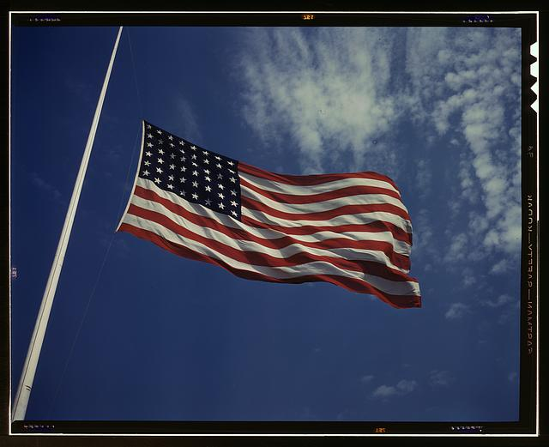 | Source 2  - A present day picture of the Statue of Liberty  - http://www.loc.gov/pictures/item/ny1251.color.570001c/resource/  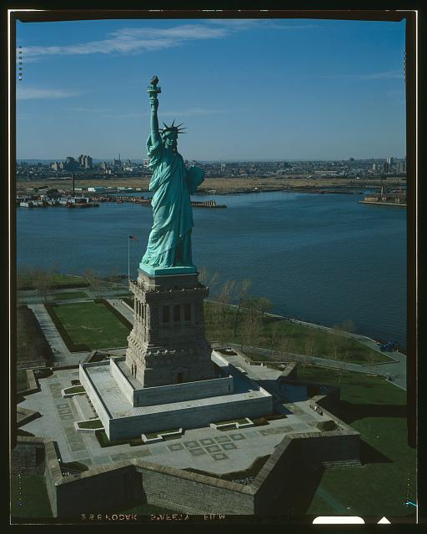

Background Knowledge / Contextual Paragraph for Teachers:
Every nation has symbols—specific objects that represent beliefs, values, traditions, or other intangible ideas that make that country unique. While these symbols may change over time, they can help to bind a nation together by reminding its
people of their nation’s history and most important principles. Here are background information links for each of the national symbols:
The American Flag http://www.pbs.org/a-capitol-fourth/history/old-glory/
The Statue of Liberty http://www.libertyellisfoundation.org/statue-history
The Bald Eagle http://www.baldeagleinfo.com/eagle/eagle9.html
The Liberty Bell http://www.ushistory.org/libertybell/
The Great Seal of the United States http://www.greatseal.com/
The White House https://www.whitehouse.gov/about/inside-white-house
Uncle Sam http://www.history.com/this-day-in-history/united-states-nicknamed-uncle-sam
Mount Rushmore https://www.nps.gov/moru/learn/historyculture/why-these-four-presidents.htm
The Bison https://www.washingtonpost.com/lifestyle/kidspost/bison-joins-bald-eagle-as-symbol-of-united-states/2016/05/10/53594ed8-16c9-11e6-aa55-670cabef46e0_story.html?utm_term=.7e89cea2c925

Building Background Knowledge for the Student
- Every nation has symbols—specific objects that represent beliefs, values, traditions, or other intangible ideas that make that country unique.
- http://www.atozkidsstuff.com/symbols.html

Strategy Instruction:
Gallery walk - place large posters of the American Symbols around the room. In groups, have students spend a couple of minutes studying each symbol. What do they notice about the symbols? What do they think is the most interesting part of the symbol? What questions do they have about the symbol?

Organize the class into small groups and give each group a picture of one symbol from the primary source set. You may want to begin by choosing the image of each symbol that is the most straightforward. Ask students to identify the symbol that is shown and to explain how it represents the United States. Have groups share their ideas. Give each group a second picture of their symbol and ask them what they can learn from the second image. For example, they might say, “The arrows in the eagle’s claw make me think of fighting. Maybe this means that the United States is powerful.”

Give students an opportunity to listen to the Star Spangles Banner. What does the song say about the United States?

Strategy Instruction Differentiation:
Teachers may guide students through the questions for analyzing a primary source:
- What do you see? (Observation)
- Are there people or objects in the picture? Or both?
- Describe the object in the picture. What is it made of? What color is it?
- What is happening in the photograph?
- Where do you think the photo was taken?
- How does this photograph make you feel? (Happy, sad, nervous, angry, etc.)
- If there any writing in the photograph? If so, can you read what it says?
- How does this photo compare to today?
- What questions do you have about this photograph?

Discussion:
What is a symbol?
Questions about the flag:
- What are the colors on the flag?
- How many stripes are there and how many of each color?
- How many stars are there?
While closely examining an image of the Statue of Liberty:
- What is the statue doing?
- What are some interesting details that you can see?
The Great Seal
- Count and list the different objects on the seal. Is there a pattern? (arrows, leaves on the olive branch, olives, stars, and stripes)
- Why does the number thirteen keep recurring? (the original thirteen colonies)
- What are some interesting details that you can see? (List the symbols as the students identify them.)

Have students look at a dollar bill - do they see any of the American symbols on the dollar bill? Are there other symbols on the dollar bill that the students recognize?

Assessment:
Students can make a paper quilt of American Symbols, including symbols that they have chosen to represent The United States.
How to Make a Classroom Quilt Using Construction Paper http://www.litcircles.org/Extension/storyquilt.html

Social Studies Standards:
- History: 1.1.2 Family and cultural traditions in the United States in the past (d) Identify and explain the meaning of American national symbols. Symbols to include but not limited to the American flag, bald eagle, Statue of Liberty, Uncle Sam, the Capitol, and the White House.

Reading and Writing Standards:
- Standard 1 - Oral Expression and Listening: 1.1.1a Describe people, places, things, and events with relevant details, expressing ideas and feelings clearly.
- Standard 2 - Reading for All Purposes: 1.2.1.b. iii. Distinguish between information provided by pictures or other illustrations and information provided by the words in a text.

Sample Activities:
Gallery Walk
Image/Photograph Primary Source Analysis Sheet (Teacher Guided) Found at: http://www.cde.state.co.us/cosocialstudies/pssets

Extra Source 1  - Bald Eagle  - By Saffron Blaze - Own work, CC BY-SA 3.0, https://commons.wikimedia.org/w/index.php?curid=18433764  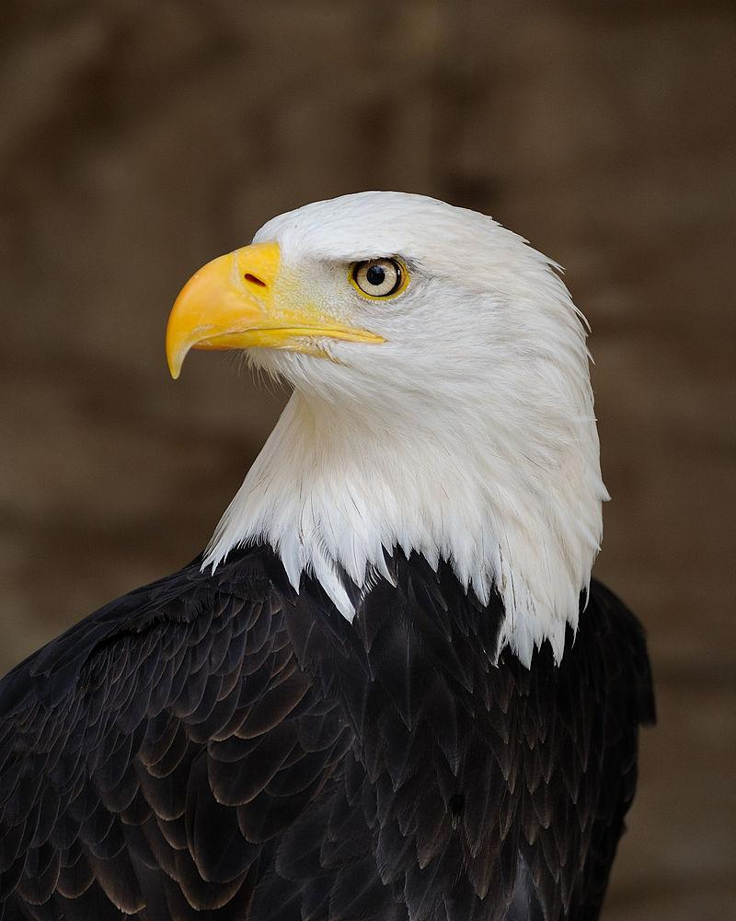 | Extra Source 2  - The Liberty Bell  - http://www.loc.gov/pictures/item/owi2001046059/PP/  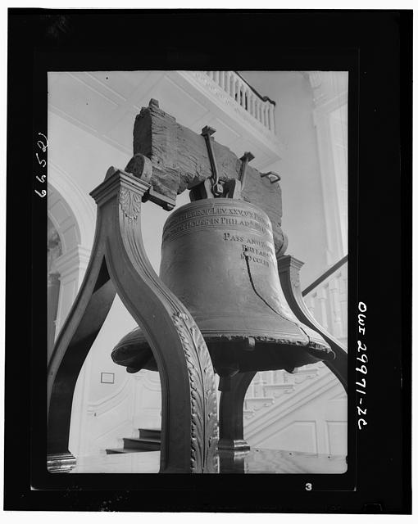
Extra Source 3  - The Great Seal of the United States  - http://hdl.loc.gov/loc.rbc/rbpe.0320250d | Extra Source 4  - The White House  - http://www.whitehousemuseum.org/residence.htm  