**Colorado’s District Sample Curriculum Project**

**Instructional Unit Authors**

North Routt and Hayden School Districts

Lori Raper

Ali Moyer

**Based on a curriculum**

**overview Sample authored by**

Aurora Public Schools

Chris Strater

Colorado Springs School District 11

Aaron Ford

Community Leadership

Shannon Loveridge

Woodland Park School District Re-2

Sue Wright

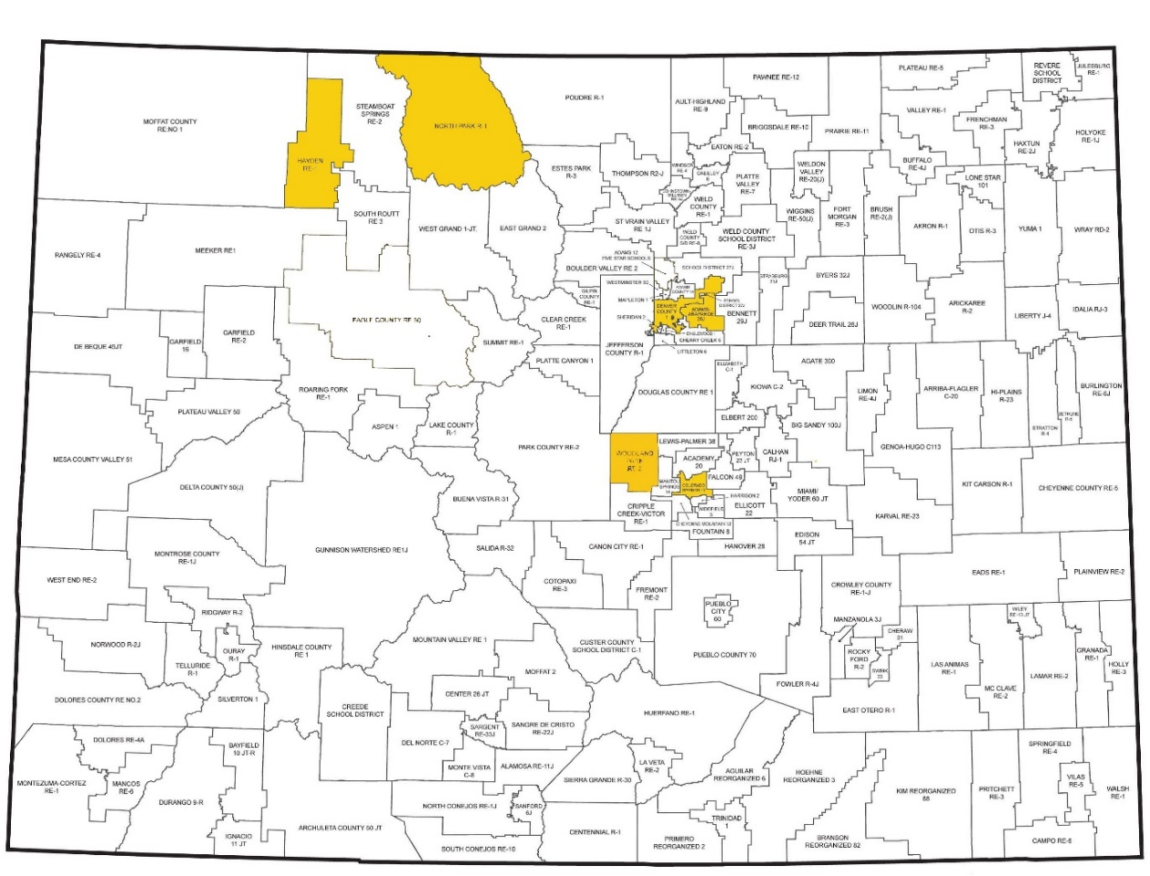

*This unit was authored by a team of Colorado educators. The template provided one example of unit design that enabled teacher-authors to organize possible learning experiences, resources, differentiation, and assessments. The unit is intended to support teachers, schools, and districts as they make their own local decisions around the best instructional plans and practices for all students.*

Date Posted: APRIL, 2018

Physical Education

1st Grade

Colorado Teacher-Authored Instructional Unit Sample

**Experimenting with Movement**

|  |  |  |  |  |  |  |
| --- | --- | --- | --- | --- | --- | --- |
| **Content Area** | Physical Education | | | **Grade Level** | 1st Grade | |
| **Course Name/Course Code** |  | | | | | |
| **Standard** | **Grade Level Expectations (GLE)** | | | | | **GLE Code** |
| 1. Movement Competence   and Understanding | 1. Demonstrate basic locomotor and non-locomotor skills, and rhythmic and cross-lateral movements | | | | | PE09-GR.1-S.1-GLE.1 |
| 1. Demonstrate fundamental manipulative skills | | | | | PE09-GR.1-S.1-GLE.2 |
| 3. Establish a beginning movement vocabulary | | | | | PE09-GR.1-S.1-GLE.3 |
| 1. Physical and Personal Wellness | 1. Identify the body’s normal reactions to moderate and vigorous physical activity | | | | | PE09-GR.1-S.2-GLE.1 |
| 1. Emotional and Social   Wellness | 1. Work independently and with others to complete work | | | | | PE09-GR.1-S.3-GLE.1 |
| 1. Follow the rules of an activity | | | | | PE09-GR.1-S.3-GLE.2 |
| 4. Prevention and Risk  Management | 1. Develop movement control for safe participation in games and sports | | | | | PE09-GR.1-S.4-GLE.1 |
| **Colorado 21st Century Skills**    **Critical Thinking and Reasoning:** *Thinking Deeply, Thinking Differently*  **Information Literacy:** *Untangling the Web*  **Collaboration:** *Working Together, Learning Together*  **Self-Direction:** *Own Your Learning*  **Invention:** *Creating Solutions* | |  | | | | |
| **Unit Titles** | | | **Length of Unit/Contact Hours** | | **Unit Number/Sequence** | |
| Experimenting with Movement | | | Teacher’s Discretion | | Teacher’s Discretion | |

|  |  |  |  |  |  |
| --- | --- | --- | --- | --- | --- |
| **Unit Title** | Experimenting with Movement | | | **Length of Unit** | Teacher’s Discretion |
| **Focusing Lens(es)** | Movement and Travel | **Standards and Grade Level Expectations Addressed in this Unit** | PE09-GR.1-S.1-GLE.1  PE09-GR.1-S.1-GLE.3 | | |
| **Inquiry Questions (Engaging- Debatable):** | * If you were to invent a new locomotor movement, what would it look like, and what would you call it? (PE09-GR.1-S.1-GLE.1-EO.a,b,c,f,g; IQ. 1,3; RA. 1; N. 1,2,3) * What makes a jog different from a run? (PE09-GR.1-S.1-GLE.3-EO.1; IQ. 2,3; RA. 2,; N. 1,2) * What are some similarities in different types of locomotor movements? (PE09-GR.1-S.1-GLE.3-EO.a; IQ. 2; RA. 2; N. 1,2) * Why would someone want to know how to do the same things in different ways? (PE09-GR.1-S.1-GLE.1-EO.a,b,c,f,g; IQ. 3,4; RA. 1; N. 1,2) | | | | |
| **Unit Strands** | Movement Competence and Understanding | | | | |
| **Concepts** | Self-Direction, Practice Competency, Experimentation, Benefits of Movement, Communication, Space, Recognition, Levels, Speeds,  Compare/Contrast, Awareness, Movement, Symmetry, Balance, Effort; Force, Directionality, Levels, Pathways, Traveling,  Variation, Locomotion, Patterning, Reasoning | | | | |

|  |  |  |
| --- | --- | --- |
| **Generalizations**  **My students will Understand that…** | **Guiding Questions**  **Factual Conceptual** | |
| Movement by traveling in various pathways, using directionality, speed, and levels provides measurable benefits to humans. (PE09-GR.1-S.1-GLE.1-EO.a,b,c,f,g; IQ. 1,3; RA. 1; N. 1,3) | What are the different pathways that one uses while moving? | Do different levels imply a specific speed? |
| Awareness of body and space help demonstrate balance in movement. (PE09-GR.1-S.1-GLE.1-EO.b,c,f,g; RA. 1,2,3; N.1) | What sports and activities require you to demonstrate balance? | How can you demonstrate balance in different ways? |
| Experimentation with various locomotor patterns, varied levels of effort and force, increase balance, coordination and movement capacities. (PE09-GR.1-S.1-GLE.1-EO.a,b,c; IQ. 1,3; RA. 1; N. 1,3) | Is greater effort or force required to change from a walk to a jog/run? | Does a person have to use greater effort to have greater force? |

|  |  |
| --- | --- |
| **Critical Content:**  **My students will Know…** | **Key Skills:**  **My students will be able to (Do)…** |
| * Personal space, general space and boundaries (PE09-GR.1-S.1-GLE.3-EO.d) * Different directions and at high, medium and low levels in space (PE09-GR.1-S.1-GLE.1-EO.a) * Locomotor movements in a variety of pathways and levels, both static and dynamic balances (PE09-GR.1-S.1-GLE.1-EO.b,g) * Forward and sideways directions using a variety of locomotor and non-locomotor patterns and change direction quickly in response to a signal (PE09-GR.1-S.1-GLE.1- EO.c) * Balance at different levels on different body parts (PE09-GR.1-S.1-GLE.1-EO.f) * Jog and a run, hop and jump, gallop and slide (PE09-GR.1-S.1-GLE.3-EO.a) * Personal space, high and low levels, fast and slow speeds, light and heavy weights, balance and twist (PE09-GR.1-S.1-GLE.3-EO.c) | * Discuss personal space, general space and boundaries (PE09-GR.1-S.1-GLE.3-EO.d) * Move in different directions and at high, medium and low levels in space (PE09-GR.1-S.1-GLE.1-EO.a) * Demonstrate locomotor movements in a variety of pathways and levels, both static and dynamic balances (PE09-GR.1-S.1-GLE.1-EO.b,g) * Travel in forward and sideways directions using a variety of locomotor and non-locomotor patterns and change direction quickly in response to a signal (PE09-GR.1-S.1-GLE.1- EO.c) * Perform balance at different levels on different body parts (PE09-GR.1-S.1-GLE.1-EO.f) * Distinguish between a jog and a run, hop and jump, gallop and slide (PE09-GR.1-S.1-GLE.3-EO.a) * Differentiate among personal space, high and low levels, fast and slow speeds, light and heavy weights, balance and twist (PE09-GR.1-S.1-GLE.3-EO.c) |

|  |  |  |
| --- | --- | --- |
| **Critical Language:** includes the Academic and Technical vocabulary, semantics, and discourse which are particular to and necessary for accessing a given discipline.  EXAMPLE: A student in Language Arts can demonstrate the ability to apply and comprehend critical language through the following statement: *“Mark Twain exposes the hypocrisy of slavery through the use of satire.”* | | |
| **A student in ______________ can demonstrate the ability to apply and comprehend critical language through the following statement(s):** | | *I can move in different ways and at different levels to show my ability to participate in a lot of activities* |
| **Academic Vocabulary:** | Recognize, space, high, medium, low, boundaries, forward, backward, personal space, general space boundaries, static and dynamic balances | |
| **Technical Vocabulary:** | Jog, run, hop, jump, gallop, slide, balance, static, dynamic, speeds, twist | |

|  |  |
| --- | --- |
| **Unit Description:** | This unit is designed to allow students to develop and explore skills to move safely in a variety of environments. Learning experiences focus on concepts safety, exploring locomotor and non-locomotor skills, as well as movement patterns using various pathways, directions and speeds.  The performance assessment provides students with the opportunity to create and perform a routine that demonstrate locomotor, non-locomotor movements, in a variety of pathways, directions, levels, and speed. |
| **Considerations:** | Most first grade students will have a general understanding of personal space, general space, locomotor skills, responsible use of equipment, and expectations for partner cooperation. However first graders will vary in developmental readiness, therefore this unit is designed to allow students to develop and/or experience manipulation of objects. In addition you may need to consider:   * Time spent with students (i.e. length of class, number of days a week) * Technology * Space * class size * physical challenges * cultural diversity |
| **Unit Generalizations** | |
| **Key Generalization:** | Movement by traveling in various pathways, using directionality, speed, and levels provides measurable benefits to humans. |
| **Supporting Generalizations:** | Awareness of body and space help demonstrate balance in movement. |
| Experimentation with various locomotor patterns, varied levels of effort and force, increase balance, coordination and movement capacities. |

|  |  |
| --- | --- |
| **Performance Assessment:** *The capstone/summative assessment for this unit.* | |
| **Claims:**  (Key generalization(s) to be mastered and demonstrated through the capstone assessment.) | Movement by traveling in various pathways, using directionality, speed, and levels provides measurable benefits to humans. |
| **Stimulus Material:**  (Engaging scenario that includes role, audience, goal/outcome and explicitly connects the key generalization) | You and your small group (i.e. no more than 4) have been asked to perform during a community evening and present your creative routine, and will be available for questions relating to the benefits to all. Your movements, both locomotor and non-locomotor, must include various pathways, directions, levels and speed. You and your small group may include music and different types of equipment. |
| **Product/Evidence:**  (Expected product from students) | Students will create and perform a routine with a small group. Students will demonstrate various pathways, directions, levels and speed. |
| **Differentiation:**  (Multiple modes for student expression) | Students may:   * Teach others their routine * Invite community/ family * Choose various songs * Create class rubric and evaluate each group |

|  |  |
| --- | --- |
| **Texts for independent reading or for class read aloud to support the content** | |
| **Informational/Non-Fiction** | **Fiction** |
| *Concepts of Health-Related Fitness*- Thomas M. Adams II minimal cost *Fitness Education for Children*- Stephen J. Virgiliominimal cost | *Bend and Stretch: Learning About Your Bones and Muscles (The Amazing Body)*- [Pamela Hill Nettleton](https://www.amazon.com/Pamela-Hill-Nettleton/e/B001IZV5XM/ref=dp_byline_cont_book_1) (Lexile 530) minimal cost*Watch Me Grow: Fun Ways to Learn About Cells, Bones, Muscles, and Joints*- [Michelle O'Brien-Palmer](https://www.amazon.com/Michelle-OBrien-Palmer/e/B000APJTYI/ref=dp_byline_cont_book_1) minimal cost*Inside Your Outside: All About the Human Body (Cat in the Hat's Learning Library)-* Tish Rabe (Lexile 660) minimal cost |
| *Teaching Children Responsible Behavior -* Sandra Hagenbach | *Personal Space Camp* - Julia Cook(Lexile 675) minimal cost*Exercise* - Liz Gogerly (Lexile 500L) minimal cost*Babar’s Yoga for Elephants -* Laurent de Brunhoff (Lexile 560L) minimal cost*Elephants Cannot Dance, Watch me Throw the Ball* - Mo Willems (Lexile 150L) minimal cost |

|  |  |  |  |  |
| --- | --- | --- | --- | --- |
| **Ongoing Discipline-Specific Learning Experiences** | | | | |
| 1. | Description: | Think/work like a physical educator: maintain safe practices while moving with or without equipment | Teacher Resources: | <http://www.gov.pe.ca/photos/original/eecd_phyeduguid.pdf> (Activity safety guidelines)  <http://www.pecentral.org/climate/perules.html> (Sample Physical Education rules and guidelines) |
| Student Resources: |  |
| Skills: | Recognize appropriate safety practices in general space | Assessment: | Students will identify safety practices after each learning experience through discussion and pair share. |
|  | | | | |  |  |
| 2. | Description: | Think/work like a physical educator: use responsible/ cooperative behaviors with partners or in your group | Teacher Resources: | <http://www.pecentral.org/climate/perules.html> (Sample Physical Education rules and guidelines)  <http://www.pecentral.org/lessonideas/searchresults.asp?subcategory=cooperative+learning> (examples of cooperative learning in PE) |
| Student Resources: |  |
| Skills: | Demonstrate use of communication to facilitate responsibility and cooperation | Assessment: | Students will demonstrate ways to show responsibility and cooperation through cooperative  learning. |
|  | | | | |
| 3. | Description: | Think/work like a physical educator: move in control in personal and general spaces. | Teacher Resources: | <http://www.sparkpe.org/wp-content/uploads/2009/11/K2_BaF_Gen_Space.pdf> (Lesson and background information on personal and general space) |
| Student Resources: | <https://www.youtube.com/watch?v=mYP4FH6xZW4> (Student-made video about personal space) |
| Skills: | Demonstrate safe movement and manipulation of their bodies in general space | Assessment: | Students will identify the difference between personal and general space through discussion and pair share. |
|  | | | | |

|  |
| --- |
| **Prior Knowledge and Experiences** |
| The learning experiences build on students’ working knowledge of personal responsibility, cooperative skills, safe movement and travel. Student experiences and developmental readiness will vary due to socio economic opportunities and prior kindergarten enrichment activities. |

|  |  |  |
| --- | --- | --- |
| **Learning Experience # 1** | | |
| Awareness of body and space help demonstrate balance in movement. | | |
| **Task Description:**  **The teacher may… so that students can…** | Awareness of body and space help demonstrate balance in movement. | |
| **Generalization Connection(s):** | <https://www.youtube.com/user/CosmicKidsYoga> (Cosmic Kids Yoga)  <https://www.youtube.com/watch?v=CITc2AxYnPY> Yoga for Kids - Vol 1 (All Standing Postures) | |
| **Teacher Resources:** | A, B, C’s of Yoga by Teresa Power | |
| **Student Resources:** | Students will perform individual and group yoga tasks as teacher specifies verbally or written to assess their balance skills. | |
| **Differentiation:**  (Multiple means for students to access content and multiple modes for student to express understanding.) | **Access** (Resources and/or Process) | **Expression** (Products and/or Performance) |
| The teacher may:   * demonstrate poses * verbal cues * use CD’s as well as other technology * use pictures/cards | The students may:   * demonstrate poses * create own poses * express how your body feels |
| **Extensions for depth and complexity:** | **Access** (Resources and/or Process) | **Expression** (Products and/or Performance) |
| The teacher may:   * offer before or after-school yoga classes * bring in an expert | The students may:   * perform more difficult poses * lead the class/partner |
| **Critical Content:** | * different directions and at high, medium and low levels in space * different levels on different body parts * Personal space, high and low levels, fast and slow speeds, light and heavy weights, balance and twist | |
| **Key Skills:** | * move in different directions at a high, medium and low levels in space * Balance at different levels on different body parts * Personal space, high and low levels and balance and twist | |
| **Critical Language:** | Balance, Twist, Dynamic, Static, Pose | |

|  |  |  |
| --- | --- | --- |
| **Learning Experience # 2** | | |
| The teacher may construct a modified series of the game Twister so that the students can investigate the concept of body and space awareness. | | |
| **Generalization Connection(s):** | Awareness of body and space help demonstrate balance in movement. | |
| **Teacher Resources:** | Google search for twister adaptations. | |
| **Student Resources:** | N/A | |
| **Assessment:** | Students will summarize their different trials with the game and discuss the benefits of the control of own body and their working relationship with their partner or group. | |
| **Differentiation:**  (Multiple means for students to access content and multiple modes for student to express understanding.) | **Access** (Resources and/or Process) | **Expression** (Products and/or Performance) |
| The teacher may:   * speed up cues * create two separate categories of cards instead of using spinners | The students may:   * develop own sets of cards in groups * exchange with other groups and play then give feedback |
| **Extensions for depth and complexity:** | **Access** (Resources and/or Process) | **Expression** (Products and/or Performance) |
| The teacher may:   * speed up cues * create two separate categories of cards instead of using spinners | The students may:   * develop own sets of cards in groups * exchange with other groups and play then give feedback |
| **Critical Content:** | * Personal space, general space and boundaries * Different levels on different body parts * Personal space, high and low levels, fast and slow speeds, light and heavy weights, balance and twist | |
| **Key Skills:** | * Discuss personal space, general space and boundaries * Balance at different levels on different body parts * Personal space, high and low levels, fast and slow speeds, light and heavy weights, balance and twist | |
| **Critical Language:** | Space, Levels, Awareness, Movement, Balance, Reasoning, Communication, Symmetry | |

|  |  |  |
| --- | --- | --- |
| **Learning Experience # 3** | | |
| The teacher may design warmups calling out locomotor and non-locomotor movements so students can compare and contrast the differences. (e.g. line drills with small groups moving across designated area: gym floor, concrete, field, etc.) | | |
| **Generalization Connection(s):** | Experimentation with various locomotor patterns, varied levels of effort and force, increase balance, coordination and movement capacities. | |
| **Teacher Resources:** | <https://www.youtube.com/watch?v=ICn7xLQIfrc> (locomotor skills moving from point A to B) | |
| **Student Resources:** | <https://www.youtube.com/watch?v=GN1cjZwqS8Y> (comparing locomotor vs non-locomotor skills) | |
| **Assessment:** | Students will demonstrate their mastery of non-locomotor and locomotor skills through playing several fleeing and chasing games (e.g. Freeze tag, Line tag, Needle and Thread) | |
| **Differentiation:**  (Multiple means for students to access content and multiple modes for student to express understanding.) | **Access** (Resources and/or Process) | **Expression** (Products and/or Performance) |
| The teacher may ask students to   * give examples of locomotor and non-locomotor movement and sort them by category movement skill vs non movement * Demonstrate movement skill vs non movement | The students may   * demonstrate whole body movements that your feet move and ones your feet don’t move * pair up and come up with patterns of Non locomotor and locomotor movements for groups or entire class |
| **Extensions for depth and complexity:** | **Access** (Resources and/or Process) | **Expression** (Products and/or Performance) |
| The teacher may   * present different patterns | The students may   * demonstrate different patterns |
| **Critical Content:** | * Jog and a run, hop and jump, gallop and slide * Forward and sideways directions using a variety of locomotor and non-locomotor patterns and change direction quickly in response to a signal | |
| **Key Skills:** | * Distinguish between a jog and a run, hop and jump, gallop and slide * Travel in forward and sideways directions using a variety of locomotor and non-locomotor patterns and change direction quickly in response to a signal | |
| **Critical Language:** | Self-Direction, Space, Recognition, Speeds, Compare/Contrast, Awareness, Movement, Balance, Effort, Force, Directionality, Levels, Pathways, Traveling, Variation, Locomotion, Patterning, Reasoning | |

|  |  |  |
| --- | --- | --- |
| **Learning Experience # 4** | | |
| The teacher may share a video recognizing and reviewing various pathways, directions and speeds. | | |
| **Generalization Connection(s):** | <https://www.youtube.com/watch?v=jzJJ8a5pAH0> (Copy of B & B game)  <https://www.youtube.com/watch?v=MFzDaBzBlL0> (Hook for relearning various pathways of our brain--”backwards bicycle”)  <https://www.youtube.com/watch?v=UIjREnjVI2I> (Live feed of busy crosswalk in NY) | |
| **Teacher Resources:** | <https://www.youtube.com/watch?v=jzJJ8a5pAH0> (Copy of B & B game)  <https://www.youtube.com/watch?v=MFzDaBzBlL0> (Hook for relearning various pathways of our brain--”backwards bicycle”)  <https://www.youtube.com/watch?v=UIjREnjVI2I> (Live feed of busy crosswalk in NY) | |
| **Student Resources:** | Students will construct a game of “Builders and Bulldozers” to engage in groups/teams to travel and vary direction, speed, and space to strategize and prove their theory. | |
| **Assessment:** | <https://www.youtube.com/watch?v=jzJJ8a5pAH0> (Copy of B & B game)  <https://www.youtube.com/watch?v=MFzDaBzBlL0> (Hook for relearning various pathways of our brain--”backwards bicycle”)  <https://www.youtube.com/watch?v=UIjREnjVI2I> (Live feed of busy crosswalk in NY) | |
| **Differentiation:**  (Multiple means for students to access content and multiple modes for student to express understanding.) | **Access** (Resources and/or Process) | **Expression** (Products and/or Performance) |
| The teacher may ask the students to   * move in various locomotor patterns * vary their speeds with different music tempo * play with a partner * devise own methods | The students may   * use different size cones or equipment * use various amounts of equipment * follow tempo of music (i.e. slow, med. fast) * master different locomotor patterns and directions |
| **Extensions for depth and complexity:** | **Access** (Resources and/or Process) | **Expression** (Products and/or Performance) |
| The teacher may challenge game by   * use different body parts for bulldozer/building * work with partners * devise own differentiation | The students will adapt or change   * follow cues from teacher * collaborate and devise new methods |
| **Critical Content:** | * Personal space, general space and boundaries * Different directions and at high, medium and low levels in space * Locomotor movements in a variety of pathways and levels * Forward and sideways directions using a variety of locomotor and non-locomotor patterns and change direction quickly in response to a signal * Jog and a run, hop and jump, gallop and slide | |
| **Key Skills:** | * Discuss personal space, general space and boundaries * Move in different directions and at high, medium and low levels in space * Demonstrate locomotor movements in a variety of pathways and levels * Travel in forward and sideways directions using a variety of locomotor and non-locomotor patterns and change direction quickly in response to a signal * Distinguish between a jog and a run, hop and jump, gallop and slide * Differentiate among personal space, high and low levels, fast and slow speeds | |
| **Critical Language:** | Jog, Run, Hop, Gallop, Slide, Speeds, Twist | |