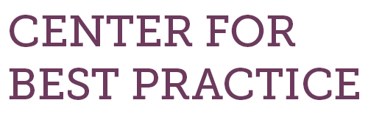
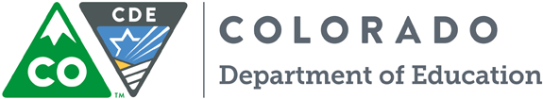
How to Do It: Tips for benefitting from CDE’s Turnaround Network

- Objective
  - How can schools determine whether entering CDE’s Turnaround Network is right for them?
  - What specific goals do you have for your schools as a result of entering the network?
- Preparation
  - Study the Turnaround Network website, including application.
  - Work closely with your district leadership on the application. District buy-in and participation are required, and essential for success.
  - Read about the work of Mass Insight, which conducts some school diagnostic visits for the network
  - Learn about Relay Graduate School of Education
  - Lay the groundwork with your staff to be sure you have their enthusiastic buy-in. Joining the network will result in changes to the way your school operates, on many levels.
- Implementation
  - Implementation is a true partnership of school, district, and CDE Turnaround Network staff. Implementation strategies will be designed by this team.
- Assessment/reflection
  - What worked?
  - What did not work?
  - How can it be adjusted?

