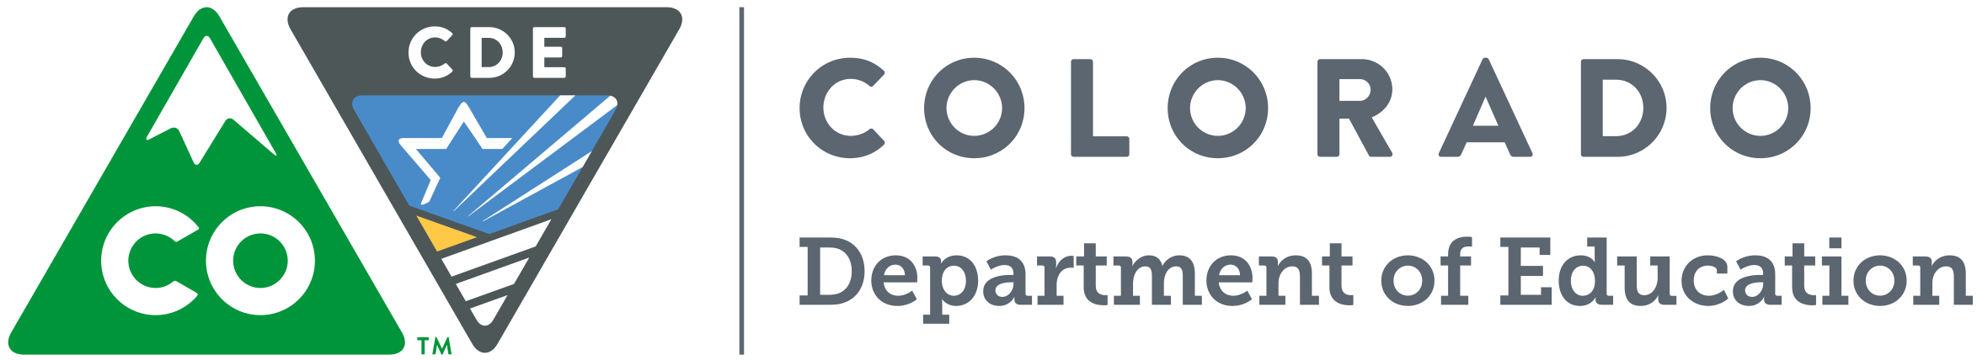
2018-19 Professional Development
Opportunity

Fundamentals of Literacy Instruction (Formally known as READing Foundations Academy)
WHO: All K-3 teachers, interventionists, special educators, para-professionals, instructional coaches and educational leaders.

WHAT: A no-cost training focused on explicit and systematic Tier 1 instruction for teachers of reading who want to implement the components and principals of scientifically based reading instruction. This dynamic course deepens educator knowledge by introducing the science of how children learn to read, illustrates the importance of all components of reading and demonstrates how to put these concepts to work in the classroom.

Classes include:
Class 1: Phoneme Articulation and the Text-Dependent Questions
Class 2: The Outcome-Driven Model and Data Analysis
Class 3: Phoneme-Grapheme Mapping ,Vocabulary and Read-Alouds
Class 4: Syllable Types and Text-Dependent Questions
Class 5: Irregular Words, Syllable Division and Morphology
Class 6: Reading Fluency and Writing
Class 7: Integration and Putting it All Together

The Academy is being offered through highly trained Colorado educators from around the state. Each class is 3 hours in length for a total of 21 hours.

HOW: Register through our on-line process and check for training locations

WHEN AND WHERE: Across the state

THE FINE PRINT:
*Participants must commit to completing all seven classes.
*Participants must bring a computer with them to the first and last class.
*Participants should bring any highlighters, sticky notes, markers, pens and pencils with them.
*Participants need to bring the teacher edition of their core reading program with them if they have one.

- Fundamentals of Literacy Instruction (FOLI) will provide K – 3 teachers an opportunity to expand their knowledge of foundational reading skills to support their students in developing and advancing their reading ability.

- FOLI is a no-cost professional development opportunity for all Colorado educators in grades K – 3.

- CDE will partner with districts and BOCES to arrange regional Academies and provide highly trained instructors.

Colorado Department of Education
201 E. Colfax Ave., Denver, CO 80203 • 720-460-8319 • Handy_T@cde.state.co.us

Want to know more? Contact Tracy Handy at Handy_T@cde.state.co.us

