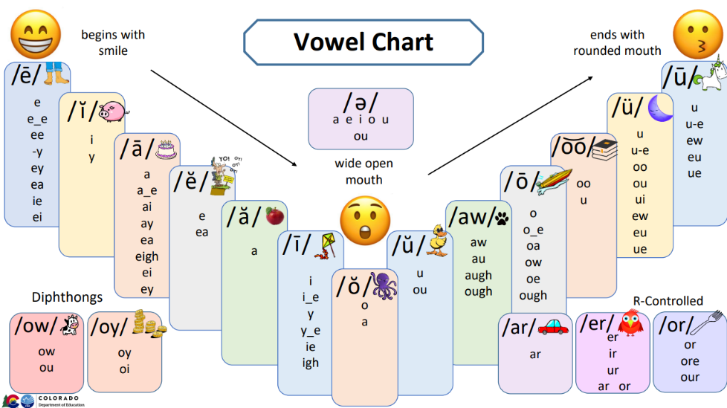Advanced Sound Wall Cards

These advanced sound wall cards include all the orthographic patterns for each sound. For more basic concepts, find the basic sound wall cards found on CDE’s Educator Resources webpage. Also included on this page is information on how to set-up a sound wall.

These cards are provided in an editable format for flexibility to include concepts that have been introduced in your scope and sequence.

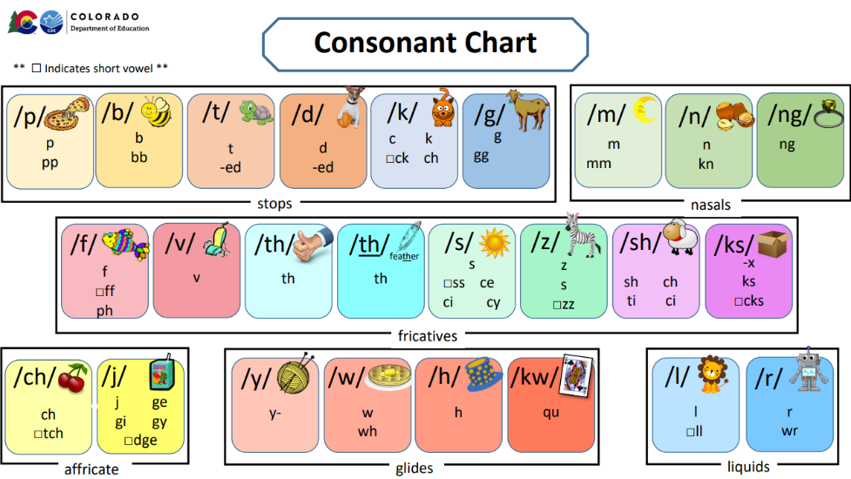

Sound walls are a high-leverage tool when the concepts as well as how to use the tool has been taught explicitly to students.

More information can be found here:

<http://www.cde.state.co.us/coloradoliteracy/readacteducatorresources>

*\*Note: The /hw/ sound typically spelled ‘wh’ in English words is not commonly utilized in American English; therefore, the ‘wh’ spelling has been incorporated into the sound card for the voiced /w/ phoneme in this resource.*

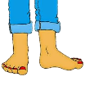 /ē/

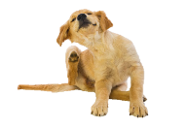 / ĭ /

e

e_e

ee

-y

ey

ea

ie

ei

i

y

/ ā/ 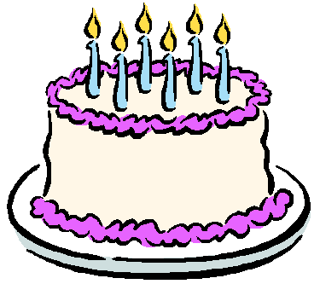

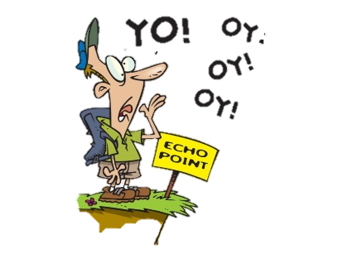 /ĕ/

a

a_e

ai

ay

ea

eigh

ei

ey

e

ea

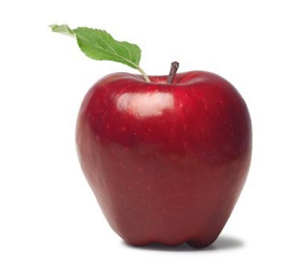 / ă/

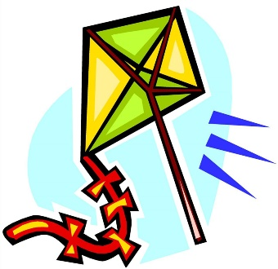 / ī /

a

i

i_e

y

y_e

ie

igh

 / ŏ/

 /ə/

o

a

a

e

i

o

u

ou

 / aw/

 /ō/

aw

au

a(l)

augh

ough

o

o_e

oa

ow

oe

ough

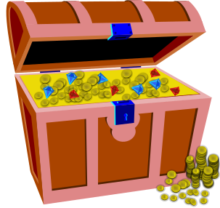duck


treasure

/zh/

/ŭ/

si

s

g

u

ou

 /o͝o /

 /ü/

oo

u

oo

ew

_ue

ou

u u_e

eu ui

 / ū/

 /ow/

u

u_e

ew

eu

ue

ow

ou

 / oy/

 /ar/

oi

oy

ar

 / er/

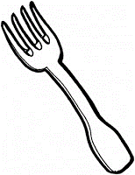 /or/

er

ir

ur

ar

or

or

ore

our

 / p/

 /b/

p

pp

b

bb

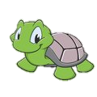 / t/

 /d/

t

tt

-ed

d

dd

-ed

 / k/

 /g/

c

k

□ck

ch

g

gg

gh

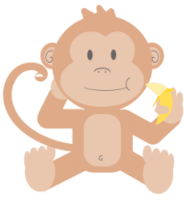 / m/

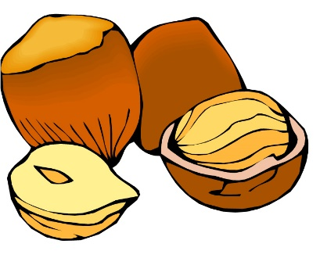 /n/

m

mm

n

nn

kn

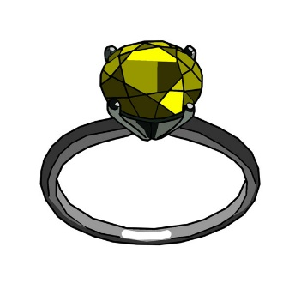 / ng/

 /f/

ng

f

ff

ph

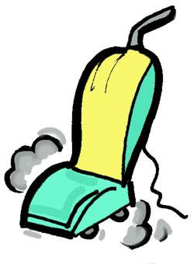 / v/

 /th/

v

th

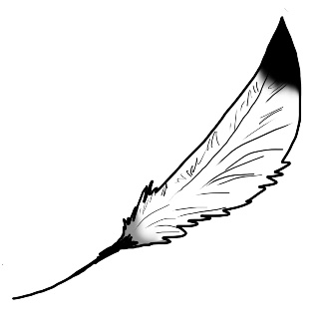 / th/

feather

 /s/

th

s

ss

ce

ci

cy

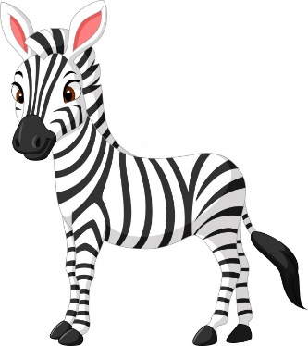 / z/

 /sh/

z

s

zz

sh

ch

ti

si

 / ks/

 /ch/

x

-ks

□cks

ch

□tch

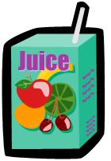 / j/

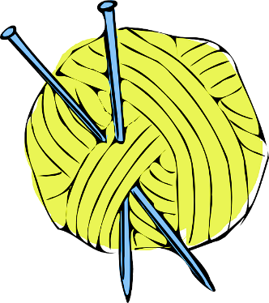 /y/

j

ge

gi

gy

□dge

y-

 / w/

 /h/

w

wh

h

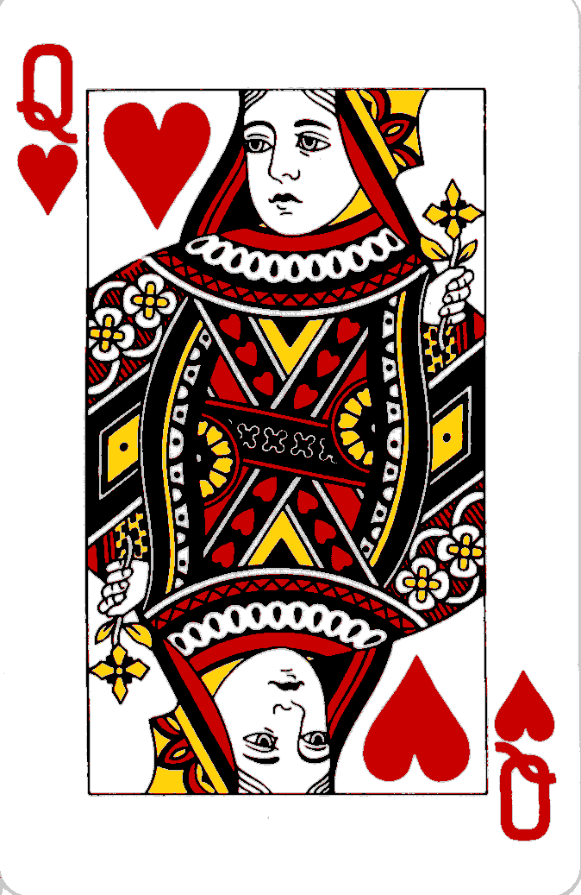 / kw/

 /l/

qu

l

ll

 / r/

r

wr



