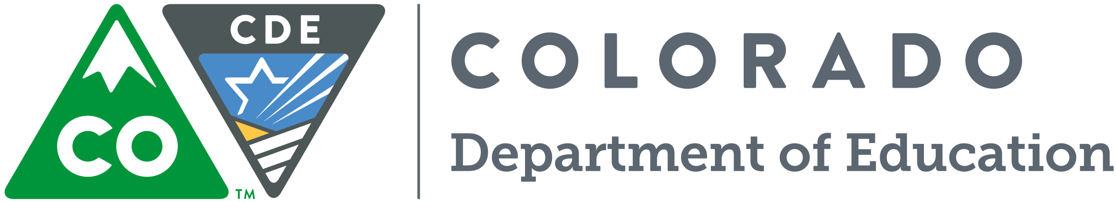

The READing Conference 2018 is going on the road! Join us in Pueblo Colorado for two days of exceptional learning with Anita Archer and other leading reading researchers and experts

WHO: All K-3 teachers, instructional coaches and leaders
WHAT: The Office of Literacy along with the Exceptional Student Services Unit at CDE will be hosting our fourth annual READing Conference on Thursday and Friday, September 27th and 28th, 2018.
- This conference is designed to support the implementation of evidence based reading instruction.
- The target audience is K-3 educators including general education teachers, special education specialists, reading coaches, reading interventionists, English Language Development specialists, principals and school leadership teams.
- The focus of the conference will be on direct and explicit instruction for all students including: English Learners, emerging readers and struggling readers.
- There is no cost to attend and lunch will be provided both days.

WHEN: September 27, 2018 (8:00am-4:00pm)
September 28, 2018 (8:00am-3:00pm)
WHERE: Pueblo Convention Center
320 Central Main Street, Pueblo Co, 81003

** Please note: The Pueblo Convention Center is centrally located and is easily accessible from many hotels in the Pueblo area. The Pueblo Convention Center is not associated with any hotel in Pueblo. Accommodations are the responsibility of the attendee.

NOTE: Registration information will be available August 2018 via the READ Act webpage: http://www.cde.state.co.us/coloradoliteracy

Want to know more?
Contact Marisa Calzadillas
at
Calzadillas_M@cde.state.co.us
303-866-6189
Colorado Department of Education
201 E. Colfax Ave., Denver, CO 80203 • Phone • email

Call to action or
key information

