|  |  |  |  |  |  |  |  |
| --- | --- | --- | --- | --- | --- | --- | --- |
| Content Area | Visual Arts | | | **Grade Level** | Middle Level (8th) | | |
| **Course Name/Course Code** | Drawing: 1, 2, & 3 Sculpture: 1, 2, & 3 Studio Art: 1, 2, & 3 | | | | | | |
| **Standard** | **Grade Level Expectations (GLE)** | | | | | | **GLE Code** |
| 1. Observe and Learn to **Comprehend** | 1. Conceptual art theories explain how works of art are created | | | | | | VA09-GR.MS-S.1-GLE.1 |
| 2. The history of art, world cultures, and artistic styles influence contemporary  art concerns | | | | | | VA09-GR.MS-S.1-GLE.2 |
| 3. Art criticism strategies are used to analyze, interpret, and make informed  judgments about works of art | | | | | | VA09-GR.MS-S.1-GLE.3 |
| 2. Envision and Critique to **Reflect** | 1. Visual literacy skills help to establish personal meaning and artistic intent in  works of art | | | | | | VA09-GR.MS-S.2-GLE.1 |
| 2. Key concepts, issues, and themes in the visual arts can solve problems  using real-world applications | | | | | | VA09-GR.MS-S.2-GLE.2 |
| 3. Invent and  Discover to **Create** | 1. Achieve artistic purpose to communicate intent | | | | | | VA09-GR.MS-S.3-GLE.1 |
| 2. Demonstrate technical proficiency and craftsmanship when planning | | | | | | VA09-GR.MS-S.3-GLE.2 |
| 3. Utilize current and available technology to refine an idea, and create original  and imaginative works of art | | | | | | VA09-GR.MS-S.3-GLE.3 |
| 4. Relate and Connect to **Transfer** | 1. Visual arts are valuable for a variety of art and non-art related lifelong  endeavors | | | | | | VA09-GR.MS-S.1-GLE.1 |
| 2. Cultural traditions and events impact visual arts within a community | | | | | | VA09-GR.MS-S.1-GLE.2 |
| 3. Visual arts provide an opportunity to explore sustainable environments,  design and architecture | | | | | | VA09-GR.MS-S.1-GLE.3 |
| **Colorado 21st Century Skills**    **Critical Thinking and Reasoning:** *Thinking Deeply, Thinking Differently*  **Information Literacy:** *Untangling the Web*  **Collaboration:** *Working Together, Learning Together*  **Self-Direction:** *Own Your Learning*  **Invention:** *Creating Solutions* | | The Colorado Academic Standards for Visual Arts are not intended to be taught in a linear (checklist of coverage) fashion, but rather should be implemented as a cyclical creative process. Each unit within this sample blueprint intentionally includes standards from all four visual arts standards to illustrate this process-based philosophy. | | | | | |
| **Unit Titles** | | | **Length of Unit/Contact Hours** | | | **Unit Number/Sequence** | |
| Inside the Artist Studio | | | Entire Quarter | | | .1 | |

|  |  |  |  |  |  |
| --- | --- | --- | --- | --- | --- |
| **Unit Title** | Inside the Artist Studio | | | **Length of Unit** | Quarter |
| **Focusing Lens(es)** | The artistic process through the 8 Studio Habits of Mind   * Develop Craft * Engage & Persist * Envision * Express * Observe * Reflect * Stretch & Explore * Understand (Arts) Community | **Standards and Grade Level Expectations Addressed in this Unit** | VA09-GR.MS-S.1-GLE.1  VA09-GR.MS-S.1-GLE.2  VA09-GR.MS-S.1-GLE.3  VA09-GR.MS-S.2-GLE.1  VA09-GR.MS-S.2-GLE.2  VA09-GR.MS-S.3-GLE.1  VA09-GR.MS-S.3-GLE.2  VA09-GR.MS-S.3-GLE.3  VA09-GR.MS-S.4-GLE.1  VA09-GR.MS-S.4-GLE.2 | | |
| **Inquiry Questions (Engaging- Debatable):** | * What choices must an artist make before beginning a work? (VA09-GR.MS-S.1-GLE.1) * What factors influence artists and artistic expression? (VA09-GR.MS-S.2-GLE.1) * How/where do artists get their ideas? (VA09-GR.MS-S.3-GLE.2) * How do artists choose tools, techniques, and materials to express their ideas? (VA09-GR.MS-S.3-GLE.1) * Why and how do people create? (VA09-GR.MS-S.1-GLE.2) * What is the purpose of art? (VA09-GR.MS-S.4-GLE.1, VA09-GR.MS-S.4-GLE.2, VA09-GR.MS-S.4-GLE.3) * What is the artistic process? (VA09-GR.MS-S.1-GLE.1, VA09-GR.MS-S.2-GLE.1, VA09-GR.MS-S.3-GLE.1) | | | | |
| **Unit Strands** | Develop Craft/Engage & Persist/Envision/Express/Observe/Reflect/Stretch & Explore/Understand (Arts) Community | | | | |
| **Concepts** | Artistic process, Self Expression, Exploration, Reflection, 8 Studio Habits of Mind | | | | |

|  |  |  |
| --- | --- | --- |
| **Generalizations**  **My students will Understand that…** | **Guiding Questions**  **Factual Conceptual** | |
| The creative process builds on the development of ideas through a process of inquiry, discovery, and research. (VA09-GR.MS-S.1-GLE.1, 2, 3) and (VA09-GR.MS-S.3-GLE.1, 2,3) and (VA09-GR.MS-S.4-GLE.1 ,2) | Where do artists get their ideas?  What are ways that artists can research their ideas?  How do artists show to the public that their work is finished?  What are examples of artists throughout history who used their own current and available technology? How were these artists considered avant-garde or unique? | How does questioning, experimenting, and researching shape the final product? |
| The making and study of art and design can be approached from a variety of viewpoints, intelligences, and perspectives. (VA09-GR.MS-S.2-GLE.1) | How does the artist’s background and culture shape their artistic process and their work?  What choices might influence how an artist begins a work of art? | Can the artist’s viewpoint be misconstrued when viewed from a different cultural perspective? |
| Artists use the 8 Studio Habits of Mind throughout the entire artistic process. (VA09-GR.MS-S.1-GLE.1, 3) and (VA09-GR.MS-S.3-GLE.1, 2,3) and (VA09-GR.MS-S.4-GLE.1 ,2) | What are the 8 Studio Habits of Mind? | Is every Studio Habit of Mind used in every artistic undertaking?  How do artists show their understanding of the 8 Studio Habits of Mind after the work is complete? |
| The 8 Studio Habits of Mind can be used in any order and that some may be used multiple times throughout the artistic process. (VA09-GR.MS-S.3-GLE.3) | Do artists have to follow a specific order of the 8 Studio Habits of Mind while participating in the artistic process? | Why may an artist revisit one of the 8 Studio Habits of Mind while participating in the artistic process? |
| Artists use playful exploration and take risks to develop new artistic techniques and processes. (VA09-GR.MS-S.2-GLE.1) | What are some risks artists take?  What risks do students take in an art class? | How could a perceived failure become a learning experience and potentially a success?  Why is risk-taking important?  How do individuals calculate risk? |

|  |  |
| --- | --- |
| **Critical Content:**  **My students will Know…** | **Key Skills:**  **My students will be able to (Do)…** |
| * The 8 Studio Habits of Mind (VA09-GR.MS-S.1-GLE.1) * How artists use expressive features and characteristics of art (VA09-GR.MS-S.2-GLE.1) * How artists achieve artistic purpose to communicate intent (VA09-GR.MS-S.3-GLE.1) and (VA09-GR.MS-S.1-GLE.2) * Steps to assembling compositions in any media using Principles of Design and Elements of Art. (VA09-GR.8-S.1-GLE.1,2,3) and (VA09-GR.8-S.2-GLE.1,2) and (VA09-GR.8-S.3-GLE.1,2,3) and (VA09-GR.8-S.4-GLE.1,2,3) * The importance of craftsmanship (VA09-GR.8-S.1-GLE.1,2,3) and (VA09-GR.8-S.2-GLE.1,2) and (VA09-GR.8-S.3-GLE.1,2,3) and (VA09-GR.8-S.4-GLE.1,2,3) | * Use characteristics and expressive features of art to create a visual representation (VA09-GR.MS-S.3-GLE.1) and (VA09-GR.MS-S.3-GLE.2) and (VA09-GR.MS-S.3-GLE.3) * Use the 8 Studio Habits of Mind throughout the art making process (VA09-GR.MS-S.1-GLE.1) and (VA09-GR.MS-S.2-GLE.1) and (VA09-GR.MS-S.3-GLE.1) and (VA09-GR.MS-S.3-GLE.2) and (VA09-GR.MS-S.3-GLE.3) * Utilize current and available technology to refine an idea, and create original and imaginative works of art (VA09-GR.MS-S.3-GLE.3) * Demonstrate personal responsibility in the planning, implementation and evaluation of works of art (VA09-GR.MS-S.3-GLE.1) * Create works of art that are display ready ((VA09-GR.MS-S.3-GLE.2) * Employ craftsmanship to enhance the creation of art. (VA09-GR.8-S.1-GLE.1,2,3) and (VA09-GR.8-S.2-GLE.1,2) and (VA09-GR.8-S.3-GLE.1,2,3) and (VA09-GR.8-S.4-GLE.1,2,3) |

|  |  |  |
| --- | --- | --- |
| **Critical Language…** includes the Academic and Technical vocabulary, semantics, and discourse which are particular to and necessary for accessing a given discipline.  EXAMPLE: A student in Language Arts can demonstrate the ability to apply and comprehend critical language through the following statement: *“Mark Twain exposes the hypocrisy of slavery through the use of satire.”* | | |
| **A student can demonstrate the ability to apply and comprehend critical language through the following statement(s):** | | * *An artist can create multiple pieces of art to intentionally communicate an idea that can be read and interpreted by a viewer or an audience.* |
| **Academic Vocabulary:** | Critique, develop craft, engage, persist, envision, express, observe, reflect, stretch, explore, community, justify, investigate, debate, analyze, document, research, interpret, context, influence | |
| **Technical Vocabulary:** | 8 Studio Habits of Mind, expressive features and characteristics of art, composition, craftsmanship, technical ability, cliché, photojournalism, design, symbol, images, avant-garde | |

**Classroom Context:**

* K-8 public charter school that pulls students from Brighton and the surrounding area
* Students have a wide selection of electives that they may take each quarter
* Each student has two elective slots that they must fill each quarter
* Each elective slot lasts one hour
* In art, they have the option to select from three levels of:
  + Two dimensional art
  + Three dimensional art
  + Storytelling though art
    - Video production
    - Animation/board game design
    - Graphic novels
* Class sizes range from 18-30 students, but typically average around 25

**Lesson Planning Rationales:**

* Create an environment that helps students develop intrinsic motivation
* Provide students with narrative feedback
* Have students shift from a fixed mindset to a growth mindset
* Have students create art that has personal value and meaning
* Provide a safe work environment
* Allow students to develop their own artistic style
* Provide differentiated instruction

**Lesson Implementation:**

Students will participate in 13 whole group learning experiences (LE) that focus on skill building, Socratic Seminars, and class/project guidelines. Students will also participate in several self-guided workdays where the teacher supervises and guides the students through the artistic process.

Learning Experience Outline

LE 1 - What makes great art Socratic Seminar? And 1 Idea 10 pictures Creativity Assessment:

* Socratic Seminar Guiding Questions
  + What makes great art?
  + How does color guide mood?
  + How does size affect meaning?
  + How does different media affect overall meaning?
  + What sparks the creative process?
  + How does art reflect/shape culture?
  + What limits great art?
  + How do you deal with fear?
  + Thoughts on “The more you know, the more you have to work with.”
* 1 Idea 10 pictures Creativity Assessment
  + Randomly select one idea
  + Create 10 small drawings that represent that idea in 10 different ways

LE 2 - Rules/Expectations/Cleaning Drawing Boot Camp (Value):

* Rules/Expectations/Cleaning (Respect):
  + Plan, organize, and complete all projects on time
  + Take responsibility for your workspace, materials, and actions
    - * + Maintain appropriate interactions with staff and students
        + Maintain a high level of self-learning/initiative
* Do good work and share it
  + Craftsmanship
  + Concept
  + Composition
* Drawing boot camp
  + Value
    - Hatching, Cross Hatching, Stippling, Blending/Smudging
    - Value through pencil type and pressure

LE 3 - Drawing Boot Camp (Observation/composition):

* Gesture Drawing
* Rule of Thirds

LE 4 - Drawing Boot Camp Different Media:

* Marker usage
* Crayon usage
* Colored Pencil usage
* Pastel usage

LE 5 - Painting Boot Camp (Watercolor):

* Wet on wet
* Dry surface
* Water on wet paint
* Wet paint and tissue
* Masking
* Salt on wet paint
* Modeling paste

LE 6 - Painting Boot Camp (Tempera):

* Characteristics
  + Non-permanent
  + Flakes off easily
  + Chalky
  + Coverage
* Double load
* Scratch
* Smooth
  + Let dry for ~3 min
  + Go back and smooth out with a dry brush
* Thin

LE 7 - Painting Boot Camp (Acrylic):

* Dry
* Washing
* Stippling
* Flicking
* Dabbing
* Detailing
* Under painting
* Layering

LE 8 - Collage Boot Camp:

* Layering
* Using painted paper
* “Junk”
* Embroider
* Stamp
* Rip vs. cut
* Weave

LE 9 - Intro to Inside the Artist's Studio. Where do artist get ideas?/What is the process for making art?  Socratic Seminar:

* Where do artists get their ideas?
* Are all ideas good?
* Is your first idea the best?
* How do the materials available affect idea generation?
* How does the world around you shape your ideas?
* What are the 8 Studio Habits of Mind?
  + Develop Craft
  + Engage and Persist
  + Envision
  + Express
  + Observe
  + Stretch and Explore
  + Understand the Art World
  + Reflect

LE 10 - What is a Collection?

* Show various collections
  + Contemporary collections
  + Master collections

LE 11 - Appropriation, Copying, and Remixing:

* Copy, Transform, Combine
* Nothing is original
* Take little bits from everywhere that speak directly to you
* Keep a swipe file
* Don’t pass others work off as your own
* Copy your heroes, examine where you fall short, build from there

LE 12 - What does your portfolio look like? **Socratic Seminar** Pick Ideas (use 99 Concentration Topics if needed):

* How do artist show their learning?
* Do artist display their failures?
* How can you communicate your ideas beyond your final piece?
* How do you display your process?
  + Do you need to?
* Complete portfolio contract

LE 13- Work Days:

* Students check Google Classroom for any reflection forms/assignments
* Students work individually/in groups to fulfill their portfolio contracts
* Teacher conferences, gives individual feedback, and shows individual demos, as needed
* Students cleanup prior to end of class time
* Students complete exit ticket. Exit Tickets focus on the following, but are not limited to:
  + Areas of success for the day
  + Areas of growth for the day
  + Areas that need improvement
  + What do they need from the teacher to be successful the following day?
  + Whole group demo suggestions
  + Review of skills
  + General check-in

LE 14 - Exhibition Requirements:

* All work mounted
* Process reflections displayed
  + Photos
  + Writing
  + Reflection sheets
  + Sketchbook/Journals
* Minimum one page artist statement
* Must present in class or after school

**Reflection:**

Areas of success:

* Student engagement has increased/ classroom disruptions have decreased.
  + One student had no interest in art last year and had to be pulled from class. This year he rushes to class to use 123D Design and the 3D Printer. He works from the start of class to the end every day. He is currently creating works of art for the staff members at school.
* The majority of students are coming into class with ideas for their individualized work.
  + Tin ships powered by rubber bands and sails.
  + Tea sets including cups, plates, and a teapot.
  + Photoshop and photo manipulation
  + Backlit paper sculpture inspired by Hari and Deepti
* Students became masters of specific areas and were able to teach other students.
* Majority of students are able to problem find/solve.
* Ownership of art has increased. Students are excited to share their work with friends and family.
* I am able to connect with my students at a deeper level. I know what interests and drives their art making.
* Risk taking has increased. Students have learned and willingly retried to learn from their mistakes.
* Students have a better understanding of the artistic process and the 8 Studio Habits of Mind.
* Project uploading and reflection forms through Seesaw and Google Classroom works well.

Areas that did not work as intended:

* Several students struggled with sticking to a specific chosen theme. I allowed them to step outside of their theme, as needed.
* Clarification on what makes a collection was needed.
* The process of collecting and storing of art for the art show needs revamped. Students were eager to take their work home.
* Written narrative feedback takes longer than expected.
* Inconsistent building Wi-Fi hindered online submission of art and reflection. I need to create a process for offline submission.
* Some students still struggled with idea generation.
* New/transferred students missed boot camps and valuable information. Demos needed to be recorded and easily accessible for viewing.
* One student struggled with ambiguity and idea generation. I needed a system in place to help these students.
* Chromebooks struggle to handle apps appropriate for an art room.
* Meeting school grading requirements (two grades per week) into this system has proven difficult. I’m currently using student reflection and portfolio progress check-in as the two assignments.
* Socratic Seminar participation is low.

Possible revisions for next quarter:

* Offer a teacher directed project for those that struggle with idea generation or need concrete direction.
* Record and have easy access to boot camps.
* Have offline mode for submitting reflections/finished work.
* Encourage Students to work on multiple projects at one time.

**Student Reflection:**

Students were asked- What has been your biggest success so far this quarter?

* The biggest success so far this quarter was surpassing my estimated art amount, and the Arthur Fist drawing was hard, but it was great when I finished.
* My biggest success has been learning how to shade properly.
* Getting my painting goals completed.
* I have learned how to use the pottery wheel and I have expanded my knowledge of color in my work.

Students were asked- What do you need to work on to be successful for the remainder of the quarter?

* I need to work on staying focused.
* Taking pictures of our art work and putting it in my folder.
* Have all my materials and be prepared for any of my following projects and to stick to my projects and finish them.
* Stay focused and stick to my theme.
* I need to complete a couple of my projects that I have started.

Students were asked- What can you do to improve your participation?

* I feel like when I don't have ideas, I start to not use my time as well, but usually when I do have ideas I work on it until it is done.
* I could do more "meaningful" work.
* Not messing around so much, not like I already don't work. I love sketching and drawing and I focus on my work, but sometimes I do mess around.
* Maybe when we have a group discussion I could participate in that.

**Portfolio Details:**

**Objective: Students in all Drawing, Sculpture, and Studio classes will be able to demonstrate personal responsibility in the planning, implementation, and evaluation of works of art through the creation of a portfolio.**

**Portfolio Requirements:**

* All work must be mounted and display ready
* All process reflections displayed:
  + Photos
  + Writing
  + Reflection sheets
  + Sketchbook/Journals
* Minimum one page artist statement that summarizes student’s:
  + Thought process though the creation of their portfolio
  + Intended purpose, meaning, or inspiration of their work
* Must present/display  in class or after school at the end of each quarter
* Number of selected pieces must match total amount of pieces from student’s portfolio contract

**Grading Requirements:**

**Student’s portfolio will be assessed using the following rubric**



**Student Work**

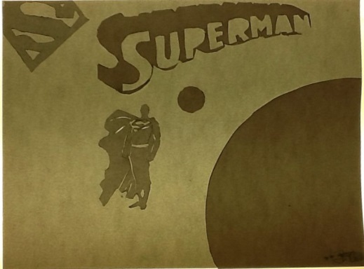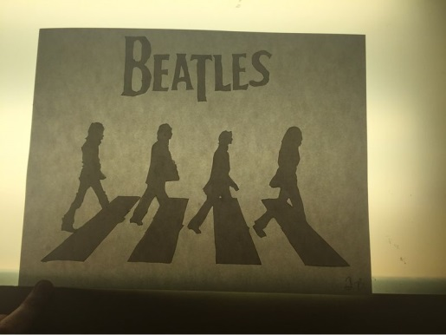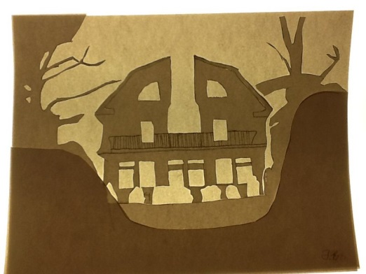 **T.B. 8th Grade (Theme- Shadow)**

**K.R. 7th Grade (Theme- Wings)**

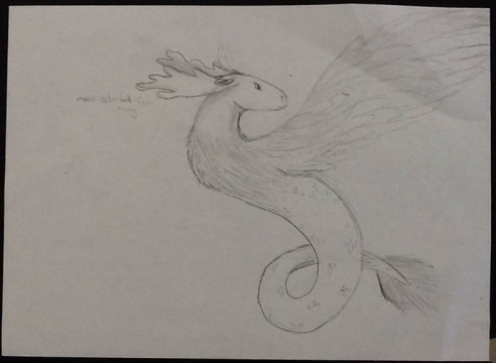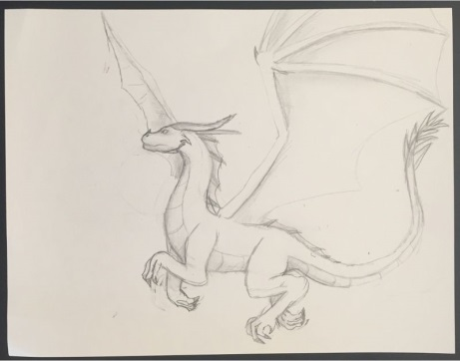

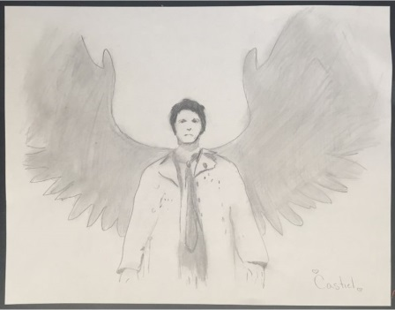

**M.C. 7th Grade (Theme- 3D Drafting/Modeling)**

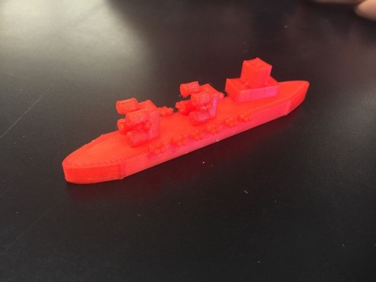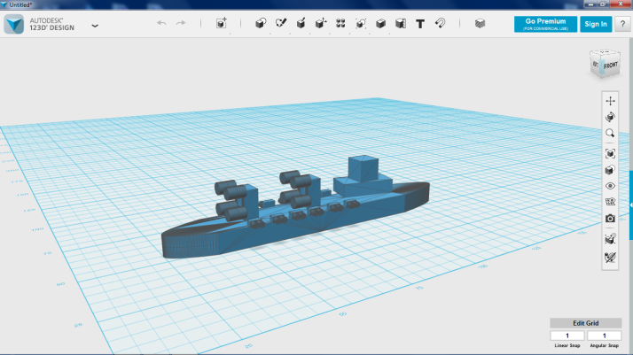

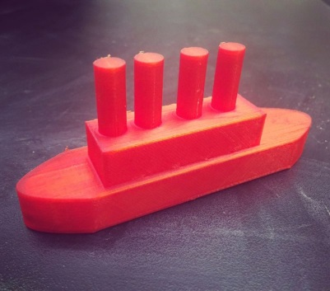

**R.G. 8th Grade (Theme- Photoshop)**

