Indicator 11 and Indicator 12
Individual Correction of Noncompliance SY 2022-2023

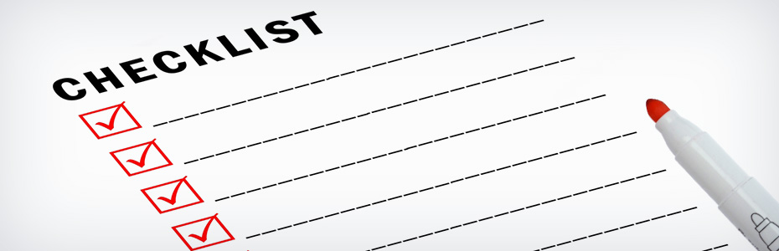
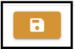
- Complete individual corrections for each student in the DMS.
- Save your data entry.
- Click on the “Submit for Approval” button once all required fields are completed for all students.
- This automatically triggers an email to CDE that your AU has completed the corrections.
- Deadline for submission of completed Correction Tracker(s) is April 1, 2024.

The CDE will verify “Individual Correction” via a desk audit process and confirm the results to the AU by July 1, 2024.
If the AU does not meet both parts of the demonstration of correction requirements, additional monitoring activities will be required.
Data will be reported in the SPP/APR in February 2025 to demonstrate Colorado's correction of noncompliance for Indicator 11 and Indicator 12.

