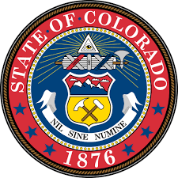

This certifies that the
Colorado High School Seal of Biliteracy for High School Diplomas
IS PRESENTED TO

( S T U D E N T N A M E )

Who has successfully fulfilled all requirements prescribed by the Colorado Senate Bill 17-123, and therefore entitled to this Seal of Biliteracy

PRINCIPAL |  | DISTRICT COORDINATOR

