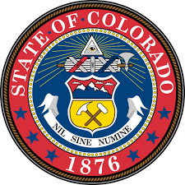

Colorado High School Diploma Endorsement for Biliteracy
This certifies that

[Student Name]

has completed the requirements for graduation as prescribed
by the Colorado Senate Bill 17-123, and is therefore entitled to this Diploma Endorsement

Principal District Coordinator

