Windows Device Preparation Checklist for TN 8.2

Device Specifications
Processor | Any
Memory | 512 MB RAM
Screen Resolution | 1024 x 768
Input Device Requirements | Keyboard–wired or wireless/Bluetooth
Headphones/earphones/ear buds | Headphones/earphones/ear buds are only required for English Language Arts/Literacy testing sessions, not mathematics testing sessions (except for students who need them for accessibility or accommodations such as text to speech).
Microphone Requirements | None
Specifications Reference | Technology Guidelines for PARCC Assessments version 4.3 p. 4-6 http://www.parcconline.org/technology

Device Configuration
- Enable Local File access to home directory.
- Verify student assessment devices meet minimum requirements by running SystemCheck.
- Any software that would allow secure test content on student computers to be viewed on another computer must be turned off.
- Enable javaw.exe exception created in Windows Firewall.
- Any applications that may automatically launch on a computer are configured not to launch during testing sessions.
To ensure maximum reliability, performance, and security, you should run only applications and processes needed for testing before you launch TestNav.
The TestNav delivery engine does not permit access to other desktop applications (including applications that may be launched automatically) without terminating the test. Configure common applications like these to NOT launch during testing sessions:
- Anti-virus software performing automatic updates
- Power management software on laptops warning of low battery levels
- Screen savers
- E-mail with auto message notification
- Calendar applications with notifications, such as Google Calendar
- Pop-up blockers
*Unless disabled, all pop-up notifications during student testing disrupt the TestNav session.
Upon receiving a pop-up notification, TestNav immediately closes the testing session. To resume testing, the test monitor must resume the student’s session in the testing administration platform before the student can log into TestNav and continue.

Browser Requirements and Configuration
OS | IE 9.0 | IE 10.0 | IE 11.0 | Chrome 35-38 | Firefox 28-33
XP (SP 3) |  |  |  | x | x
Vista | x |  |  | x | x
7 | x | x | x | x | x
8.0 |  | x |  | x | x
8.1 |  |  | x | x | x

Browser Configuration
- Enable pop-ups for Pearson sites.
- Disable Skype plugins.
- Internet Explorer Browser Configuration
- Disabling Accelerators in Internet Explorer 9, 10, and 11
- Firefox Browser Configuration
- Chrome Browser Configuration
- Enable Java in Chrome browsers

Install and Enable Java
Browser | Supported Java Version
IE 9 | 1.5, 1.6, 1.7, 1.8
IE 10 | 1.6, 1.7, 1.8
IE 11 | 1.7, 1.8
Chrome 35-38 | 1.6, 1.7, 1.8
Firefox 28-33 | 1.6.30, 1.7, 1.8
TestNav 8 opens a Java applet to run full screen, which prevents students from accessing other programs while testing on desktop and laptop computers.
- If a testing computer does not have Java installed, you must install and configure it to use TestNav. Download the latest supported version of Java, and follow the installation instructions.
- After you install Java. See How do I enable Java on my web browser?
- If Java is already installed, check to make sure it is the most current supported release. If not, update Java.

Java Security Warnings
The first time you launch TestNav 8 and TestNav SystemCheck, you must permit the TestNav Java applet to run. Browsers require this action to successfully launch TestNav and to run TestNav SystemCheck.

- Users that do not accept the security certificates will see an error message. These users must close the browser entirely and complete the update before they can use TestNav and SystemCheck.

Follow the instructions below. If the screen below appears when the TestNav or TestNav SystemCheck java applet attempts to download, select the Do not show this again for apps from the publisher and location above check box, and then click the Run button to continue to TestNav and TestNav SystemCheck. This ensures that the warning screen will not appear again.

- If the screen below appears when the TestNav or TestNav SystemCheck java applet attempts to download, select the Do not show this again for this app and web site check box, and then click the Allow button to continue to TestNav and TestNav SystemCheck. This ensures that the warning screen will not appear again.
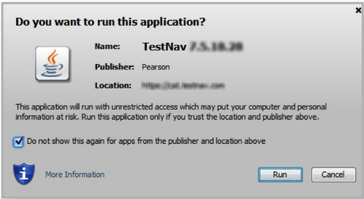

Eliminate the Java Prompt when Testing
By default, Java requests permission to run TestNav 8 every time it launches. To stop this behavior and instead launch tests immediately, change a setting in the Java Control Panel.
Follow the instructions below.
- Click Control Panel > Java.
- Click Advanced.
Select Enable - hide warning and run with protections:
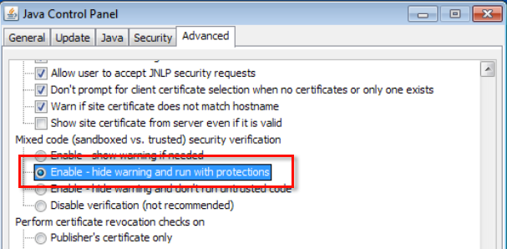

Disable Java Expiration Check
Beginning with Java 7, Oracle automatically checks your Java version and may send a pop-up notification to immediately accept Java Critical Patch updates. Expiration check notifies you that your Java version has expired. If a student receives this pop-up notification, the test an administrator must accept the update before the test monitor can resume the student's testing session.
Java DOES ALLOW you to disable this notification to avoid interruption. To disable expiration check, see Option to disable the “JRE out of date” warning in Oracle’s Update Release Notes.

Find your SRF and Log Files
For Windows computers, the default location for this file is the Pearson folder in the user's home directory. You can configure your backup location in the TestNav configuration located in PearsonAccess. You can also set multiple locations SRF file save locations.
- Multiple locations allow you to have the SRF saved both on the local device and on a network drive. This is useful for those times when testing problems force a test to be stopped and when it subsequently may not be able to be completed on the exact same device. TestNav is then able to find the SRF on the network drive. However, multiple locations and custom locations are only available on Windows and Mac.
TestNav creates a Pearson directory in the home directory of the testing computer. SRFs are stored in the main Pearson directory.
The TestNav client creates a directory called “logs” in the Pearson folder in the user’s home directory. The TestNav client logs the current system output and error messages for diagnostic purposes.

Windows XP
C:\Documents and Settings\username\Pearson\...
Windows Vista, Windows 7, and Windows 8
C:\Users\username\Pearson\...

