Guidance for Finalizing Accreditation Categories and Submitting Requests to Reconsider for District Accreditation Ratings and School Plan Types

Updated September 12, 2022
Table of Contents
Overview 4
Framework Pause and 2022-23 Accountability System 4
Submitting School Accreditation Categories 5
General Accreditation Process 5
Accreditation Process for New Schools 6
Accreditation Process for Insufficient State Data Ratings 7
Accreditation Process for Using a District-Created School Performance Framework 7
2022 Request to Reconsider 8
Eligibility to Participate in the 2022 Request to Reconsider Process 9
Request to Reconsider Submission 9
Summary Requirements for a Request 10
Conditions for a Request 11
Expedited Clock Adjustment 11
Body of Evidence of Student Performance 12
Accountability Participation Impact 14
Calculation Error 15
Impact of Alternative Education Campuses on the District Transitional Framework 15
Districts with a Single School 16
Districts with a Closed School 16
Small Districts and Schools 16
Note on Insufficient State Data Ratings 17
Note on Alternative Education Campuses 17
Note on Schools and Districts with Board Orders 17
Reviewing a Request to Reconsider 17
CDE Decision-Making Considerations 18
Final District Accreditation Rating, School Plan Type, and Clock Status 19
Accreditation Contract 19
Technical Assistance and Support 20
Request to Reconsider Excel Tool for Local Assessment Data Submissions 20
Appendix A: School Accreditation and Request to Reconsider Form 21
School Accreditation and Request to Reconsider Form (Login Page) 21
School Accreditation and Request to Reconsider Form (Main Page) 22
School Accreditation and Request to Reconsider Form (Request to Reconsider Tab) 24
Appendix B: Eligibility for a 2022 Request to Reconsider 25
Appendix C: Grade Configurations and State Data Availability 26
Appendix D: Acadience Data Submission 26

Overview
The Education Accountability Act of 2009 (S.B. 09-163) and H.B. 18-1355 authorize the Colorado Department of Education to conduct an annual review of the performance of public schools and districts in the state. Based upon that evaluation, the department then makes recommendations to the State Board of Education concerning the type of school improvement plan to be implemented in each school and the accreditation category and improvement plan for each district. The process for determining each district’s initial accreditation rating and each school’s initial plan type and the process for submitting district and school plans are outlined in the Colorado District Accountability Handbook.
Each year, districts have the opportunity to review the state identified district accreditation rating or school plan type. If the district disagrees with the initial rating/plan type, then additional performance data may be submitted to CDE through the request to reconsider process. The purpose of this document is to outline the process for all districts to annually accredit their schools, and for districts who disagree with their district or school preliminary ratings or plan type, the process to request reconsideration.

Framework Pause and 2022 Accountability System
In response to disruptions created by COVID-19, Colorado paused the performance frameworks for two school years (2020 and 2021). For 2021, district and school plan types were rolled over from the 2020 school year (which were rolled over from 2019). During this pause, the status of schools and districts on the accountability clock was not adjusted. In 2021, a modified request to reconsider process was made available to schools and districts on the accountability clock (i.e., Priority Improvement, Turnaround) to adjust plan types, but years on performance watch remained on hold.
For 2022, SB 22-137 requires the department to calculate 2022 transitional performance frameworks and suspends automatic advancement or exit from the accountability clock. Any adjustments for schools on performance watch (i.e., move to “on watch,” exit the clock fully) can only occur through the 2022 request to reconsider process. The request to reconsider process is open to all schools and districts that meet allowable conditions. Note that the State Board of Education added a 90% total participation on state assessments threshold to engage in the 2022 request to reconsider process.

Submitting School Accreditation Categories

General Accreditation Process
All districts must submit the School Accreditation and Request to Reconsider form which is housed within the UIP online system (available to district accountability contacts) by September 23, 2022. The form includes detailed instructions concerning the required information, including the following:
- A determination from the district or Charter School Institute (CSI) regarding whether it agrees with CDE’s recommended plan types and/or clock status. For eligible schools and districts that disagree with CDE’s recommendations, see information about request to reconsider;
- If the district or CSI does not use the State’s school transitional performance framework and school plan types to accredit schools, the district or CSI must attach a description of the district’s accreditation process, including:
  - Performance indicators the district evaluates and the measures, metrics and cut-points used to evaluate them
  - Weighting of the performance indicators the district evaluates, and how they roll up into an accreditation category
  - Accreditation categories for the district’s schools (e.g., the ratings given to schools and how they translate to CDE plan types)
  - Percent of schools in each of the district’s accreditation categories based on the district's school transitional performance framework results
  - Actual accreditation results for the district’s schools (e.g., each school's accreditation report, or an Excel spreadsheet with each school's result)
  - Link to additional information on the district's school transitional performance framework (if available)
- Assurance that the district’s or CSI’s selections have been verified by the district superintendent or CSI executive director, as well as the local board chair and for charter schools not authorized by CSI, the charter school’s board chair (as applicable).
Accreditation categories must be submitted to CDE by the district rather than by individual schools. If different school transitional performance frameworks are used for different groups of schools (e.g., charter schools), then the district must attach an explanation of each specific framework in the Accreditation Portal. Accreditation information will only be accepted in the specified format, as it allows for the department to post the information online on SchoolView.
Form Submission. The School Accreditation and Request to Reconsider form is the district’s way of indicating whether it agrees with the state’s preliminary plan types for schools and the district. The form guides users to select the accreditation options available for their district (either agree or disagree) and assures these selections have been verified by the superintendent and local board chair. The form is pre-populated with the preliminary plan types/clock status for schools based on the 2022 School Transitional Performance Frameworks and the preliminary accreditation rating/clock status for the district based on the 2022 District Transitional Performance Frameworks (it does not reflect any request to reconsider decisions). If assigned staff are having issues accessing the form, contact your district’s Local Access Manager (LAM) and ensure the individual is assigned an “Accountability Contact” role, as described in this guide.
Example of the Form
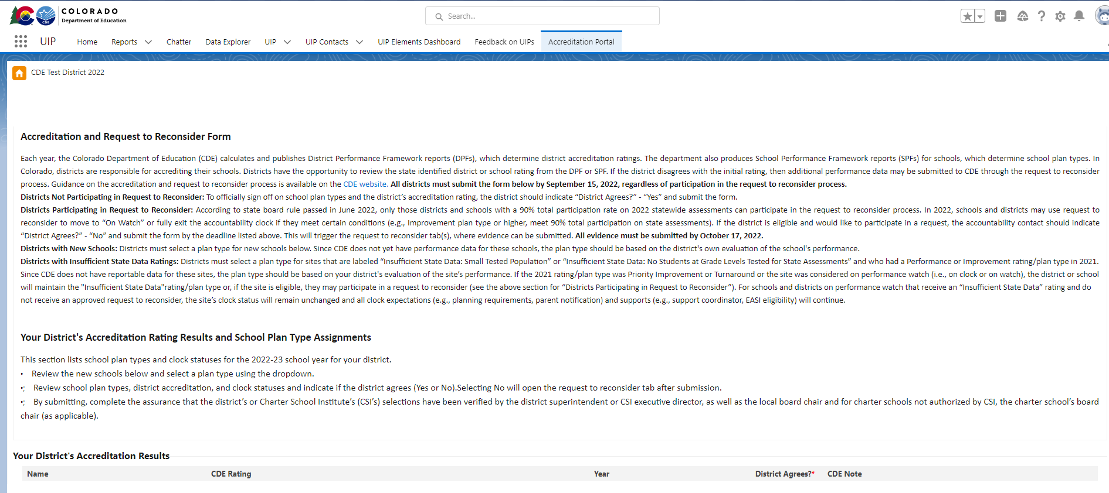
See Appendix A: School Accreditation and Request to Reconsider Form for a walkthrough of the form.
Once the form is submitted, districts do not need to provide any additional materials until ratings/plan types are finalized by the State Board of Education in November, unless it is participating in a request to reconsider. Once the district’s rating and all school plan types are finalized by the state board, districts that are rated Insufficient State Data or Improvement or below will need to sign the district’s accreditation contract. See Final District Accreditation Rating, School Plan Type, and Clock Status for more information.
Note that districts participating in a request to reconsider have additional requirements and timelines for submission based on their request conditions. Ratings/plan types for those schools and districts will also not be finalized until the December State Board of Education meeting. See request to reconsider for more information.
If the district does not submit the form by the September 23, 2022 deadline or indicate to the department the need for an extension, the department will consider the district accreditation rating and school plan types final and will submit them to the state board for approval.

Accreditation Process for New Schools
Districts must select a plan type for new schools using the dropdown on the accreditation form. Since CDE does not have data for these schools, the plan type should be based on the district's own evaluation of the school's performance.

Accreditation Process for Insufficient State Data Ratings
For districts or schools that did not receive a CDE rating/plan type because of low participation on state assessments, no state data, or are small sites that do not meet the required number of reportable students, the accreditation form will be pre-populated with “Insufficient State Data”, “Insufficient State Data: No Students at Grade Levels Tested for State Assessments”, or “Insufficient State Data: Small Tested Population”.
- For districts and schools labeled “Insufficient State Data” or “Insufficient State Data: Low Participation”: the district will not be eligible to assign an accreditation rating or plan type and will maintain the “Insufficient State Data” rating/plan type and any associated clock status.
- For districts and schools labeled "Insufficient State Data: Small Tested Population" or “Insufficient State Data: No Students at Grade Levels Tested for State Assessments”: where the rating/plan type was Performance or Improvement in 2021, districts are eligible to select the district accreditation rating or school plan type using the drop-down menu on the form. Since CDE does not have data for these sites, the plan type should be based on the district's evaluation of the site’s performance. If the 2021 rating/plan type was Priority Improvement or Turnaround or the site was considered on performance watch (i.e. on clock or on watch), the district or school will maintain the "Insufficient State Data" rating/plan type. If eligible, the site may submit a request to reconsider, aligned with the requirements of the Body of Evidence condition.

Accreditation Process for Using a District-Created School Performance Framework
If a district is using a school performance framework different from the state’s to accredit the district’s schools, a summary of the specific performance framework used to determine the school’s plan type assignment, and the actual framework results for the school, as indicated on the School Accreditation Form, will need to be submitted. If the district-created school performance framework is deemed to be more rigorous than the state school transitional performance framework, CDE will defer to the district-created framework rating only if the rating shows a lower rating than the state school transitional performance framework. If the district-created school transitional performance framework shows a higher rating than the state school transitional performance framework and the site has 90% total participation on state assessments in 2022, the district can submit additional evidence through request to reconsider to support the higher rating, aligned with the requirements of the Body of Evidence condition for a request.

2022 Request to Reconsider
In Colorado, districts are responsible for accrediting their schools. Districts have the opportunity to review the state identified district or school rating from the District Transitional Performance Framework or School Transitional Performance Framework. If, in reviewing the performance of the district overall or of an individual school, a district determines that a different accreditation rating or plan type assignment better describes the performance of students in the district or school, then the district should engage in the request to reconsider process. Schools and districts may use the 2022 request to reconsider process to request a:
- Change in district rating or school plan type (for example, request a change in rating from Improvement to Performance),
- Clock adjustment - unique for 2022 (for example, request to exit the accountability clock if the school was previously considered “On Watch” or Year 1 On Clock), or
- Change in both a rating or plan type and clock status (for example, request a change from Priority Improvement - Year 2 On Clock to Improvement - Year 2 On Watch).
Note: If a site receives an approved request, this will likely impact the district or school’s clock expectations (e.g., planning requirements, parent notification) and supports (e.g., support coordinator, EASI eligibility). Table 1 has scenarios of the accountability clock over time if approval is granted through the 2022 request to reconsider process. For additional scenarios and the requirements associated with each, see the Performance Watch Labels and Progression fact sheet on the CDE website.
Table 1: Examples of Request to Reconsider Results Over Time
2021  Final Plan Type  (Rolled over over from 2019 SPF) | 2022 Preliminary Plan Type | Request Type | 2022  Final  Plan Type  (Approved Request to Reconsider) | 2023  Final Plan Type  (Clock progress resumes) | 2024  Final Plan Type
Performance | Improvement | Rating Change | Performance | Performance | Performance
Priority Improvement - Y3 | Performance - Y3 (clock status held from 2019 SPF) | Clock Adjustment | Performance - Y3 On Watch | Improvement (no longer on clock or on watch) | Priority Improvement - Y1
Priority Improvement - Y3 | Priority Improvement - Y3 (clock status held from 2019 SPF) | Both Rating Change and Clock Adjustment | Improvement - Y3 On Watch | Priority Improvement - Y4 | Improvement - Y4 On Watch

Eligibility to Participate in the 2022 Request to Reconsider Process
The State Board approved rules on 2022 accountability and the request to reconsider process in June 2022. Rule language is available on the CDE website. Based on State Board rule, districts and schools must meet the following eligibility requirements in order to participate in the 2022 request to reconsider:
- Only those districts and schools with a 90% total participation rate in both English language arts/Evidence-based reading and writing and math on 2022 statewide assessments can participate in the request to reconsider process. See Appendix B: Eligibility for a 2022 Request to Reconsider for how this is determined.
- A district or school may use request to reconsider to move to “On Watch” or fully exit the accountability clock if the site meets certain conditions (e.g., Improvement plan type or higher, meet 90% total participation on state assessments).
- Certain historical practices (e.g., ability to request Insufficient State Data with less than 85% participation rate if the district or school is able to demonstrate that data is not representative) are not available in 2022.

Request to Reconsider Submission
Districts have the opportunity to review the state identified district or school rating from the transitional performance framework. If the district disagrees with the preliminary rating, the district must indicate it disagrees with the rating using the Accreditation and Request to Reconsider form within the UIP online system. For a walkthrough (including screenshots) of the accreditation form, see Appendix A: School Accreditation and Request to Reconsider Form.
Form Submission. To initiate the process, the accountability contact will need to “disagree” with the preliminary plan type and/or clock status using the Accreditation and Request to Reconsider form by September 23, 2022. The accountability contact must complete an assurance that the district’s or CSI’s selections have been verified by the district superintendent or CSI executive director, as well as the local board chair and for charter schools not authorized by CSI, the charter school’s board chair, if applicable.
Final Submission. Once the Accreditation and Request to Reconsider form is submitted, a Request to Reconsider tab will be available for each district and school. Each Request tab will include one area to upload evidence and draft a narrative response per district and/or school(s). Final submission of the request form and any accompanying materials is due October 25, 2022. Any requests submitted by the deadline will be considered part of public record. If the district would like to rescind a request before the final deadline, resubmit the Accreditation and Request to Reconsider form. For additional support, see Technical Assistance and Support. See Figure 1 for a full timeline of the process.

Figure 1. Timeline for Request to Reconsider
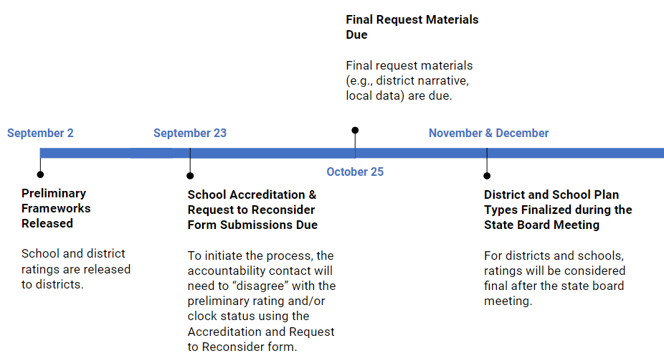

Summary Requirements for a Request
The department will only consider requests that meet one or more of the conditions for a request in assigning a different district accreditation category or school plan type or clock status given through the district or school transitional performance framework report. See Figure 2 for a request decision tree.
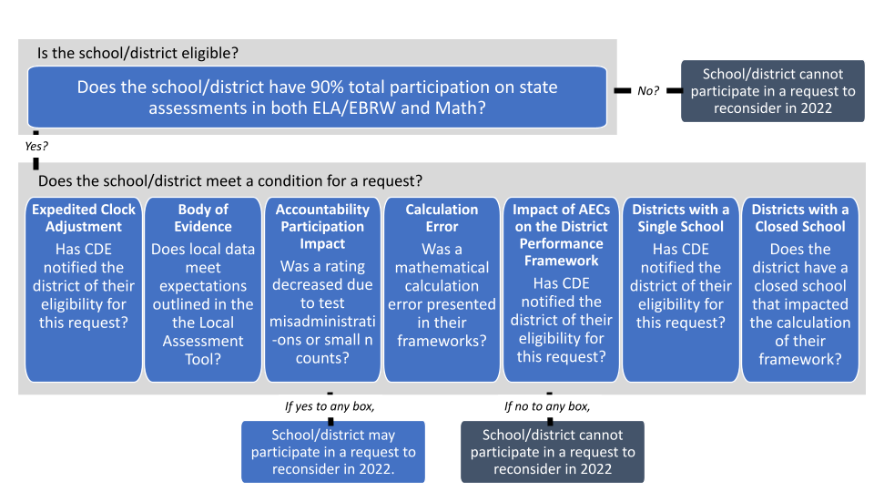
Figure 2. Decision Tree for Making a Request
Districts must follow the process outlined below on how to submit a request to reconsider, which includes:
- Meet 90% or higher total participation on state assessments in 2022 (see State Board rules and Appendix B: Eligibility for a 2022 Request to Reconsider).
- A complete Accreditation and Request to Reconsider form (see Appendix A: School Accreditation and Request to Reconsider Form). This form includes an assurance by the accountability contact that the district’s or CSI’s selections have been verified by the district superintendent or CSI executive director, as well as the local board chair and for charter schools not authorized by CSI, the charter school’s board chair, if applicable.
- If participating in a Body of Evidence, Accountability Participation Impact, Calculation Error, or Districts with a Closed School request, the district must provide a district narrative that presents the district’s rationale for why the district disagrees with the state’s District or School Transitional Performance Framework, and why the district would propose a different accreditation rating or school plan type. This statement should:
  - Include the condition of the request per the next section;
  - Include a description of any relevant data analysis or rationale associated with the request.
- If participating in Body of Evidence request, include submission of local data through the 2022 Local Assessment Tool excel template or include the submission of other data in coordination with CDE. Attach the completed data templates on the request tab in the Accreditation Portal within the UIP online system.
Request to reconsider submissions that do not include all applicable criteria by the deadline of October 25, 2022 will not be accepted. All documentation received by October 25, 2022 will be considered final and part of public record.

Conditions for a Request
A request must meet one or more of the following conditions to be recommended to the state board for approval:

Expedited Clock Adjustment
Unique to 2022, this approach relies on 2022 state performance data (i.e., achievement, growth, and postsecondary workforce readiness) and will be calculated by CDE for all schools and districts (including BOCES and the Charter School Institute). For schools and districts on Performance Watch (i.e. On Clock, On Watch or On Hold), if state data demonstrate at least 90% total participation in both English Language Arts and Mathematics and a rating of Improvement or higher, the department will notify district accountability contacts of their district’s eligibility for an expedited recommendation to the State Board of Education to adjust the school’s or district’s clock status (i.e., move to On Watch or exit the clock fully). All schools are eligible to participate in this request if it meets this criteria, including Alternative Education Campuses (AECs). If CDE identifies a district or school as eligible for this pathway, CDE will notify the district and the district does not need to supply further evidence (e.g., body of evidence). The district does, however, need to complete the Accreditation and Request to Reconsider form, available in the Accreditation Portal tab within the UIP online system, to indicate agreement for adjusting the district or school clock status. Details about CDE’s process for calculating the expedited pathway include:
- A minimum total participation rate of 90% on state measures is required for the school or district overall to submit a Request to Reconsider form. For example, a multi-level K-8 school must have had at least 90% of all enrolled students receiving valid test scores in both CMAS English Language Arts and Math for inclusion in this pathway. Note that parent excusals and students not testing due to COVID are included in the total participation rate denominator and excluded from the numerator. See Appendix B: Eligibility for a 2022 Request to Reconsider and refer to the Participation and Accountability guide posted on the CDE website.
- If a district or school is considered “On Watch” (i.e., was previously on the accountability clock but received a rating of Improvement or higher in 2019) or was on the clock Year 1 and receives an Improvement rating or higher in 2022, it is permitted to exit Performance Watch (i.e., on clock or “On Watch” statuses) through an expedited clock adjustment request. For a school or district on the clock Year 2 or higher, it will be considered “On Watch” and will still be on Performance Watch. In 2023, if that district or school receives another Improvement rating or higher, it will be off Performance Watch. If it receives a rating of Priority Improvement or Turnaround, it will be back on Performance Watch. For rating and clock scenarios and requirements, see the Performance Watch Labels and Progression fact sheet on the CDE website.
- Districts should use their knowledge of the school’s performance to determine whether the school should participate in an expedited request. If the district declines to participate in an expedited request, the school’s clock status will remain unchanged and all clock requirements, expectations, and supports (e.g. support coordinator, EASI eligibility) will continue.

Body of Evidence of Student Performance
Body of evidence requests rely on valid and reliable data demonstrating the progress the district/school has made in its performance on the state’s key performance indicators (i.e., achievement, growth, and postsecondary workforce readiness) overall and for individual disaggregated groups, and in meeting the minimum expectations set by the state, district, or the school. Schools and districts must have 90% total participation on state assessments to submit a body of evidence request and must demonstrate local performance and practices commensurate with earning an improved rating or plan type. Alternative Education Campuses (AECs) are not eligible for this pathway. For body of evidence requests, CDE will review the following supplemental information:
- Local Data Submission for Districts and Traditional (non-AEC) Schools: Student performance on interim assessments is reviewed by CDE, with a performance standard set on these assessments by CDE in consultation with the vendor. Performance data must be submitted using the 2022 Local Assessment Tool excel template for both achievement and growth indicators on the Request tab in the Accreditation Portal within the UIP online system. Submissions must be based upon results from student performance on nationally normed local assessments and must be representative of the referenced student population. To ensure all local assessment data are appropriate and sufficient for consideration as part of the request process, the following requirements will apply:
  - All local assessment data must come from nationally normed interim or benchmark assessments and include both achievement score results and a growth or progress metric (examples include but are not limited to: NWEA MAP, iReady, STAR, Acadience).
  - Minimum 95% participation rate (denominator based on entire enrolled student population) for each applicable grade level or student group is required for consideration. This will ensure local results adequately represent district or school enrollment across included grade levels and disaggregated student groups. Also note that the participation rate has been a long standing requirement for this particular condition.
  - Data must be submitted for English Language Arts. Mathematics data submissions can be submitted, if available. Data for Science, Social Studies or other locally tested content areas will not be considered for this process.
  - Data should be reported consistently for all grades and student groups administering the same assessment, and CDE may reject requests where data has been selectively reported.
  - Districts and schools must have at least 16 valid student test scores per EMH level for achievement and 20 for growth. Smaller systems can report grade-specific results that fall below these minimum reporting requirements for consideration, but the local data tool will be considered Personally Identifiable Information (PII) and will not be released publicly.
  - All submitted performance data must have been collected during the 2021-2022 school year and can only represent the most recent year of results.
  - Submitted achievement data must represent End of Year (e.g., final testing period, Spring) student results, and growth data must represent student progress from Beginning of Year (e.g., Fall) to End of Year (e.g., Spring).
  - Achievement and growth expectations corresponding to the rating categories of Does Not Meet, Approaching, Meets, and Exceeds have been established by CDE using historical national norming information for each assessment.
  - The 2022 Local Assessment Tool will automatically score submitted results and total up indicator and overall totals.
  - If a school or district must submit data not included in the 2022 Local Assessment Tool or if a school or district finds that their assessments do not align to the local assessment tool, contact Aislinn Walsh (walsh_a@cde.state.co.us).
- Postsecondary and Workforce Readiness: The department will consider trend analysis indicating improved performance over time on additional post-secondary measures. This includes AP/IB exams and/or remediation rates, a minimum 95% participation rate of the applicable student population is required for consideration. CDE will also consider additional data around matriculation that may have not been captured with this measure or included in HB15-1170. For example, proof of out-of-country CTE, 2-yr, or 4-yr enrollment, gap year with acceptance letter to higher education institution, and/or verification of death.
- Plan for Improvement: In addition to the above data submission, districts and schools may utilize their Unified Improvement Plan to strengthen their district narrative, demonstrate an upward trajectory of student performance, and to describe plans for sustained continuous improvement. See the section on Technical Assistance and Support to request improvement planning support from CDE.
- Extenuating circumstances: CDE will review supplemental material for districts and schools concerning the extent to which the school or district has been subject to an event that has caused significant disruption during the school year, including but not limited to acts of violence, the death of students or staff, or natural disasters such as fire, flood, earthquake, avalanche or tornado, but not including the broader impacts of the COVID-19 pandemic. The State Board of Education voted to keep the 90% total participation rate threshold in place for this condition in 2022.
Data from additional assessments or measures should be submitted to the Request tab on the Accreditation Portal using the Request to Reconsider Data Templates, which are available on the request to reconsider website.

Accountability Participation Impact
Districts and schools with 90% total participation who had their rating “decreased due to participation” by not meeting the 95% accountability participation rate in two or more content areas may make a request around the following conditions (requests will not be considered around the actual participation rate and the “low participation” or “met participation” descriptors on the ratings):
- Historically, a district or school could request to use the multi-year participation rate (or the single year participation rate) if it was not meeting the accountability participation rate requirement in the frameworks. In 2022, CDE cannot calculate a multi-year transitional performance framework due to the framework pause. Therefore, this option is not available this year.
- CDE will consider issues of N count (i.e., exception for smaller districts/schools) in reviewing requests to reconsider based on participation rates. This includes issues for sites with fewer than 50 students enrolled in tested grades or instances in which one or two nonparticipants resulted in a decreased rating.
- If the 95% participation rate requirement has not been met due to reasons other than parent refusals, such as test misadministration, the district and school has a clear and justified reason why students did not count as participants, and a plan to ensure participation improves in the future, CDE may consider a request to reconsider. There may be special considerations given to schools or districts with a test misadministration. In rare instances, a test misadministration may deem some tests invalid, and thus, lower the overall participation rating, once parent excuses are removed, for a school or district to less than 95%. Depending on the size of the district or school, particularly smaller sized districts or schools, the few non-participants may have a larger impact on the district or school than it would a larger district. If the district and/or school has historically met the 95% participation rate requirement on state assessments and the district or school acknowledges the errors in the misadministration and has made changes to ensure these errors do not happen in the future, a request may be considered.

Calculation Error
Districts and schools with a 90% total participation rate may submit a request to reconsider based on a mathematical calculation error in the data presented in the transitional performance frameworks. This generally excludes data submission and verification concerns through the completion of the Student Biographical Data (SBD) collection or failure to participate in SBD which resulted in uncorrected errors on the district/school transitional performance framework(s).

Impact of Alternative Education Campuses on the District Transitional Framework
As per SB 13-217 and 1 CCR 301-1, CDE may re-evaluate the accreditation category assigned to districts through the District Transitional Framework for districts that serve a significant number of students in Alternative Education Campuses (AECs) and have 90% total participation. CDE recognizes the unique circumstances and needs of students enrolled in AECs, and that the transitional performance frameworks could be considered a disincentive for authorizing Alternative Education Campuses. Thus, districts which serve large numbers of AEC students may submit a Request for Reconsideration of its DPF rating if it meets the following criteria:
- Removing the data for students enrolled in the Alternative Education Campus(es) from the calculations of the District’s or Institute’s performance on the Performance Indicators would otherwise cause the District or Institute to receive a higher Accreditation rating; and
- The Alternative Education Campus(es) has/have been assigned by the State Board to implement a Performance Plan; or the Alternative Education Campus(es) no longer serves students.
- For those Districts or Institute that serve only Alternative Education Campus(es), the calculations of the District’s or Institute’s performance on the Performance Indicators on the Alternative Education Campus school transitional performance framework would allow the district to receive a higher Accreditation rating.
CDE staff will calculate the impact data on a district’s rating and will notify potentially eligible districts. AEC SPF ratings will not be available until after the release of the preliminary transitional performance frameworks, so once those are completed, CDE will identify which districts are eligible for this request. If recommended for approval through this pathway, the district does not need to supply further evidence (e.g., body of evidence). The district does, however, need to complete the Accreditation and Request to Reconsider form, available in the Accreditation Portal tab within the UIP online system, to indicate agreement for changing the district or school rating or clock status.

Districts with a Single School
Districts with a single school and 90% total participation may elect to use the school transitional performance framework rating as the district accreditation rating, when there is only one public school in a district. CDE will notify eligible districts of their eligibility for this condition.

Districts with a Closed School
Districts with 90% total participation and Priority Improvement or Turnaround Plan types that have closed a district school at the department or state board’s request, or due to a district decision based on low performance, may request a reconsideration for re-calculating the District Transitional Framework with the closed school removed. Additionally, if the district decided to close or transfer a school, then this impact may be considered as part of a request.

Small Districts and Schools
For smaller schools and districts, data submitted through the body of evidence may be weighed more heavily, as state data may not be fully representative or may not be able to be reviewed due to small N size.
If a request does not meet expectations, then the department will not recommend the request for approval to the State Board of Education. The site’s rating or plan type and clock status would remain unchanged and all clock expectations (e.g., planning requirements, parent notification) and supports (e.g., support coordinator, EASI eligibility) would continue. Prior to final submission, schools and districts can utilize office hours or contact CDE for support on requests before they are submitted (see the section on Technical Assistance and Support for details). Note that any final submissions for request to reconsider are considered public record, even if the requests are not approved.
If after consideration of the additional evidence through the request to reconsider process, the state board approves the recommended district accreditation category, school plan type, or the state board determines a school or district can exit performance watch or change years on the clock, only the final determination will be reported on the district or school transitional performance framework report posted online on SchoolView. Note, however, that the initial data on the performance indicators and percent of points earned will not change.

Note on Insufficient State Data Ratings
In 2022, a school or district may not request an Insufficient State Data Rating through the request to reconsider process due to the 90% total participation eligibility requirement. The State Board of Education specifically voted to exclude this condition in 2022. For information on the accreditation process for schools assigned an Insufficient State Data rating see Accreditation Process for Insufficient State Data Ratings.

Note on Alternative Education Campuses
The Selection of Measures process for Alternative Education Campuses (AECs), which includes participation in the AEC Actual Measures and Data Pipeline Collection, is currently the process whereby CDE accepts and incorporates local measure data into the Alternative Education Campus school transitional performance framework for both schools with an AEC designation already in place and schools which are receiving an AEC designation for the first time. Note that the inclusion of local data or measures is not an option for districts to submit for the AEC transitional performance framework for the Body of Evidence condition through the request to reconsider process; therefore, submission of these local measures through the Selection of Measures process (the Actual Measures and Data Pipeline Collection) must occur before the frameworks are generated.

Note on Schools and Districts with Board Orders
For schools and districts with board orders, an approved request may impact the board order for that site and will change their priority level on supports (e.g., support coordinator, EASI eligibility). Eligible schools or districts should indicate on the Accreditation and Request to Reconsider form whether the site would like to change or remove their board order in the “District Narrative” box. Discuss the implications of this change with your district’s assigned support coordinator or Turnaround Support Manager.

Reviewing a Request to Reconsider
Upon receipt of a complete Accreditation and Request to Reconsider form and accompanying documentation, the department will review the request and formulate a recommendation as to the district’s final accreditation rating, the school’s plan type, and/or clock status. The review will be conducted by a cross-unit CDE team. CDE staff will evaluate the extent to which the request meets the conditions and criteria outlined in this document and whether the additional evidence supports a different rating and/or clock status. The staff will then make a recommendation to the Commissioner as to the district’s final accreditation rating, school plan type, and/or clock status. The Commissioner will request the State Board to approve the department’s recommendations on ratings, plan types, and/or clock status at the State Board of Education Meeting in December.

CDE Decision-Making Considerations
Requests for reconsideration will only be considered if the request is to change the district accreditation rating, school plan type, and/or clock status. Requests will not be considered if the request is to change individual performance indicator ratings or data points within the frameworks. The department will only consider requests that meet one or more of the conditions for a request to reconsider as outlined in this policy guidance document. All requests received by October 25, 2022 are public documents and part of public record. If a district does not wish for a request to be a part of public record, it may opt to rescind the request prior to October 25, 2022.
For requests for reconsideration concerning accountability participation rate impact, calculation errors, the impact of Alternative Education Campuses, districts with a single school, and districts with a closed school, re-calculations will be made by CDE to determine the impact on the overall accreditation rating/school plan type assignment, if the necessary conditions are met and data submitted.

Final District Accreditation Rating, School Plan Type, and Clock Status
The department will make its final recommendations on new plan types to the State Board of Education as early as November 2022. For districts and schools participating in request to reconsider, the state board will make final recommendations no later than December 2022.
If a district wishes to further appeal a district accreditation category of Accredited with Priority Improvement Plan or Accredited with Turnaround Plan, the district will have the opportunity to file an appeal to the State Board (see 1 CCR 301-1, section 5.11 “Rules for the Administration of Accreditation of School Districts”).

Accreditation Contract
Districts Accredited with Improvement, Priority Improvement, Turnaround: Once district accreditation ratings and school plan types are finalized by the State Board of Education in November and December, districts must annually complete the accreditation contract for their district. The accreditation contract will be made available to superintendents via DocuSign and must be signed by both the district superintendent and the local school board president by the end of December.
Districts Accredited with Insufficient State Data: Once district accreditation ratings and school plan types are finalized by the State Board of Education in November and December, districts must complete the accreditation contract for their district. The accreditation contract will be made available to superintendents via DocuSign and must be signed by both the district superintendent and the local school board president by the end of December.
Districts Accredited or Accredited with Distinction: If requested by the district or local board, a customized accreditation contract will be made available to superintendents via DocuSign; district superintendents and board presidents will have until the end of December, to sign it. Otherwise the existing contract will be automatically renewed. Contact accountability@cde.state.co.us to request an updated contract. CDE recommends that a new contract be signed when there is a new superintendent and/or board president. Otherwise, contracts must be signed at least every five years.

Technical Assistance and Support
Informational Webinar and Office Hours: CDE staff held an accreditation and request to reconsider informational webinar Monday, Aug. 15 at 1pm. This webinar is posted publicly on the Request to Reconsider Website. If a district would like individualized assistance from CDE, register for Office Hours (held via Zoom) here. Office Hours will begin Wednesday, Aug. 17 and will be held from 2 - 4 pm every Wednesday and Thursday until the request to reconsider process concludes.
Improvement Planning Support: The department is available right away for improvement planning support. Contact staff here.
General Request to Reconsider Questions and Support: Contact accountability@cde.state.co.us or Aislinn Walsh, walsh_a@cde.state.co.us or (720) 614-2151.

Request to Reconsider Excel Tool for Local Assessment Data Submissions
CDE has created the 2022 Local Assessment Tool template in Microsoft Excel for districts and schools to submit local K-2 data as part of the Body of Evidence pathway. The intention for this template is to minimize the level of effort required when submitting additional data for untested grade levels and student groups and shorten the timeline for CDE to approve requests. If a nationally normed assessment is not listed in the tool, contact CDE for further consultation. If a school or district would like to submit multiple years of data, the school or district must (1) demonstrate that the data is comparable to the data from the 2021-2022 school year (e.g. testing modalities are comparable across time and student participation was consistent across time) and (2) consult with CDE on the submission of the data. If a school or district must submit data not included in the 2022 Local Assessment Tool, contact CDE. The department may be able to analyze the local data using past templates, however, it will lengthen the overall process and may not result in an approved request.
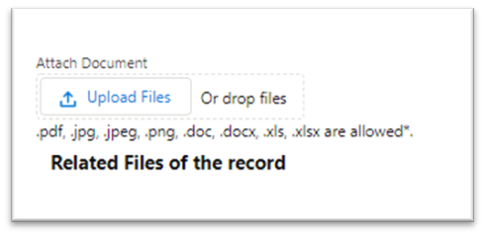
If a district would like to share the Local Assessment Tool with CDE staff for feedback, it must be sent via Secure File Transfer Protocol (SFTP), via Syncplicity, or attached to the Accreditation Portal in the online system (see image). Student Personally Identifiable Information (PII) should not be sent over email and will not be accepted.

Appendix A: School Accreditation and Request to Reconsider Form
This form is used to verify district ratings, school plan types, and clock statuses and to indicate participation in a request to reconsider. If anyone in the district is having issues accessing the form, contact the district’s Local Access Manager (LAM) and ensure the individual is assigned an “Accountability Contact” role, as described in this guide. For additional support, fill out the assistance request form using your district’s information.

School Accreditation and Request to Reconsider Form (Login Page)
To log in, go to the UIP online system login page, located at https://www.cde.state.co.us/uip/uip-online-system.
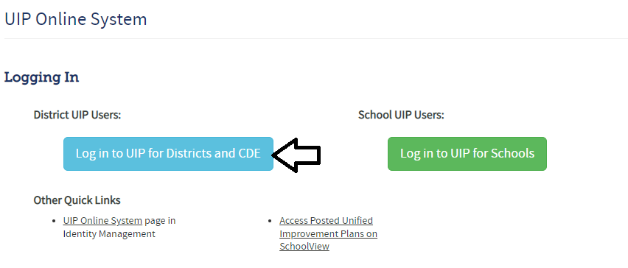

School Accreditation and Request to Reconsider Form (Main Page)
To find the form, go to the “Accreditation Portal” tab at the top of your screen (shown below).
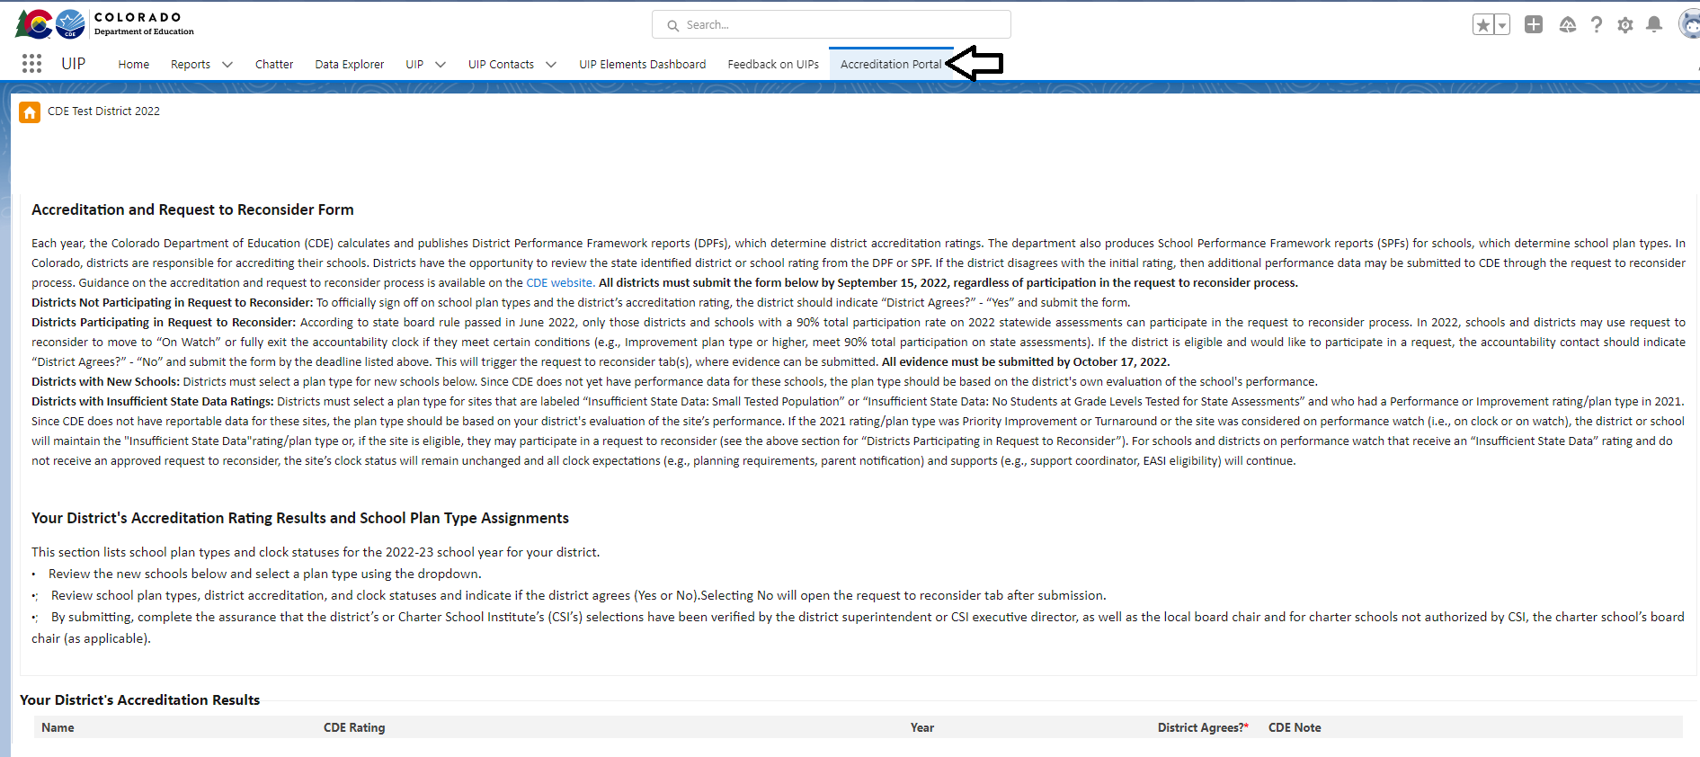
The form includes instructions for the various accreditation pathways (e.g., new schools, insufficient state data ratings, requests to reconsider). The form is pre-populated with the preliminary ratings/plan types/clock year for schools and districts (it does not reflect any request to reconsider decisions). The form guides users to select the accreditation options available for their district (either agree or disagree). Dropdowns are available for new schools or eligible Insufficient State Data ratings to select a rating type based on the district’s evaluation of performance.
Select agree (if the district does not want to participation in a request to reconsider for that site) or disagree (if the district does want to participate in a request to reconsider for that site).
Select rating using the dropdown (for new schools or Insufficient State Data: Small Tested Population or Insufficient State Data: No Students Tested)
Submit the form and submit the assurance.
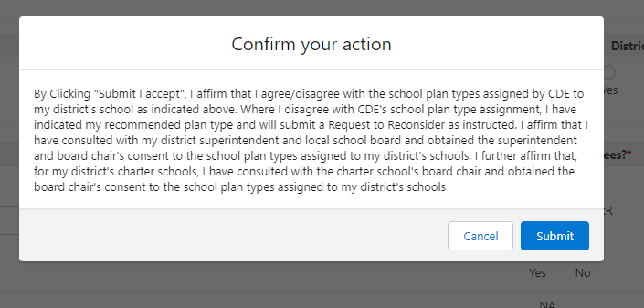

School Accreditation and Request to Reconsider Form (Request to Reconsider Tab)
Once the form is submitted, a request tab will appear for each site (click on Request To Reconsider to see the tab).
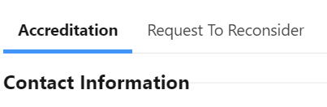
Each site that is eligible for a request will have their own tab. Complete the dropdown for the request type and submit any additional materials required for that condition on each tab. Once all tabs are submitted, your requests are complete. See the “Status” indicator for whether you have successfully submitted each tab.

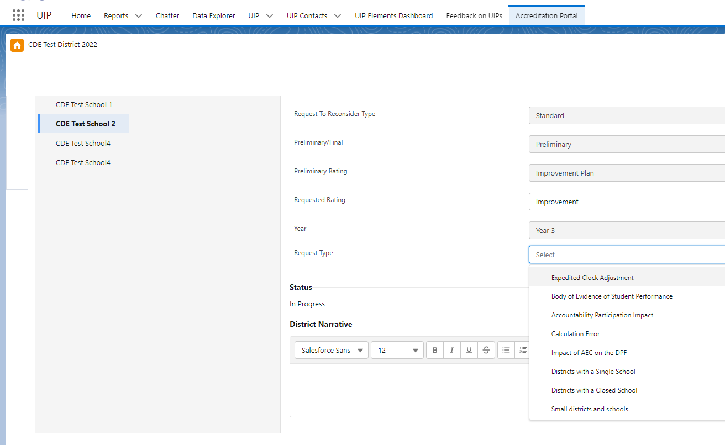

Appendix B: Eligibility for a 2022 Request to Reconsider
According to state board rule, for a school or district to be eligible for a 2022 request to reconsider, it must have 90% total participation rate on state assessments. In order to determine why the school or district is eligible or not eligible for a request, this appendix describes in more detail how this is calculated.
Calculation. Total participation rates combine all the assessment records for each subject area (English language arts, math and science) across all grade levels within a given school or district. For multi‐level schools and districts that serve high school, the PSAT/SAT Evidence‐based Reading and Writing results are combined with the English language arts results. Parent excusals are counted as non-participants (they are included in the denominator). Total participation rates best reflect the actual percentage of students enrolled that participated in testing. See Figure 3 for how these participation rates are captured on the first page of your school or district’s transitional performance framework. To understand more about participation and accountability calculations, refer to the guidance posted on the CDE website.
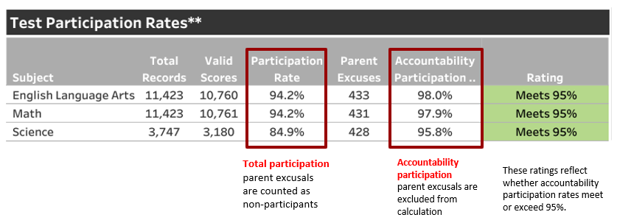
Figure 3. Participation Rates

Eligibility for a request to reconsider in 2022. If a school or district has 90% total participation (rounded to the nearest tenth) on English language arts and math, the site is eligible for a request to reconsider. As shown in Figure 3 above, this example school/district would be considered eligible to participate in a request because it has 94.2% total participation in both English language arts and math. Science is not included to calculate request to reconsider eligibility. District and school request to reconsider eligibility are available in a new “Participation” tab in the online UIP data dashboards (available to districts 8/24). To find this dashboard, any UIP user can log into the UIP and find their eligibility under the “Data Narrative - Trend Analysis” tab. The dashboard also includes their sites’ achievement, growth, and postsecondary and workforce readiness data.

Appendix C: Grade Configurations and State Data Availability
The charts below show the state-level data* (English language arts/evidence-based reading and writing, math, and science) available by grade level.
2022 Achievement Data Availability at each grade level:
Grade/ Subject | K | 1 | 2 | 3 | 4 | 5 | 6 | 7 | 8 | 9 | 10 | 11 | 12
ELA/EBRW | N/A | N/A | N/A | Yes | Yes | Yes | Yes | Yes | Yes | Yes | Yes | Yes | N/A
Math | N/A | N/A | N/A | Yes | Yes | Yes | Yes | Yes | Yes | Yes | Yes | Yes | N/A
Science | N/A | N/A | N/A | N/A | N/A | Yes | N/A | N/A | Yes | N/A | N/A | Yes | N/A
2022 Growth Data Availability** at each grade level:
Grade/ Subject | K | 1 | 2 | 3 | 4 | 5 | 6 | 7 | 8 | 9 | 10 | 11 | 12
ELA/EBRW | N/A | N/A | N/A | N/A | Yes | No | Yes | No | Yes | No | Yes | Yes | N/A
Math | N/A | N/A | N/A | N/A | No | Yes | No | Yes | No | Yes | Yes | Yes | N/A
Science | N/A | N/A | N/A | N/A | N/A | N/A | N/A | N/A | N/A | N/A | N/A | N/A | N/A
*WIDA ACCESS achievement data is not included in performance frameworks but is included on the CDE website. ACCESS growth results are included in performance frameworks and are available on the ACCESS growth results page.
**Growth data in 2022 is limited due to the alternating CMAS assessment schedule in 2021 for elementary and middle schools.

2022 Postsecondary Workforce Readiness Data Availability. For High School grade levels, postsecondary and workforce readiness data reported in the frameworks (i.e., graduation, dropout, and matriculation rates) are lagged from the 2020-21 school year.

